  Year 4 · Multiplication and division B · Step 17  Correspondence problems | 
  Year 4 · Multiplication and division B · Step 17
  Correspondence problems
  1 | A lunch has 2 types of bread and 4 fillings. A sandwich has one bread and one filling.  a) How many different sandwiches can be made?  b) How many different sandwiches could be made with 7 fillings?
  1 | A lunch has 2 types of bread and 4 fillings. A sandwich has one bread and one filling.  a) How many different sandwiches can be made?  b) How many different sandwiches could be made with 7 fillings?
  2 | A pizzeria has 3 different bases and 6 different toppings. A pizza has one base and one topping.
    3 × 6 =
    There are |  | different pizzas.
  2 | A pizzeria has 3 different bases and 6 different toppings. A pizza has one base and one topping.
    3 × 6 =
    There are |  | different pizzas.
  3 | A child picks one sport, one art and one outdoor activity from 3 sports, 2 arts and 4 outdoor activities.  How many different combinations are there?
  3 | A child picks one sport, one art and one outdoor activity from 3 sports, 2 arts and 4 outdoor activities.  How many different combinations are there?
  4 | How many main meals are there?
     | 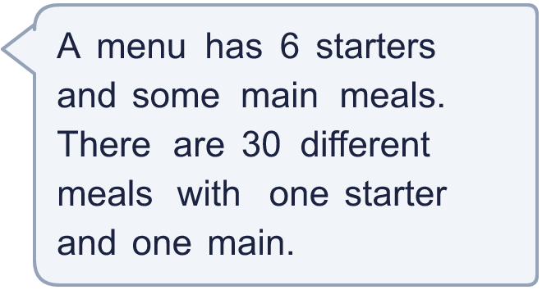
  4 | How many main meals are there?
  5 | A lunch has 2 types of bread and 4 fillings. A sandwich has one bread and one filling.  a) How many different sandwiches can be made?  b) How many different sandwiches could be made with 7 fillings?
  5 | A lunch has 2 types of bread and 4 fillings. A sandwich has one bread and one filling.  a) How many different sandwiches can be made?  b) How many different sandwiches could be made with 7 fillings?
  6 | A pizzeria has 4 different bases and 5 different toppings. A pizza has one base and one topping.
    4 × 5 =
    There are |  | different pizzas.
  6 | A pizzeria has 4 different bases and 5 different toppings. A pizza has one base and one topping.
    4 × 5 =
    There are |  | different pizzas.
  7 | A child picks one sport, one art and one outdoor activity from 4 sports, 4 arts and 4 outdoor activities.  How many different combinations are there?
  7 | A child picks one sport, one art and one outdoor activity from 4 sports, 4 arts and 4 outdoor activities.  How many different combinations are there?
  8 | How many main meals are there?
    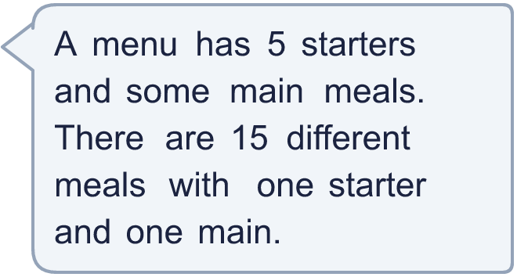
  8 | How many main meals are there?

  9 | Is Boba correct? Circle yes or no.  Yes / No  What is the correct answer?  Explain Boba’s mistake.
    
  9 | Is Boba correct? Circle yes or no.  Yes / No  What is the correct answer?  Explain Boba’s mistake.
  10 | Rosie has 6 skirts and 2 t-shirts. Tia has 4 skirts and 2 t-shirts. Each outfit has one skirt and one t-shirt.  a) How many outfits can Rosie make?  b) How many outfits can Tia make?  c) Who has more choices? Write Rosie or Tia.
  10 | Rosie has 6 skirts and 2 t-shirts. Tia has 4 skirts and 2 t-shirts. Each outfit has one skirt and one t-shirt.  a) How many outfits can Rosie make?  b) How many outfits can Tia make?  c) Who has more choices? Write Rosie or Tia.
  11 | A café offers a choice of drinks and a choice of cakes. There are 20 different drink and cake combinations.  How many drinks and how many cakes could there be? Write two different answers (each at least 2).
  11 | A café offers a choice of drinks and a choice of cakes. There are 20 different drink and cake combinations.  How many drinks and how many cakes could there be? Write two different answers (each at least 2).
  12 | At a camp there are 5 sports, 3 arts and 2 outdoor activities. Each child chooses one of each.  a) How many combinations are there?  One sport is cancelled.  b) How many combinations are there now?
  12 | At a camp there are 5 sports, 3 arts and 2 outdoor activities. Each child chooses one of each.  a) How many combinations are there?  One sport is cancelled.  b) How many combinations are there now?
  13 | Rosie has 4 skirts and 3 t-shirts. Tia has 3 skirts and 3 t-shirts. Each outfit has one skirt and one t-shirt.  a) How many outfits can Rosie make?  b) How many outfits can Tia make?  c) Who has more choices? Write Rosie or Tia.
  13 | Rosie has 4 skirts and 3 t-shirts. Tia has 3 skirts and 3 t-shirts. Each outfit has one skirt and one t-shirt.  a) How many outfits can Rosie make?  b) How many outfits can Tia make?  c) Who has more choices? Write Rosie or Tia.
  14 | At a camp there are 3 sports, 4 arts and 3 outdoor activities. Each child chooses one of each.  a) How many combinations are there?  One sport is cancelled.  b) How many combinations are there now?
  14 | At a camp there are 3 sports, 4 arts and 3 outdoor activities. Each child chooses one of each.  a) How many combinations are there?  One sport is cancelled.  b) How many combinations are there now?

Year 4 · Multiplication and division B · Step 17
Correspondence problems
Answers (teacher copy)

  1 | A lunch has 2 types of bread and 4 fillings. A sandwich has one bread and one filling.  a) How many different sandwiches can be made? 8  b) How many different sandwiches could be made with 7 fillings? 14
  2 | A pizzeria has 3 different bases and 6 different toppings. A pizza has one base and one topping.  3 × 6 = 18  There are 18 different pizzas.
  3 | A child picks one sport, one art and one outdoor activity from 3 sports, 2 arts and 4 outdoor activities.  How many different combinations are there? 24
  4 | How many main meals are there? 5
  5 | A lunch has 2 types of bread and 4 fillings. A sandwich has one bread and one filling.  a) How many different sandwiches can be made? 8  b) How many different sandwiches could be made with 7 fillings? 14
  6 | A pizzeria has 4 different bases and 5 different toppings. A pizza has one base and one topping.  4 × 5 = 20  There are 20 different pizzas.
  7 | A child picks one sport, one art and one outdoor activity from 4 sports, 4 arts and 4 outdoor activities.  How many different combinations are there? 64
  8 | How many main meals are there? 3
  9 | Is Boba correct? Circle yes or no.  Yes / No  What is the correct answer? 9  Explain Boba’s mistake.  3 × 3 = 9. Zach added the number of choices instead of multiplying them.
  10 | Rosie has 6 skirts and 2 t-shirts. Tia has 4 skirts and 2 t-shirts. Each outfit has one skirt and one t-shirt.  a) How many outfits can Rosie make? 12  b) How many outfits can Tia make? 8  c) Who has more choices? Write Rosie or Tia. Rosie
  11 | A café offers a choice of drinks and a choice of cakes. There are 20 different drink and cake combinations.  How many drinks and how many cakes could there be? Write two different answers (each at least 2).  for example 2 × 10; 4 × 5
  12 | At a camp there are 5 sports, 3 arts and 2 outdoor activities. Each child chooses one of each.  a) How many combinations are there? 30  One sport is cancelled.  b) How many combinations are there now? 24
  13 | Rosie has 4 skirts and 3 t-shirts. Tia has 3 skirts and 3 t-shirts. Each outfit has one skirt and one t-shirt.  a) How many outfits can Rosie make? 12  b) How many outfits can Tia make? 9  c) Who has more choices? Write Rosie or Tia. Rosie
  14 | At a camp there are 3 sports, 4 arts and 3 outdoor activities. Each child chooses one of each.  a) How many combinations are there? 36  One sport is cancelled.  b) How many combinations are there now? 24

