  Year 4 · Length and perimeter · Step 3  Perimeter on a grid | 
  Year 4 · Length and perimeter · Step 3
  Perimeter on a grid
  1 | Count the lengths of the edges to work out the perimeter of the shape.  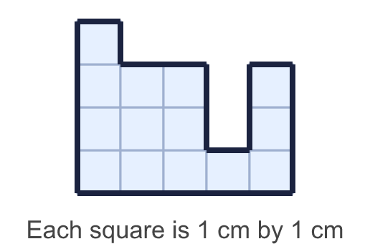
    Perimeter = |  | cm.
  1 | Count the lengths of the edges to work out the perimeter of the shape.
    Perimeter = |  | cm.
  2 | Work out the perimeter of the rectangle.  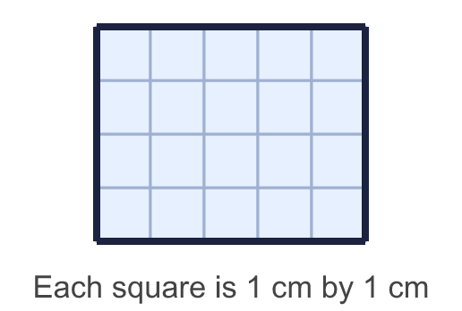
    Perimeter = |  | cm.
  2 | Work out the perimeter of the rectangle.
    Perimeter = |  | cm.
  3 | Work out the perimeter of each shape. Which shape has the greater perimeter?  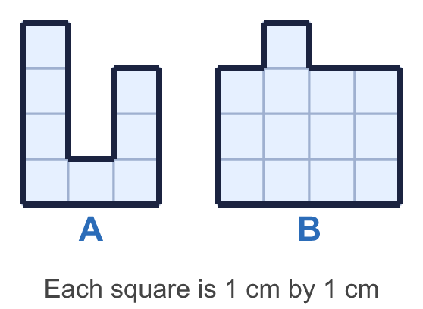
    a) Shape A: |  | cm.
    b) Shape B: |  | cm.
    Greater perimeter: shape
  3 | Work out the perimeter of each shape. Which shape has the greater perimeter?
    a) Shape A: |  | cm.
    b) Shape B: |  | cm.
    Greater perimeter: shape
  4 | Count the lengths of the edges to work out the perimeter of the shape.  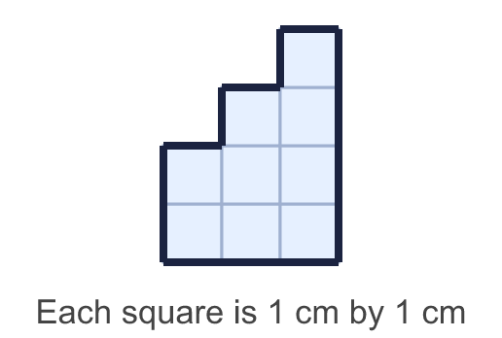
    Perimeter = |  | cm.
  4 | Count the lengths of the edges to work out the perimeter of the shape.
    Perimeter = |  | cm.
  5 | Work out the perimeter of the rectangle.  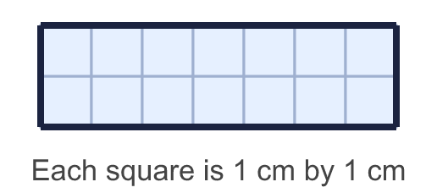
    Perimeter = |  | cm.
  5 | Work out the perimeter of the rectangle.
    Perimeter = |  | cm.
  6 | Count the lengths of the edges to work out the perimeter of the shape.  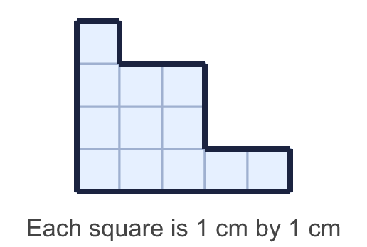
    Perimeter = |  | cm.
  6 | Count the lengths of the edges to work out the perimeter of the shape.
    Perimeter = |  | cm.
  7 | Work out the perimeter of each shape. Which shape has the greater perimeter?  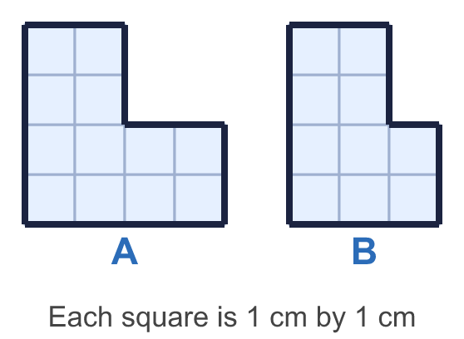
    a) Shape A: |  | cm.
    b) Shape B: |  | cm.
    Greater perimeter: shape
  7 | Work out the perimeter of each shape. Which shape has the greater perimeter?
    a) Shape A: |  | cm.
    b) Shape B: |  | cm.
    Greater perimeter: shape
  8 | Work out the perimeter of the rectangle.  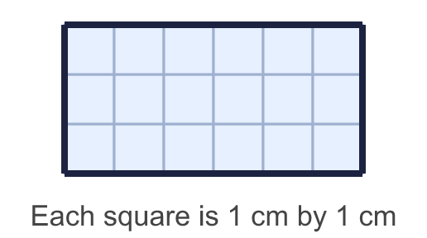
    Perimeter = |  | cm.
  8 | Work out the perimeter of the rectangle.
    Perimeter = |  | cm.

  9 | Rectangles have sides that are whole numbers of centimetres. A 2 cm by 5 cm rectangle is the same as a 5 cm by 2 cm rectangle.  How many different rectangles have a perimeter of 14 cm?
    rectangles
  9 | Rectangles have sides that are whole numbers of centimetres. A 2 cm by 5 cm rectangle is the same as a 5 cm by 2 cm rectangle.  How many different rectangles have a perimeter of 14 cm?
    rectangles
  10 | Work out the perimeter of each shape. Which shape has the greater perimeter?  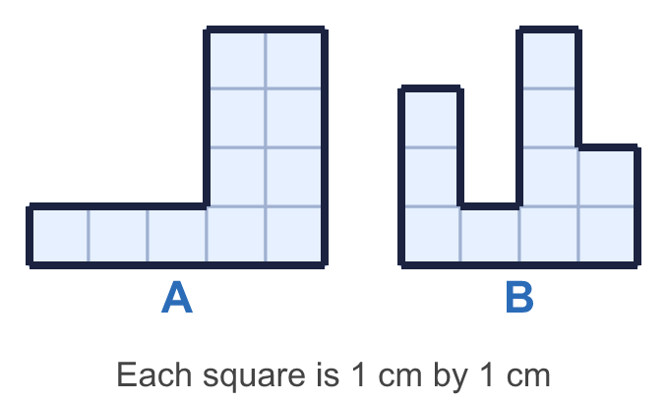
    a) Shape A: |  | cm.
    b) Shape B: |  | cm.
    Greater perimeter: shape
  10 | Work out the perimeter of each shape. Which shape has the greater perimeter?
    a) Shape A: |  | cm.
    b) Shape B: |  | cm.
    Greater perimeter: shape
  11 | 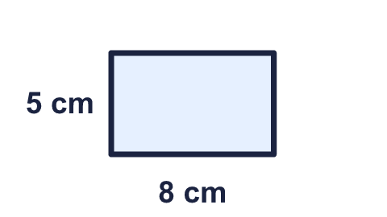  Is Sam correct? Circle yes or no.  Yes / No  Explain how you know.
     | 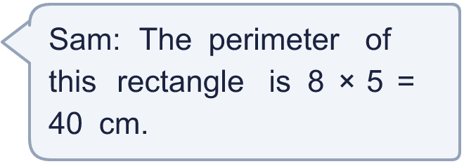
  11 | Is Sam correct? Circle yes or no.  Yes / No  Explain how you know.
  12 | Count the lengths of the edges to work out the perimeter of the shape.  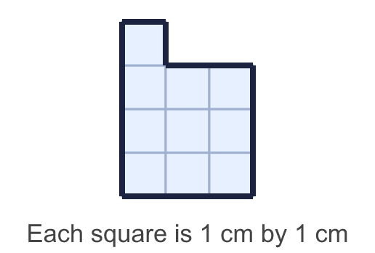
    Perimeter = |  | cm.
  12 | Count the lengths of the edges to work out the perimeter of the shape.
    Perimeter = |  | cm.
  13 | Rectangles have sides that are whole numbers of centimetres. A 2 cm by 5 cm rectangle is the same as a 5 cm by 2 cm rectangle.  How many different rectangles have a perimeter of 12 cm?
    rectangles
  13 | Rectangles have sides that are whole numbers of centimetres. A 2 cm by 5 cm rectangle is the same as a 5 cm by 2 cm rectangle.  How many different rectangles have a perimeter of 12 cm?
    rectangles
  14 | A rectangle is 11 cm long and 5 cm wide. Which calculations give its perimeter? Write the letters.  A: 2 × 11 + 5  B: 4 × 11  C: 2 × 11 + 2 × 5  D: 2 × (11 + 5)  E: 11 × 5
  14 | A rectangle is 11 cm long and 5 cm wide. Which calculations give its perimeter? Write the letters.  A: 2 × 11 + 5  B: 4 × 11  C: 2 × 11 + 2 × 5  D: 2 × (11 + 5)  E: 11 × 5

Year 4 · Length and perimeter · Step 3
Perimeter on a grid
Answers (teacher copy)

  1 | Count the lengths of the edges to work out the perimeter of the shape.  Perimeter = 22 cm.
  2 | Work out the perimeter of the rectangle.  Perimeter = 18 cm.
  3 | Work out the perimeter of each shape. Which shape has the greater perimeter?  a) Shape A: 18 cm.  b) Shape B: 16 cm.  Greater perimeter: shape A
  4 | Count the lengths of the edges to work out the perimeter of the shape.  Perimeter = 14 cm.
  5 | Work out the perimeter of the rectangle.  Perimeter = 18 cm.
  6 | Count the lengths of the edges to work out the perimeter of the shape.  Perimeter = 18 cm.
  7 | Work out the perimeter of each shape. Which shape has the greater perimeter?  a) Shape A: 16 cm.  b) Shape B: 14 cm.  Greater perimeter: shape A
  8 | Work out the perimeter of the rectangle.  Perimeter = 18 cm.
  9 | Rectangles have sides that are whole numbers of centimetres. A 2 cm by 5 cm rectangle is the same as a 5 cm by 2 cm rectangle.  How many different rectangles have a perimeter of 14 cm?  3 rectangles
  10 | Work out the perimeter of each shape. Which shape has the greater perimeter?  a) Shape A: 18 cm.  b) Shape B: 20 cm.  Greater perimeter: shape B
  11 | Is Sam correct? Circle yes or no.  Yes / No  Explain how you know.  No. 8 × 5 = 40 is the area, not the perimeter. The perimeter is 8 + 5 + 8 + 5 = 26 cm.
  12 | Count the lengths of the edges to work out the perimeter of the shape.  Perimeter = 14 cm.
  13 | Rectangles have sides that are whole numbers of centimetres. A 2 cm by 5 cm rectangle is the same as a 5 cm by 2 cm rectangle.  How many different rectangles have a perimeter of 12 cm?  3 rectangles
  14 | A rectangle is 11 cm long and 5 cm wide. Which calculations give its perimeter? Write the letters.  A: 2 × 11 + 5  B: 4 × 11  C: 2 × 11 + 2 × 5  D: 2 × (11 + 5)  E: 11 × 5  C, D

