  Year 4 · Length and perimeter · Step 5  Perimeter of rectilinear shapes | 
  Year 4 · Length and perimeter · Step 5
  Perimeter of rectilinear shapes
  1 | Count the lengths of the edges to work out the perimeter of the shape.  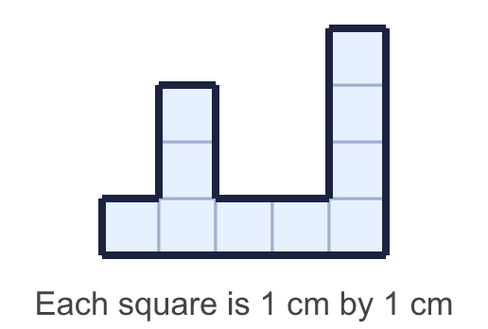
    Perimeter = |  | cm.
  1 | Count the lengths of the edges to work out the perimeter of the shape.
    Perimeter = |  | cm.
  2 | Work out the perimeter of the shape.  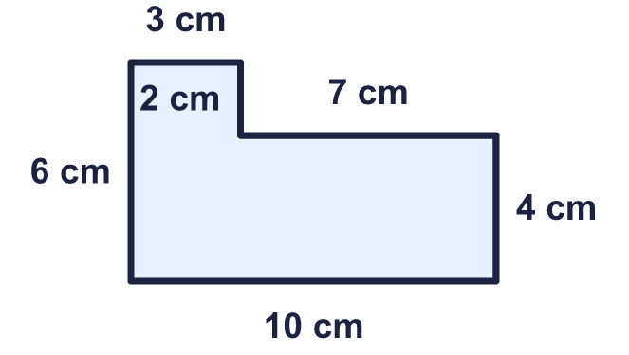
    Perimeter = |  | cm.
  2 | Work out the perimeter of the shape.
    Perimeter = |  | cm.
  3 | Work out the perimeter of the shape.  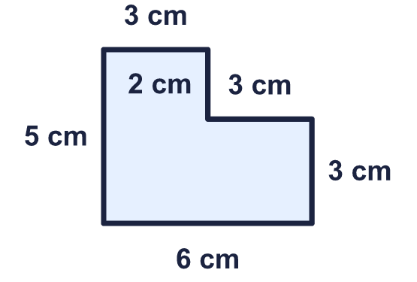
    Perimeter = |  | cm.
  3 | Work out the perimeter of the shape.
    Perimeter = |  | cm.
  4 | Work out the perimeter of the shape.  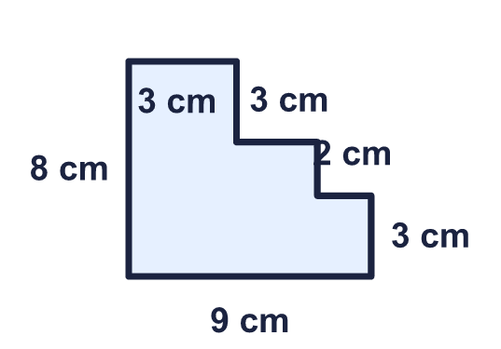
    Perimeter = |  | cm.
  4 | Work out the perimeter of the shape.
    Perimeter = |  | cm.
  5 | Work out the perimeter of the shape.  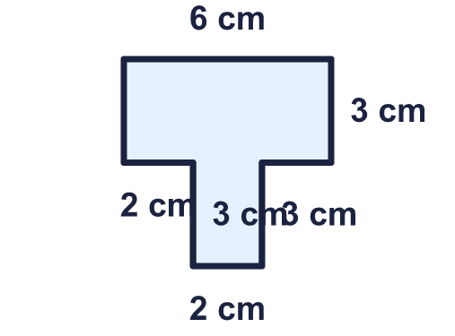
    Perimeter = |  | cm.
  5 | Work out the perimeter of the shape.
    Perimeter = |  | cm.
  6 | Work out the perimeter of the shape.  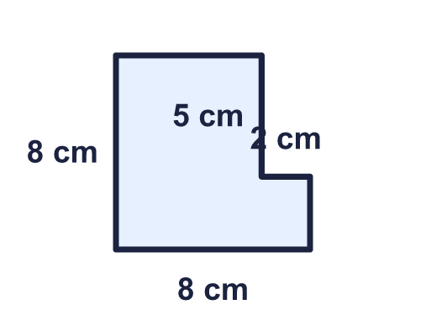
    Perimeter = |  | cm.
  6 | Work out the perimeter of the shape.
    Perimeter = |  | cm.
  7 | Work out the perimeter of each shape. Which shape has the greater perimeter?  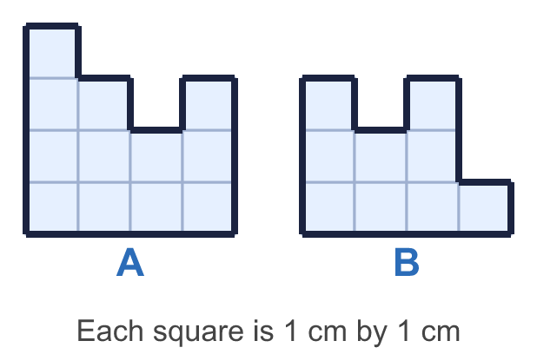
    a) Shape A: |  | cm.
    b) Shape B: |  | cm.
    Greater perimeter: shape
  7 | Work out the perimeter of each shape. Which shape has the greater perimeter?
    a) Shape A: |  | cm.
    b) Shape B: |  | cm.
    Greater perimeter: shape
  8 | Work out the perimeter of each shape. Which shape has the greater perimeter?  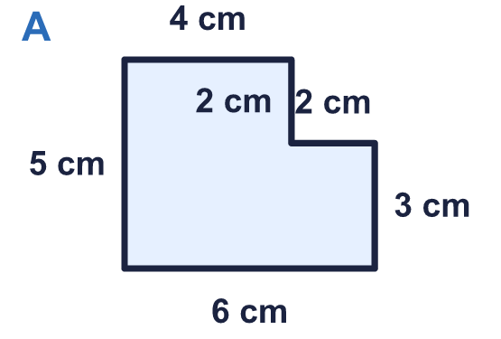  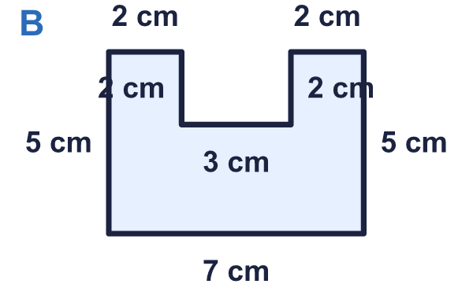
    a) Shape A: |  | cm.
    b) Shape B: |  | cm.
    Greater perimeter: shape
  8 | Work out the perimeter of each shape. Which shape has the greater perimeter?
    a) Shape A: |  | cm.
    b) Shape B: |  | cm.
    Greater perimeter: shape

  9 | 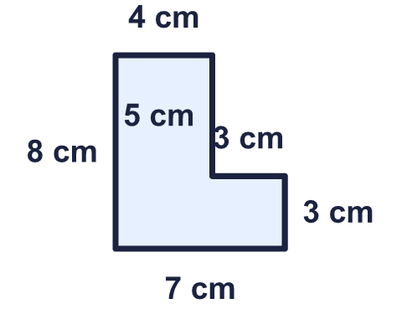  Is Tia correct? Circle yes or no.  Yes / No  Explain how you know.
    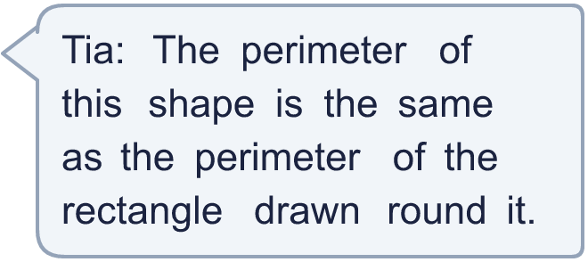
  9 | Is Tia correct? Circle yes or no.  Yes / No  Explain how you know.
  10 | 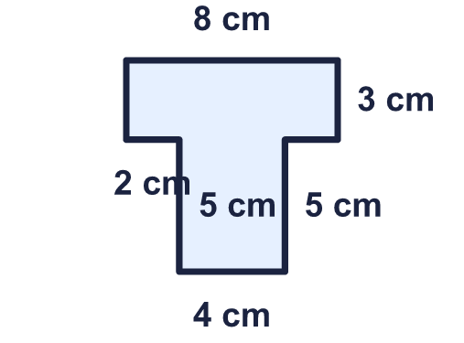  Is Jo correct? Circle yes or no.  Yes / No  Explain how you know.
     | 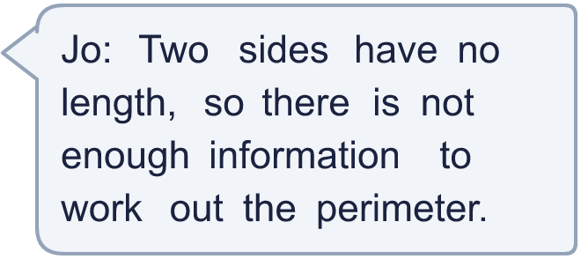
  10 | Is Jo correct? Circle yes or no.  Yes / No  Explain how you know.
  11 | Work out the perimeter of each shape. Which shape has the greater perimeter?  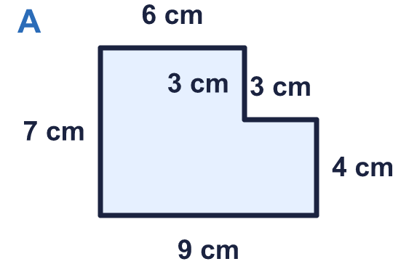  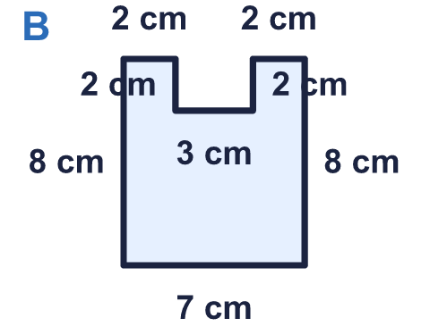
    a) Shape A: |  | cm.
    b) Shape B: |  | cm.
    Greater perimeter: shape
  11 | Work out the perimeter of each shape. Which shape has the greater perimeter?
    a) Shape A: |  | cm.
    b) Shape B: |  | cm.
    Greater perimeter: shape
  12 | Work out the perimeter of the shape.  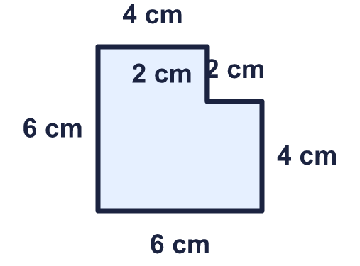
    Perimeter = |  | cm.
  12 | Work out the perimeter of the shape.
    Perimeter = |  | cm.
  13 | 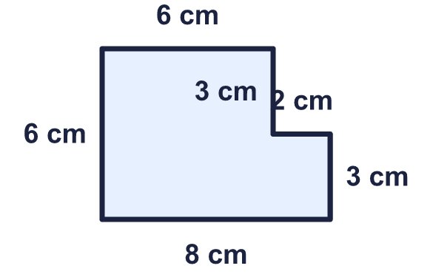  Is Mo correct? Circle yes or no.  Yes / No  Explain how you know.
    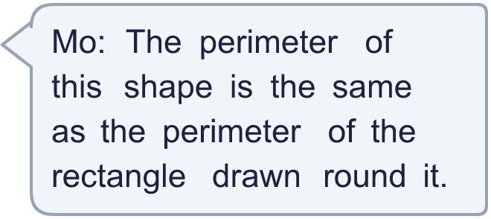
  13 | Is Mo correct? Circle yes or no.  Yes / No  Explain how you know.
  14 | Work out the perimeter of the shape.  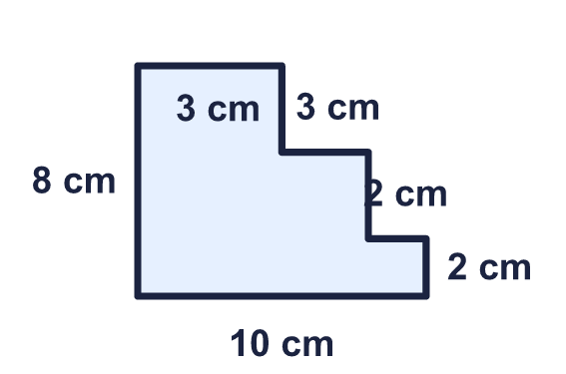
    Perimeter = |  | cm.
  14 | Work out the perimeter of the shape.
    Perimeter = |  | cm.

Year 4 · Length and perimeter · Step 5
Perimeter of rectilinear shapes
Answers (teacher copy)

  1 | Count the lengths of the edges to work out the perimeter of the shape.  Perimeter = 22 cm.
  2 | Work out the perimeter of the shape.  Perimeter = 32 cm.
  3 | Work out the perimeter of the shape.  Perimeter = 22 cm.
  4 | Work out the perimeter of the shape.  Perimeter = 34 cm.
  5 | Work out the perimeter of the shape.  Perimeter = 24 cm.
  6 | Work out the perimeter of the shape.  Perimeter = 32 cm.
  7 | Work out the perimeter of each shape. Which shape has the greater perimeter?  a) Shape A: 18 cm.  b) Shape B: 16 cm.  Greater perimeter: shape A
  8 | Work out the perimeter of each shape. Which shape has the greater perimeter?  a) Shape A: 22 cm.  b) Shape B: 28 cm.  Greater perimeter: shape B
  9 | Is Tia correct? Circle yes or no.  Yes / No  Explain how you know.  Yes. The shape has a perimeter of 30 cm and the rectangle round it also has a perimeter of 30 cm.
  10 | Is Jo correct? Circle yes or no.  Yes / No  Explain how you know.  No. The unmarked sides can be worked out from the other sides. Then the perimeter is 32 cm.
  11 | Work out the perimeter of each shape. Which shape has the greater perimeter?  a) Shape A: 32 cm.  b) Shape B: 34 cm.  Greater perimeter: shape B
  12 | Work out the perimeter of the shape.  Perimeter = 24 cm.
  13 | Is Mo correct? Circle yes or no.  Yes / No  Explain how you know.  Yes. The shape has a perimeter of 28 cm and the rectangle round it also has a perimeter of 28 cm.
  14 | Work out the perimeter of the shape.  Perimeter = 36 cm.

