  Year 4 · Length and perimeter · Step 9  Perimeter of polygons | 
  Year 4 · Length and perimeter · Step 9
  Perimeter of polygons
  1 | Work out the perimeter of the triangle.  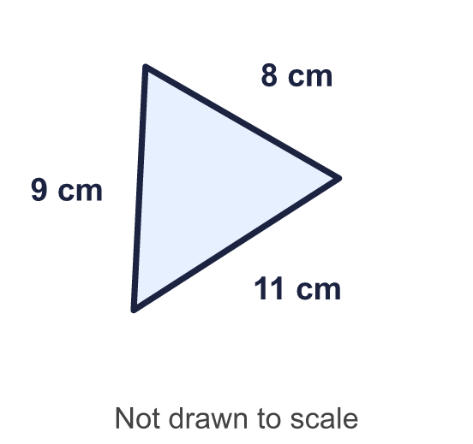
    Perimeter = |  | cm.
  1 | Work out the perimeter of the triangle.
    Perimeter = |  | cm.
  2 | Work out the perimeter of the quadrilateral.  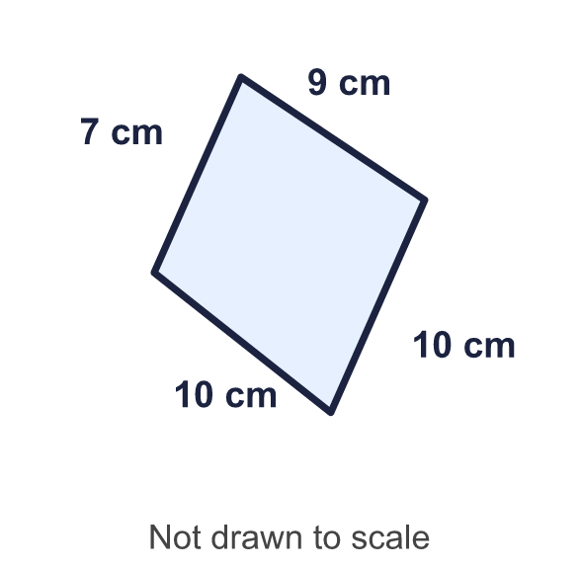
    Perimeter = |  | cm.
  2 | Work out the perimeter of the quadrilateral.
    Perimeter = |  | cm.
  3 | Work out the perimeter of the pentagon.  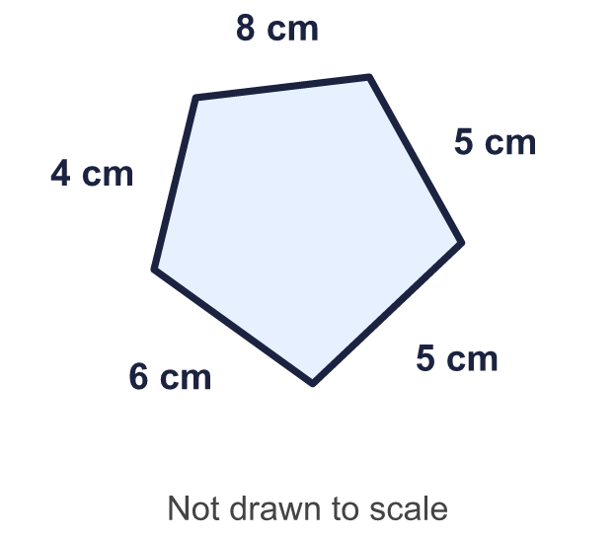
    Perimeter = |  | cm.
  3 | Work out the perimeter of the pentagon.
    Perimeter = |  | cm.
  4 | This is a regular hexagon. All its sides are the same length. Work out the perimeter.  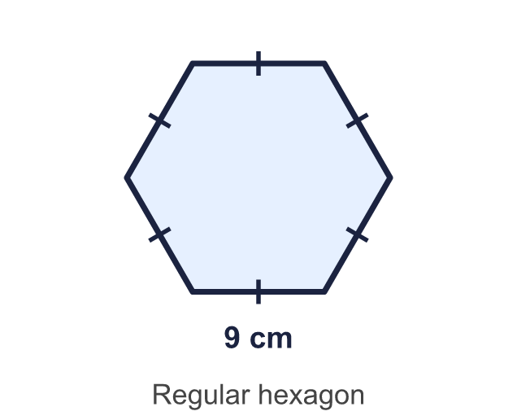
    Perimeter = |  | cm.
  4 | This is a regular hexagon. All its sides are the same length. Work out the perimeter.
    Perimeter = |  | cm.
  5 | Work out the perimeter of each regular polygon.  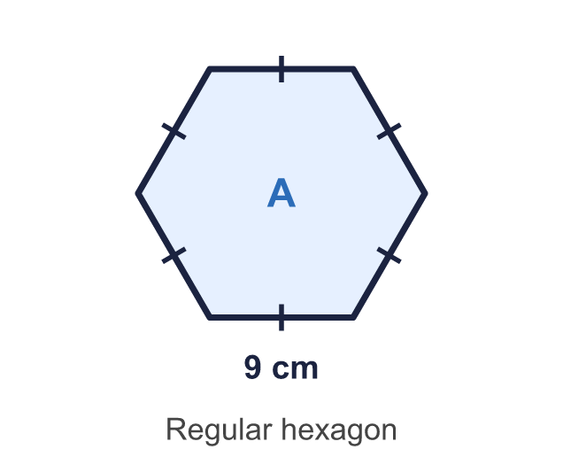  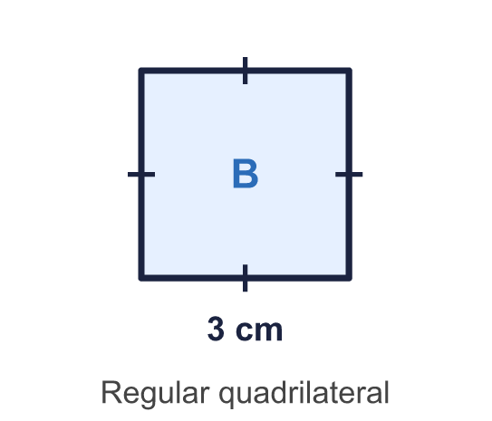
    a) Shape A: |  | cm.
    b) Shape B: |  | cm.
  5 | Work out the perimeter of each regular polygon.
    a) Shape A: |  | cm.
    b) Shape B: |  | cm.
  6 | Work out the perimeter of the quadrilateral.  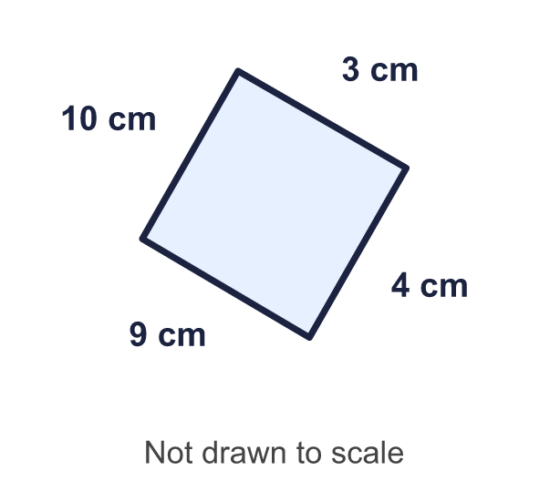
    Perimeter = |  | cm.
  6 | Work out the perimeter of the quadrilateral.
    Perimeter = |  | cm.
  7 | Work out the perimeter of the triangle.  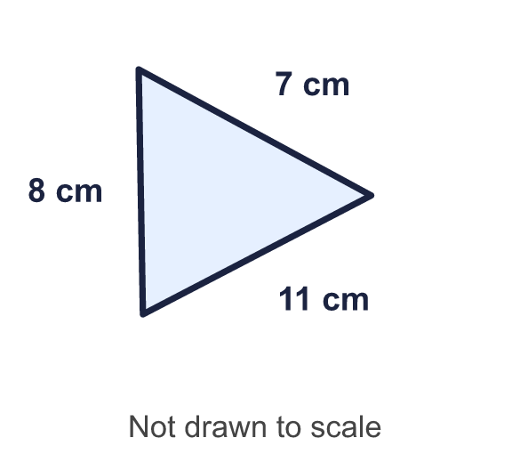
    Perimeter = |  | cm.
  7 | Work out the perimeter of the triangle.
    Perimeter = |  | cm.
  8 | This is a regular octagon. All its sides are the same length. Work out the perimeter.  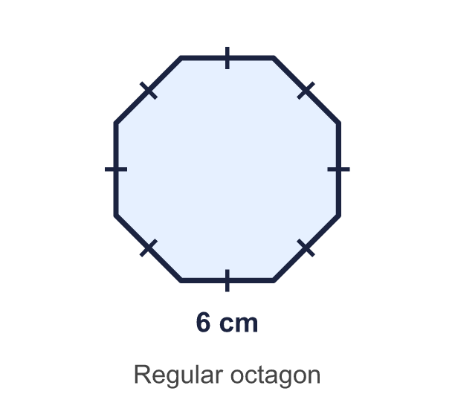
    Perimeter = |  | cm.
  8 | This is a regular octagon. All its sides are the same length. Work out the perimeter.
    Perimeter = |  | cm.

  9 | Work out the perimeter of the pentagon.  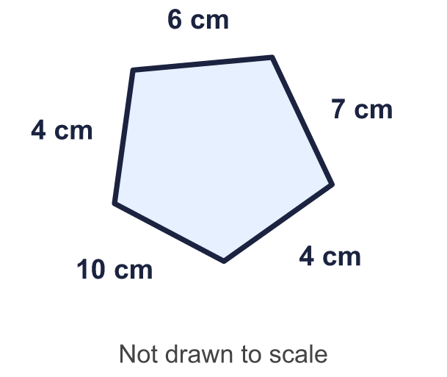
    Perimeter = |  | cm.
  9 | Work out the perimeter of the pentagon.
    Perimeter = |  | cm.
  10 | A regular pentagon has a perimeter of 45 cm.
    Length of one side = |  | cm.
  10 | A regular pentagon has a perimeter of 45 cm.
    Length of one side = |  | cm.
  11 | A square and an equilateral triangle each have a perimeter of 12 cm.  How much longer is a side of the triangle than a side of the square?
    Difference = |  | cm.
  11 | A square and an equilateral triangle each have a perimeter of 12 cm.  How much longer is a side of the triangle than a side of the square?
    Difference = |  | cm.
  12 | Work out the perimeter of the quadrilateral.  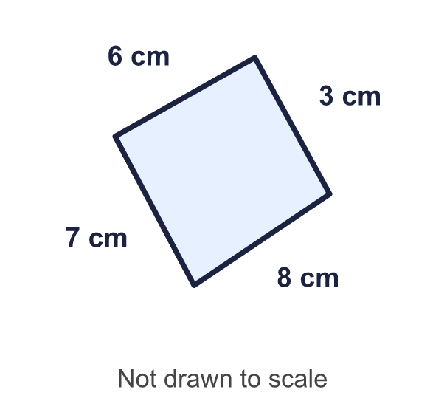
    Perimeter = |  | cm.
  12 | Work out the perimeter of the quadrilateral.
    Perimeter = |  | cm.
  13 | Three regular polygons each have a perimeter of 48 cm. Work out the length of one side of each.
    a) a square: |  | cm.
    b) an equilateral triangle:
    cm.
    c) a regular hexagon: |  | cm.
  13 | Three regular polygons each have a perimeter of 48 cm. Work out the length of one side of each.
    a) a square: |  | cm.
    b) an equilateral triangle:
    cm.
    c) a regular hexagon: |  | cm.
  14 | Work out the perimeter of the triangle.  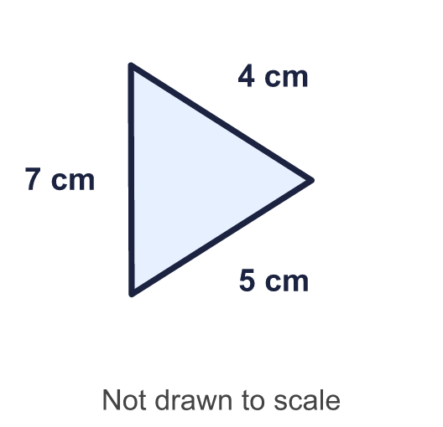
    Perimeter = |  | cm.
  14 | Work out the perimeter of the triangle.
    Perimeter = |  | cm.

Year 4 · Length and perimeter · Step 9
Perimeter of polygons
Answers (teacher copy)

  1 | Work out the perimeter of the triangle.  Perimeter = 28 cm.
  2 | Work out the perimeter of the quadrilateral.  Perimeter = 36 cm.
  3 | Work out the perimeter of the pentagon.  Perimeter = 28 cm.
  4 | This is a regular hexagon. All its sides are the same length. Work out the perimeter.  Perimeter = 54 cm.
  5 | Work out the perimeter of each regular polygon.  a) Shape A: 54 cm.  b) Shape B: 12 cm.
  6 | Work out the perimeter of the quadrilateral.  Perimeter = 26 cm.
  7 | Work out the perimeter of the triangle.  Perimeter = 26 cm.
  8 | This is a regular octagon. All its sides are the same length. Work out the perimeter.  Perimeter = 48 cm.
  9 | Work out the perimeter of the pentagon.  Perimeter = 31 cm.
  10 | A regular pentagon has a perimeter of 45 cm.  Length of one side = 9 cm.
  11 | A square and an equilateral triangle each have a perimeter of 12 cm.  How much longer is a side of the triangle than a side of the square?  Difference = 1 cm.
  12 | Work out the perimeter of the quadrilateral.  Perimeter = 24 cm.
  13 | Three regular polygons each have a perimeter of 48 cm. Work out the length of one side of each.  a) a square: 12 cm.  b) an equilateral triangle: 16 cm.  c) a regular hexagon: 8 cm.
  14 | Work out the perimeter of the triangle.  Perimeter = 16 cm.

