  Year 4 · Length and perimeter · Step 4  Perimeter of a rectangle | 
  Year 4 · Length and perimeter · Step 4
  Perimeter of a rectangle
  1 | Work out the perimeter of the rectangle.  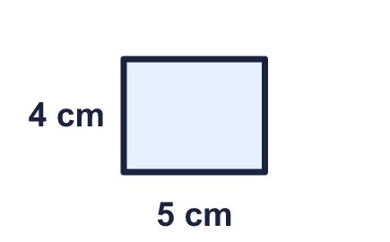
    Perimeter = |  | cm.
  1 | Work out the perimeter of the rectangle.
    Perimeter = |  | cm.
  2 | Work out the perimeter of the rectangle.  
    Perimeter = |  | m.
  2 | Work out the perimeter of the rectangle.
    Perimeter = |  | m.
  3 | A rectangle is 14 cm long and 5 cm wide.
    Perimeter = |  | cm.
  3 | A rectangle is 14 cm long and 5 cm wide.
    Perimeter = |  | cm.
  4 | Work out the perimeter of the square.  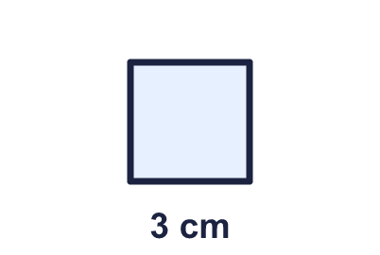
    Perimeter = |  | cm.
  4 | Work out the perimeter of the square.
    Perimeter = |  | cm.
  5 | Work out the perimeter of the rectangle.  
    Perimeter = |  | cm.
  5 | Work out the perimeter of the rectangle.
    Perimeter = |  | cm.
  6 | This rectangle has a perimeter of 32 cm. Find the missing width.  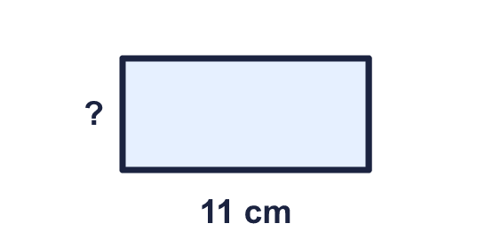
    Width = |  | cm.
  6 | This rectangle has a perimeter of 32 cm. Find the missing width.
    Width = |  | cm.
  7 | A square has a perimeter of 20 cm.
    Length of one side = |  | cm.
  7 | A square has a perimeter of 20 cm.
    Length of one side = |  | cm.
  8 | A rectangle is 12 cm long and 6 cm wide.
    Perimeter = |  | cm.
  8 | A rectangle is 12 cm long and 6 cm wide.
    Perimeter = |  | cm.

  9 | 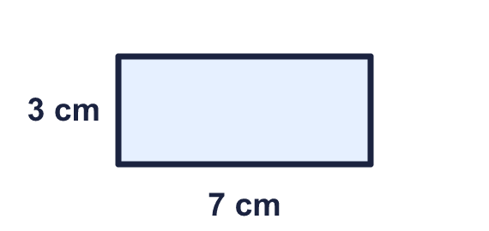  Is Amir correct? Circle yes or no.  Yes / No  Explain how you know.
     | 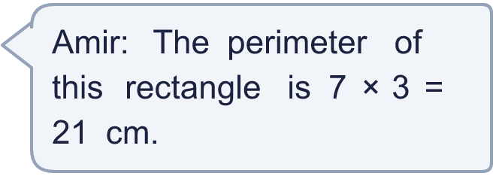
  9 | Is Amir correct? Circle yes or no.  Yes / No  Explain how you know.
  10 | A rectangle is 10 cm long and 4 cm wide. Which calculations give its perimeter? Write the letters.  A: 10 + 4 + 10 + 4  B: 10 × 2 + 4 × 2  C: 10 × 4  D: 2 × 10 + 4  E: 4 × 10
  10 | A rectangle is 10 cm long and 4 cm wide. Which calculations give its perimeter? Write the letters.  A: 10 + 4 + 10 + 4  B: 10 × 2 + 4 × 2  C: 10 × 4  D: 2 × 10 + 4  E: 4 × 10
  11 | Rectangles have sides that are whole numbers of centimetres. A 2 cm by 5 cm rectangle is the same as a 5 cm by 2 cm rectangle.  How many different rectangles have a perimeter of 20 cm?
    rectangles
  11 | Rectangles have sides that are whole numbers of centimetres. A 2 cm by 5 cm rectangle is the same as a 5 cm by 2 cm rectangle.  How many different rectangles have a perimeter of 20 cm?
    rectangles
  12 | This rectangle has a perimeter of 34 cm. Find the missing width.  
    Width = |  | cm.
  12 | This rectangle has a perimeter of 34 cm. Find the missing width.
    Width = |  | cm.
  13 | 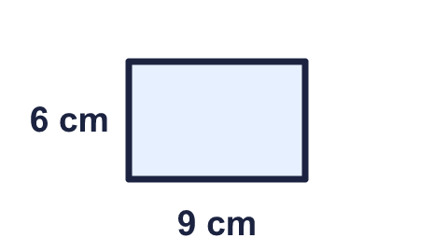  Is Tia correct? Circle yes or no.  Yes / No  Explain how you know.
    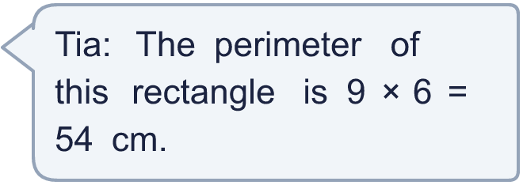
  13 | Is Tia correct? Circle yes or no.  Yes / No  Explain how you know.
  14 | A square has a perimeter of 44 cm.
    Length of one side = |  | cm.
  14 | A square has a perimeter of 44 cm.
    Length of one side = |  | cm.

Year 4 · Length and perimeter · Step 4
Perimeter of a rectangle
Answers (teacher copy)

  1 | Work out the perimeter of the rectangle.  Perimeter = 18 cm.
  2 | Work out the perimeter of the rectangle.  Perimeter = 32 m.
  3 | A rectangle is 14 cm long and 5 cm wide.  Perimeter = 38 cm.
  4 | Work out the perimeter of the square.  Perimeter = 12 cm.
  5 | Work out the perimeter of the rectangle.  Perimeter = 20 cm.
  6 | This rectangle has a perimeter of 32 cm. Find the missing width.  Width = 5 cm.
  7 | A square has a perimeter of 20 cm.  Length of one side = 5 cm.
  8 | A rectangle is 12 cm long and 6 cm wide.  Perimeter = 36 cm.
  9 | Is Amir correct? Circle yes or no.  Yes / No  Explain how you know.  No. 7 × 3 = 21 is the area, not the perimeter. The perimeter is 7 + 3 + 7 + 3 = 20 cm.
  10 | A rectangle is 10 cm long and 4 cm wide. Which calculations give its perimeter? Write the letters.  A: 10 + 4 + 10 + 4  B: 10 × 2 + 4 × 2  C: 10 × 4  D: 2 × 10 + 4  E: 4 × 10  A, B
  11 | Rectangles have sides that are whole numbers of centimetres. A 2 cm by 5 cm rectangle is the same as a 5 cm by 2 cm rectangle.  How many different rectangles have a perimeter of 20 cm?  5 rectangles
  12 | This rectangle has a perimeter of 34 cm. Find the missing width.  Width = 3 cm.
  13 | Is Tia correct? Circle yes or no.  Yes / No  Explain how you know.  No. 9 × 6 = 54 is the area, not the perimeter. The perimeter is 9 + 6 + 9 + 6 = 30 cm.
  14 | A square has a perimeter of 44 cm.  Length of one side = 11 cm.

