  Year 4 · Length and perimeter · Step 6  Find missing lengths in rectilinear shapes | 
  Year 4 · Length and perimeter · Step 6
  Find missing lengths in rectilinear shapes
  1 | Work out the missing lengths.  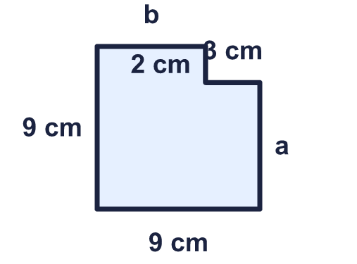
    a = |  | cm.
    b = |  | cm.
  1 | Work out the missing lengths.
    a = |  | cm.
    b = |  | cm.
  2 | Work out the perimeter of the shape.  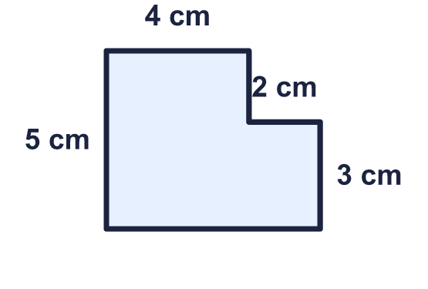
    Perimeter = |  | cm.
  2 | Work out the perimeter of the shape.
    Perimeter = |  | cm.
  3 | Work out the missing lengths.  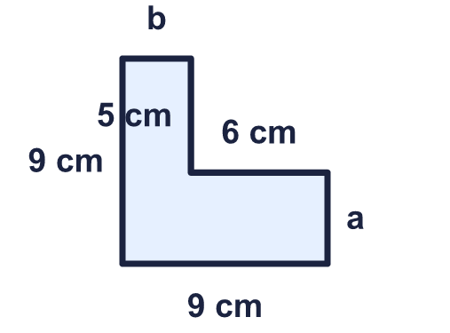
    a = |  | cm.
    b = |  | cm.
  3 | Work out the missing lengths.
    a = |  | cm.
    b = |  | cm.
  4 | The perimeter of the shape is 38 cm. Work out the missing length.  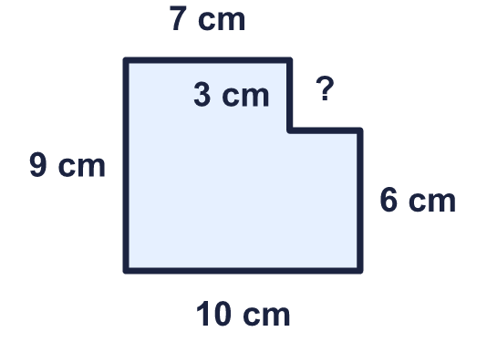
    Missing length = |  | cm.
  4 | The perimeter of the shape is 38 cm. Work out the missing length.
    Missing length = |  | cm.
  5 | Work out the perimeter of the shape.  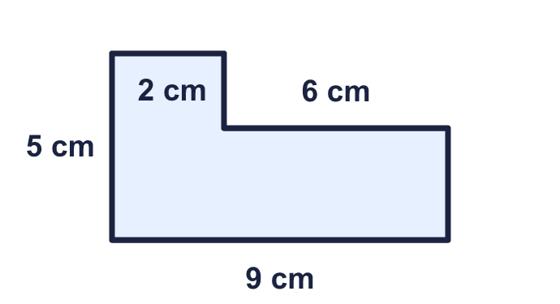
    Perimeter = |  | cm.
  5 | Work out the perimeter of the shape.
    Perimeter = |  | cm.
  6 | Work out the perimeter of the shape.  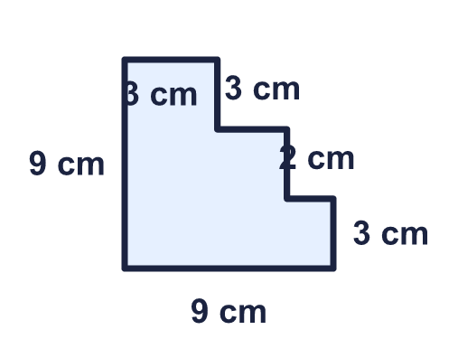
    Perimeter = |  | cm.
  6 | Work out the perimeter of the shape.
    Perimeter = |  | cm.
  7 | Work out the perimeter of the shape.  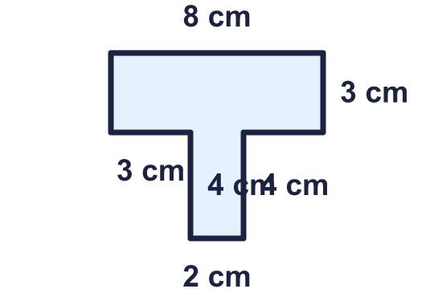
    Perimeter = |  | cm.
  7 | Work out the perimeter of the shape.
    Perimeter = |  | cm.
  8 | Work out the missing lengths.  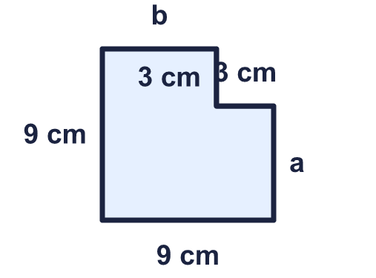
    a = |  | cm.
    b = |  | cm.
  8 | Work out the missing lengths.
    a = |  | cm.
    b = |  | cm.

  9 | The perimeter of the shape is 28 cm. Work out the missing length.  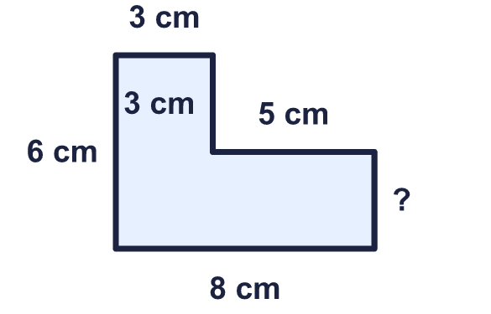
    Missing length = |  | cm.
  9 | The perimeter of the shape is 28 cm. Work out the missing length.
    Missing length = |  | cm.
  10 | 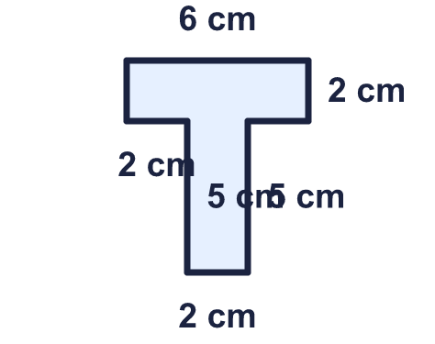  Is Zach correct? Circle yes or no.  Yes / No  Explain how you know.
     | 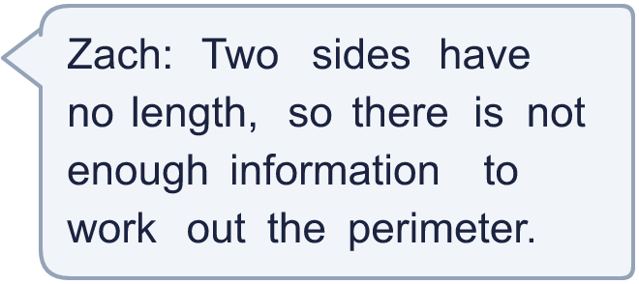
  10 | Is Zach correct? Circle yes or no.  Yes / No  Explain how you know.
  11 | The perimeter of the shape is 38 cm. Work out the missing length.  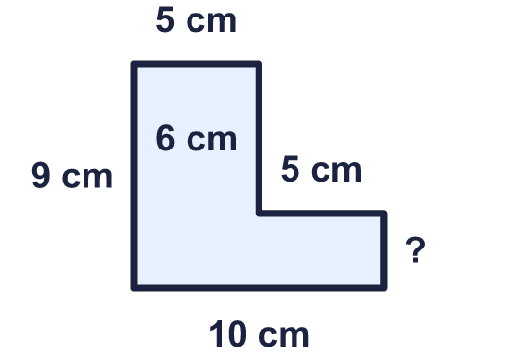
    Missing length = |  | cm.
  11 | The perimeter of the shape is 38 cm. Work out the missing length.
    Missing length = |  | cm.
  12 | Work out the missing lengths.  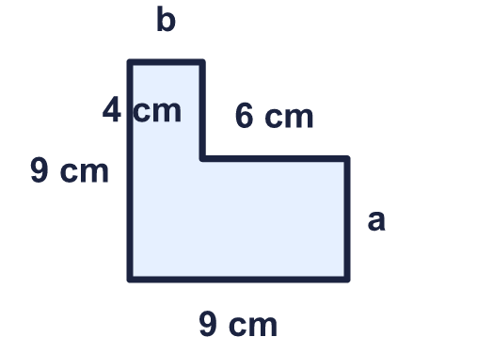
    a = |  | cm.
    b = |  | cm.
  12 | Work out the missing lengths.
    a = |  | cm.
    b = |  | cm.
  13 | 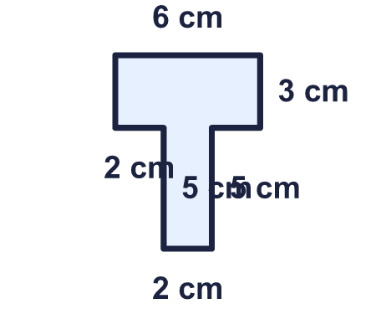  Is Jo correct? Circle yes or no.  Yes / No  Explain how you know.
    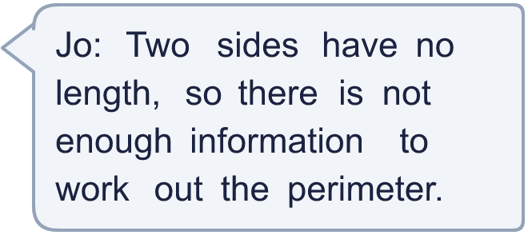
  13 | Is Jo correct? Circle yes or no.  Yes / No  Explain how you know.
  14 | The perimeter of the shape is 32 cm. Work out the missing length.  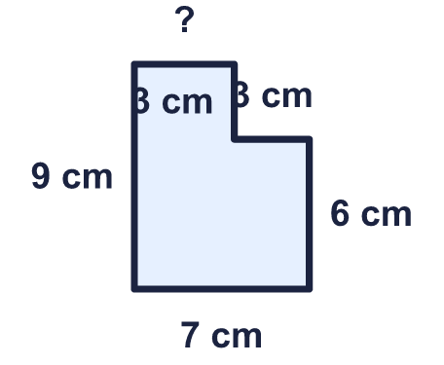
    Missing length = |  | cm.
  14 | The perimeter of the shape is 32 cm. Work out the missing length.
    Missing length = |  | cm.

Year 4 · Length and perimeter · Step 6
Find missing lengths in rectilinear shapes
Answers (teacher copy)

  1 | Work out the missing lengths.  a = 7 cm.  b = 6 cm.
  2 | Work out the perimeter of the shape.  Perimeter = 22 cm.
  3 | Work out the missing lengths.  a = 4 cm.  b = 3 cm.
  4 | The perimeter of the shape is 38 cm. Work out the missing length.  Missing length = 3 cm.
  5 | Work out the perimeter of the shape.  Perimeter = 28 cm.
  6 | Work out the perimeter of the shape.  Perimeter = 36 cm.
  7 | Work out the perimeter of the shape.  Perimeter = 30 cm.
  8 | Work out the missing lengths.  a = 6 cm.  b = 6 cm.
  9 | The perimeter of the shape is 28 cm. Work out the missing length.  Missing length = 3 cm.
  10 | Is Zach correct? Circle yes or no.  Yes / No  Explain how you know.  No. The unmarked sides can be worked out from the other sides. Then the perimeter is 26 cm.
  11 | The perimeter of the shape is 38 cm. Work out the missing length.  Missing length = 3 cm.
  12 | Work out the missing lengths.  a = 5 cm.  b = 3 cm.
  13 | Is Jo correct? Circle yes or no.  Yes / No  Explain how you know.  No. The unmarked sides can be worked out from the other sides. Then the perimeter is 28 cm.
  14 | The perimeter of the shape is 32 cm. Work out the missing length.  Missing length = 4 cm.

