  Year 4 · Fractions · Step 1  Understand the whole | 
  Year 4 · Fractions · Step 1
  Understand the whole
  1 | What fraction of the bar is shaded? What fraction is not shaded?  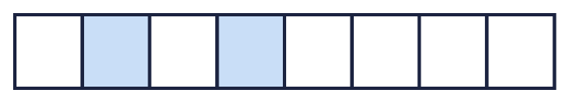
  1 | What fraction of the bar is shaded? What fraction is not shaded?
  2 | Look at the bar.  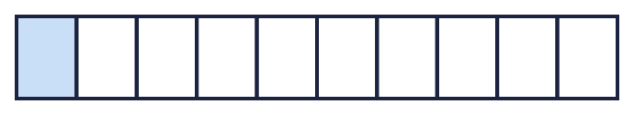
    The whole is divided into
    equal parts.
    Each part is worth 1 out of
  2 | Look at the bar.
    The whole is divided into
    equal parts.
    Each part is worth 1 out of
  3 | Complete the additions to make 1 whole.  a) ¹⁄₇ + ?⁄₇ = 1  b) ²⁄₅ + ?⁄₅ = 1  c) ³⁄₉ + ?⁄₉ = 1
  3 | Complete the additions to make 1 whole.  a) ¹⁄₇ + ?⁄₇ = 1  b) ²⁄₅ + ?⁄₅ = 1  c) ³⁄₉ + ?⁄₉ = 1
  4 | What fraction of the bar is shaded? What fraction is not shaded?  
  4 | What fraction of the bar is shaded? What fraction is not shaded?
  5 | Look at the bar.
    The whole is divided into
    equal parts.
    Each part is worth 1 out of
  5 | Look at the bar.
    The whole is divided into
    equal parts.
    Each part is worth 1 out of
  6 | Complete the additions to make 1 whole.  a) ³⁄₇ + ?⁄₇ = 1  b) ⁶⁄₈ + ?⁄₈ = 1
  6 | Complete the additions to make 1 whole.  a) ³⁄₇ + ?⁄₇ = 1  b) ⁶⁄₈ + ?⁄₈ = 1
  7 | What fraction of the bar is shaded? What fraction is not shaded?  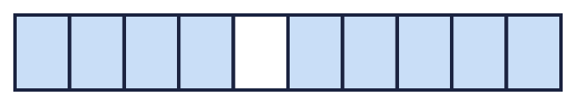
  7 | What fraction of the bar is shaded? What fraction is not shaded?
  8 | Complete the additions to make 1 whole.  a) ⁵⁄₉ + ?⁄₉ = 1  b) ⁵⁄₈ + ?⁄₈ = 1
  8 | Complete the additions to make 1 whole.  a) ⁵⁄₉ + ?⁄₉ = 1  b) ⁵⁄₈ + ?⁄₈ = 1

  9 | Work out the additions. What do you notice?  a) ⁴⁄₅ + ¹⁄₅ =  b) ⁵⁄₈ + ³⁄₈ =  c) ¹⁄₉ + ⁸⁄₉ =
  9 | Work out the additions. What do you notice?  a) ⁴⁄₅ + ¹⁄₅ =  b) ⁵⁄₈ + ³⁄₈ =  c) ¹⁄₉ + ⁸⁄₉ =
  10 | What fraction of the bar is shaded? What fraction is not shaded?  
  10 | What fraction of the bar is shaded? What fraction is not shaded?
  11 | Complete the part-whole model.  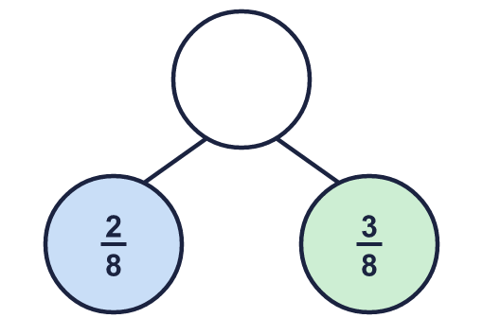
    The whole is
  11 | Complete the part-whole model.
    The whole is
  12 | Look at the bar.
    The whole is divided into
    equal parts.
    Each part is worth 1 out of
  12 | Look at the bar.
    The whole is divided into
    equal parts.
    Each part is worth 1 out of
  13 | Complete the additions to make 1 whole.  a) ⁷⁄₁₀ + ?⁄₁₀ = 1  b) ³⁄₇ + ?⁄₇ = 1  c) ¹⁄₁₂ + ?⁄₁₂ = 1
  13 | Complete the additions to make 1 whole.  a) ⁷⁄₁₀ + ?⁄₁₀ = 1  b) ³⁄₇ + ?⁄₇ = 1  c) ¹⁄₁₂ + ?⁄₁₂ = 1
  14 | Work out the additions. What do you notice?  a) ⁴⁄₅ + ¹⁄₅ =  b) ⁶⁄₁₀ + ⁴⁄₁₀ =  c) ⁶⁄₉ + ³⁄₉ =
  14 | Work out the additions. What do you notice?  a) ⁴⁄₅ + ¹⁄₅ =  b) ⁶⁄₁₀ + ⁴⁄₁₀ =  c) ⁶⁄₉ + ³⁄₉ =

Year 4 · Fractions · Step 1
Understand the whole
Answers (teacher copy)

  1 | What fraction of the bar is shaded? What fraction is not shaded?  Shaded: ²⁄₈  Not shaded: ⁶⁄₈
  2 | Look at the bar.  The whole is divided into 10 equal parts.  Each part is worth 1 out of 10
  3 | Complete the additions to make 1 whole.  a) ¹⁄₇ + ?⁄₇ = 1 6  b) ²⁄₅ + ?⁄₅ = 1 3  c) ³⁄₉ + ?⁄₉ = 1 6
  4 | What fraction of the bar is shaded? What fraction is not shaded?  Shaded: ¹⁄₃  Not shaded: ²⁄₃
  5 | Look at the bar.  The whole is divided into 3 equal parts.  Each part is worth 1 out of 3
  6 | Complete the additions to make 1 whole.  a) ³⁄₇ + ?⁄₇ = 1 4  b) ⁶⁄₈ + ?⁄₈ = 1 2
  7 | What fraction of the bar is shaded? What fraction is not shaded?  Shaded: ⁹⁄₁₀  Not shaded: ¹⁄₁₀
  8 | Complete the additions to make 1 whole.  a) ⁵⁄₉ + ?⁄₉ = 1 4  b) ⁵⁄₈ + ?⁄₈ = 1 3
  9 | Work out the additions. What do you notice?  a) ⁴⁄₅ + ¹⁄₅ = 1  b) ⁵⁄₈ + ³⁄₈ = 1  c) ¹⁄₉ + ⁸⁄₉ = 1
  10 | What fraction of the bar is shaded? What fraction is not shaded?  Shaded: ⁴⁄₅  Not shaded: ¹⁄₅
  11 | Complete the part-whole model.  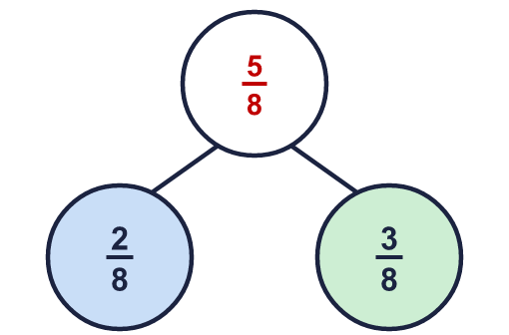  The whole is ⁵⁄₈
  12 | Look at the bar.  The whole is divided into 10 equal parts.  Each part is worth 1 out of 10
  13 | Complete the additions to make 1 whole.  a) ⁷⁄₁₀ + ?⁄₁₀ = 1 3  b) ³⁄₇ + ?⁄₇ = 1 4  c) ¹⁄₁₂ + ?⁄₁₂ = 1 11
  14 | Work out the additions. What do you notice?  a) ⁴⁄₅ + ¹⁄₅ = 1  b) ⁶⁄₁₀ + ⁴⁄₁₀ = 1  c) ⁶⁄₉ + ³⁄₉ = 1

