  Year 4 · Fractions · Step 6  Understand improper fractions | 
  Year 4 · Fractions · Step 6
  Understand improper fractions
  1 | All of the parts are shaded. The bars are the same size.  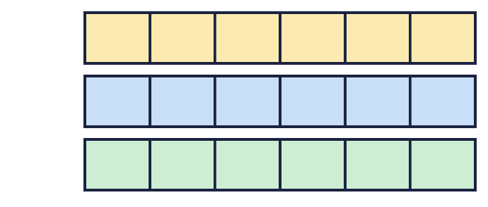
    There are |  | wholes.
    As a fraction this is
  1 | All of the parts are shaded. The bars are the same size.
    There are |  | wholes.
    As a fraction this is
  2 | How many wholes is each improper fraction worth?  a) ⁸⁄₄ = ?  b) ³⁰⁄₆ = ?  c) ⁹⁄₃ = ?
  2 | How many wholes is each improper fraction worth?  a) ⁸⁄₄ = ?  b) ³⁰⁄₆ = ?  c) ⁹⁄₃ = ?
  3 | The bars are the same size. Write the mixed number and the improper fraction that the bars show.  
  3 | The bars are the same size. Write the mixed number and the improper fraction that the bars show.
  4 | Shade the bar models to show ⁵⁄₃.  
  4 | Shade the bar models to show ⁵⁄₃.
  5 | The number line goes from 0 to 2. Write the fraction in each box as an improper fraction.  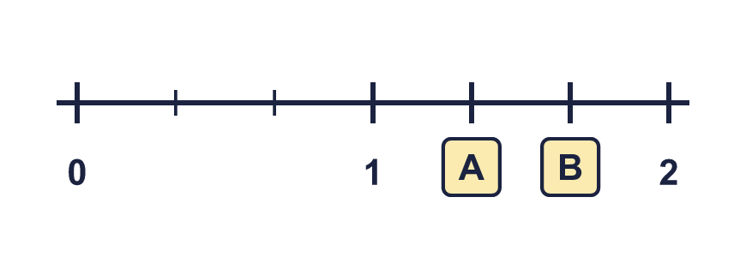
  5 | The number line goes from 0 to 2. Write the fraction in each box as an improper fraction.
  6 | All of the parts are shaded. The bars are the same size.  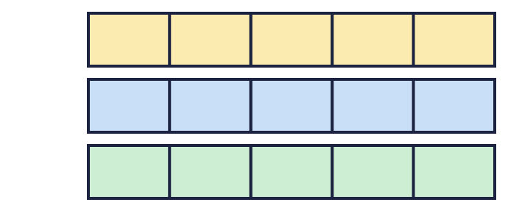
    There are |  | wholes.
    As a fraction this is
  6 | All of the parts are shaded. The bars are the same size.
    There are |  | wholes.
    As a fraction this is
  7 | Shade the bar models to show ⁹⁄₆.  
  7 | Shade the bar models to show ⁹⁄₆.
  8 | How many wholes is each improper fraction worth?  a) ¹²⁄₄ = ?  b) ⁹⁄₃ = ?
  8 | How many wholes is each improper fraction worth?  a) ¹²⁄₄ = ?  b) ⁹⁄₃ = ?

  9 | Shade the bar models to show ¹⁴⁄₆.  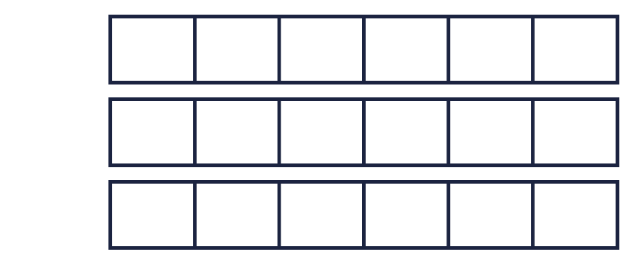
  9 | Shade the bar models to show ¹⁴⁄₆.
  10 | How many wholes is each improper fraction worth?  a) ¹²⁄₃ = ?  b) ⁶⁄₂ = ?  c) ¹⁸⁄₃ = ?
  10 | How many wholes is each improper fraction worth?  a) ¹²⁄₃ = ?  b) ⁶⁄₂ = ?  c) ¹⁸⁄₃ = ?
  11 | Write two improper fractions that are between 4 and 5.
  11 | Write two improper fractions that are between 4 and 5.
  12 | How many pies is this? Write a mixed number.
    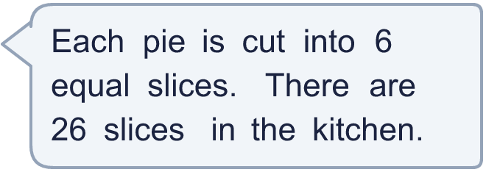
  12 | How many pies is this? Write a mixed number.
  13 | Which is greater: ⁹⁄₄ or 4 ³⁄₄? Write the greater number.
  13 | Which is greater: ⁹⁄₄ or 4 ³⁄₄? Write the greater number.
  14 | The number line goes from 0 to 2. Write the fraction in each box as an improper fraction.  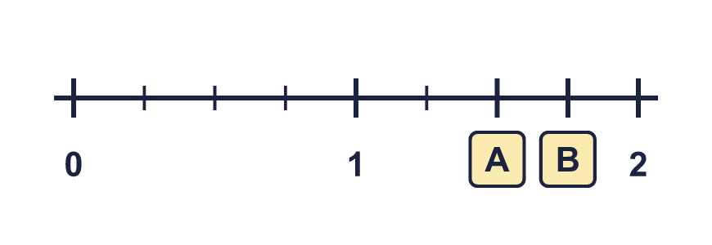
  14 | The number line goes from 0 to 2. Write the fraction in each box as an improper fraction.

Year 4 · Fractions · Step 6
Understand improper fractions
Answers (teacher copy)

  1 | All of the parts are shaded. The bars are the same size.  There are 3 wholes.  As a fraction this is ¹⁸⁄₆
  2 | How many wholes is each improper fraction worth?  a) ⁸⁄₄ = ? 2  b) ³⁰⁄₆ = ? 5  c) ⁹⁄₃ = ? 3
  3 | The bars are the same size. Write the mixed number and the improper fraction that the bars show.  Mixed number: 1 ³⁄₄  Improper fraction: ⁷⁄₄
  4 | Shade the bar models to show ⁵⁄₃.  
  5 | The number line goes from 0 to 2. Write the fraction in each box as an improper fraction.  A = ⁴⁄₃ B = ⁵⁄₃
  6 | All of the parts are shaded. The bars are the same size.  There are 3 wholes.  As a fraction this is ¹⁵⁄₅
  7 | Shade the bar models to show ⁹⁄₆.  
  8 | How many wholes is each improper fraction worth?  a) ¹²⁄₄ = ? 3  b) ⁹⁄₃ = ? 3
  9 | Shade the bar models to show ¹⁴⁄₆.  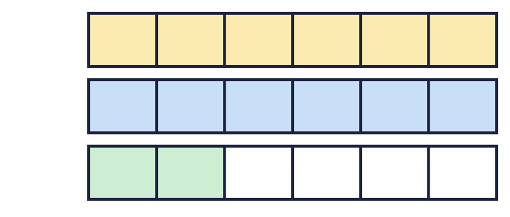
  10 | How many wholes is each improper fraction worth?  a) ¹²⁄₃ = ? 4  b) ⁶⁄₂ = ? 3  c) ¹⁸⁄₃ = ? 6
  11 | Write two improper fractions that are between 4 and 5.  for example ¹⁷⁄₄ and ²²⁄₅
  12 | How many pies is this? Write a mixed number. 4 ¹⁄₃
  13 | Which is greater: ⁹⁄₄ or 4 ³⁄₄? Write the greater number.  4 ³⁄₄
  14 | The number line goes from 0 to 2. Write the fraction in each box as an improper fraction.  A = ⁶⁄₄ B = ⁷⁄₄

