  Year 4 · Fractions · Step 13  Subtract two fractions | 
  Year 4 · Fractions · Step 13
  Subtract two fractions
  1 | Work out the subtractions. Write each answer in its simplest form.  a) ²⁄₉ − ¹⁄₉ =  b) ²⁄₂ − ¹⁄₂ =  c) ⁴⁄₁₂ − ²⁄₁₂ =
  1 | Work out the subtractions. Write each answer in its simplest form.  a) ²⁄₉ − ¹⁄₉ =  b) ²⁄₂ − ¹⁄₂ =  c) ⁴⁄₁₂ − ²⁄₁₂ =
  2 | Complete the part-whole model.  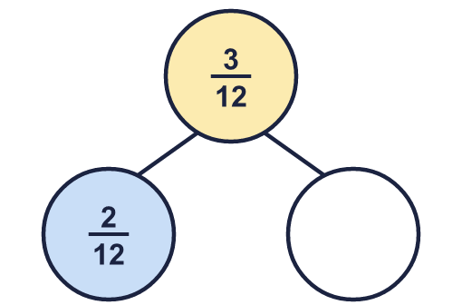
    The missing part is
  2 | Complete the part-whole model.
    The missing part is
  3 | Work out the subtractions. Write each answer in its simplest form.  a) ⁴⁄₆ − ²⁄₆ =  b) ⁴⁄₆ − ¹⁄₆ =  c) ²⁄₂ − ¹⁄₂ =
  3 | Work out the subtractions. Write each answer in its simplest form.  a) ⁴⁄₆ − ²⁄₆ =  b) ⁴⁄₆ − ¹⁄₆ =  c) ²⁄₂ − ¹⁄₂ =
  4 | Work out the subtractions. Write each answer as a mixed number (or a whole number).  a) ¹¹⁄₄ − ⁴⁄₄ =  b) ¹⁰⁄₄ − ⁵⁄₄ =  c) ¹⁹⁄₈ − ⁵⁄₈ =
  4 | Work out the subtractions. Write each answer as a mixed number (or a whole number).  a) ¹¹⁄₄ − ⁴⁄₄ =  b) ¹⁰⁄₄ − ⁵⁄₄ =  c) ¹⁹⁄₈ − ⁵⁄₈ =
  5 | Work out the subtractions. Write each answer in its simplest form.  a) ²⁄₃ − ¹⁄₃ =  b) ⁷⁄₁₂ − ³⁄₁₂ =
  5 | Work out the subtractions. Write each answer in its simplest form.  a) ²⁄₃ − ¹⁄₃ =  b) ⁷⁄₁₂ − ³⁄₁₂ =
  6 | Complete the part-whole model.  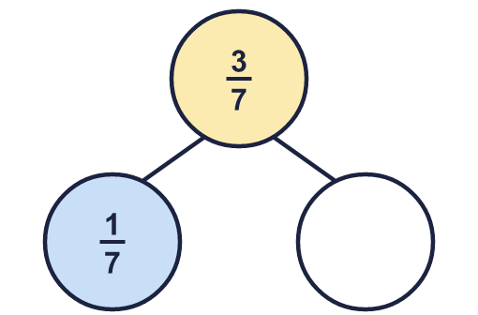
    The missing part is
  6 | Complete the part-whole model.
    The missing part is
  7 | Work out the subtractions. Write each answer as a mixed number (or a whole number).  a) ¹⁷⁄₇ − ⁹⁄₇ =  b) ¹⁰⁄₆ − ²⁄₆ =
  7 | Work out the subtractions. Write each answer as a mixed number (or a whole number).  a) ¹⁷⁄₇ − ⁹⁄₇ =  b) ¹⁰⁄₆ − ²⁄₆ =
  8 | Work out the subtractions. Write each answer in its simplest form.  a) ⁴⁄₁₂ − ¹⁄₁₂ =  b) ⁸⁄₁₀ − ⁴⁄₁₀ =
  8 | Work out the subtractions. Write each answer in its simplest form.  a) ⁴⁄₁₂ − ¹⁄₁₂ =  b) ⁸⁄₁₀ − ⁴⁄₁₀ =

  9 | Is Boba correct? Circle yes or no.  Yes / No  Explain the mistake.
     | 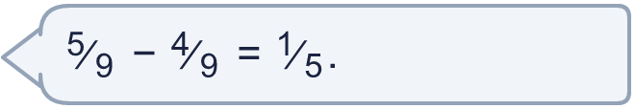
  9 | Is Boba correct? Circle yes or no.  Yes / No  Explain the mistake.
  10 | A cake is cut into 12 equal slices. ⁶⁄₁₂ of the cake is eaten at lunch and ²⁄₁₂ of the cake is eaten at tea.  What fraction of the cake is left?
  10 | A cake is cut into 12 equal slices. ⁶⁄₁₂ of the cake is eaten at lunch and ²⁄₁₂ of the cake is eaten at tea.  What fraction of the cake is left?
  11 | Complete the part-whole model.  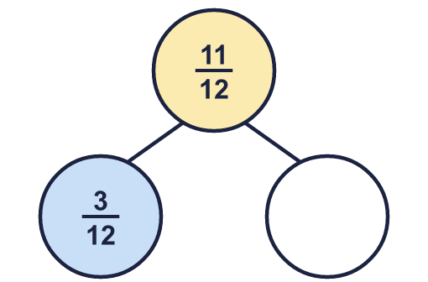
    The missing part is
  11 | Complete the part-whole model.
    The missing part is
  12 | Is Boba correct? Circle yes or no.  Yes / No  Explain the mistake.
    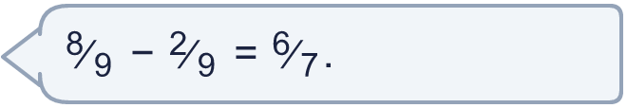
  12 | Is Boba correct? Circle yes or no.  Yes / No  Explain the mistake.
  13 | A cake is cut into 10 equal slices. ²⁄₁₀ of the cake is eaten at lunch and ⁷⁄₁₀ of the cake is eaten at tea.  What fraction of the cake is left?
  13 | A cake is cut into 10 equal slices. ²⁄₁₀ of the cake is eaten at lunch and ⁷⁄₁₀ of the cake is eaten at tea.  What fraction of the cake is left?
  14 | Work out the subtractions. Write each answer as a mixed number (or a whole number).  a) ¹⁹⁄₈ − ¹⁄₈ =  b) ¹⁴⁄₆ − ¹⁄₆ =  c) ¹⁶⁄₉ − ³⁄₉ =
  14 | Work out the subtractions. Write each answer as a mixed number (or a whole number).  a) ¹⁹⁄₈ − ¹⁄₈ =  b) ¹⁴⁄₆ − ¹⁄₆ =  c) ¹⁶⁄₉ − ³⁄₉ =

Year 4 · Fractions · Step 13
Subtract two fractions
Answers (teacher copy)

  1 | Work out the subtractions. Write each answer in its simplest form.  a) ²⁄₉ − ¹⁄₉ = ¹⁄₉  b) ²⁄₂ − ¹⁄₂ = ¹⁄₂  c) ⁴⁄₁₂ − ²⁄₁₂ = ¹⁄₆
  2 | Complete the part-whole model.  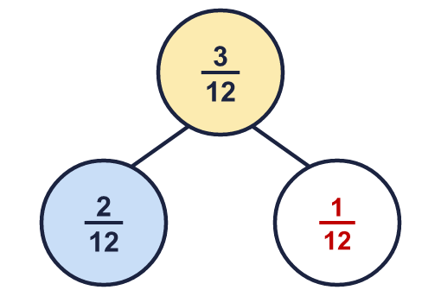  The missing part is ¹⁄₁₂
  3 | Work out the subtractions. Write each answer in its simplest form.  a) ⁴⁄₆ − ²⁄₆ = ¹⁄₃  b) ⁴⁄₆ − ¹⁄₆ = ¹⁄₂  c) ²⁄₂ − ¹⁄₂ = ¹⁄₂
  4 | Work out the subtractions. Write each answer as a mixed number (or a whole number).  a) ¹¹⁄₄ − ⁴⁄₄ = 1 ³⁄₄  b) ¹⁰⁄₄ − ⁵⁄₄ = 1 ¹⁄₄  c) ¹⁹⁄₈ − ⁵⁄₈ = 1 ³⁄₄
  5 | Work out the subtractions. Write each answer in its simplest form.  a) ²⁄₃ − ¹⁄₃ = ¹⁄₃  b) ⁷⁄₁₂ − ³⁄₁₂ = ¹⁄₃
  6 | Complete the part-whole model.  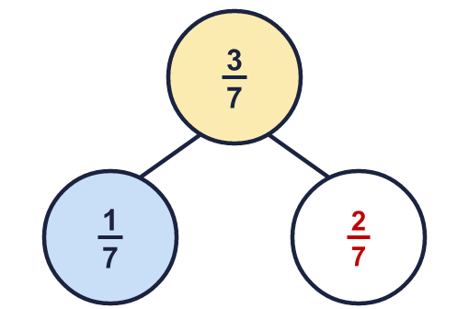  The missing part is ²⁄₇
  7 | Work out the subtractions. Write each answer as a mixed number (or a whole number).  a) ¹⁷⁄₇ − ⁹⁄₇ = 1 ¹⁄₇  b) ¹⁰⁄₆ − ²⁄₆ = 1 ¹⁄₃
  8 | Work out the subtractions. Write each answer in its simplest form.  a) ⁴⁄₁₂ − ¹⁄₁₂ = ¹⁄₄  b) ⁸⁄₁₀ − ⁴⁄₁₀ = ²⁄₅
  9 | Is Boba correct? Circle yes or no.  Yes / No  Explain the mistake.  No. ⁵⁄₉ − ⁴⁄₉ = ¹⁄₉. The denominator stays the same when you subtract.
  10 | A cake is cut into 12 equal slices. ⁶⁄₁₂ of the cake is eaten at lunch and ²⁄₁₂ of the cake is eaten at tea.  What fraction of the cake is left? ¹⁄₃
  11 | Complete the part-whole model.  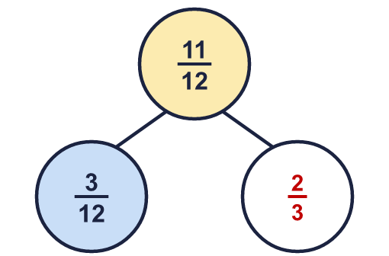  The missing part is ²⁄₃
  12 | Is Boba correct? Circle yes or no.  Yes / No  Explain the mistake.  No. ⁸⁄₉ − ²⁄₉ = ²⁄₃. The denominator stays the same when you subtract.
  13 | A cake is cut into 10 equal slices. ²⁄₁₀ of the cake is eaten at lunch and ⁷⁄₁₀ of the cake is eaten at tea.  What fraction of the cake is left? ¹⁄₁₀
  14 | Work out the subtractions. Write each answer as a mixed number (or a whole number).  a) ¹⁹⁄₈ − ¹⁄₈ = 2 ¹⁄₄  b) ¹⁴⁄₆ − ¹⁄₆ = 2 ¹⁄₆  c) ¹⁶⁄₉ − ³⁄₉ = 1 ⁴⁄₉

