  Year 4 · Fractions · Step 3  Partition a mixed number | 
  Year 4 · Fractions · Step 3
  Partition a mixed number
  1 | The bars are the same size. Write the mixed number and the improper fraction that the bars show.  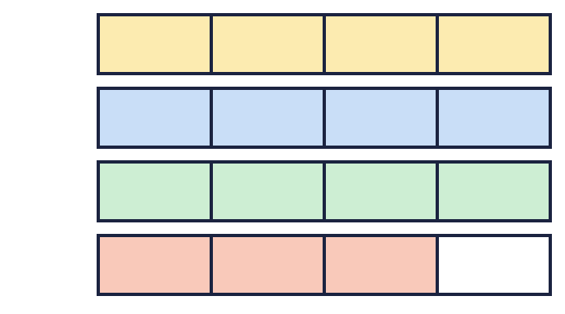
  1 | The bars are the same size. Write the mixed number and the improper fraction that the bars show.
  2 | Write the missing number in each partition.  a) 4 ⁵⁄₇ = ? + ⁵⁄₇  b) 5 ⁵⁄₆ = ? + ⁵⁄₆  c) 3 ³⁄₄ = 2 + ?⁄₄
  2 | Write the missing number in each partition.  a) 4 ⁵⁄₇ = ? + ⁵⁄₇  b) 5 ⁵⁄₆ = ? + ⁵⁄₆  c) 3 ³⁄₄ = 2 + ?⁄₄
  3 | Complete the part-whole model.  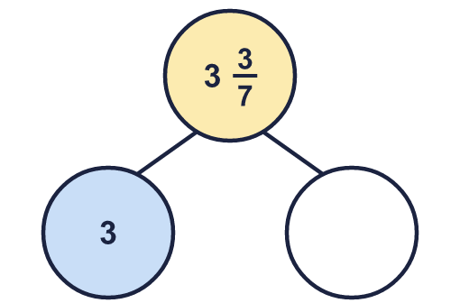
    The missing part is
  3 | Complete the part-whole model.
    The missing part is
  4 | The bars are the same size. Write the mixed number and the improper fraction that the bars show.  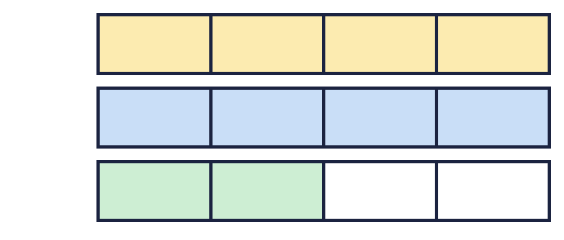
  4 | The bars are the same size. Write the mixed number and the improper fraction that the bars show.
  5 | Write the missing number in each partition.  a) 4 ⁵⁄₉ = 3 + ?⁄₉  b) 2 ⁵⁄₇ = ? + ⁵⁄₇
  5 | Write the missing number in each partition.  a) 4 ⁵⁄₉ = 3 + ?⁄₉  b) 2 ⁵⁄₇ = ? + ⁵⁄₇
  6 | Complete the part-whole model.  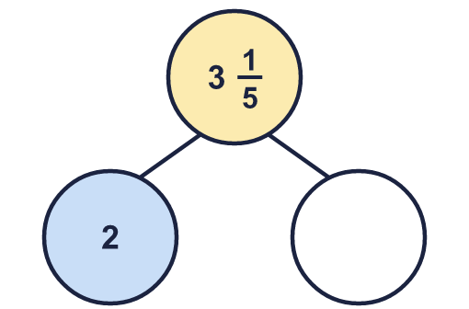
    The missing part is
  6 | Complete the part-whole model.
    The missing part is
  7 | The bars are the same size. Write the mixed number and the improper fraction that the bars show.  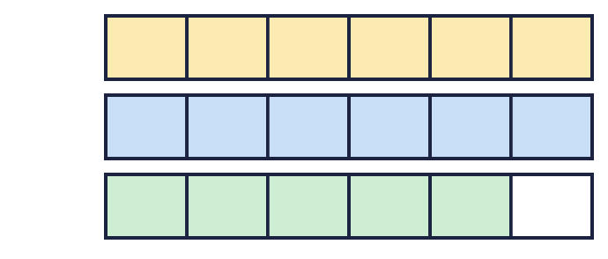
  7 | The bars are the same size. Write the mixed number and the improper fraction that the bars show.
  8 | Write the missing number in each partition.  a) 4 ³⁄₄ = 3 + ?⁄₄  b) 8 ²⁄₃ = ? + ²⁄₃
  8 | Write the missing number in each partition.  a) 4 ³⁄₄ = 3 + ?⁄₄  b) 8 ²⁄₃ = ? + ²⁄₃

  9 | Complete the part-whole model.  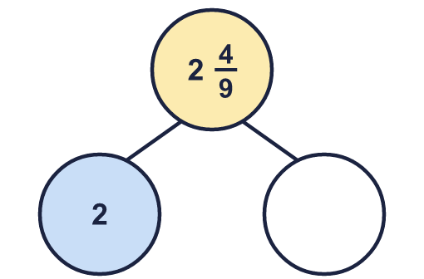
    The missing part is
  9 | Complete the part-whole model.
    The missing part is
  10 | Is Boba correct? Circle yes or no.  Yes / No  Explain the mistake.
    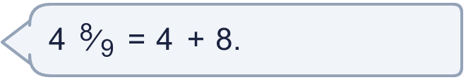
  10 | Is Boba correct? Circle yes or no.  Yes / No  Explain the mistake.
  11 | Write the missing number in each partition.  a) 7 ³⁄₄ = 6 + ?⁄₄  b) 3 ⁷⁄₈ = 2 + ?⁄₈  c) 5 ¹⁄₆ = 5 + ?⁄₆
  11 | Write the missing number in each partition.  a) 7 ³⁄₄ = 6 + ?⁄₄  b) 3 ⁷⁄₈ = 2 + ?⁄₈  c) 5 ¹⁄₆ = 5 + ?⁄₆
  12 | The bars are the same size. Write the mixed number and the improper fraction that the bars show.  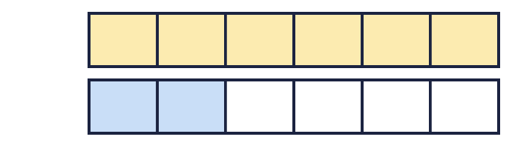
  12 | The bars are the same size. Write the mixed number and the improper fraction that the bars show.
  13 | Is Boba correct? Circle yes or no.  Yes / No  Explain the mistake.
    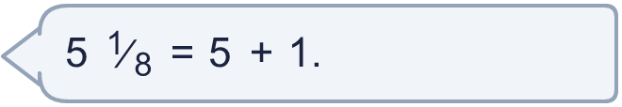
  13 | Is Boba correct? Circle yes or no.  Yes / No  Explain the mistake.
  14 | Write the missing number in each partition.  a) 4 ²⁄₉ = 3 + ?⁄₉  b) 4 ⁸⁄₉ = 3 + ?⁄₉  c) 4 ¹⁄₆ = 4 + ?⁄₆
  14 | Write the missing number in each partition.  a) 4 ²⁄₉ = 3 + ?⁄₉  b) 4 ⁸⁄₉ = 3 + ?⁄₉  c) 4 ¹⁄₆ = 4 + ?⁄₆

Year 4 · Fractions · Step 3
Partition a mixed number
Answers (teacher copy)

  1 | The bars are the same size. Write the mixed number and the improper fraction that the bars show.  Mixed number: 3 ³⁄₄  Improper fraction: ¹⁵⁄₄
  2 | Write the missing number in each partition.  a) 4 ⁵⁄₇ = ? + ⁵⁄₇ 4  b) 5 ⁵⁄₆ = ? + ⁵⁄₆ 5  c) 3 ³⁄₄ = 2 + ?⁄₄ 7
  3 | Complete the part-whole model.  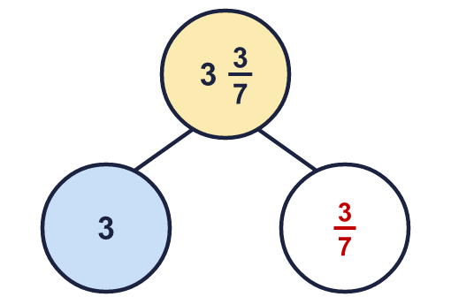  The missing part is ³⁄₇
  4 | The bars are the same size. Write the mixed number and the improper fraction that the bars show.  Mixed number: 2 ²⁄₄  Improper fraction: ¹⁰⁄₄
  5 | Write the missing number in each partition.  a) 4 ⁵⁄₉ = 3 + ?⁄₉ 14  b) 2 ⁵⁄₇ = ? + ⁵⁄₇ 2
  6 | Complete the part-whole model.  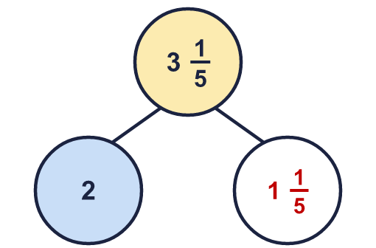  The missing part is 1 ¹⁄₅
  7 | The bars are the same size. Write the mixed number and the improper fraction that the bars show.  Mixed number: 2 ⁵⁄₆  Improper fraction: ¹⁷⁄₆
  8 | Write the missing number in each partition.  a) 4 ³⁄₄ = 3 + ?⁄₄ 7  b) 8 ²⁄₃ = ? + ²⁄₃ 8
  9 | Complete the part-whole model.  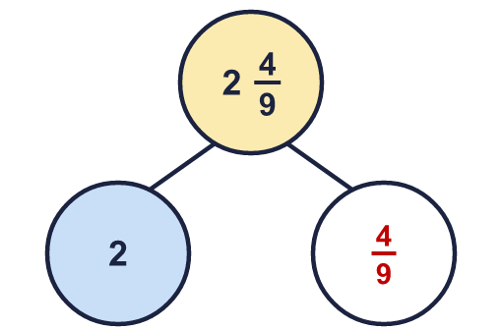  The missing part is ⁴⁄₉
  10 | Is Boba correct? Circle yes or no.  Yes / No  Explain the mistake.  No. 4 ⁸⁄₉ = 4 + ⁸⁄₉. The 8 is 8 parts of size ¹⁄₉, not 8 wholes.
  11 | Write the missing number in each partition.  a) 7 ³⁄₄ = 6 + ?⁄₄ 7  b) 3 ⁷⁄₈ = 2 + ?⁄₈ 15  c) 5 ¹⁄₆ = 5 + ?⁄₆ 1
  12 | The bars are the same size. Write the mixed number and the improper fraction that the bars show.  Mixed number: 1 ²⁄₆  Improper fraction: ⁸⁄₆
  13 | Is Boba correct? Circle yes or no.  Yes / No  Explain the mistake.  No. 5 ¹⁄₈ = 5 + ¹⁄₈. The 1 is 1 parts of size ¹⁄₈, not 1 wholes.
  14 | Write the missing number in each partition.  a) 4 ²⁄₉ = 3 + ?⁄₉ 11  b) 4 ⁸⁄₉ = 3 + ?⁄₉ 17  c) 4 ¹⁄₆ = 4 + ?⁄₆ 1

