  Year 4 · Fractions · Step 4  Number lines with mixed numbers | 
  Year 4 · Fractions · Step 4
  Number lines with mixed numbers
  1 | The number line goes from 0 to 3. There are 7 gaps between each whole number. Write the mixed number in each box.  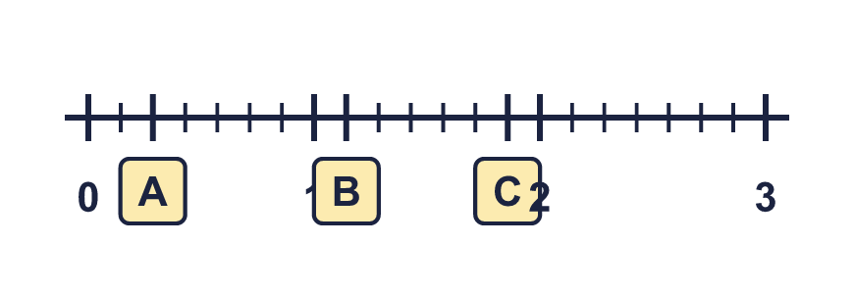
  1 | The number line goes from 0 to 3. There are 7 gaps between each whole number. Write the mixed number in each box.
  2 | What numbers are the arrows pointing to? Write each one as a mixed number.  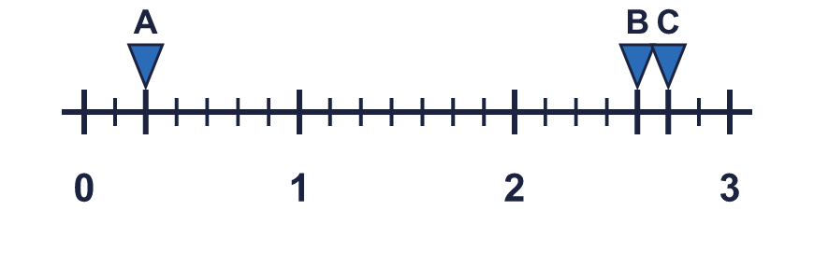
  2 | What numbers are the arrows pointing to? Write each one as a mixed number.
  3 | The number line goes from 0 to 3. There are 5 gaps between each whole number. Write the mixed number in each box.  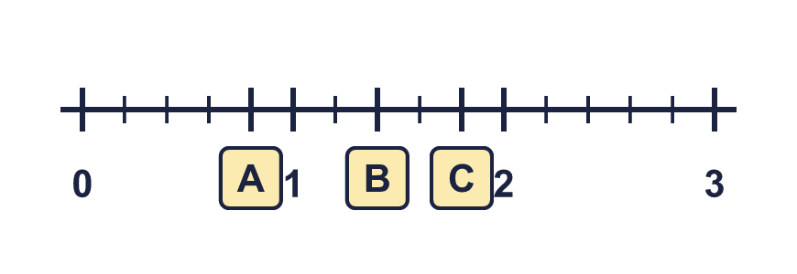
  3 | The number line goes from 0 to 3. There are 5 gaps between each whole number. Write the mixed number in each box.
  4 | What numbers are the arrows pointing to? Write each one as a mixed number.  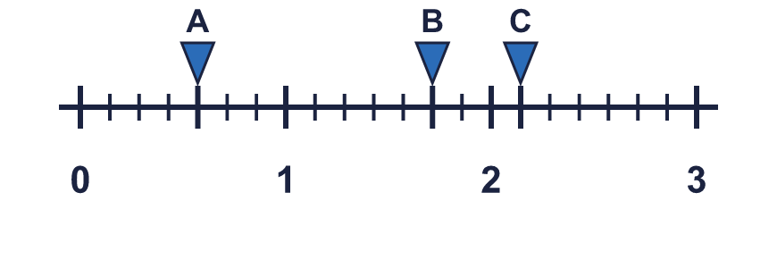
  4 | What numbers are the arrows pointing to? Write each one as a mixed number.
  5 | The number line goes from 0 to 2. Write the fraction in each box as an improper fraction.  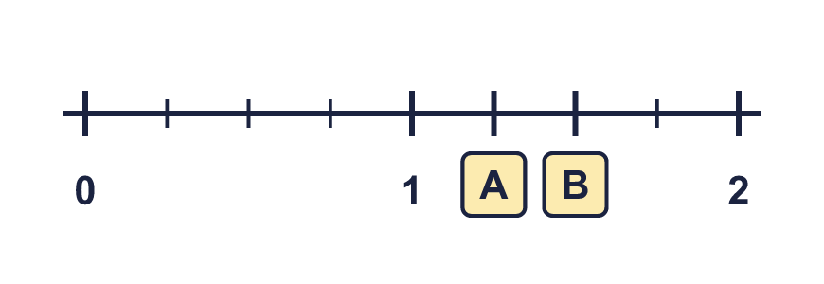
  5 | The number line goes from 0 to 2. Write the fraction in each box as an improper fraction.
  6 | The number line goes from 0 to 3. There are 5 gaps between each whole number. Write the mixed number in each box.  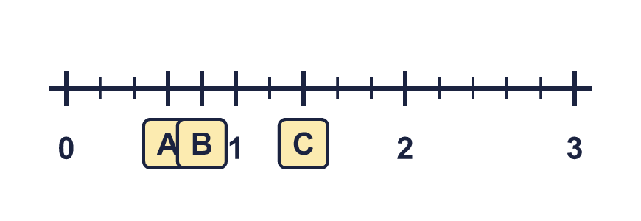
  6 | The number line goes from 0 to 3. There are 5 gaps between each whole number. Write the mixed number in each box.
  7 | What numbers are the arrows pointing to? Write each one as a mixed number.  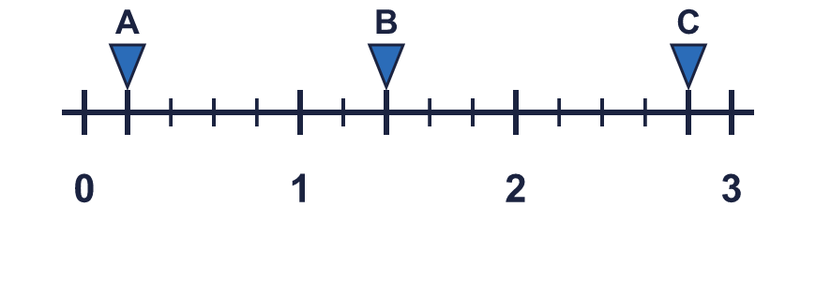
  7 | What numbers are the arrows pointing to? Write each one as a mixed number.
  8 | Write the fraction shown by each lettered box on the number line.  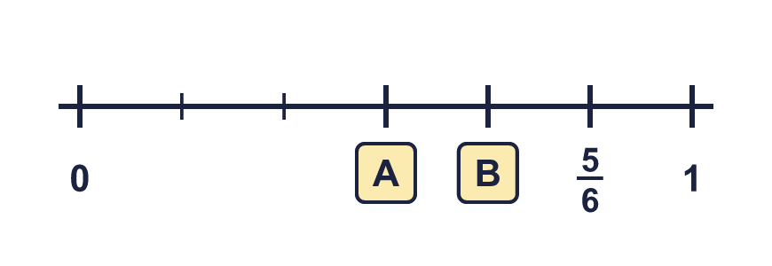
  8 | Write the fraction shown by each lettered box on the number line.

  9 | What numbers are the arrows pointing to? Write each one as a mixed number.  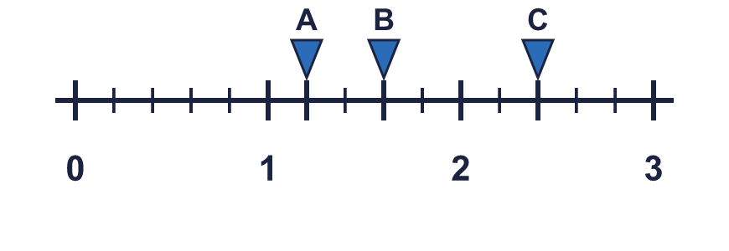
  9 | What numbers are the arrows pointing to? Write each one as a mixed number.
  10 | Write the mixed numbers in order.  a) 7 ⁴⁄₅ 6 ³⁄₅ 2 ⁴⁄₅ 7 ³⁄₅  b) 3 ²⁄₅ 7 ⁴⁄₅ 9 ³⁄₅ 2 ⁴⁄₅
  10 | Write the mixed numbers in order.  a) 7 ⁴⁄₅ 6 ³⁄₅ 2 ⁴⁄₅ 7 ³⁄₅  b) 3 ²⁄₅ 7 ⁴⁄₅ 9 ³⁄₅ 2 ⁴⁄₅
  11 | The number line goes from 0 to 3. There are 7 gaps between each whole number. Write the mixed number in each box.  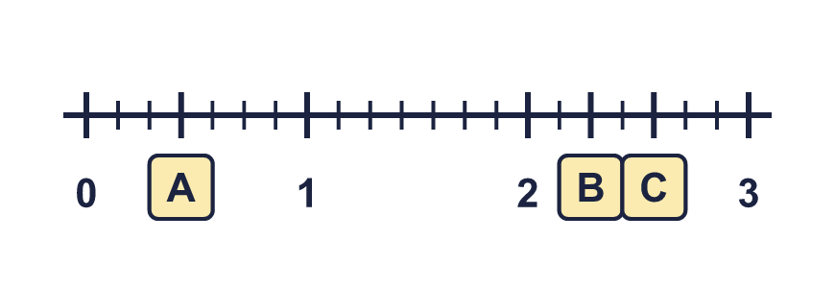
  11 | The number line goes from 0 to 3. There are 7 gaps between each whole number. Write the mixed number in each box.
  12 | Which is the greatest number?  ¹⁹⁄₅ 3 ³⁄₅ ¹²⁄₅
  12 | Which is the greatest number?  ¹⁹⁄₅ 3 ³⁄₅ ¹²⁄₅
  13 | Write an improper fraction that is greater than 2 ¹⁄₇ and less than 3 ²⁄₇.
  13 | Write an improper fraction that is greater than 2 ¹⁄₇ and less than 3 ²⁄₇.
  14 | What numbers are the arrows pointing to? Write each one as a mixed number.  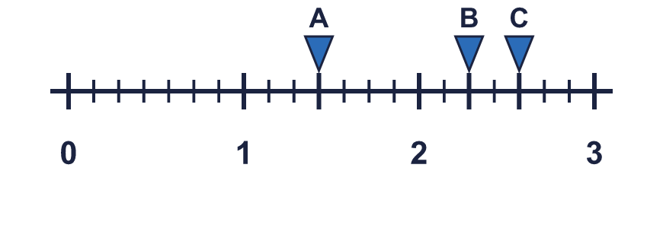
  14 | What numbers are the arrows pointing to? Write each one as a mixed number.

Year 4 · Fractions · Step 4
Number lines with mixed numbers
Answers (teacher copy)

  1 | The number line goes from 0 to 3. There are 7 gaps between each whole number. Write the mixed number in each box.  A = ²⁄₇ B = 1 ¹⁄₇ C = 1 ⁶⁄₇
  2 | What numbers are the arrows pointing to? Write each one as a mixed number.  A = ²⁄₇ B = 2 ⁴⁄₇ C = 2 ⁵⁄₇
  3 | The number line goes from 0 to 3. There are 5 gaps between each whole number. Write the mixed number in each box.  A = ⁴⁄₅ B = 1 ²⁄₅ C = 1 ⁴⁄₅
  4 | What numbers are the arrows pointing to? Write each one as a mixed number.  A = ⁴⁄₇ B = 1 ⁵⁄₇ C = 2 ¹⁄₇
  5 | The number line goes from 0 to 2. Write the fraction in each box as an improper fraction.  A = ⁵⁄₄ B = ⁶⁄₄
  6 | The number line goes from 0 to 3. There are 5 gaps between each whole number. Write the mixed number in each box.  A = ³⁄₅ B = ⁴⁄₅ C = 1 ²⁄₅
  7 | What numbers are the arrows pointing to? Write each one as a mixed number.  A = ¹⁄₅ B = 1 ²⁄₅ C = 2 ⁴⁄₅
  8 | Write the fraction shown by each lettered box on the number line.  A = ³⁄₆ B = ⁴⁄₆
  9 | What numbers are the arrows pointing to? Write each one as a mixed number.  A = 1 ¹⁄₅ B = 1 ³⁄₅ C = 2 ²⁄₅
  10 | Write the mixed numbers in order.  a) 7 ⁴⁄₅ 6 ³⁄₅ 2 ⁴⁄₅ 7 ³⁄₅  smallest first: 2 ⁴⁄₅, 6 ³⁄₅, 7 ³⁄₅, 7 ⁴⁄₅  b) 3 ²⁄₅ 7 ⁴⁄₅ 9 ³⁄₅ 2 ⁴⁄₅  greatest first: 9 ³⁄₅, 7 ⁴⁄₅, 3 ²⁄₅, 2 ⁴⁄₅
  11 | The number line goes from 0 to 3. There are 7 gaps between each whole number. Write the mixed number in each box.  A = ³⁄₇ B = 2 ²⁄₇ C = 2 ⁴⁄₇
  12 | Which is the greatest number?  ¹⁹⁄₅ 3 ³⁄₅ ¹²⁄₅  ¹⁹⁄₅
  13 | Write an improper fraction that is greater than 2 ¹⁄₇ and less than 3 ²⁄₇.  for example ²⁰⁄₇
  14 | What numbers are the arrows pointing to? Write each one as a mixed number.  A = 1 ³⁄₇ B = 2 ²⁄₇ C = 2 ⁴⁄₇

