  Year 4 · Fractions · Step 9  Equivalent fractions on a number line | 
  Year 4 · Fractions · Step 9
  Equivalent fractions on a number line
  1 | Arrow A is in the same place on both number lines. Write the missing numerator.  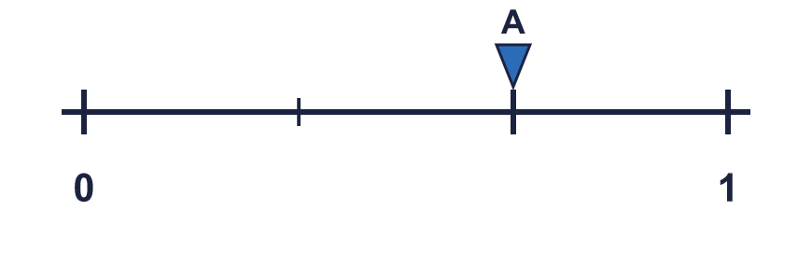  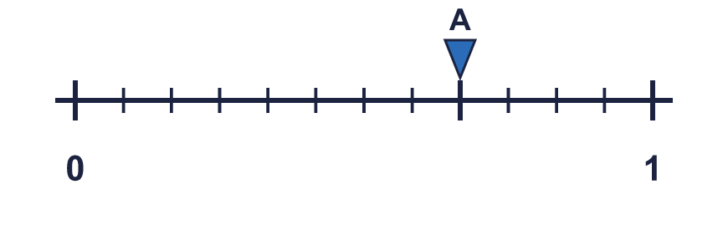  ²⁄₃ = ?⁄₁₂
  1 | Arrow A is in the same place on both number lines. Write the missing numerator.  ²⁄₃ = ?⁄₁₂
  2 | Which of these fractions are equal to the fraction that arrow A points to? Write them.  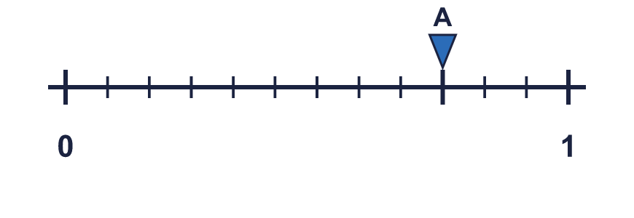  ³⁄₄ ³⁄₈ ⁴⁄₅ ¹²⁄₁₆ ⁶⁄₈
  2 | Which of these fractions are equal to the fraction that arrow A points to? Write them.  ³⁄₄ ³⁄₈ ⁴⁄₅ ¹²⁄₁₆ ⁶⁄₈
  3 | Arrow A is in the same place on both number lines. Write the missing numerator.  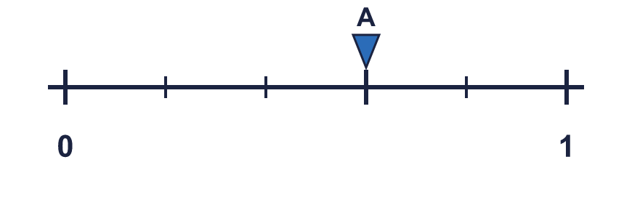  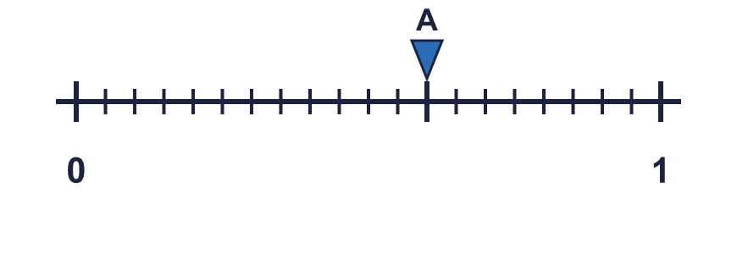  ³⁄₅ = ?⁄₂₀
  3 | Arrow A is in the same place on both number lines. Write the missing numerator.  ³⁄₅ = ?⁄₂₀
  4 | Each bar is the same length. Use the bars to find the missing numerators.  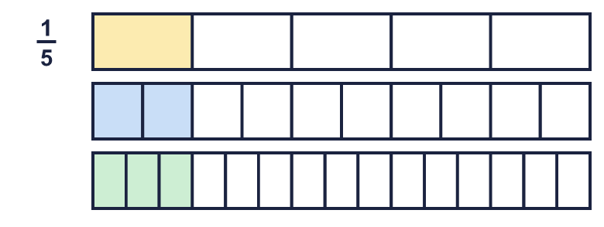  a) ¹⁄₅ = ?⁄₁₀  b) ¹⁄₅ = ?⁄₁₅
  4 | Each bar is the same length. Use the bars to find the missing numerators.  a) ¹⁄₅ = ?⁄₁₀  b) ¹⁄₅ = ?⁄₁₅
  5 | Write the missing numerator in each pair of equal fractions.  a) ¹⁄₂ = ?⁄₆  b) ²⁄₄ = ?⁄₈
  5 | Write the missing numerator in each pair of equal fractions.  a) ¹⁄₂ = ?⁄₆  b) ²⁄₄ = ?⁄₈
  6 | Which of these fractions are equal to the fraction that arrow A points to? Write them.  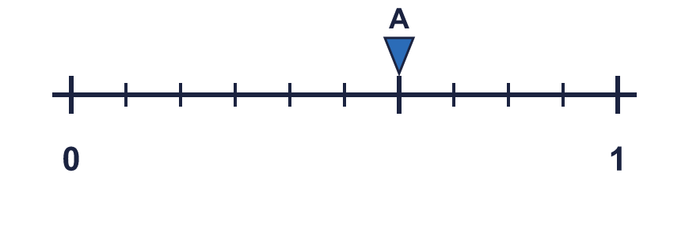  ⁴⁄₆ ³⁄₁₀ ⁶⁄₁₀ ³⁄₅ ⁹⁄₁₅
  6 | Which of these fractions are equal to the fraction that arrow A points to? Write them.  ⁴⁄₆ ³⁄₁₀ ⁶⁄₁₀ ³⁄₅ ⁹⁄₁₅
  7 | Arrow A is in the same place on both number lines. Write the missing numerator.  ³⁄₅ = ?⁄₁₀
  7 | Arrow A is in the same place on both number lines. Write the missing numerator.  ³⁄₅ = ?⁄₁₀
  8 | Write the missing denominator in each pair of equal fractions.  a) ¹⁄₄ = ⁵⁄?  b) ⁴⁄₆ = ²⁰⁄?
  8 | Write the missing denominator in each pair of equal fractions.  a) ¹⁄₄ = ⁵⁄?  b) ⁴⁄₆ = ²⁰⁄?

  9 | Is Boba correct? Circle yes or no.  Yes / No  Explain your answer.
     | 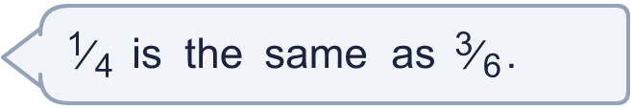
  9 | Is Boba correct? Circle yes or no.  Yes / No  Explain your answer.
  10 | Write three different fractions that are equal to ¹⁄₅.  All the denominators must be multiples of 4.
  10 | Write three different fractions that are equal to ¹⁄₅.  All the denominators must be multiples of 4.
  11 | Three of these fractions are equal to ¹⁄₅. Write the fraction that is not.  ³⁄₁₅ ⁵⁄₂₅ ²⁄₁₀ ³⁄₂₀
  11 | Three of these fractions are equal to ¹⁄₅. Write the fraction that is not.  ³⁄₁₅ ⁵⁄₂₅ ²⁄₁₀ ³⁄₂₀
  12 | Is Boba correct? Circle yes or no.  Yes / No  Explain your answer.
    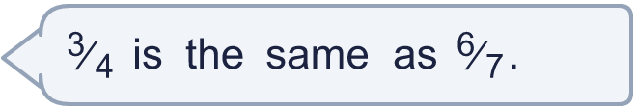
  12 | Is Boba correct? Circle yes or no.  Yes / No  Explain your answer.
  13 | Which of these fractions are equal to the fraction that arrow A points to? Write them.  ¹²⁄₂₀ ³⁄₅ ³⁄₁₀ ⁴⁄₆ ¹⁵⁄₂₅
  13 | Which of these fractions are equal to the fraction that arrow A points to? Write them.  ¹²⁄₂₀ ³⁄₅ ³⁄₁₀ ⁴⁄₆ ¹⁵⁄₂₅
  14 | Write the missing numerator in each pair of equal fractions.  a) ³⁄₅ = ?⁄₂₅  b) ⁴⁄₅ = ?⁄₂₅  c) ¹⁄₈ = ?⁄₂₄
  14 | Write the missing numerator in each pair of equal fractions.  a) ³⁄₅ = ?⁄₂₅  b) ⁴⁄₅ = ?⁄₂₅  c) ¹⁄₈ = ?⁄₂₄

Year 4 · Fractions · Step 9
Equivalent fractions on a number line
Answers (teacher copy)

  1 | Arrow A is in the same place on both number lines. Write the missing numerator.  ²⁄₃ = ?⁄₁₂ 8
  2 | Which of these fractions are equal to the fraction that arrow A points to? Write them.  ³⁄₄ ³⁄₈ ⁴⁄₅ ¹²⁄₁₆ ⁶⁄₈  ³⁄₄, ¹²⁄₁₆, ⁶⁄₈
  3 | Arrow A is in the same place on both number lines. Write the missing numerator.  ³⁄₅ = ?⁄₂₀ 12
  4 | Each bar is the same length. Use the bars to find the missing numerators.  a) ¹⁄₅ = ?⁄₁₀ 2  b) ¹⁄₅ = ?⁄₁₅ 3
  5 | Write the missing numerator in each pair of equal fractions.  a) ¹⁄₂ = ?⁄₆ 3  b) ²⁄₄ = ?⁄₈ 4
  6 | Which of these fractions are equal to the fraction that arrow A points to? Write them.  ⁴⁄₆ ³⁄₁₀ ⁶⁄₁₀ ³⁄₅ ⁹⁄₁₅  ⁶⁄₁₀, ³⁄₅, ⁹⁄₁₅
  7 | Arrow A is in the same place on both number lines. Write the missing numerator.  ³⁄₅ = ?⁄₁₀ 6
  8 | Write the missing denominator in each pair of equal fractions.  a) ¹⁄₄ = ⁵⁄? 20  b) ⁴⁄₆ = ²⁰⁄? 30
  9 | Is Boba correct? Circle yes or no.  Yes / No  Explain your answer.  No. ³⁄₆ = ¹⁄₂ but ¹⁄₄ = ¹⁄₄. To make an equal fraction you multiply the top and the bottom by the same number.
  10 | Write three different fractions that are equal to ¹⁄₅.  All the denominators must be multiples of 4.  for example ⁴⁄₂₀, ⁸⁄₄₀, ¹²⁄₆₀
  11 | Three of these fractions are equal to ¹⁄₅. Write the fraction that is not.  ³⁄₁₅ ⁵⁄₂₅ ²⁄₁₀ ³⁄₂₀  ³⁄₂₀
  12 | Is Boba correct? Circle yes or no.  Yes / No  Explain your answer.  No. ⁶⁄₇ = ⁶⁄₇ but ³⁄₄ = ³⁄₄. To make an equal fraction you multiply the top and the bottom by the same number.
  13 | Which of these fractions are equal to the fraction that arrow A points to? Write them.  ¹²⁄₂₀ ³⁄₅ ³⁄₁₀ ⁴⁄₆ ¹⁵⁄₂₅  ¹²⁄₂₀, ³⁄₅, ¹⁵⁄₂₅
  14 | Write the missing numerator in each pair of equal fractions.  a) ³⁄₅ = ?⁄₂₅ 15  b) ⁴⁄₅ = ?⁄₂₅ 20  c) ¹⁄₈ = ?⁄₂₄ 3

