  Year 4 · Fractions · Step 10  Equivalent fraction families | 
  Year 4 · Fractions · Step 10
  Equivalent fraction families
  1 | Each bar is the same length. Use the bars to find the missing numerators.  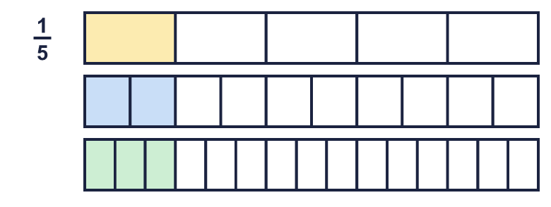  a) ¹⁄₅ = ?⁄₁₀  b) ¹⁄₅ = ?⁄₁₅
  1 | Each bar is the same length. Use the bars to find the missing numerators.  a) ¹⁄₅ = ?⁄₁₀  b) ¹⁄₅ = ?⁄₁₅
  2 | Write the missing numerator in each pair of equal fractions.  a) ²⁄₅ = ?⁄₂₀  b) ³⁄₄ = ?⁄₂₀  c) ²⁄₃ = ?⁄₆
  2 | Write the missing numerator in each pair of equal fractions.  a) ²⁄₅ = ?⁄₂₀  b) ³⁄₄ = ?⁄₂₀  c) ²⁄₃ = ?⁄₆
  3 | Write the missing denominator in each pair of equal fractions.  a) ¹⁄₃ = ³⁄?  b) ¹⁄₂ = ²⁄?  c) ³⁄₆ = ¹⁵⁄?
  3 | Write the missing denominator in each pair of equal fractions.  a) ¹⁄₃ = ³⁄?  b) ¹⁄₂ = ²⁄?  c) ³⁄₆ = ¹⁵⁄?
  4 | Three of these fractions are equal to ¹⁄₂. Write the fraction that is not.  ⁴⁄₁₀ ³⁄₆ ⁶⁄₁₂ ⁴⁄₈
  4 | Three of these fractions are equal to ¹⁄₂. Write the fraction that is not.  ⁴⁄₁₀ ³⁄₆ ⁶⁄₁₂ ⁴⁄₈
  5 | Write the missing numerator in each pair of equal fractions.  a) ¹⁄₂ = ?⁄₈  b) ¹⁄₆ = ?⁄₂₄
  5 | Write the missing numerator in each pair of equal fractions.  a) ¹⁄₂ = ?⁄₈  b) ¹⁄₆ = ?⁄₂₄
  6 | Write the missing denominator in each pair of equal fractions.  a) ¹⁄₂ = ²⁄?  b) ²⁄₃ = ¹⁰⁄?
  6 | Write the missing denominator in each pair of equal fractions.  a) ¹⁄₂ = ²⁄?  b) ²⁄₃ = ¹⁰⁄?
  7 | Each bar is the same length. Use the bars to find the missing numerators.  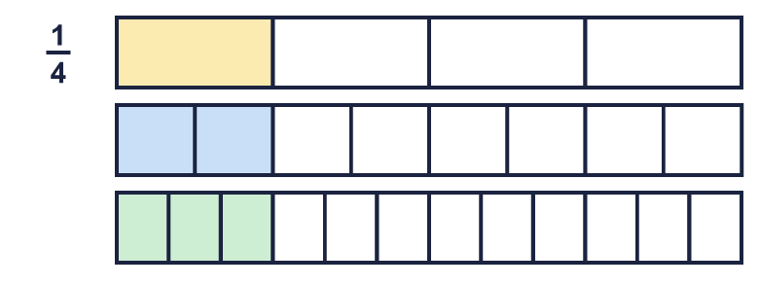  a) ¹⁄₄ = ?⁄₈  b) ¹⁄₄ = ?⁄₁₂
  7 | Each bar is the same length. Use the bars to find the missing numerators.  a) ¹⁄₄ = ?⁄₈  b) ¹⁄₄ = ?⁄₁₂
  8 | Three of these fractions are equal to ¹⁄₃. Write the fraction that is not.  ⁴⁄₁₅ ⁶⁄₁₈ ²⁄₆ ⁴⁄₁₂
  8 | Three of these fractions are equal to ¹⁄₃. Write the fraction that is not.  ⁴⁄₁₅ ⁶⁄₁₈ ²⁄₆ ⁴⁄₁₂

  9 | Is Boba correct? Circle yes or no.  Yes / No  Explain your answer.
     | 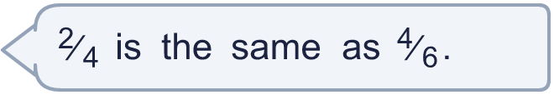
  9 | Is Boba correct? Circle yes or no.  Yes / No  Explain your answer.
  10 | Write three different fractions that are equal to ¹⁄₅.  All the denominators must be multiples of 2.
  10 | Write three different fractions that are equal to ¹⁄₅.  All the denominators must be multiples of 2.
  11 | Is Boba correct? Circle yes or no.  Yes / No  Explain your answer.
    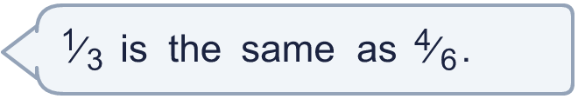
  11 | Is Boba correct? Circle yes or no.  Yes / No  Explain your answer.
  12 | Three of these fractions are equal to ¹⁄₄. Write the fraction that is not.  ²⁄₁₂ ⁵⁄₂₀ ²⁄₈ ⁶⁄₂₄
  12 | Three of these fractions are equal to ¹⁄₄. Write the fraction that is not.  ²⁄₁₂ ⁵⁄₂₀ ²⁄₈ ⁶⁄₂₄
  13 | Write three different fractions that are equal to ¹⁄₄.  All the denominators must be multiples of 2.
  13 | Write three different fractions that are equal to ¹⁄₄.  All the denominators must be multiples of 2.
  14 | Write the missing numerator in each pair of equal fractions.  a) ¹⁄₃ = ?⁄₉  b) ⁴⁄₅ = ?⁄₂₅  c) ¹⁄₂ = ?⁄₈
  14 | Write the missing numerator in each pair of equal fractions.  a) ¹⁄₃ = ?⁄₉  b) ⁴⁄₅ = ?⁄₂₅  c) ¹⁄₂ = ?⁄₈

Year 4 · Fractions · Step 10
Equivalent fraction families
Answers (teacher copy)

  1 | Each bar is the same length. Use the bars to find the missing numerators.  a) ¹⁄₅ = ?⁄₁₀ 2  b) ¹⁄₅ = ?⁄₁₅ 3
  2 | Write the missing numerator in each pair of equal fractions.  a) ²⁄₅ = ?⁄₂₀ 8  b) ³⁄₄ = ?⁄₂₀ 15  c) ²⁄₃ = ?⁄₆ 4
  3 | Write the missing denominator in each pair of equal fractions.  a) ¹⁄₃ = ³⁄? 9  b) ¹⁄₂ = ²⁄? 4  c) ³⁄₆ = ¹⁵⁄? 30
  4 | Three of these fractions are equal to ¹⁄₂. Write the fraction that is not.  ⁴⁄₁₀ ³⁄₆ ⁶⁄₁₂ ⁴⁄₈  ⁴⁄₁₀
  5 | Write the missing numerator in each pair of equal fractions.  a) ¹⁄₂ = ?⁄₈ 4  b) ¹⁄₆ = ?⁄₂₄ 4
  6 | Write the missing denominator in each pair of equal fractions.  a) ¹⁄₂ = ²⁄? 4  b) ²⁄₃ = ¹⁰⁄? 15
  7 | Each bar is the same length. Use the bars to find the missing numerators.  a) ¹⁄₄ = ?⁄₈ 2  b) ¹⁄₄ = ?⁄₁₂ 3
  8 | Three of these fractions are equal to ¹⁄₃. Write the fraction that is not.  ⁴⁄₁₅ ⁶⁄₁₈ ²⁄₆ ⁴⁄₁₂  ⁴⁄₁₅
  9 | Is Boba correct? Circle yes or no.  Yes / No  Explain your answer.  No. ⁴⁄₆ = ²⁄₃ but ²⁄₄ = ¹⁄₂. To make an equal fraction you multiply the top and the bottom by the same number.
  10 | Write three different fractions that are equal to ¹⁄₅.  All the denominators must be multiples of 2.  for example ²⁄₁₀, ⁴⁄₂₀, ⁶⁄₃₀
  11 | Is Boba correct? Circle yes or no.  Yes / No  Explain your answer.  No. ⁴⁄₆ = ²⁄₃ but ¹⁄₃ = ¹⁄₃. To make an equal fraction you multiply the top and the bottom by the same number.
  12 | Three of these fractions are equal to ¹⁄₄. Write the fraction that is not.  ²⁄₁₂ ⁵⁄₂₀ ²⁄₈ ⁶⁄₂₄  ²⁄₁₂
  13 | Write three different fractions that are equal to ¹⁄₄.  All the denominators must be multiples of 2.  for example ²⁄₈, ⁴⁄₁₆, ⁶⁄₂₄
  14 | Write the missing numerator in each pair of equal fractions.  a) ¹⁄₃ = ?⁄₉ 3  b) ⁴⁄₅ = ?⁄₂₅ 20  c) ¹⁄₂ = ?⁄₈ 4

