  Year 4 · Fractions · Step 2  Count beyond 1 | 
  Year 4 · Fractions · Step 2
  Count beyond 1
  1 | The jumps on the number line are equal. Write the missing numbers as mixed numbers, or whole numbers.  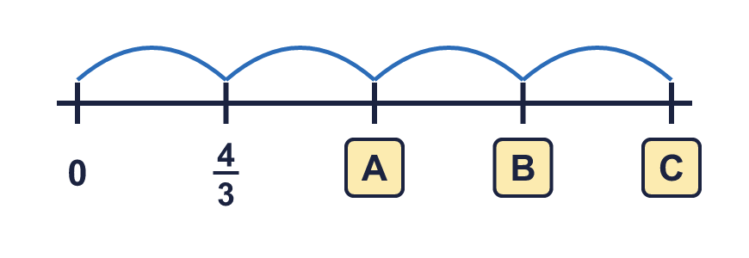
  1 | The jumps on the number line are equal. Write the missing numbers as mixed numbers, or whole numbers.
  2 | Write the fraction shown by each lettered box on the number line.  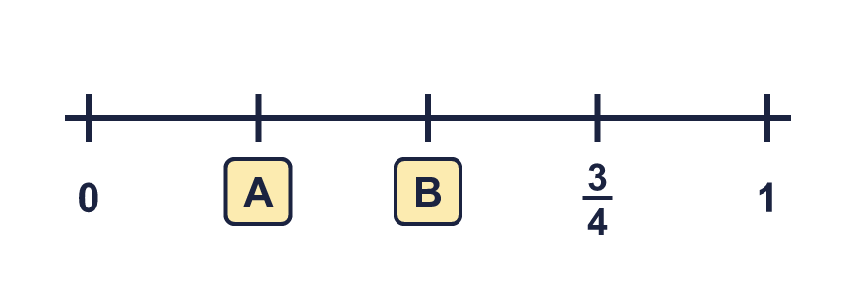
  2 | Write the fraction shown by each lettered box on the number line.
  3 | This sequence goes up by the same amount each time. Write the next two numbers.  1, 1 ⁵⁄₇, 2 ³⁄₇, ..., ...
  3 | This sequence goes up by the same amount each time. Write the next two numbers.  1, 1 ⁵⁄₇, 2 ³⁄₇, ..., ...
  4 | The number line goes from 0 to 2. Write the fraction in each box as an improper fraction.  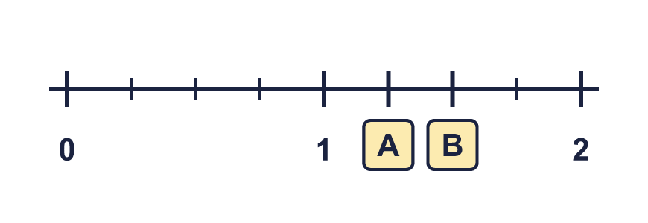
  4 | The number line goes from 0 to 2. Write the fraction in each box as an improper fraction.
  5 | The jumps on the number line are equal. Write the missing numbers as mixed numbers, or whole numbers.  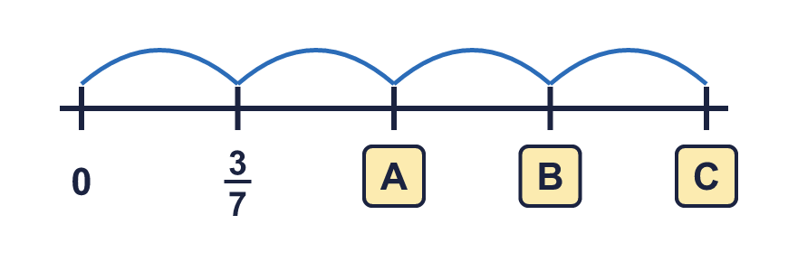
  5 | The jumps on the number line are equal. Write the missing numbers as mixed numbers, or whole numbers.
  6 | The number line goes from 0 to 3. There are 3 gaps between each whole number. Write the mixed number in each box.  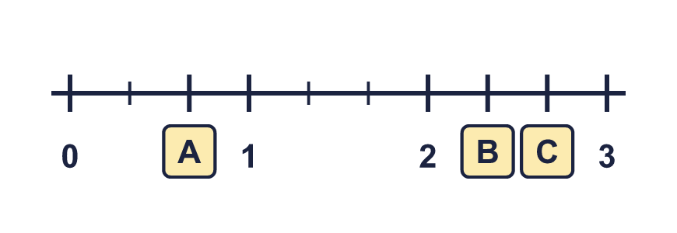
  6 | The number line goes from 0 to 3. There are 3 gaps between each whole number. Write the mixed number in each box.
  7 | This sequence goes up by the same amount each time. Write the next two numbers.  2, 2 ⁴⁄₅, 3 ³⁄₅, ..., ...
  7 | This sequence goes up by the same amount each time. Write the next two numbers.  2, 2 ⁴⁄₅, 3 ³⁄₅, ..., ...
  8 | Write the fraction shown by each lettered box on the number line.  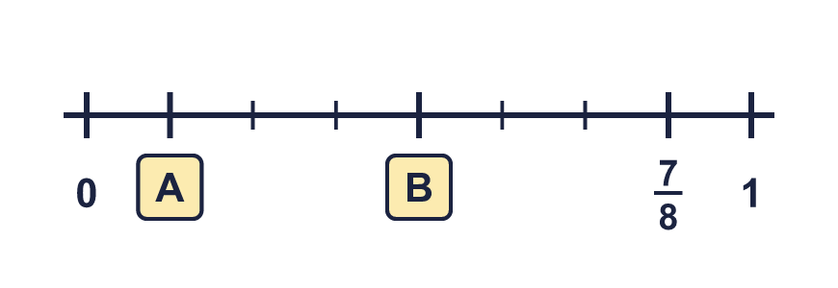
  8 | Write the fraction shown by each lettered box on the number line.

  9 | What numbers are the arrows pointing to? Write each one as a mixed number.  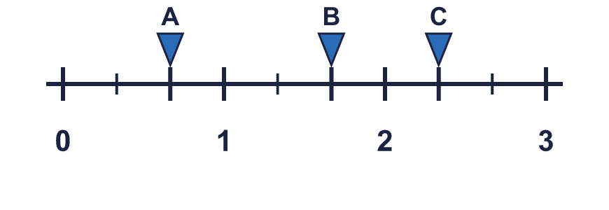
  9 | What numbers are the arrows pointing to? Write each one as a mixed number.
  10 | This sequence goes up by the same amount each time. Write the next two numbers.  0, ²⁄₃, 1 ¹⁄₃, ..., ...
  10 | This sequence goes up by the same amount each time. Write the next two numbers.  0, ²⁄₃, 1 ¹⁄₃, ..., ...
  11 | The number line goes from 0 to 3. There are 7 gaps between each whole number. Write the mixed number in each box.  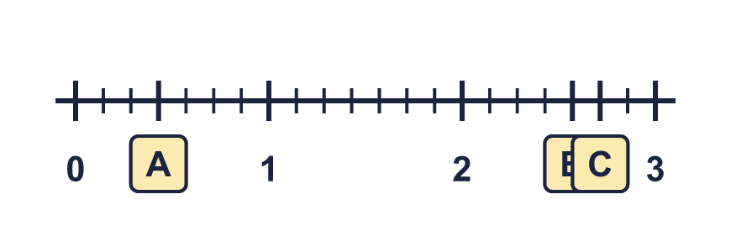
  11 | The number line goes from 0 to 3. There are 7 gaps between each whole number. Write the mixed number in each box.
  12 | The jumps on the number line are equal. Write the missing numbers as mixed numbers, or whole numbers.  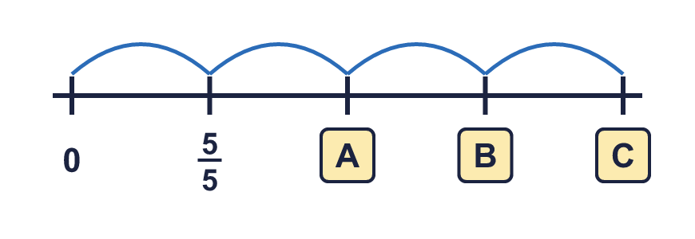
  12 | The jumps on the number line are equal. Write the missing numbers as mixed numbers, or whole numbers.
  13 | The number line goes from 0 to 2. Write the fraction in each box as an improper fraction.  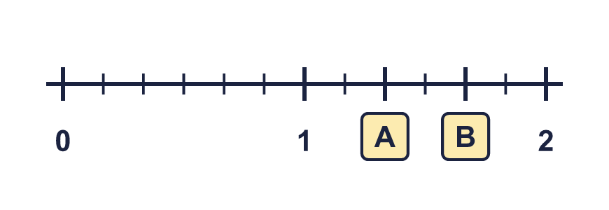
  13 | The number line goes from 0 to 2. Write the fraction in each box as an improper fraction.
  14 | What numbers are the arrows pointing to? Write each one as a mixed number.  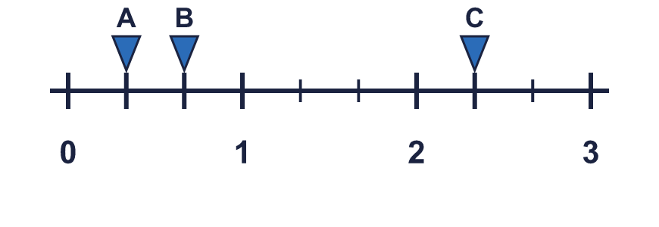
  14 | What numbers are the arrows pointing to? Write each one as a mixed number.

Year 4 · Fractions · Step 2
Count beyond 1
Answers (teacher copy)

  1 | The jumps on the number line are equal. Write the missing numbers as mixed numbers, or whole numbers.  A = 2 ²⁄₃ B = 4 C = 5 ¹⁄₃
  2 | Write the fraction shown by each lettered box on the number line.  A = ¹⁄₄ B = ²⁄₄
  3 | This sequence goes up by the same amount each time. Write the next two numbers.  1, 1 ⁵⁄₇, 2 ³⁄₇, ..., ...  3 ¹⁄₇ 3 ⁶⁄₇
  4 | The number line goes from 0 to 2. Write the fraction in each box as an improper fraction.  A = ⁵⁄₄ B = ⁶⁄₄
  5 | The jumps on the number line are equal. Write the missing numbers as mixed numbers, or whole numbers.  A = ⁶⁄₇ B = 1 ²⁄₇ C = 1 ⁵⁄₇
  6 | The number line goes from 0 to 3. There are 3 gaps between each whole number. Write the mixed number in each box.  A = ²⁄₃ B = 2 ¹⁄₃ C = 2 ²⁄₃
  7 | This sequence goes up by the same amount each time. Write the next two numbers.  2, 2 ⁴⁄₅, 3 ³⁄₅, ..., ...  4 ²⁄₅ 5 ¹⁄₅
  8 | Write the fraction shown by each lettered box on the number line.  A = ¹⁄₈ B = ⁴⁄₈
  9 | What numbers are the arrows pointing to? Write each one as a mixed number.  A = ²⁄₃ B = 1 ²⁄₃ C = 2 ¹⁄₃
  10 | This sequence goes up by the same amount each time. Write the next two numbers.  0, ²⁄₃, 1 ¹⁄₃, ..., ...  2 2 ²⁄₃
  11 | The number line goes from 0 to 3. There are 7 gaps between each whole number. Write the mixed number in each box.  A = ³⁄₇ B = 2 ⁴⁄₇ C = 2 ⁵⁄₇
  12 | The jumps on the number line are equal. Write the missing numbers as mixed numbers, or whole numbers.  A = 2 B = 3 C = 4
  13 | The number line goes from 0 to 2. Write the fraction in each box as an improper fraction.  A = ⁸⁄₆ B = ¹⁰⁄₆
  14 | What numbers are the arrows pointing to? Write each one as a mixed number.  A = ¹⁄₃ B = ²⁄₃ C = 2 ¹⁄₃

