  Year 4 · Fractions · Step 7  Convert mixed numbers to improper fractions | 
  Year 4 · Fractions · Step 7
  Convert mixed numbers to improper fractions
  1 | Convert each mixed number to an improper fraction.  a) 2 ¹⁄₅ =  b) 2 ¹⁄₃ =  c) 3 ¹⁄₄ =
  1 | Convert each mixed number to an improper fraction.  a) 2 ¹⁄₅ =  b) 2 ¹⁄₃ =  c) 3 ¹⁄₄ =
  2 | Write each whole number as a fraction with the denominator shown.  a) 6 = ?⁄₂  b) 4 = ?⁄₂  c) 4 = ?⁄₈
  2 | Write each whole number as a fraction with the denominator shown.  a) 6 = ?⁄₂  b) 4 = ?⁄₂  c) 4 = ?⁄₈
  3 | Convert each mixed number to an improper fraction.  a) 1 ²⁄₅ =  b) 1 ¹⁄₄ =  c) 2 ¹⁄₄ =
  3 | Convert each mixed number to an improper fraction.  a) 1 ²⁄₅ =  b) 1 ¹⁄₄ =  c) 2 ¹⁄₄ =
  4 | The bars are the same size. Write the mixed number and the improper fraction that the bars show.  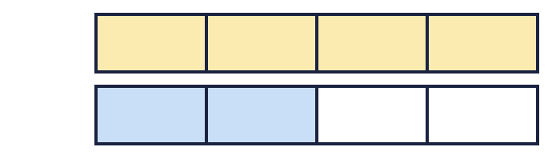
  4 | The bars are the same size. Write the mixed number and the improper fraction that the bars show.
  5 | Convert each mixed number to an improper fraction.  a) 2 ²⁄₃ =  b) 4 ¹⁄₄ =
  5 | Convert each mixed number to an improper fraction.  a) 2 ²⁄₃ =  b) 4 ¹⁄₄ =
  6 | Write each whole number as a fraction with the denominator shown.  a) 5 = ?⁄₆  b) 3 = ?⁄₂
  6 | Write each whole number as a fraction with the denominator shown.  a) 5 = ?⁄₆  b) 3 = ?⁄₂
  7 | Convert each mixed number to an improper fraction.  a) 3 ⁴⁄₅ =  b) 3 ³⁄₄ =
  7 | Convert each mixed number to an improper fraction.  a) 3 ⁴⁄₅ =  b) 3 ³⁄₄ =
  8 | Convert each mixed number to an improper fraction.  a) 3 ⁴⁄₅ =  b) 3 ¹⁄₂ =
  8 | Convert each mixed number to an improper fraction.  a) 3 ⁴⁄₅ =  b) 3 ¹⁄₂ =

  9 | Is Boba correct? Circle yes or no.  Yes / No  Explain the mistake.
     | 
  9 | Is Boba correct? Circle yes or no.  Yes / No  Explain the mistake.
  10 | Which is greater: ¹⁷⁄₆ or 3 ⁴⁄₆? Write the greater number.
  10 | Which is greater: ¹⁷⁄₆ or 3 ⁴⁄₆? Write the greater number.
  11 | Three friends each eat some pizzas. Ana eats ⁷⁄₄ of a pizza, Ben eats ¹³⁄₈ of a pizza, Cal eats ⁴⁄₃ of a pizza.  Who eats the most pizza?
  11 | Three friends each eat some pizzas. Ana eats ⁷⁄₄ of a pizza, Ben eats ¹³⁄₈ of a pizza, Cal eats ⁴⁄₃ of a pizza.  Who eats the most pizza?
  12 | Write two improper fractions that are between 2 and 3.
  12 | Write two improper fractions that are between 2 and 3.
  13 | Is Boba correct? Circle yes or no.  Yes / No  Explain the mistake.
    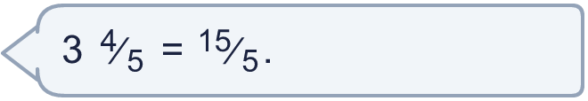
  13 | Is Boba correct? Circle yes or no.  Yes / No  Explain the mistake.
  14 | How many pizzas is this? Write a mixed number.
    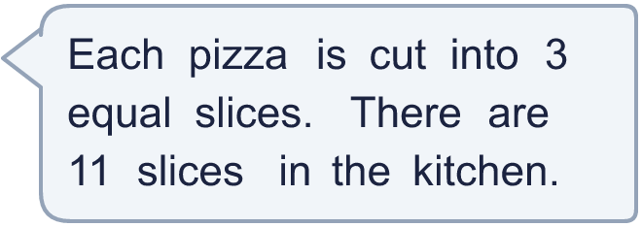
  14 | How many pizzas is this? Write a mixed number.

Year 4 · Fractions · Step 7
Convert mixed numbers to improper fractions
Answers (teacher copy)

  1 | Convert each mixed number to an improper fraction.  a) 2 ¹⁄₅ = ¹¹⁄₅  b) 2 ¹⁄₃ = ⁷⁄₃  c) 3 ¹⁄₄ = ¹³⁄₄
  2 | Write each whole number as a fraction with the denominator shown.  a) 6 = ?⁄₂ 12  b) 4 = ?⁄₂ 8  c) 4 = ?⁄₈ 32
  3 | Convert each mixed number to an improper fraction.  a) 1 ²⁄₅ = ⁷⁄₅  b) 1 ¹⁄₄ = ⁵⁄₄  c) 2 ¹⁄₄ = ⁹⁄₄
  4 | The bars are the same size. Write the mixed number and the improper fraction that the bars show.  Mixed number: 1 ²⁄₄  Improper fraction: ⁶⁄₄
  5 | Convert each mixed number to an improper fraction.  a) 2 ²⁄₃ = ⁸⁄₃  b) 4 ¹⁄₄ = ¹⁷⁄₄
  6 | Write each whole number as a fraction with the denominator shown.  a) 5 = ?⁄₆ 30  b) 3 = ?⁄₂ 6
  7 | Convert each mixed number to an improper fraction.  a) 3 ⁴⁄₅ = ¹⁹⁄₅  b) 3 ³⁄₄ = ¹⁵⁄₄
  8 | Convert each mixed number to an improper fraction.  a) 3 ⁴⁄₅ = ¹⁹⁄₅  b) 3 ¹⁄₂ = ⁷⁄₂
  9 | Is Boba correct? Circle yes or no.  Yes / No  Explain the mistake.  No. 3 ¹⁄₆ = ¹⁹⁄₆. Boba multiplied the whole number by the denominator but forgot to add the 1 extra parts.
  10 | Which is greater: ¹⁷⁄₆ or 3 ⁴⁄₆? Write the greater number.  3 ⁴⁄₆
  11 | Three friends each eat some pizzas. Ana eats ⁷⁄₄ of a pizza, Ben eats ¹³⁄₈ of a pizza, Cal eats ⁴⁄₃ of a pizza.  Who eats the most pizza?  Ana
  12 | Write two improper fractions that are between 2 and 3.  for example ⁹⁄₄ and ¹²⁄₅
  13 | Is Boba correct? Circle yes or no.  Yes / No  Explain the mistake.  No. 3 ⁴⁄₅ = ¹⁹⁄₅. Boba multiplied the whole number by the denominator but forgot to add the 4 extra parts.
  14 | How many pizzas is this? Write a mixed number. 3 ²⁄₃

