  Year 4 · Fractions · Step 5  Compare and order mixed numbers | 
  Year 4 · Fractions · Step 5
  Compare and order mixed numbers
  1 | Write < or > in each box.
    a) | 6 ²⁄₅ |  | 7 ²⁄₅
    b) | 5 ³⁄₅ |  | 5 ¹⁄₅
    c) | 3 ⁴⁄₅ |  | 7 ⁴⁄₅
  1 | Write < or > in each box.
    a) | 6 ²⁄₅ |  | 7 ²⁄₅
    b) | 5 ³⁄₅ |  | 5 ¹⁄₅
    c) | 3 ⁴⁄₅ |  | 7 ⁴⁄₅
  2 | Write the mixed numbers in order.  a) 3 ¹⁄₅ 4 ²⁄₅ 8 ¹⁄₅ 6 ²⁄₅  b) 6 ⁴⁄₅ 3 ³⁄₅ 8 ³⁄₅ 5 ⁴⁄₅
  2 | Write the mixed numbers in order.  a) 3 ¹⁄₅ 4 ²⁄₅ 8 ¹⁄₅ 6 ²⁄₅  b) 6 ⁴⁄₅ 3 ³⁄₅ 8 ³⁄₅ 5 ⁴⁄₅
  3 | Write < or > in each box.
    a) | 5 ¹⁄₄ |  | 4 ¹⁄₄
    b) | 8 ²⁄₄ |  | 8 ¹⁄₄
    c) | 2 ²⁄₄ |  | 2 ¹⁄₄
  3 | Write < or > in each box.
    a) | 5 ¹⁄₄ |  | 4 ¹⁄₄
    b) | 8 ²⁄₄ |  | 8 ¹⁄₄
    c) | 2 ²⁄₄ |  | 2 ¹⁄₄
  4 | Which is the greatest number?  ¹⁶⁄₇ 3 ⁶⁄₇ ¹⁵⁄₇
  4 | Which is the greatest number?  ¹⁶⁄₇ 3 ⁶⁄₇ ¹⁵⁄₇
  5 | Write < or > in each box.
    a) | 5 ¹⁄₄ |  | 5 ²⁄₄
    b) | 3 ¹⁄₄ |  | 8 ¹⁄₄
  5 | Write < or > in each box.
    a) | 5 ¹⁄₄ |  | 5 ²⁄₄
    b) | 3 ¹⁄₄ |  | 8 ¹⁄₄
  6 | Write the mixed numbers in order.  a) 8 ⁴⁄₈ 7 ³⁄₈ 6 ¹⁄₈ 6 ⁵⁄₈  b) 8 ⁴⁄₈ 5 ⁴⁄₈ 9 ⁷⁄₈ 7 ⁶⁄₈
  6 | Write the mixed numbers in order.  a) 8 ⁴⁄₈ 7 ³⁄₈ 6 ¹⁄₈ 6 ⁵⁄₈  b) 8 ⁴⁄₈ 5 ⁴⁄₈ 9 ⁷⁄₈ 7 ⁶⁄₈
  7 | Write < or > in each box.
    a) | 8 ³⁄₅ |  | 3 ³⁄₅
    b) | 7 ⁴⁄₅ |  | 7 ²⁄₅
  7 | Write < or > in each box.
    a) | 8 ³⁄₅ |  | 3 ³⁄₅
    b) | 7 ⁴⁄₅ |  | 7 ²⁄₅
  8 | Which is the greatest number?  ¹⁶⁄₇ 2 ⁶⁄₇ ²⁵⁄₇
  8 | Which is the greatest number?  ¹⁶⁄₇ 2 ⁶⁄₇ ²⁵⁄₇

  9 | Is Boba correct? Circle yes or no.  Yes / No  Explain how you know.
     | 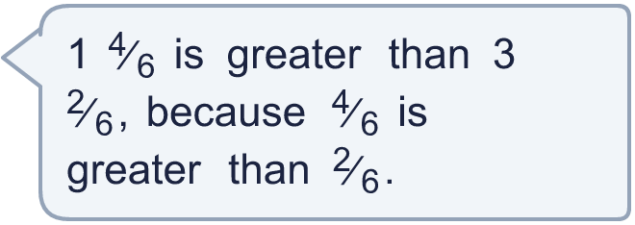
  9 | Is Boba correct? Circle yes or no.  Yes / No  Explain how you know.
  10 | Write an improper fraction that is greater than 4 ¹⁄₆ and less than 5 ²⁄₆.
  10 | Write an improper fraction that is greater than 4 ¹⁄₆ and less than 5 ²⁄₆.
  11 | Three friends each eat some pizzas. Ana eats ⁷⁄₄ of a pizza, Ben eats ¹¹⁄₆ of a pizza, Cal eats ²⁰⁄₇ of a pizza.  Who eats the most pizza?
  11 | Three friends each eat some pizzas. Ana eats ⁷⁄₄ of a pizza, Ben eats ¹¹⁄₆ of a pizza, Cal eats ²⁰⁄₇ of a pizza.  Who eats the most pizza?
  12 | Write the mixed numbers in order.  a) 2 ⁵⁄₈ 2 ⁴⁄₈ 9 ³⁄₈ 9 ⁷⁄₈  b) 9 ⁴⁄₈ 5 ³⁄₈ 3 ²⁄₈ 2 ⁴⁄₈
  12 | Write the mixed numbers in order.  a) 2 ⁵⁄₈ 2 ⁴⁄₈ 9 ³⁄₈ 9 ⁷⁄₈  b) 9 ⁴⁄₈ 5 ³⁄₈ 3 ²⁄₈ 2 ⁴⁄₈
  13 | Is Boba correct? Circle yes or no.  Yes / No  Explain how you know.
    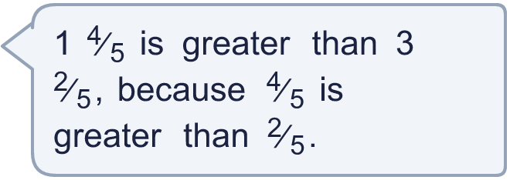
  13 | Is Boba correct? Circle yes or no.  Yes / No  Explain how you know.
  14 | Which is the greatest number?  ¹⁸⁄₅ 3 ¹⁄₅ ¹⁴⁄₅
  14 | Which is the greatest number?  ¹⁸⁄₅ 3 ¹⁄₅ ¹⁴⁄₅

Year 4 · Fractions · Step 5
Compare and order mixed numbers
Answers (teacher copy)

  1 | Write < or > in each box.  a) 6 ²⁄₅ < 7 ²⁄₅  b) 5 ³⁄₅ > 5 ¹⁄₅  c) 3 ⁴⁄₅ < 7 ⁴⁄₅
  2 | Write the mixed numbers in order.  a) 3 ¹⁄₅ 4 ²⁄₅ 8 ¹⁄₅ 6 ²⁄₅  smallest first: 3 ¹⁄₅, 4 ²⁄₅, 6 ²⁄₅, 8 ¹⁄₅  b) 6 ⁴⁄₅ 3 ³⁄₅ 8 ³⁄₅ 5 ⁴⁄₅  greatest first: 8 ³⁄₅, 6 ⁴⁄₅, 5 ⁴⁄₅, 3 ³⁄₅
  3 | Write < or > in each box.  a) 5 ¹⁄₄ > 4 ¹⁄₄  b) 8 ²⁄₄ > 8 ¹⁄₄  c) 2 ²⁄₄ > 2 ¹⁄₄
  4 | Which is the greatest number?  ¹⁶⁄₇ 3 ⁶⁄₇ ¹⁵⁄₇  3 ⁶⁄₇
  5 | Write < or > in each box.  a) 5 ¹⁄₄ < 5 ²⁄₄  b) 3 ¹⁄₄ < 8 ¹⁄₄
  6 | Write the mixed numbers in order.  a) 8 ⁴⁄₈ 7 ³⁄₈ 6 ¹⁄₈ 6 ⁵⁄₈  smallest first: 6 ¹⁄₈, 6 ⁵⁄₈, 7 ³⁄₈, 8 ⁴⁄₈  b) 8 ⁴⁄₈ 5 ⁴⁄₈ 9 ⁷⁄₈ 7 ⁶⁄₈  greatest first: 9 ⁷⁄₈, 8 ⁴⁄₈, 7 ⁶⁄₈, 5 ⁴⁄₈
  7 | Write < or > in each box.  a) 8 ³⁄₅ > 3 ³⁄₅  b) 7 ⁴⁄₅ > 7 ²⁄₅
  8 | Which is the greatest number?  ¹⁶⁄₇ 2 ⁶⁄₇ ²⁵⁄₇  ²⁵⁄₇
  9 | Is Boba correct? Circle yes or no.  Yes / No  Explain how you know.  No. 3 ²⁄₆ has 3 wholes and 1 ⁴⁄₆ has only 1 whole, so 3 ²⁄₆ is greater. Compare the whole numbers first.
  10 | Write an improper fraction that is greater than 4 ¹⁄₆ and less than 5 ²⁄₆.  for example ²⁹⁄₆
  11 | Three friends each eat some pizzas. Ana eats ⁷⁄₄ of a pizza, Ben eats ¹¹⁄₆ of a pizza, Cal eats ²⁰⁄₇ of a pizza.  Who eats the most pizza?  Cal
  12 | Write the mixed numbers in order.  a) 2 ⁵⁄₈ 2 ⁴⁄₈ 9 ³⁄₈ 9 ⁷⁄₈  smallest first: 2 ⁴⁄₈, 2 ⁵⁄₈, 9 ³⁄₈, 9 ⁷⁄₈  b) 9 ⁴⁄₈ 5 ³⁄₈ 3 ²⁄₈ 2 ⁴⁄₈  greatest first: 9 ⁴⁄₈, 5 ³⁄₈, 3 ²⁄₈, 2 ⁴⁄₈
  13 | Is Boba correct? Circle yes or no.  Yes / No  Explain how you know.  No. 3 ²⁄₅ has 3 wholes and 1 ⁴⁄₅ has only 1 whole, so 3 ²⁄₅ is greater. Compare the whole numbers first.
  14 | Which is the greatest number?  ¹⁸⁄₅ 3 ¹⁄₅ ¹⁴⁄₅  ¹⁸⁄₅

