  Year 4 · Fractions · Step 11  Add two or more fractions | 
  Year 4 · Fractions · Step 11
  Add two or more fractions
  1 | Work out the additions. Write each answer in its simplest form.  a) ³⁄₁₂ + ³⁄₁₂ =  b) ⁵⁄₇ + ¹⁄₇ =  c) ⁵⁄₁₂ + ⁴⁄₁₂ =
  1 | Work out the additions. Write each answer in its simplest form.  a) ³⁄₁₂ + ³⁄₁₂ =  b) ⁵⁄₇ + ¹⁄₇ =  c) ⁵⁄₁₂ + ⁴⁄₁₂ =
  2 | Complete the part-whole model.  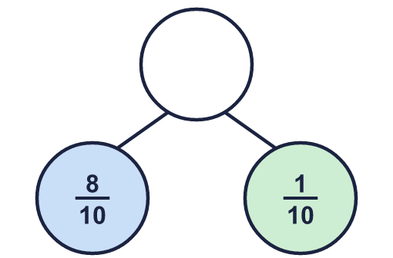
    The whole is
  2 | Complete the part-whole model.
    The whole is
  3 | Work out the additions. Write each answer in its simplest form.  a) ¹⁄₂ + ¹⁄₂ =  b) ¹⁄₃ + ¹⁄₃ =  c) ⁵⁄₁₁ + ¹⁄₁₁ =
  3 | Work out the additions. Write each answer in its simplest form.  a) ¹⁄₂ + ¹⁄₂ =  b) ¹⁄₃ + ¹⁄₃ =  c) ⁵⁄₁₁ + ¹⁄₁₁ =
  4 | Work out the additions. Write each answer as a mixed number (or a whole number).  a) ¹⁰⁄₁₂ + ⁵⁄₁₂ + ⁴⁄₁₂ =  b) ⁷⁄₁₁ + ⁸⁄₁₁ + ⁵⁄₁₁ =  c) ⁶⁄₈ + ⁴⁄₈ + ²⁄₈ =
  4 | Work out the additions. Write each answer as a mixed number (or a whole number).  a) ¹⁰⁄₁₂ + ⁵⁄₁₂ + ⁴⁄₁₂ =  b) ⁷⁄₁₁ + ⁸⁄₁₁ + ⁵⁄₁₁ =  c) ⁶⁄₈ + ⁴⁄₈ + ²⁄₈ =
  5 | Work out the additions. Write each answer as a mixed number (or a whole number).  a) ³⁄₃ + ²⁄₃ =  b) ⁵⁄₇ + ⁴⁄₇ =
  5 | Work out the additions. Write each answer as a mixed number (or a whole number).  a) ³⁄₃ + ²⁄₃ =  b) ⁵⁄₇ + ⁴⁄₇ =
  6 | Work out the additions. Write each answer in its simplest form.  a) ¹⁄₇ + ¹⁄₇ =  b) ²⁄₆ + ¹⁄₆ =
  6 | Work out the additions. Write each answer in its simplest form.  a) ¹⁄₇ + ¹⁄₇ =  b) ²⁄₆ + ¹⁄₆ =
  7 | Work out the additions. Write each answer as a mixed number (or a whole number).  a) ⁵⁄₈ + ⁶⁄₈ =  b) ⁵⁄₇ + ⁴⁄₇ =
  7 | Work out the additions. Write each answer as a mixed number (or a whole number).  a) ⁵⁄₈ + ⁶⁄₈ =  b) ⁵⁄₇ + ⁴⁄₇ =
  8 | Work out the additions. Write each answer as a mixed number (or a whole number).  a) ⁵⁄₁₁ + ³⁄₁₁ + ⁴⁄₁₁ =  b) ¹⁄₁₂ + ⁶⁄₁₂ + ¹⁰⁄₁₂ =
  8 | Work out the additions. Write each answer as a mixed number (or a whole number).  a) ⁵⁄₁₁ + ³⁄₁₁ + ⁴⁄₁₁ =  b) ¹⁄₁₂ + ⁶⁄₁₂ + ¹⁰⁄₁₂ =

  9 | Is Boba correct? Circle yes or no.  Yes / No  Explain the mistake.
     | 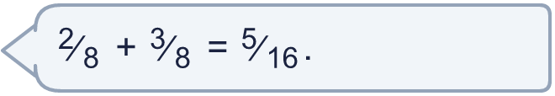
  9 | Is Boba correct? Circle yes or no.  Yes / No  Explain the mistake.
  10 | Teddy walked ⁴⁄₅ km. Rosie walked ¹⁄₅ km. Jack walked ²⁄₅ km.  How far did they walk altogether? km
  10 | Teddy walked ⁴⁄₅ km. Rosie walked ¹⁄₅ km. Jack walked ²⁄₅ km.  How far did they walk altogether? km
  11 | Complete the part-whole model.  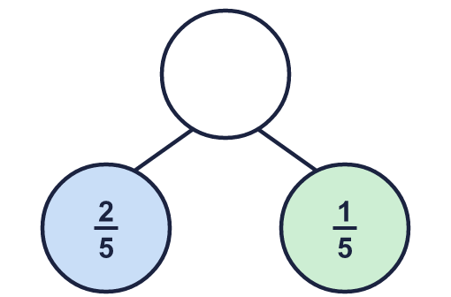
    The whole is
  11 | Complete the part-whole model.
    The whole is
  12 | Is Boba correct? Circle yes or no.  Yes / No  Explain the mistake.
    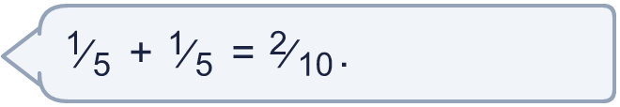
  12 | Is Boba correct? Circle yes or no.  Yes / No  Explain the mistake.
  13 | Rosie walked ⁴⁄₅ km. Whitney walked ¹⁄₅ km. Teddy walked ³⁄₅ km.  How far did they walk altogether? km
  13 | Rosie walked ⁴⁄₅ km. Whitney walked ¹⁄₅ km. Teddy walked ³⁄₅ km.  How far did they walk altogether? km
  14 | Work out the additions. Write each answer as a mixed number (or a whole number).  a) ³⁄₄ + ³⁄₄ =  b) ⁵⁄₈ + ⁶⁄₈ =  c) ⁶⁄₈ + ⁴⁄₈ =
  14 | Work out the additions. Write each answer as a mixed number (or a whole number).  a) ³⁄₄ + ³⁄₄ =  b) ⁵⁄₈ + ⁶⁄₈ =  c) ⁶⁄₈ + ⁴⁄₈ =

Year 4 · Fractions · Step 11
Add two or more fractions
Answers (teacher copy)

  1 | Work out the additions. Write each answer in its simplest form.  a) ³⁄₁₂ + ³⁄₁₂ = ¹⁄₂  b) ⁵⁄₇ + ¹⁄₇ = ⁶⁄₇  c) ⁵⁄₁₂ + ⁴⁄₁₂ = ³⁄₄
  2 | Complete the part-whole model.  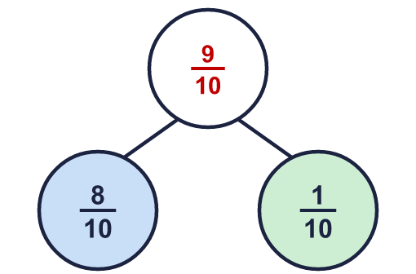  The whole is ⁹⁄₁₀
  3 | Work out the additions. Write each answer in its simplest form.  a) ¹⁄₂ + ¹⁄₂ = 1  b) ¹⁄₃ + ¹⁄₃ = ²⁄₃  c) ⁵⁄₁₁ + ¹⁄₁₁ = ⁶⁄₁₁
  4 | Work out the additions. Write each answer as a mixed number (or a whole number).  a) ¹⁰⁄₁₂ + ⁵⁄₁₂ + ⁴⁄₁₂ = 1 ⁷⁄₁₂  b) ⁷⁄₁₁ + ⁸⁄₁₁ + ⁵⁄₁₁ = 1 ⁹⁄₁₁  c) ⁶⁄₈ + ⁴⁄₈ + ²⁄₈ = 1 ¹⁄₂
  5 | Work out the additions. Write each answer as a mixed number (or a whole number).  a) ³⁄₃ + ²⁄₃ = 1 ²⁄₃  b) ⁵⁄₇ + ⁴⁄₇ = 1 ²⁄₇
  6 | Work out the additions. Write each answer in its simplest form.  a) ¹⁄₇ + ¹⁄₇ = ²⁄₇  b) ²⁄₆ + ¹⁄₆ = ¹⁄₂
  7 | Work out the additions. Write each answer as a mixed number (or a whole number).  a) ⁵⁄₈ + ⁶⁄₈ = 1 ³⁄₈  b) ⁵⁄₇ + ⁴⁄₇ = 1 ²⁄₇
  8 | Work out the additions. Write each answer as a mixed number (or a whole number).  a) ⁵⁄₁₁ + ³⁄₁₁ + ⁴⁄₁₁ = 1 ¹⁄₁₁  b) ¹⁄₁₂ + ⁶⁄₁₂ + ¹⁰⁄₁₂ = 1 ⁵⁄₁₂
  9 | Is Boba correct? Circle yes or no.  Yes / No  Explain the mistake.  No. ²⁄₈ + ³⁄₈ = ⁵⁄₈. When the denominators are the same you add the numerators and keep the denominator.
  10 | Teddy walked ⁴⁄₅ km. Rosie walked ¹⁄₅ km. Jack walked ²⁄₅ km.  How far did they walk altogether? 1 ²⁄₅ km
  11 | Complete the part-whole model.  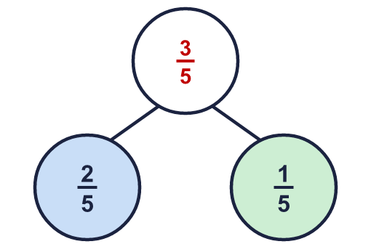  The whole is ³⁄₅
  12 | Is Boba correct? Circle yes or no.  Yes / No  Explain the mistake.  No. ¹⁄₅ + ¹⁄₅ = ²⁄₅. When the denominators are the same you add the numerators and keep the denominator.
  13 | Rosie walked ⁴⁄₅ km. Whitney walked ¹⁄₅ km. Teddy walked ³⁄₅ km.  How far did they walk altogether? 1 ³⁄₅ km
  14 | Work out the additions. Write each answer as a mixed number (or a whole number).  a) ³⁄₄ + ³⁄₄ = 1 ¹⁄₂  b) ⁵⁄₈ + ⁶⁄₈ = 1 ³⁄₈  c) ⁶⁄₈ + ⁴⁄₈ = 1 ¹⁄₄

