  Year 4 · Decimals A · Step 3  Tenths on a place value chart | 
  Year 4 · Decimals A · Step 3
  Tenths on a place value chart
  1 | Write the number shown on each place value chart.  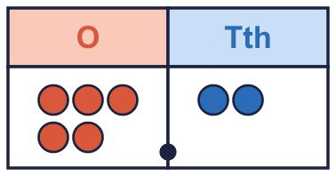  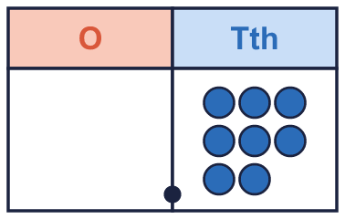
    a) The number is
    b) The number is
  1 | Write the number shown on each place value chart.
    a) The number is
    b) The number is
  2 | Use counters to make each number. Write how many counters go in each column.  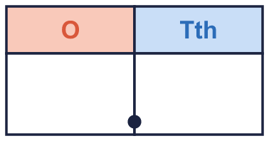
    a) 2.8: ones |  | tenths
  2 | Use counters to make each number. Write how many counters go in each column.
    a) 2.8: ones |  | tenths
  3 | What is the value of the digit in each number?
    a) the digit 5 in 6.5:
    b) the digit 5 in 4.5:
    c) the digit 2 in 3.2:
  3 | What is the value of the digit in each number?
    a) the digit 5 in 6.5:
    b) the digit 5 in 4.5:
    c) the digit 2 in 3.2:
  4 | Write each number as a decimal.
    a) 3 ones and 7 tenths:
    b) 5 ones and 5 tenths:
  4 | Write each number as a decimal.
    a) 3 ones and 7 tenths:
    b) 5 ones and 5 tenths:
  5 | Write each as one decimal.
    a) 6 + 0.4 =
    b) 2 + 0.7 =
  5 | Write each as one decimal.
    a) 6 + 0.4 =
    b) 2 + 0.7 =
  6 | Write the missing number.
    a) 1.9 = 1 +
    b) 8.3 = 8 +
    c) 1.1 = 1 +
  6 | Write the missing number.
    a) 1.9 = 1 +
    b) 8.3 = 8 +
    c) 1.1 = 1 +
  7 | Write <, > or = in each box.
    a) 4.9 |  | 2.8
    b) 2.4 |  | 4.9
    c) 2.5 |  | 6.6
  7 | Write <, > or = in each box.
    a) 4.9 |  | 2.8
    b) 2.4 |  | 4.9
    c) 2.5 |  | 6.6
  8 | Boba has 40 tenths counters. Exchange groups of 10 tenths for 1 one.  What number do the counters show?
  8 | Boba has 40 tenths counters. Exchange groups of 10 tenths for 1 one.  What number do the counters show?

  9 | 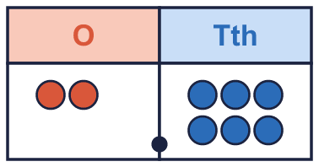  Is Alex correct? Circle yes or no.  Yes / No  Explain how you know.
     | 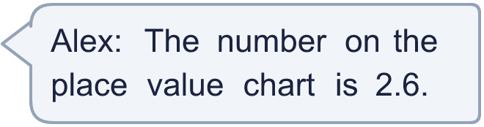
  9 | Is Alex correct? Circle yes or no.  Yes / No  Explain how you know.
  10 | She uses both cards to make a number like _._ Write the largest number she can make.
    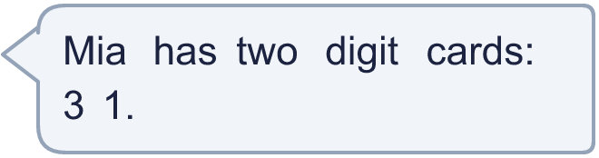
  10 | She uses both cards to make a number like _._ Write the largest number she can make.
  11 | Which of these are equal to 1.9? Write the letters.  A: 9.1  B: ¹⁹⁄₁₀  C: 1 + 0.9  D: 1.09
  11 | Which of these are equal to 1.9? Write the letters.  A: 9.1  B: ¹⁹⁄₁₀  C: 1 + 0.9  D: 1.09
  12 | The place value chart shows a number. Write the number that is 1 tenth (0.1) more and the number that is 1 tenth less.  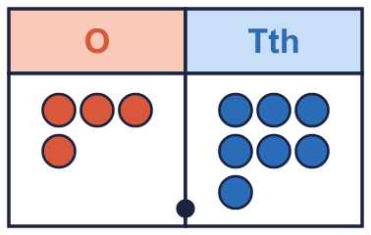
    1 tenth more:
    1 tenth less:
  12 | The place value chart shows a number. Write the number that is 1 tenth (0.1) more and the number that is 1 tenth less.
    1 tenth more:
    1 tenth less:
  13 | Write a decimal that is between 2.6 and 2.8.
  13 | Write a decimal that is between 2.6 and 2.8.
  14 | Is Jo correct? Circle yes or no.  Yes / No  Explain how you know.
     | 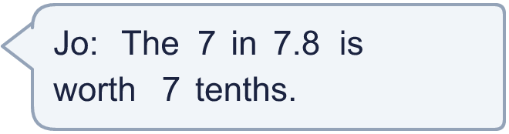
  14 | Is Jo correct? Circle yes or no.  Yes / No  Explain how you know.

Year 4 · Decimals A · Step 3
Tenths on a place value chart
Answers (teacher copy)

  1 | Write the number shown on each place value chart.  a) The number is 5.2  b) The number is 0.8
  2 | Use counters to make each number. Write how many counters go in each column.  a) 2.8: ones 2 tenths 8
  3 | What is the value of the digit in each number?  a) the digit 5 in 6.5: 0.5  b) the digit 5 in 4.5: 0.5  c) the digit 2 in 3.2: 0.2
  4 | Write each number as a decimal.  a) 3 ones and 7 tenths: 3.7  b) 5 ones and 5 tenths: 5.5
  5 | Write each as one decimal.  a) 6 + 0.4 = 6.4  b) 2 + 0.7 = 2.7
  6 | Write the missing number.  a) 1.9 = 1 + 0.9  b) 8.3 = 8 + 0.3  c) 1.1 = 1 + 0.1
  7 | Write <, > or = in each box.  a) 4.9 > 2.8  b) 2.4 < 4.9  c) 2.5 < 6.6
  8 | Boba has 40 tenths counters. Exchange groups of 10 tenths for 1 one.  What number do the counters show? 4
  9 | Is Alex correct? Circle yes or no.  Yes / No  Explain how you know.  Yes. The chart shows 2 ones and 6 tenths, so the number is 2.6.
  10 | She uses both cards to make a number like _._ Write the largest number she can make.  3.1
  11 | Which of these are equal to 1.9? Write the letters.  A: 9.1  B: ¹⁹⁄₁₀  C: 1 + 0.9  D: 1.09  B, C
  12 | The place value chart shows a number. Write the number that is 1 tenth (0.1) more and the number that is 1 tenth less.  1 tenth more: 4.8  1 tenth less: 4.6
  13 | Write a decimal that is between 2.6 and 2.8.  2.7
  14 | Is Jo correct? Circle yes or no.  Yes / No  Explain how you know.  No. In 7.8 the 7 is in the ones column, so it is worth 7 ones.

