  Year 4 · Decimals A · Step 4  Tenths on a number line | 
  Year 4 · Decimals A · Step 4
  Tenths on a number line
  1 | The number line is split into 10 equal steps. Write the number that each arrow points to.  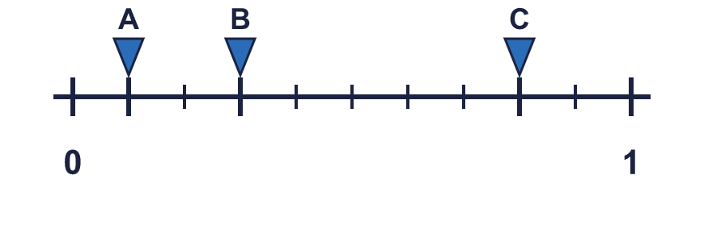
    A = |  | B = |  | C =
  1 | The number line is split into 10 equal steps. Write the number that each arrow points to.
    A = |  | B = |  | C =
  2 | The number line is split into 10 equal steps. Write the number each arrow points to.  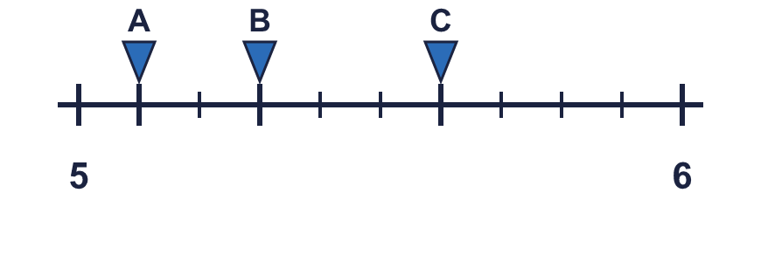
    A = |  | B = |  | C =
  2 | The number line is split into 10 equal steps. Write the number each arrow points to.
    A = |  | B = |  | C =
  3 | Count up in tenths. Write the missing numbers in order.  6.6, 6.7, 6.8, ?, ?, 7.1
  3 | Count up in tenths. Write the missing numbers in order.  6.6, 6.7, 6.8, ?, ?, 7.1
  4 | Count down in tenths. Write the missing numbers in order.  1.6, ?, 1.4, ?, 1.2, 1.1
  4 | Count down in tenths. Write the missing numbers in order.  1.6, ?, 1.4, ?, 1.2, 1.1
  5 | The number line is split into 10 equal steps. The middle is marked. Write the number each arrow points to.  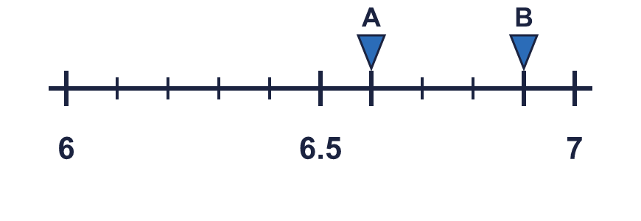
    A = |  | B =
  5 | The number line is split into 10 equal steps. The middle is marked. Write the number each arrow points to.
    A = |  | B =
  6 | Write these numbers in order, starting with the smallest.  2.9 4.3 5.7 3.4
  6 | Write these numbers in order, starting with the smallest.  2.9 4.3 5.7 3.4
  7 | Write the two whole numbers each decimal is between.
    a) 5.9 is between |  | and
    b) 1.4 is between |  | and
    c) 6.7 is between |  | and
  7 | Write the two whole numbers each decimal is between.
    a) 5.9 is between |  | and
    b) 1.4 is between |  | and
    c) 6.7 is between |  | and
  8 | Work out each answer.
    a) 2.7 + 0.1 =
    b) 2.7 − 0.1 =
    c) 3.2 + 0.2 =
  8 | Work out each answer.
    a) 2.7 + 0.1 =
    b) 2.7 − 0.1 =
    c) 3.2 + 0.2 =

  9 | Is Ron correct? Circle yes or no.  Yes / No  Explain how you know.
     | 
  9 | Is Ron correct? Circle yes or no.  Yes / No  Explain how you know.
  10 | Look at the number sequence.  1.4, 1.6, 1.8, 2, 2.2, …
    The rule is
    The next two numbers are
  10 | Look at the number sequence.  1.4, 1.6, 1.8, 2, 2.2, …
    The rule is
    The next two numbers are
  11 | He uses all three cards to make a number like __._ Write the largest number he can make.
    
  11 | He uses all three cards to make a number like __._ Write the largest number he can make.
  12 | A plant is 6.8 cm long. A stem is 0.2 cm longer than the plant.
  12 | A plant is 6.8 cm long. A stem is 0.2 cm longer than the plant.
  13 | Write a decimal that is between 3 and 3.2.
  13 | Write a decimal that is between 3 and 3.2.
  14 | Challenge  A bead string has 48 beads. Each bead is 1 tenth of a centimetre long.  How long is the bead string in centimetres? cm
  14 | Challenge  A bead string has 48 beads. Each bead is 1 tenth of a centimetre long.  How long is the bead string in centimetres? cm

Year 4 · Decimals A · Step 4
Tenths on a number line
Answers (teacher copy)

  1 | The number line is split into 10 equal steps. Write the number that each arrow points to.  A = 0.1 B = 0.3 C = 0.8
  2 | The number line is split into 10 equal steps. Write the number each arrow points to.  A = 5.1 B = 5.3 C = 5.6
  3 | Count up in tenths. Write the missing numbers in order.  6.6, 6.7, 6.8, ?, ?, 7.1  6.9, 7
  4 | Count down in tenths. Write the missing numbers in order.  1.6, ?, 1.4, ?, 1.2, 1.1  1.5, 1.3
  5 | The number line is split into 10 equal steps. The middle is marked. Write the number each arrow points to.  A = 6.6 B = 6.9
  6 | Write these numbers in order, starting with the smallest.  2.9 4.3 5.7 3.4  2.9, 3.4, 4.3, 5.7
  7 | Write the two whole numbers each decimal is between.  a) 5.9 is between 5 and 6  b) 1.4 is between 1 and 2  c) 6.7 is between 6 and 7
  8 | Work out each answer.  a) 2.7 + 0.1 = 2.8  b) 2.7 − 0.1 = 2.6  c) 3.2 + 0.2 = 3.4
  9 | Is Ron correct? Circle yes or no.  Yes / No  Explain how you know.  Yes. 8.7 + 0.1 = 8.8 and 8.8 = 8.8, so they are equal.
  10 | Look at the number sequence.  1.4, 1.6, 1.8, 2, 2.2, …  The rule is add 0.2  The next two numbers are 2.4, 2.6
  11 | He uses all three cards to make a number like __._ Write the largest number he can make.  98.3
  12 | A plant is 6.8 cm long. A stem is 0.2 cm longer than the plant.  How long is the stem? 7 cm
  13 | Write a decimal that is between 3 and 3.2.  3.1
  14 | Challenge  A bead string has 48 beads. Each bead is 1 tenth of a centimetre long.  How long is the bead string in centimetres? 4.8 cm

