  Year 4 · Decimals A · Step 1  Tenths as fractions | 
  Year 4 · Decimals A · Step 1
  Tenths as fractions
  1 | Each bar is split into 10 equal parts. What fraction of each bar is shaded?  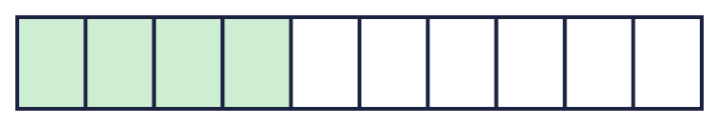  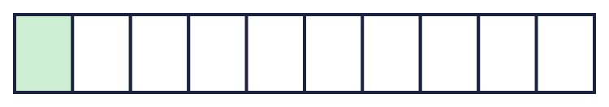
    a)
    b)
  1 | Each bar is split into 10 equal parts. What fraction of each bar is shaded?
    a)
    b)
  2 | How many tenths are shaded? How many tenths are not shaded?  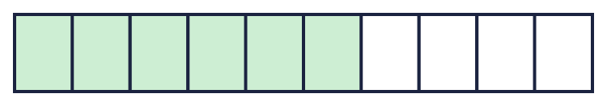  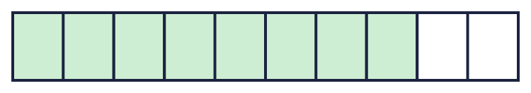
    a) shaded: |  | not shaded:
    b) shaded: |  | not shaded:
  2 | How many tenths are shaded? How many tenths are not shaded?
    a) shaded: |  | not shaded:
    b) shaded: |  | not shaded:
  3 | There are 10 pencils in a pot. 6 of them are green.
    What fraction are green?
    What fraction are not green?
  3 | There are 10 pencils in a pot. 6 of them are green.
    What fraction are green?
    What fraction are not green?
  4 | Count in tenths. Write the missing fractions in order.  ³⁄₁₀, ?, ⁵⁄₁₀, ⁶⁄₁₀, ?, ⁸⁄₁₀
  4 | Count in tenths. Write the missing fractions in order.  ³⁄₁₀, ?, ⁵⁄₁₀, ⁶⁄₁₀, ?, ⁸⁄₁₀
  5 | Write the missing number.
    a) ³⁄₁₀ + |  | /10 = ¹⁰⁄₁₀
    b) ⁶⁄₁₀ + |  | /10 = ¹⁰⁄₁₀
    c) ⁵⁄₁₀ + |  | /10 = ¹⁰⁄₁₀
  5 | Write the missing number.
    a) ³⁄₁₀ + |  | /10 = ¹⁰⁄₁₀
    b) ⁶⁄₁₀ + |  | /10 = ¹⁰⁄₁₀
    c) ⁵⁄₁₀ + |  | /10 = ¹⁰⁄₁₀
  6 | Write < or > in each box.
    a) ³⁄₁₀ |  | ²⁄₁₀
    b) ⁶⁄₁₀ |  | ⁵⁄₁₀
    c) ⁵⁄₁₀ |  | ⁹⁄₁₀
  6 | Write < or > in each box.
    a) ³⁄₁₀ |  | ²⁄₁₀
    b) ⁶⁄₁₀ |  | ⁵⁄₁₀
    c) ⁵⁄₁₀ |  | ⁹⁄₁₀
  7 | Write these fractions in order, starting with the smallest.  ⁴⁄₁₀ ¹⁄₁₀ ⁵⁄₁₀ ⁶⁄₁₀
  7 | Write these fractions in order, starting with the smallest.  ⁴⁄₁₀ ¹⁄₁₀ ⁵⁄₁₀ ⁶⁄₁₀
  8 | Which of these fractions are tenths? Write the letters.  A: ⁹⁄₁₀  B: ⁵⁄₁₀₀  C: ⁹⁄₅  D: ⁸⁄₁₀₀
  8 | Which of these fractions are tenths? Write the letters.  A: ⁹⁄₁₀  B: ⁵⁄₁₀₀  C: ⁹⁄₅  D: ⁸⁄₁₀₀

  9 | Is Dora correct? Circle yes or no.  Yes / No  Explain how you know.
     | 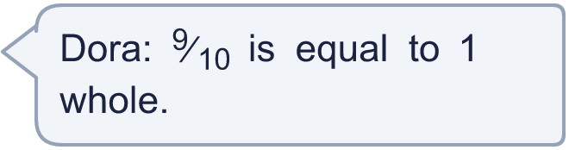
  9 | Is Dora correct? Circle yes or no.  Yes / No  Explain how you know.
  10 | There are 10 coins in a box. ²⁄₁₀ of them are red and ⁴⁄₁₀ of them are blue. The rest are green.
    What fraction are green?
  10 | There are 10 coins in a box. ²⁄₁₀ of them are red and ⁴⁄₁₀ of them are blue. The rest are green.
    What fraction are green?
  11 | ⁶⁄₁₀ of the birds in a picture are red. The whole picture has ¹⁰⁄₁₀ birds.
    What fraction of the birds are not red?
  11 | ⁶⁄₁₀ of the birds in a picture are red. The whole picture has ¹⁰⁄₁₀ birds.
    What fraction of the birds are not red?
  12 | Which of these are equal to 1 whole? Write the letters.  A: ⁹⁄₁₀  B: ¹⁰⁄₁₀  C: 1  D: ¹⁄₁₀
  12 | Which of these are equal to 1 whole? Write the letters.  A: ⁹⁄₁₀  B: ¹⁰⁄₁₀  C: 1  D: ¹⁄₁₀
  13 | Count down in tenths. Write the missing fractions in order.  ⁸⁄₁₀, ⁷⁄₁₀, ?, ⁵⁄₁₀, ?, ³⁄₁₀
  13 | Count down in tenths. Write the missing fractions in order.  ⁸⁄₁₀, ⁷⁄₁₀, ?, ⁵⁄₁₀, ?, ³⁄₁₀
  14 | Challenge  I am thinking of a fraction. It is ⁴⁄₁₀ less than ¹⁰⁄₁₀.
    My fraction is
  14 | Challenge  I am thinking of a fraction. It is ⁴⁄₁₀ less than ¹⁰⁄₁₀.
    My fraction is

Year 4 · Decimals A · Step 1
Tenths as fractions
Answers (teacher copy)

  1 | Each bar is split into 10 equal parts. What fraction of each bar is shaded?  a) ⁴⁄₁₀  b) ¹⁄₁₀
  2 | How many tenths are shaded? How many tenths are not shaded?  a) shaded: 6 not shaded: 4  b) shaded: 8 not shaded: 2
  3 | There are 10 pencils in a pot. 6 of them are green.  What fraction are green? ⁶⁄₁₀  What fraction are not green? ⁴⁄₁₀
  4 | Count in tenths. Write the missing fractions in order.  ³⁄₁₀, ?, ⁵⁄₁₀, ⁶⁄₁₀, ?, ⁸⁄₁₀  ⁴⁄₁₀, ⁷⁄₁₀
  5 | Write the missing number.  a) ³⁄₁₀ + 7 /10 = ¹⁰⁄₁₀  b) ⁶⁄₁₀ + 4 /10 = ¹⁰⁄₁₀  c) ⁵⁄₁₀ + 5 /10 = ¹⁰⁄₁₀
  6 | Write < or > in each box.  a) ³⁄₁₀ > ²⁄₁₀  b) ⁶⁄₁₀ > ⁵⁄₁₀  c) ⁵⁄₁₀ < ⁹⁄₁₀
  7 | Write these fractions in order, starting with the smallest.  ⁴⁄₁₀ ¹⁄₁₀ ⁵⁄₁₀ ⁶⁄₁₀  ¹⁄₁₀, ⁴⁄₁₀, ⁵⁄₁₀, ⁶⁄₁₀
  8 | Which of these fractions are tenths? Write the letters.  A: ⁹⁄₁₀  B: ⁵⁄₁₀₀  C: ⁹⁄₅  D: ⁸⁄₁₀₀  A
  9 | Is Dora correct? Circle yes or no.  Yes / No  Explain how you know.  No. ⁹⁄₁₀ = 0.9 and 1 = 1, so they are not equal.
  10 | There are 10 coins in a box. ²⁄₁₀ of them are red and ⁴⁄₁₀ of them are blue. The rest are green.  What fraction are green? ⁴⁄₁₀
  11 | ⁶⁄₁₀ of the birds in a picture are red. The whole picture has ¹⁰⁄₁₀ birds.  What fraction of the birds are not red? ⁴⁄₁₀
  12 | Which of these are equal to 1 whole? Write the letters.  A: ⁹⁄₁₀  B: ¹⁰⁄₁₀  C: 1  D: ¹⁄₁₀  B, C
  13 | Count down in tenths. Write the missing fractions in order.  ⁸⁄₁₀, ⁷⁄₁₀, ?, ⁵⁄₁₀, ?, ³⁄₁₀  ⁶⁄₁₀, ⁴⁄₁₀
  14 | Challenge  I am thinking of a fraction. It is ⁴⁄₁₀ less than ¹⁰⁄₁₀.  My fraction is ⁶⁄₁₀

