  Year 4 · Decimals A · Step 2  Tenths as decimals | 
  Year 4 · Decimals A · Step 2
  Tenths as decimals
  1 | Each bar is split into 10 equal parts. Write the fraction and the decimal that is shaded.  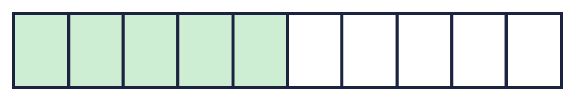  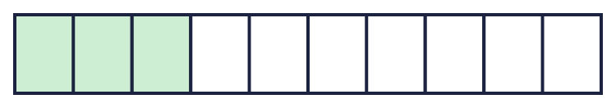
    a) fraction: |  | decimal:
    b) fraction: |  | decimal:
  1 | Each bar is split into 10 equal parts. Write the fraction and the decimal that is shaded.
    a) fraction: |  | decimal:
    b) fraction: |  | decimal:
  2 | Write each fraction as a decimal.
    a) ⁹⁄₁₀ =
    b) ¹⁄₁₀ =
    c) ²⁄₁₀ =
  2 | Write each fraction as a decimal.
    a) ⁹⁄₁₀ =
    b) ¹⁄₁₀ =
    c) ²⁄₁₀ =
  3 | Write each decimal as a fraction.
    a) 0.7 =
    b) 0.1 =
    c) 0.9 =
  3 | Write each decimal as a fraction.
    a) 0.7 =
    b) 0.1 =
    c) 0.9 =
  4 | The number line is split into 10 equal steps. Write the number that each arrow points to.  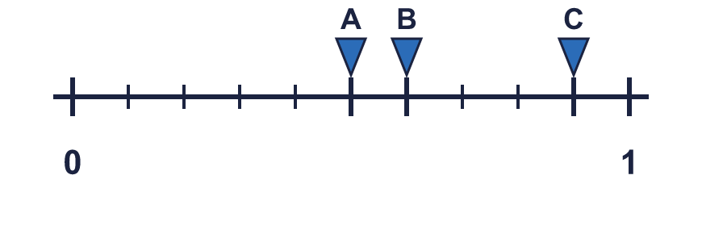
    A = |  | B = |  | C =
  4 | The number line is split into 10 equal steps. Write the number that each arrow points to.
    A = |  | B = |  | C =
  5 | Write each fraction as a decimal.
    a) ²⁴⁄₁₀ =
    b) ²⁶⁄₁₀ =
    c) ³⁹⁄₁₀ =
  5 | Write each fraction as a decimal.
    a) ²⁴⁄₁₀ =
    b) ²⁶⁄₁₀ =
    c) ³⁹⁄₁₀ =
  6 | Count up in tenths. Write the missing numbers in order.  0.1, ?, ?, 0.4, 0.5, 0.6
  6 | Count up in tenths. Write the missing numbers in order.  0.1, ?, ?, 0.4, 0.5, 0.6
  7 | Write <, > or = in each box.
    a) ⁸⁄₁₀ |  | 0.4
    b) ⁵⁄₁₀ |  | 0.9
    c) ³⁄₁₀ |  | 0.8
    d) ⁸⁄₁₀ |  | 0.7
  7 | Write <, > or = in each box.
    a) ⁸⁄₁₀ |  | 0.4
    b) ⁵⁄₁₀ |  | 0.9
    c) ³⁄₁₀ |  | 0.8
    d) ⁸⁄₁₀ |  | 0.7
  8 | Write these in order, starting with the smallest.  0.1 ³⁄₁₀ 0.9 ⁷⁄₁₀
  8 | Write these in order, starting with the smallest.  0.1 ³⁄₁₀ 0.9 ⁷⁄₁₀

  9 | Is Leo correct? Circle yes or no.  Yes / No  Explain how you know.
     | 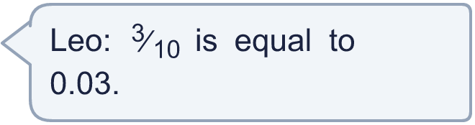
  9 | Is Leo correct? Circle yes or no.  Yes / No  Explain how you know.
  10 | Which of these are equal to 0.7? Write the letters.  A: ³⁄₁₀  B: 0.7  C: ⁷⁄₁₀  D: 0.07
  10 | Which of these are equal to 0.7? Write the letters.  A: ³⁄₁₀  B: 0.7  C: ⁷⁄₁₀  D: 0.07
  11 | Match each fraction to the equal decimal. Write the letter.  A: 0.1 B: 0.7 C: 0.9 D: 0.45
    a) ⁹⁄₁₀ →
    b) ¹⁄₁₀ →
    c) ⁷⁄₁₀ →
  11 | Match each fraction to the equal decimal. Write the letter.  A: 0.1 B: 0.7 C: 0.9 D: 0.45
    a) ⁹⁄₁₀ →
    b) ¹⁄₁₀ →
    c) ⁷⁄₁₀ →
  12 | A jug has 0.4 litre of juice. 0.3 litre more is poured in.
  12 | A jug has 0.4 litre of juice. 0.3 litre more is poured in.
  13 | Write a decimal that is between 0.1 and 0.3.
  13 | Write a decimal that is between 0.1 and 0.3.
  14 | Challenge  How many tenths (0.1) make 2.4?
  14 | Challenge  How many tenths (0.1) make 2.4?

Year 4 · Decimals A · Step 2
Tenths as decimals
Answers (teacher copy)

  1 | Each bar is split into 10 equal parts. Write the fraction and the decimal that is shaded.  a) fraction: ⁵⁄₁₀ decimal: 0.5  b) fraction: ³⁄₁₀ decimal: 0.3
  2 | Write each fraction as a decimal.  a) ⁹⁄₁₀ = 0.9  b) ¹⁄₁₀ = 0.1  c) ²⁄₁₀ = 0.2
  3 | Write each decimal as a fraction.  a) 0.7 = ⁷⁄₁₀  b) 0.1 = ¹⁄₁₀  c) 0.9 = ⁹⁄₁₀
  4 | The number line is split into 10 equal steps. Write the number that each arrow points to.  A = 0.5 B = 0.6 C = 0.9
  5 | Write each fraction as a decimal.  a) ²⁴⁄₁₀ = 2.4  b) ²⁶⁄₁₀ = 2.6  c) ³⁹⁄₁₀ = 3.9
  6 | Count up in tenths. Write the missing numbers in order.  0.1, ?, ?, 0.4, 0.5, 0.6  0.2, 0.3
  7 | Write <, > or = in each box.  a) ⁸⁄₁₀ > 0.4  b) ⁵⁄₁₀ < 0.9  c) ³⁄₁₀ < 0.8  d) ⁸⁄₁₀ > 0.7
  8 | Write these in order, starting with the smallest.  0.1 ³⁄₁₀ 0.9 ⁷⁄₁₀  0.1, ³⁄₁₀, ⁷⁄₁₀, 0.9
  9 | Is Leo correct? Circle yes or no.  Yes / No  Explain how you know.  No. ³⁄₁₀ = 0.3 and 0.03 = 0.03, so they are not equal.
  10 | Which of these are equal to 0.7? Write the letters.  A: ³⁄₁₀  B: 0.7  C: ⁷⁄₁₀  D: 0.07  B, C
  11 | Match each fraction to the equal decimal. Write the letter.  A: 0.1 B: 0.7 C: 0.9 D: 0.45  a) ⁹⁄₁₀ → C  b) ¹⁄₁₀ → A  c) ⁷⁄₁₀ → B
  12 | A jug has 0.4 litre of juice. 0.3 litre more is poured in.  How much is in the jug now? 0.7 litre
  13 | Write a decimal that is between 0.1 and 0.3.  0.2
  14 | Challenge  How many tenths (0.1) make 2.4?  24

