  Year 4 · Decimals A · Step 9  Hundredths on a place value chart | 
  Year 4 · Decimals A · Step 9
  Hundredths on a place value chart
  1 | Write the number shown on each place value chart.  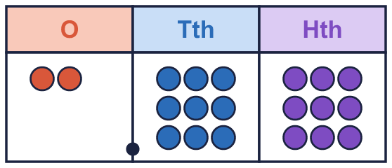  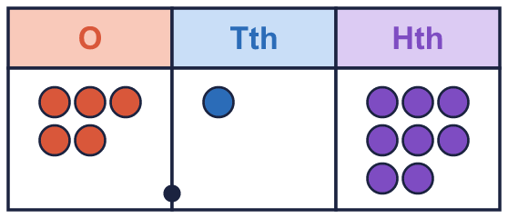
    a) The number is
    b) The number is
  1 | Write the number shown on each place value chart.
    a) The number is
    b) The number is
  2 | Use counters to make each number. Write how many counters go in each column.  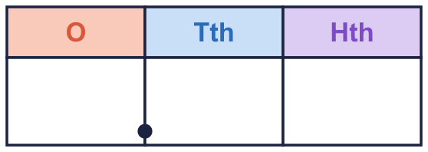
    a) 2.78:
  2 | Use counters to make each number. Write how many counters go in each column.
    a) 2.78:
  3 | What is the value of the digit in each number?
    a) the digit 5 in 3.95:
    b) the digit 8 in 1.87:
    c) the digit 4 in 9.48:
  3 | What is the value of the digit in each number?
    a) the digit 5 in 3.95:
    b) the digit 8 in 1.87:
    c) the digit 4 in 9.48:
  4 | Write each number as a decimal.
    a) 2 ones, 4 tenths and 2 hundredths:
    b) 4 ones and 2 tenths:
  4 | Write each number as a decimal.
    a) 2 ones, 4 tenths and 2 hundredths:
    b) 4 ones and 2 tenths:
  5 | Write the missing number.
    a) 0.53 = 0.5 +
    b) 0.22 = 0.2 +
  5 | Write the missing number.
    a) 0.53 = 0.5 +
    b) 0.22 = 0.2 +
  6 | Write each number as one decimal.
    a) 6 + 0.3 + 0.04 =
    b) 7 + 0.5 + 0.09 =
    c) 2 + 0.8 + 0.06 =
  6 | Write each number as one decimal.
    a) 6 + 0.3 + 0.04 =
    b) 7 + 0.5 + 0.09 =
    c) 2 + 0.8 + 0.06 =
  7 | Boba has 81 hundredths counters. What number do the counters show?
  7 | Boba has 81 hundredths counters. What number do the counters show?
  8 | Write < or > in each box.
    a) 0.52 |  | 0.69
    b) 0.32 |  | 0.14
    c) 0.18 |  | 0.34
    d) 0.66 |  | 0.76
  8 | Write < or > in each box.
    a) 0.52 |  | 0.69
    b) 0.32 |  | 0.14
    c) 0.18 |  | 0.34
    d) 0.66 |  | 0.76

  9 | 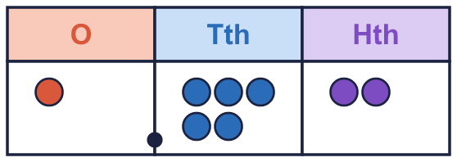  Is Nina correct? Circle yes or no.  Yes / No  Explain how you know.
     | 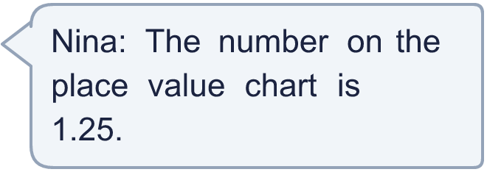
  9 | Is Nina correct? Circle yes or no.  Yes / No  Explain how you know.
  10 | She uses all three cards to make a number with 2 decimal places, like _.__ Write the largest number she can make.
    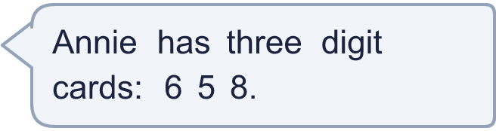
  10 | She uses all three cards to make a number with 2 decimal places, like _.__ Write the largest number she can make.
  11 | Write the missing number.
    a) 0.1 + |  | + 0.09 = 0.27
  11 | Write the missing number.
    a) 0.1 + |  | + 0.09 = 0.27
  12 | Which of these are equal to 0.60? Write the letters.  A: 0.5 + 0.1  B: 0.6  C: ⁶⁄₁₀  D: 0.06
  12 | Which of these are equal to 0.60? Write the letters.  A: 0.5 + 0.1  B: 0.6  C: ⁶⁄₁₀  D: 0.06
  13 | Write a decimal with 2 decimal places that is between 2.7 and 2.8.
  13 | Write a decimal with 2 decimal places that is between 2.7 and 2.8.
  14 | Is Eva correct? Circle yes or no.  Yes / No  Explain how you know.
     | 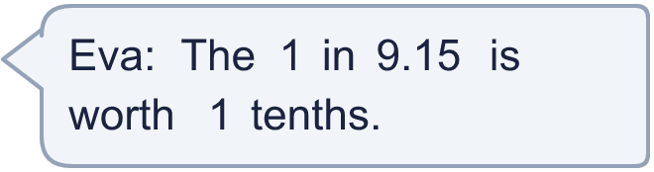
  14 | Is Eva correct? Circle yes or no.  Yes / No  Explain how you know.

Year 4 · Decimals A · Step 9
Hundredths on a place value chart
Answers (teacher copy)

  1 | Write the number shown on each place value chart.  a) The number is 2.99  b) The number is 5.18
  2 | Use counters to make each number. Write how many counters go in each column.  a) 2.78: 2 7 8
  3 | What is the value of the digit in each number?  a) the digit 5 in 3.95: 0.05  b) the digit 8 in 1.87: 0.8  c) the digit 4 in 9.48: 0.4
  4 | Write each number as a decimal.  a) 2 ones, 4 tenths and 2 hundredths: 2.42  b) 4 ones and 2 tenths: 4.2
  5 | Write the missing number.  a) 0.53 = 0.5 + 0.03  b) 0.22 = 0.2 + 0.02
  6 | Write each number as one decimal.  a) 6 + 0.3 + 0.04 = 6.34  b) 7 + 0.5 + 0.09 = 7.59  c) 2 + 0.8 + 0.06 = 2.86
  7 | Boba has 81 hundredths counters. What number do the counters show?  0.81
  8 | Write < or > in each box.  a) 0.52 < 0.69  b) 0.32 > 0.14  c) 0.18 < 0.34  d) 0.66 < 0.76
  9 | Is Nina correct? Circle yes or no.  Yes / No  Explain how you know.  No. The chart shows 1 one, 5 tenths and 2 hundredths, so the number is 1.52.
  10 | She uses all three cards to make a number with 2 decimal places, like _.__ Write the largest number she can make.  8.65
  11 | Write the missing number.  a) 0.1 + 0.08 + 0.09 = 0.27
  12 | Which of these are equal to 0.60? Write the letters.  A: 0.5 + 0.1  B: 0.6  C: ⁶⁄₁₀  D: 0.06  A, B, C
  13 | Write a decimal with 2 decimal places that is between 2.7 and 2.8.  2.75
  14 | Is Eva correct? Circle yes or no.  Yes / No  Explain how you know.  Yes. In 9.15 the 1 is in the tenths column, so it is worth 1 tenth.

