  Year 4 · Decimals A · Step 8  Hundredths as decimals | 
  Year 4 · Decimals A · Step 8
  Hundredths as decimals
  1 | The hundred square is 1 whole. Write the fraction and the decimal that is shaded.  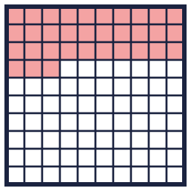
    a) fraction: |  | decimal:
  1 | The hundred square is 1 whole. Write the fraction and the decimal that is shaded.
    a) fraction: |  | decimal:
  2 | Write each fraction as a decimal.
    a) ⁶³⁄₁₀₀ =
    b) ³¹⁄₁₀₀ =
  2 | Write each fraction as a decimal.
    a) ⁶³⁄₁₀₀ =
    b) ³¹⁄₁₀₀ =
  3 | Write each decimal as a fraction.
    a) 0.41 =
    b) 0.47 =
    c) 0.83 =
  3 | Write each decimal as a fraction.
    a) 0.41 =
    b) 0.47 =
    c) 0.83 =
  4 | Write each number as a decimal.
    a) thirteen hundredths:
    b) twenty-six hundredths:
  4 | Write each number as a decimal.
    a) thirteen hundredths:
    b) twenty-six hundredths:
  5 | Write each number as a decimal.
    a) 4 tenths and 7 hundredths:
    b) 7 tenths and 8 hundredths:
  5 | Write each number as a decimal.
    a) 4 tenths and 7 hundredths:
    b) 7 tenths and 8 hundredths:
  6 | Write the missing number.
    a) 0.39 = 0.3 +
    b) 0.79 = 0.7 +
  6 | Write the missing number.
    a) 0.39 = 0.3 +
    b) 0.79 = 0.7 +
  7 | Write < or > in each box.
    a) 0.42 |  | 0.98
    b) 0.18 |  | 0.87
    c) 0.89 |  | 0.83
  7 | Write < or > in each box.
    a) 0.42 |  | 0.98
    b) 0.18 |  | 0.87
    c) 0.89 |  | 0.83
  8 | Match each fraction to the equal decimal. Write the letter.  A: 0.07 B: 0.09 C: 0.57 D: 0.37
    a) ³⁷⁄₁₀₀ →
    b) ⁷⁄₁₀₀ →
    c) ⁹⁄₁₀₀ →
  8 | Match each fraction to the equal decimal. Write the letter.  A: 0.07 B: 0.09 C: 0.57 D: 0.37
    a) ³⁷⁄₁₀₀ →
    b) ⁷⁄₁₀₀ →
    c) ⁹⁄₁₀₀ →

  9 | 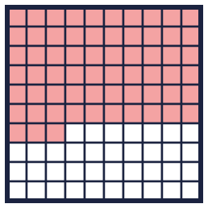  Is Eva correct? Circle yes or no.  Yes / No  Explain how you know.
     | 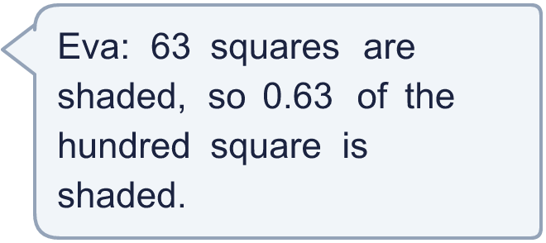
  9 | Is Eva correct? Circle yes or no.  Yes / No  Explain how you know.
  10 | Which of these are equal to ²³⁄_{100?} Write the letters.  A: 0.23  B: 0.2 + 0.03  C: ²³⁄₁₀₀  D: 2.3
  10 | Which of these are equal to ²³⁄_{100?} Write the letters.  A: 0.23  B: 0.2 + 0.03  C: ²³⁄₁₀₀  D: 2.3
  11 | Write the missing number.
    a) ²⁄₁₀ = |  | /100
    b) ¹⁄₁₀ = |  | /100
    c) ⁴⁄₁₀ = |  | /100
  11 | Write the missing number.
    a) ²⁄₁₀ = |  | /100
    b) ¹⁄₁₀ = |  | /100
    c) ⁴⁄₁₀ = |  | /100
  12 | Boba has 0.3 litre of juice. Eva adds 0.04 litre more.
  12 | Boba has 0.3 litre of juice. Eva adds 0.04 litre more.
  13 | Is Zach correct? Circle yes or no.  Yes / No  Explain how you know.
     | 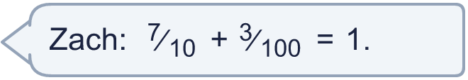
  13 | Is Zach correct? Circle yes or no.  Yes / No  Explain how you know.
  14 | Challenge  How many hundredths (0.01) make 0.8?
  14 | Challenge  How many hundredths (0.01) make 0.8?

Year 4 · Decimals A · Step 8
Hundredths as decimals
Answers (teacher copy)

  1 | The hundred square is 1 whole. Write the fraction and the decimal that is shaded.  a) fraction: ³³⁄₁₀₀ decimal: 0.33
  2 | Write each fraction as a decimal.  a) ⁶³⁄₁₀₀ = 0.63  b) ³¹⁄₁₀₀ = 0.31
  3 | Write each decimal as a fraction.  a) 0.41 = ⁴¹⁄₁₀₀  b) 0.47 = ⁴⁷⁄₁₀₀  c) 0.83 = ⁸³⁄₁₀₀
  4 | Write each number as a decimal.  a) thirteen hundredths: 0.13  b) twenty-six hundredths: 0.26
  5 | Write each number as a decimal.  a) 4 tenths and 7 hundredths: 0.47  b) 7 tenths and 8 hundredths: 0.78
  6 | Write the missing number.  a) 0.39 = 0.3 + 0.09  b) 0.79 = 0.7 + 0.09
  7 | Write < or > in each box.  a) 0.42 < 0.98  b) 0.18 < 0.87  c) 0.89 > 0.83
  8 | Match each fraction to the equal decimal. Write the letter.  A: 0.07 B: 0.09 C: 0.57 D: 0.37  a) ³⁷⁄₁₀₀ → D  b) ⁷⁄₁₀₀ → A  c) ⁹⁄₁₀₀ → B
  9 | Is Eva correct? Circle yes or no.  Yes / No  Explain how you know.  Yes. 63 squares out of 100 are shaded. That is ⁶³⁄₁₀₀, which is 0.63.
  10 | Which of these are equal to ²³⁄_{100?} Write the letters.  A: 0.23  B: 0.2 + 0.03  C: ²³⁄₁₀₀  D: 2.3  A, B, C
  11 | Write the missing number.  a) ²⁄₁₀ = 20 /100  b) ¹⁄₁₀ = 10 /100  c) ⁴⁄₁₀ = 40 /100
  12 | Boba has 0.3 litre of juice. Eva adds 0.04 litre more.  How much juice is there now? 0.34 litre
  13 | Is Zach correct? Circle yes or no.  Yes / No  Explain how you know.  No. ⁷⁄₁₀ + ³⁄₁₀₀ = 0.73 and 1 = 1, so they are not equal.
  14 | Challenge  How many hundredths (0.01) make 0.8?  80

