  Year 4 · Decimals A · Step 6  Divide a 2-digit number by 10 | 
  Year 4 · Decimals A · Step 6
  Divide a 2-digit number by 10
  1 | Each place value chart shows a number. Divide the number by 10. Write the answer.  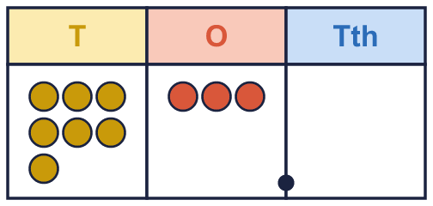  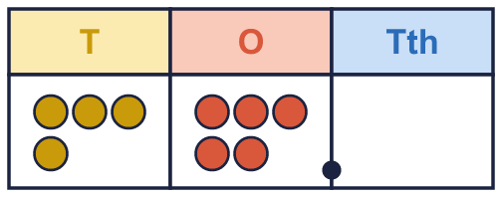
    a) the number ÷ 10 =
    b) the number ÷ 10 =
  1 | Each place value chart shows a number. Divide the number by 10. Write the answer.
    a) the number ÷ 10 =
    b) the number ÷ 10 =
  2 | Work out each division.
    a) 65 ÷ 10 =
    b) 20 ÷ 10 =
    c) 62 ÷ 10 =
    d) 79 ÷ 10 =
  2 | Work out each division.
    a) 65 ÷ 10 =
    b) 20 ÷ 10 =
    c) 62 ÷ 10 =
    d) 79 ÷ 10 =
  3 | 88 litres of juice are shared equally into 10 boxes.
  3 | 88 litres of juice are shared equally into 10 boxes.
  4 | Write the missing number.
    a) |  | ÷ 10 = 4.3
    b) |  | ÷ 10 = 5.4
    c) |  | ÷ 10 = 5.6
  4 | Write the missing number.
    a) |  | ÷ 10 = 4.3
    b) |  | ÷ 10 = 5.4
    c) |  | ÷ 10 = 5.6
  5 | Each place value chart shows a number. Divide the number by 10. Write the answer.  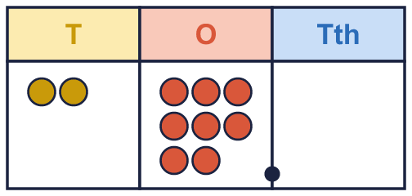  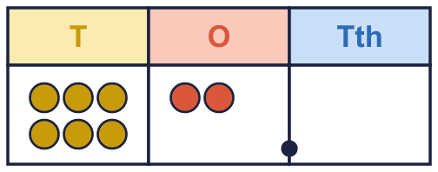
    a) the number ÷ 10 =
    b) the number ÷ 10 =
  5 | Each place value chart shows a number. Divide the number by 10. Write the answer.
    a) the number ÷ 10 =
    b) the number ÷ 10 =
  6 | Write <, > or = in each box.
    a) 68 ÷ 10 |  | 3.4
    b) 97 ÷ 10 |  | 7.8
    c) 33 ÷ 10 |  | 1.4
  6 | Write <, > or = in each box.
    a) 68 ÷ 10 |  | 3.4
    b) 97 ÷ 10 |  | 7.8
    c) 33 ÷ 10 |  | 1.4
  7 | Write these in order, starting with the smallest.  31 ÷ 10 2.9 62 ÷ 10 1.2
  7 | Write these in order, starting with the smallest.  31 ÷ 10 2.9 62 ÷ 10 1.2
  8 | There are 10 mm in 1 cm. A snail is 63 mm long.  How long is the snail in centimetres? cm
  8 | There are 10 mm in 1 cm. A snail is 63 mm long.  How long is the snail in centimetres? cm

  9 | Is Dora correct? Circle yes or no.  Yes / No  Explain how you know.
     | 
  9 | Is Dora correct? Circle yes or no.  Yes / No  Explain how you know.
  10 | Ron works out 95 ÷ 10.  Is Boba correct? Circle yes or no.  Yes / No  Explain the mistake. Then write the correct answer.
    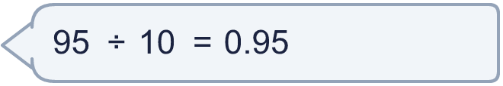
  10 | Ron works out 95 ÷ 10.  Is Boba correct? Circle yes or no.  Yes / No  Explain the mistake. Then write the correct answer.
  11 | Work out each answer. Do the bracket first.
    a) (80 + 7) ÷ 10 =
    b) (30 + 5) ÷ 10 =
  11 | Work out each answer. Do the bracket first.
    a) (80 + 7) ÷ 10 =
    b) (30 + 5) ÷ 10 =
  12 | Which of these are equal to 7.7? Write the letters.  A: 77 ÷ 10  B: 77 ÷ 100  C: 770 ÷ 100  D: 770 ÷ 100
  12 | Which of these are equal to 7.7? Write the letters.  A: 77 ÷ 10  B: 77 ÷ 100  C: 770 ÷ 100  D: 770 ÷ 100
  13 | Work out 46 ÷ 10 and 32 ÷ 10, then add the answers.
    46 ÷ 10 + 32 ÷ 10 =
  13 | Work out 46 ÷ 10 and 32 ÷ 10, then add the answers.
    46 ÷ 10 + 32 ÷ 10 =
  14 | Challenge  I am thinking of a 2-digit number. When I divide it by 10 the answer is 8.9.
    My number is
  14 | Challenge  I am thinking of a 2-digit number. When I divide it by 10 the answer is 8.9.
    My number is

Year 4 · Decimals A · Step 6
Divide a 2-digit number by 10
Answers (teacher copy)

  1 | Each place value chart shows a number. Divide the number by 10. Write the answer.  a) the number ÷ 10 = 7.3  b) the number ÷ 10 = 4.5
  2 | Work out each division.  a) 65 ÷ 10 = 6.5  b) 20 ÷ 10 = 2  c) 62 ÷ 10 = 6.2  d) 79 ÷ 10 = 7.9
  3 | 88 litres of juice are shared equally into 10 boxes.  How much is in each box? 8.8
  4 | Write the missing number.  a) 43 ÷ 10 = 4.3  b) 54 ÷ 10 = 5.4  c) 56 ÷ 10 = 5.6
  5 | Each place value chart shows a number. Divide the number by 10. Write the answer.  a) the number ÷ 10 = 2.8  b) the number ÷ 10 = 6.2
  6 | Write <, > or = in each box.  a) 68 ÷ 10 > 3.4  b) 97 ÷ 10 > 7.8  c) 33 ÷ 10 > 1.4
  7 | Write these in order, starting with the smallest.  31 ÷ 10 2.9 62 ÷ 10 1.2  1.2, 2.9, 31 ÷ 10, 62 ÷ 10
  8 | There are 10 mm in 1 cm. A snail is 63 mm long.  How long is the snail in centimetres? 6.3 cm
  9 | Is Dora correct? Circle yes or no.  Yes / No  Explain how you know.  Yes. 97 ÷ 10 = 9.7 and 9.7 = 9.7, so they are equal.
  10 | Ron works out 95 ÷ 10.  Is Boba correct? Circle yes or no.  Yes / No  Explain the mistake. Then write the correct answer.  No. Every digit moves 1 place to the right, not 2. 95 ÷ 10 = 9.5. The correct answer is 9.5.  9.5
  11 | Work out each answer. Do the bracket first.  a) (80 + 7) ÷ 10 = 8.7  b) (30 + 5) ÷ 10 = 3.5
  12 | Which of these are equal to 7.7? Write the letters.  A: 77 ÷ 10  B: 77 ÷ 100  C: 770 ÷ 100  D: 770 ÷ 100  A, C, D
  13 | Work out 46 ÷ 10 and 32 ÷ 10, then add the answers.  46 ÷ 10 + 32 ÷ 10 = 7.8
  14 | Challenge  I am thinking of a 2-digit number. When I divide it by 10 the answer is 8.9.  My number is 89

