  Year 4 · Decimals A · Step 10  Divide a 1- or 2-digit number by 100 | 
  Year 4 · Decimals A · Step 10
  Divide a 1- or 2-digit number by 100
  1 | Each place value chart shows a number. Divide the number by 100. Write the answer.  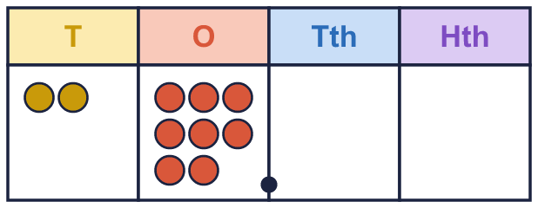
    a) the number ÷ 100 =
  1 | Each place value chart shows a number. Divide the number by 100. Write the answer.
    a) the number ÷ 100 =
  2 | Work out each division.
    a) 5 ÷ 100 =
    b) 60 ÷ 100 =
    c) 43 ÷ 100 =
    d) 68 ÷ 100 =
  2 | Work out each division.
    a) 5 ÷ 100 =
    b) 60 ÷ 100 =
    c) 43 ÷ 100 =
    d) 68 ÷ 100 =
  3 | Divide by 10 and then by 10 again. What do you notice about 4 ÷ 100?
    a) 4 ÷ 10 =
    b) 0.4 ÷ 10 =
    c) 4 ÷ 100 =
  3 | Divide by 10 and then by 10 again. What do you notice about 4 ÷ 100?
    a) 4 ÷ 10 =
    b) 0.4 ÷ 10 =
    c) 4 ÷ 100 =
  4 | Write the missing number.
    a) |  | ÷ 100 = 0.09
    b) |  | ÷ 100 = 0.13
    c) |  | ÷ 100 = 0.04
  4 | Write the missing number.
    a) |  | ÷ 100 = 0.09
    b) |  | ÷ 100 = 0.13
    c) |  | ÷ 100 = 0.04
  5 | Each place value chart shows a number. Divide the number by 100. Write the answer.  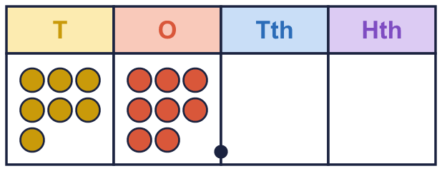
    a) the number ÷ 100 =
  5 | Each place value chart shows a number. Divide the number by 100. Write the answer.
    a) the number ÷ 100 =
  6 | Work out each division.
    a) 4 ÷ 100 =
    b) 31 ÷ 100 =
    c) 31 ÷ 100 =
  6 | Work out each division.
    a) 4 ÷ 100 =
    b) 31 ÷ 100 =
    c) 31 ÷ 100 =
  7 | Write <, > or = in each box.
    a) 64 ÷ 100 |  | 0.27
    b) 66 ÷ 100 |  | 0.23
    c) 67 ÷ 100 |  | 0.9
  7 | Write <, > or = in each box.
    a) 64 ÷ 100 |  | 0.27
    b) 66 ÷ 100 |  | 0.23
    c) 67 ÷ 100 |  | 0.9
  8 | There are 100 cm in 1 m. A rope is 97 cm long.  How long is the rope in metres? m
  8 | There are 100 cm in 1 m. A rope is 97 cm long.  How long is the rope in metres? m

  9 | Is Nina correct? Circle yes or no.  Yes / No  Explain how you know.
     | 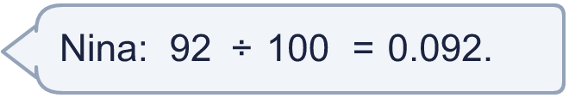
  9 | Is Nina correct? Circle yes or no.  Yes / No  Explain how you know.
  10 | Tiny works out 58 ÷ 100.  Is Boba correct? Circle yes or no.  Yes / No  Explain the mistake. Then write the correct answer.
    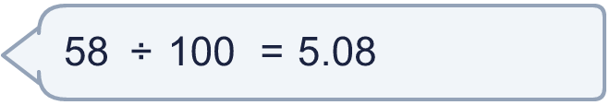
  10 | Tiny works out 58 ÷ 100.  Is Boba correct? Circle yes or no.  Yes / No  Explain the mistake. Then write the correct answer.
  11 | Which of these are equal to 0.97? Write the letters.  A: 97 ÷ 10  B: 97 ÷ 100  C: 9.7 ÷ 10  D: 970 ÷ 1,000
  11 | Which of these are equal to 0.97? Write the letters.  A: 97 ÷ 10  B: 97 ÷ 100  C: 9.7 ÷ 10  D: 970 ÷ 1,000
  12 | Complete the calculation.
    3 × 2 ÷ 100 =
  12 | Complete the calculation.
    3 × 2 ÷ 100 =
  13 | Work out 97 ÷ 100 and 13 ÷ 100, then add the answers.
    97 ÷ 100 + 13 ÷ 100 =
  13 | Work out 97 ÷ 100 and 13 ÷ 100, then add the answers.
    97 ÷ 100 + 13 ÷ 100 =
  14 | Challenge  I am thinking of a 2-digit number. When I divide it by 100 the answer is 0.57.
    My number is
  14 | Challenge  I am thinking of a 2-digit number. When I divide it by 100 the answer is 0.57.
    My number is

Year 4 · Decimals A · Step 10
Divide a 1- or 2-digit number by 100
Answers (teacher copy)

  1 | Each place value chart shows a number. Divide the number by 100. Write the answer.  a) the number ÷ 100 = 0.28
  2 | Work out each division.  a) 5 ÷ 100 = 0.05  b) 60 ÷ 100 = 0.6  c) 43 ÷ 100 = 0.43  d) 68 ÷ 100 = 0.68
  3 | Divide by 10 and then by 10 again. What do you notice about 4 ÷ 100?  a) 4 ÷ 10 = 0.4  b) 0.4 ÷ 10 = 0.04  c) 4 ÷ 100 = 0.04
  4 | Write the missing number.  a) 9 ÷ 100 = 0.09  b) 13 ÷ 100 = 0.13  c) 4 ÷ 100 = 0.04
  5 | Each place value chart shows a number. Divide the number by 100. Write the answer.  a) the number ÷ 100 = 0.78
  6 | Work out each division.  a) 4 ÷ 100 = 0.04  b) 31 ÷ 100 = 0.31  c) 31 ÷ 100 = 0.31
  7 | Write <, > or = in each box.  a) 64 ÷ 100 > 0.27  b) 66 ÷ 100 > 0.23  c) 67 ÷ 100 < 0.9
  8 | There are 100 cm in 1 m. A rope is 97 cm long.  How long is the rope in metres? 0.97 m
  9 | Is Nina correct? Circle yes or no.  Yes / No  Explain how you know.  No. 92 ÷ 100 = 0.92 and 0.092 = 0.092, so they are not equal.
  10 | Tiny works out 58 ÷ 100.  Is Boba correct? Circle yes or no.  Yes / No  Explain the mistake. Then write the correct answer.  No. To divide by 100 every digit moves 2 places to the right, so the digits stay in the same order. 58 ÷ 100 = 0.58. The correct answer is 0.58.  0.58
  11 | Which of these are equal to 0.97? Write the letters.  A: 97 ÷ 10  B: 97 ÷ 100  C: 9.7 ÷ 10  D: 970 ÷ 1,000  B, C, D
  12 | Complete the calculation.  3 × 2 ÷ 100 = 0.06
  13 | Work out 97 ÷ 100 and 13 ÷ 100, then add the answers.  97 ÷ 100 + 13 ÷ 100 = 1.1
  14 | Challenge  I am thinking of a 2-digit number. When I divide it by 100 the answer is 0.57.  My number is 57

