  Year 4 · Decimals A · Step 5  Divide a 1-digit number by 10 | 
  Year 4 · Decimals A · Step 5
  Divide a 1-digit number by 10
  1 | Each place value chart shows a number. Divide the number by 10. Write the answer.  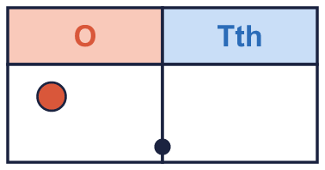  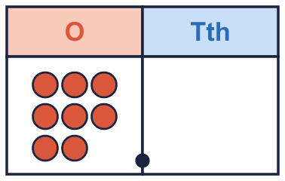
    a) the number ÷ 10 =
    b) the number ÷ 10 =
  1 | Each place value chart shows a number. Divide the number by 10. Write the answer.
    a) the number ÷ 10 =
    b) the number ÷ 10 =
  2 | Work out each division.
    a) 3 ÷ 10 =
    b) 7 ÷ 10 =
    c) 6 ÷ 10 =
    d) 1 ÷ 10 =
  2 | Work out each division.
    a) 3 ÷ 10 =
    b) 7 ÷ 10 =
    c) 6 ÷ 10 =
    d) 1 ÷ 10 =
  3 | 8 ones divided by ten is equal to 8 tenths. Write this as a decimal.
    8 ÷ 10 =
  3 | 8 ones divided by ten is equal to 8 tenths. Write this as a decimal.
    8 ÷ 10 =
  4 | Write the missing number.
    a) |  | ÷ 10 = 0.7
    b) |  | ÷ 10 = 0.8
    c) |  | ÷ 10 = 0.5
  4 | Write the missing number.
    a) |  | ÷ 10 = 0.7
    b) |  | ÷ 10 = 0.8
    c) |  | ÷ 10 = 0.5
  5 | Each place value chart shows a number. Divide the number by 10. Write the answer.
    a) the number ÷ 10 =
  5 | Each place value chart shows a number. Divide the number by 10. Write the answer.
    a) the number ÷ 10 =
  6 | Work out each division. What do you notice?
    a) 1 ÷ 10 =
    b) 10 ÷ 10 =
  6 | Work out each division. What do you notice?
    a) 1 ÷ 10 =
    b) 10 ÷ 10 =
  7 | Write <, > or = in each box.
    a) 9 ÷ 10 |  | 1 ÷ 10
    b) 7 ÷ 10 |  | 1 ÷ 10
    c) 9 ÷ 10 |  | 6 ÷ 10
  7 | Write <, > or = in each box.
    a) 9 ÷ 10 |  | 1 ÷ 10
    b) 7 ÷ 10 |  | 1 ÷ 10
    c) 9 ÷ 10 |  | 6 ÷ 10
  8 | 8 kilograms are shared equally between 10 people.  How many does each person get? kilograms
  8 | 8 kilograms are shared equally between 10 people.  How many does each person get? kilograms

  9 | Is Dora correct? Circle yes or no.  Yes / No  Explain how you know.
     | 
  9 | Is Dora correct? Circle yes or no.  Yes / No  Explain how you know.
  10 | Eva works out 7 ÷ 10.  Is Boba correct? Circle yes or no.  Yes / No  Explain the mistake. Then write the correct answer.
    
  10 | Eva works out 7 ÷ 10.  Is Boba correct? Circle yes or no.  Yes / No  Explain the mistake. Then write the correct answer.
  11 | Dora puts ones counters on a place value chart. Then Dora divides the number by 10 by moving every counter 1 column to the right.  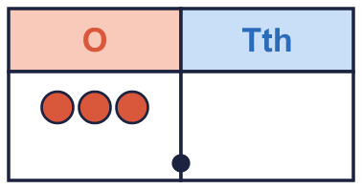
  11 | Dora puts ones counters on a place value chart. Then Dora divides the number by 10 by moving every counter 1 column to the right.
  12 | Which of these are equal to 0.8? Write the letters.  A: 0.8  B: 80 ÷ 100  C: 8 ÷ 10  D: 8 ÷ 100
  12 | Which of these are equal to 0.8? Write the letters.  A: 0.8  B: 80 ÷ 100  C: 8 ÷ 10  D: 8 ÷ 100
  13 | Complete the number sentence.
    2 × 3 ÷ 10 =
  13 | Complete the number sentence.
    2 × 3 ÷ 10 =
  14 | Challenge  Boba is thinking of a 1-digit number. When Boba divides it by 10 the answer is 0.5.
    Boba's number is
  14 | Challenge  Boba is thinking of a 1-digit number. When Boba divides it by 10 the answer is 0.5.
    Boba's number is

Year 4 · Decimals A · Step 5
Divide a 1-digit number by 10
Answers (teacher copy)

  1 | Each place value chart shows a number. Divide the number by 10. Write the answer.  a) the number ÷ 10 = 0.1  b) the number ÷ 10 = 0.8
  2 | Work out each division.  a) 3 ÷ 10 = 0.3  b) 7 ÷ 10 = 0.7  c) 6 ÷ 10 = 0.6  d) 1 ÷ 10 = 0.1
  3 | 8 ones divided by ten is equal to 8 tenths. Write this as a decimal.  8 ÷ 10 = 0.8
  4 | Write the missing number.  a) 7 ÷ 10 = 0.7  b) 8 ÷ 10 = 0.8  c) 5 ÷ 10 = 0.5
  5 | Each place value chart shows a number. Divide the number by 10. Write the answer.  a) the number ÷ 10 = 0.1
  6 | Work out each division. What do you notice?  a) 1 ÷ 10 = 0.1  b) 10 ÷ 10 = 1
  7 | Write <, > or = in each box.  a) 9 ÷ 10 > 1 ÷ 10  b) 7 ÷ 10 > 1 ÷ 10  c) 9 ÷ 10 > 6 ÷ 10
  8 | 8 kilograms are shared equally between 10 people.  How many does each person get? 0.8 kilograms
  9 | Is Dora correct? Circle yes or no.  Yes / No  Explain how you know.  No. 2 ÷ 10 = 0.2 and 0.3 = 0.3, so they are not equal.
  10 | Eva works out 7 ÷ 10.  Is Boba correct? Circle yes or no.  Yes / No  Explain the mistake. Then write the correct answer.  No. Dividing makes a number smaller. Tiny made it ten times bigger. 7 ÷ 10 = 0.7. The correct answer is 0.7.  0.7
  11 | Dora puts ones counters on a place value chart. Then Dora divides the number by 10 by moving every counter 1 column to the right.  Write the new number: 0.3
  12 | Which of these are equal to 0.8? Write the letters.  A: 0.8  B: 80 ÷ 100  C: 8 ÷ 10  D: 8 ÷ 100  A, B, C
  13 | Complete the number sentence.  2 × 3 ÷ 10 = 0.6
  14 | Challenge  Boba is thinking of a 1-digit number. When Boba divides it by 10 the answer is 0.5.  Boba's number is 5

