  Year 4 · Place value · Step 4  Thousands | 
  Year 4 · Place value · Step 4
  Thousands
  1 | Count up in thousands. Write the missing numbers.
    1,000, |  | , | 3,000, | 4,000,
  1 | Count up in thousands. Write the missing numbers.
    1,000, |  | , | 3,000, | 4,000,
  2 | Write each as a number.  a) 9 thousands =  b) 2 thousands =  c) 3 thousands =
  2 | Write each as a number.  a) 9 thousands =  b) 2 thousands =  c) 3 thousands =
  3 | Write each number in numerals or in words.  a) 9,000 =  b) 6,000 =  c) five thousand =
  3 | Write each number in numerals or in words.  a) 9,000 =  b) 6,000 =  c) five thousand =
  4 | Eva starts at zero and counts up in 1,000s. Which of these numbers does she say? Write the letters.  a) 9,100  b) 9,000  c) 7,000  d) 1,500  e) 4,000  f) 700  g) 2,500  h) 1,000
  4 | Eva starts at zero and counts up in 1,000s. Which of these numbers does she say? Write the letters.  a) 9,100  b) 9,000  c) 7,000  d) 1,500  e) 4,000  f) 700  g) 2,500  h) 1,000
  5 | Complete the sentences.  b) 70 hundreds =
    a) | 8,000 = |  | hundreds
    c) | 3,000 = |  | hundreds
  5 | Complete the sentences.  b) 70 hundreds =
    a) | 8,000 = |  | hundreds
    c) | 3,000 = |  | hundreds
  6 | Count back in thousands. Write the missing numbers.
    8,000, |  | , | 6,000, |  | , | 4,000
  6 | Count back in thousands. Write the missing numbers.
    8,000, |  | , | 6,000, |  | , | 4,000
  7 | a) How many points does Dexter have?  b) Amir has 2 fewer stickers than Dexter. How many points does Amir have?
    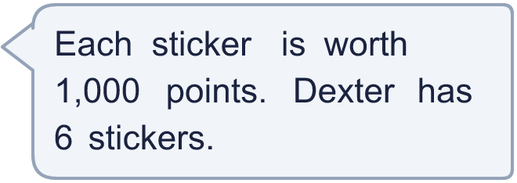
  7 | a) How many points does Dexter have?  b) Amir has 2 fewer stickers than Dexter. How many points does Amir have?
  8 | Write <, > or = in each box.
    a) | 8 thousands |  | 8,000
    b) | 25 hundreds |  | 250
    c) | 3 thousands |  | 57 hundreds
  8 | Write <, > or = in each box.
    a) | 8 thousands |  | 8,000
    b) | 25 hundreds |  | 250
    c) | 3 thousands |  | 57 hundreds

  9 | Is Boba correct? Circle yes or no.  Yes / No  Explain how you know.
     | 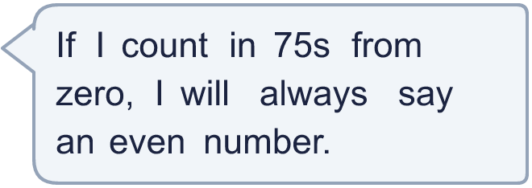
  9 | Is Boba correct? Circle yes or no.  Yes / No  Explain how you know.
  10
     | 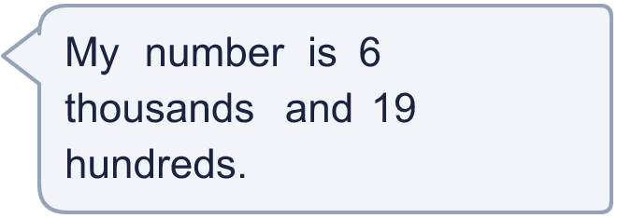
  10
  11 | Class 4B fills 6 jars with 1,000 pennies in each jar. They also have 300 spare pennies.  a) How many pennies do they have altogether?  b) They need 9,000 pennies to buy a game. How many more pennies do they need?
  11 | Class 4B fills 6 jars with 1,000 pennies in each jar. They also have 300 spare pennies.  a) How many pennies do they have altogether?  b) They need 9,000 pennies to buy a game. How many more pennies do they need?
  12 | Three of these cards show the same number. Which card is different?  a) 6 thousands  b) 6,000  c) 60 hundreds  d) 60 tens
  12 | Three of these cards show the same number. Which card is different?  a) 6 thousands  b) 6,000  c) 60 hundreds  d) 60 tens
  13 | Is Boba correct? Circle yes or no.  Yes / No  Explain how you know.
     | 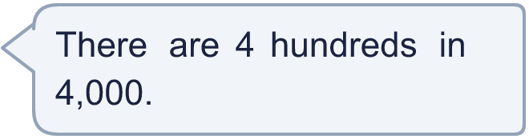
  13 | Is Boba correct? Circle yes or no.  Yes / No  Explain how you know.
  14 | Write three different ways to make 9,000 using thousands and hundreds. For example, 7 thousands and 20 hundreds.
  14 | Write three different ways to make 9,000 using thousands and hundreds. For example, 7 thousands and 20 hundreds.

Year 4 · Place value · Step 4
Thousands
Answers (teacher copy)

  1 | Count up in thousands. Write the missing numbers.  1,000, 2,000 , 3,000, 4,000, 5,000
  2 | Write each as a number.  a) 9 thousands = 9,000  b) 2 thousands = 2,000  c) 3 thousands = 3,000
  3 | Write each number in numerals or in words.  a) 9,000 = nine thousand  b) 6,000 = six thousand  c) five thousand = 5,000
  4 | Eva starts at zero and counts up in 1,000s. Which of these numbers does she say? Write the letters.  a) 9,100  b) 9,000  c) 7,000  d) 1,500  e) 4,000  f) 700  g) 2,500  h) 1,000  She says b and c and e and h
  5 | Complete the sentences.  a) 8,000 = 80 hundreds  b) 70 hundreds = 7,000  c) 3,000 = 30 hundreds
  6 | Count back in thousands. Write the missing numbers.  8,000, 7,000 , 6,000, 5,000 , 4,000
  7 | a) How many points does Dexter have? 6,000  b) Amir has 2 fewer stickers than Dexter. How many points does Amir have? 4,000
  8 | Write <, > or = in each box.  a) 8 thousands = 8,000  b) 25 hundreds > 250  c) 3 thousands < 57 hundreds
  9 | Is Boba correct? Circle yes or no.  Yes / No  Explain how you know.  No. The first number Boba says is 75, and 75 is odd.
  10 | What number am I thinking of? 7,900
  11 | Class 4B fills 6 jars with 1,000 pennies in each jar. They also have 300 spare pennies.  a) How many pennies do they have altogether? 6,300  b) They need 9,000 pennies to buy a game. How many more pennies do they need? 2,700
  12 | Three of these cards show the same number. Which card is different?  a) 6 thousands  b) 6,000  c) 60 hundreds  d) 60 tens  The different card is 60 tens
  13 | Is Boba correct? Circle yes or no.  Yes / No  Explain how you know.  No. 1,000 is 10 hundreds, so 4,000 is 40 hundreds.
  14 | Write three different ways to make 9,000 using thousands and hundreds. For example, 7 thousands and 20 hundreds.  for example 9 thousands; 90 hundreds; 8 thousands and 10 hundreds

