  Year 4 · Place value · Step 9  Round to the nearest 100 | 
  Year 4 · Place value · Step 9
  Round to the nearest 100
  1 | Round each number to the nearest 100.  a) 650 to the nearest 100 =  b) 410 to the nearest 100 =  c) 270 to the nearest 100 =
  1 | Round each number to the nearest 100.  a) 650 to the nearest 100 =  b) 410 to the nearest 100 =  c) 270 to the nearest 100 =
  2 | The arrows show two numbers: A is 1,230 and B is 1,260. Round each to the nearest 100.  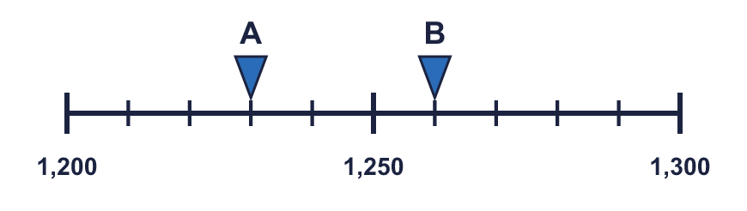
    A rounds to
    B rounds to
  2 | The arrows show two numbers: A is 1,230 and B is 1,260. Round each to the nearest 100.
    A rounds to
    B rounds to
  3 | Round each number to the nearest 100.  a) 2,809 to the nearest 100 =  b) 1,356 to the nearest 100 =  c) 5,692 to the nearest 100 =
  3 | Round each number to the nearest 100.  a) 2,809 to the nearest 100 =  b) 1,356 to the nearest 100 =  c) 5,692 to the nearest 100 =
  4 | Complete the sentences.
    a) | 4,353 is closer to
    than
    b) | 4,353 rounds to
    to the nearest 100
    c) | 4,719 is closer to
    than
    d) | 4,719 rounds to
    to the nearest 100
  4 | Complete the sentences.
    a) | 4,353 is closer to
    than
    b) | 4,353 rounds to
    to the nearest 100
    c) | 4,719 is closer to
    than
    d) | 4,719 rounds to
    to the nearest 100
  5 | Round each number to the nearest 10 and the nearest 100. The headings show the place to round to. Complete the table.  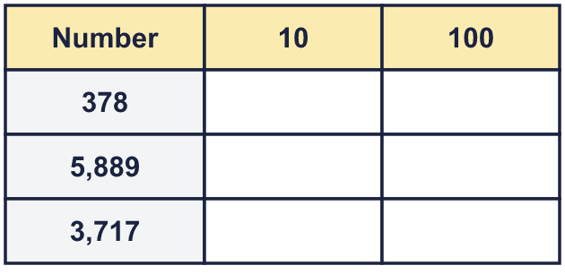
  5 | Round each number to the nearest 10 and the nearest 100. The headings show the place to round to. Complete the table.
  6 | Circle the numbers that round to 4,200 to the nearest 100. Write their letters.  a) 4,190  b) 4,306  c) 4,150  d) 4,238  e) 4,250  f) 4,083
  6 | Circle the numbers that round to 4,200 to the nearest 100. Write their letters.  a) 4,190  b) 4,306  c) 4,150  d) 4,238  e) 4,250  f) 4,083
  7 | Round 8,111 to each place.  a) the nearest 10 =  b) the nearest 100 =
  7 | Round 8,111 to each place.  a) the nearest 10 =  b) the nearest 100 =
  8 | These are the crowds at five football matches. Round each crowd to the nearest 100. Complete the last column of the table.  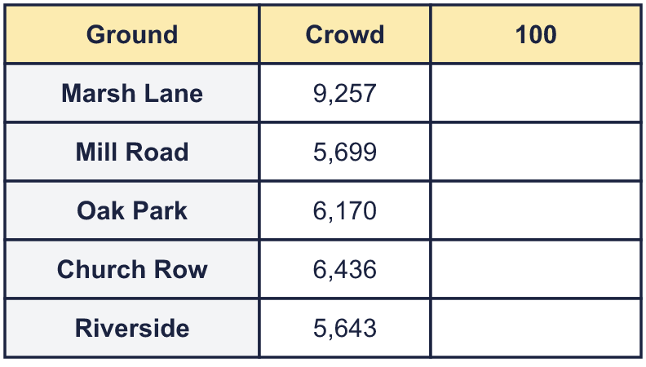
  8 | These are the crowds at five football matches. Round each crowd to the nearest 100. Complete the last column of the table.

  9 | Is Boba correct? Circle yes or no.  Yes / No  Explain how you know.
    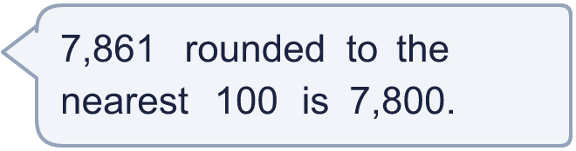
  9 | Is Boba correct? Circle yes or no.  Yes / No  Explain how you know.
  10 | A whole number rounds to 4,900 to the nearest 100.  a) What is the greatest it could be?  b) What is the smallest it could be?
  10 | A whole number rounds to 4,900 to the nearest 100.  a) What is the greatest it could be?  b) What is the smallest it could be?
  11 | a) Who is correct?  b) Explain the mistakes the other two have made.
     | 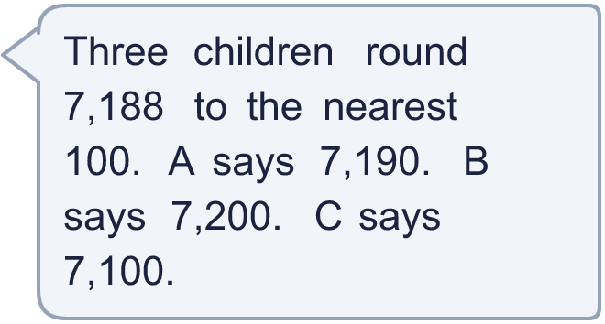
  11 | a) Who is correct?  b) Explain the mistakes the other two have made.
  12 | a) 2,234 rounded to the nearest 100 is  b) 4,279 rounded to the nearest 100 is  c) The estimated total is  d) The exact total is
     | 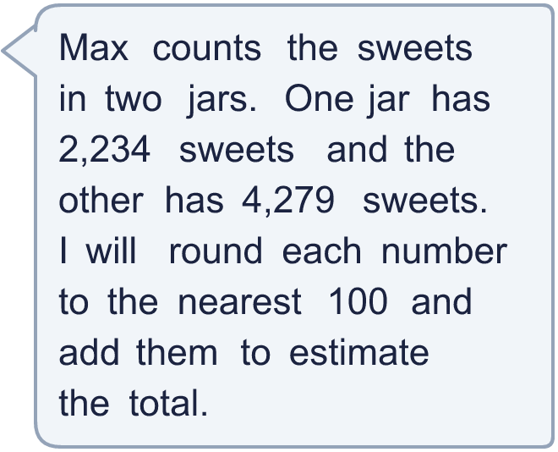
  12 | a) 2,234 rounded to the nearest 100 is  b) 4,279 rounded to the nearest 100 is  c) The estimated total is  d) The exact total is
  13 | a) Which place did the newspaper round to? Write 10 or 100.  b) What is the crowd rounded to the nearest 10?
     | 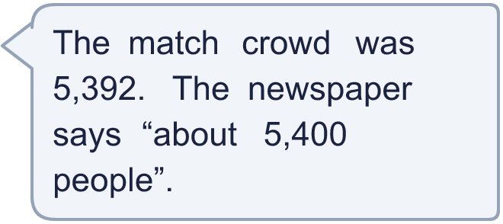
  13 | a) Which place did the newspaper round to? Write 10 or 100.  b) What is the crowd rounded to the nearest 10?
  14 | Write three different numbers that round to 6,400 to the nearest 100.
  14 | Write three different numbers that round to 6,400 to the nearest 100.

Year 4 · Place value · Step 9
Round to the nearest 100
Answers (teacher copy)

  1 | Round each number to the nearest 100.  a) 650 to the nearest 100 = 700  b) 410 to the nearest 100 = 400  c) 270 to the nearest 100 = 300
  2 | The arrows show two numbers: A is 1,230 and B is 1,260. Round each to the nearest 100.  A rounds to 1,200 B rounds to 1,300
  3 | Round each number to the nearest 100.  a) 2,809 to the nearest 100 = 2,800  b) 1,356 to the nearest 100 = 1,400  c) 5,692 to the nearest 100 = 5,700
  4 | Complete the sentences.  a) 4,353 is closer to 4,400 than 4,300  b) 4,353 rounds to 4,400 to the nearest 100  c) 4,719 is closer to 4,700 than 4,800  d) 4,719 rounds to 4,700 to the nearest 100
  5 | Round each number to the nearest 10 and the nearest 100. The headings show the place to round to. Complete the table.  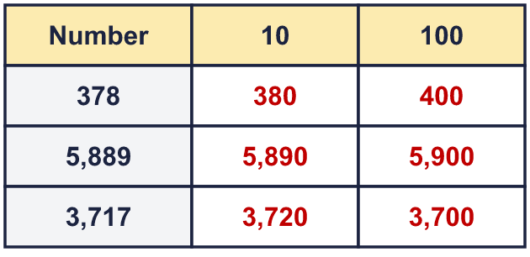
  6 | Circle the numbers that round to 4,200 to the nearest 100. Write their letters.  a) 4,190  b) 4,306  c) 4,150  d) 4,238  e) 4,250  f) 4,083  a, c, d
  7 | Round 8,111 to each place.  a) the nearest 10 = 8,110  b) the nearest 100 = 8,100
  8 | These are the crowds at five football matches. Round each crowd to the nearest 100. Complete the last column of the table.  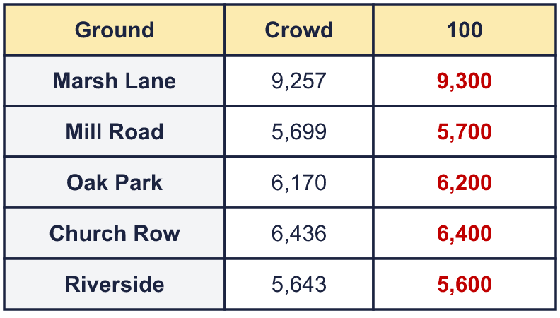
  9 | Is Boba correct? Circle yes or no.  Yes / No  Explain how you know.  The digit to the right of the rounding column is 6, which is 5 or more, so we round up. 7,861 rounds to 7,900, not 7,800.
  10 | A whole number rounds to 4,900 to the nearest 100.  a) What is the greatest it could be? 4,949  b) What is the smallest it could be? 4,850
  11 | a) Who is correct? B  b) Explain the mistakes the other two have made.  The correct answer is 7,200. The digit to the right of the rounding column is 8, so we round up. One of the others rounded to the nearest 10, and one always rounded down.
  12 | a) 2,234 rounded to the nearest 100 is 2,200  b) 4,279 rounded to the nearest 100 is 4,300  c) The estimated total is 6,500  d) The exact total is 6,513
  13 | a) Which place did the newspaper round to? Write 10 or 100. 100  b) What is the crowd rounded to the nearest 10? 5,390
  14 | Write three different numbers that round to 6,400 to the nearest 100.  Any three numbers from 6,350 to 6,449, for example 6,350, 6,400, 6,449

