  Year 4 · Place value · Step 8  Round to the nearest 10 | 
  Year 4 · Place value · Step 8
  Round to the nearest 10
  1 | Round each number to the nearest 10.  a) 75 to the nearest 10 =  b) 21 to the nearest 10 =  c) 86 to the nearest 10 =
  1 | Round each number to the nearest 10.  a) 75 to the nearest 10 =  b) 21 to the nearest 10 =  c) 86 to the nearest 10 =
  2 | The arrows show two numbers: A is 74 and B is 78. Round each to the nearest 10.  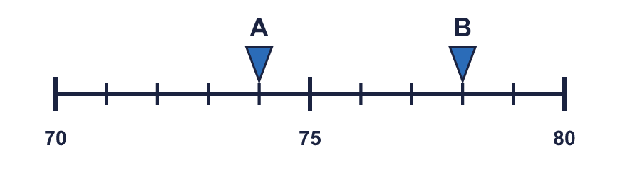
    A rounds to
    B rounds to
  2 | The arrows show two numbers: A is 74 and B is 78. Round each to the nearest 10.
    A rounds to
    B rounds to
  3 | Round each number to the nearest 10.  a) 670 to the nearest 10 =  b) 905 to the nearest 10 =  c) 996 to the nearest 10 =
  3 | Round each number to the nearest 10.  a) 670 to the nearest 10 =  b) 905 to the nearest 10 =  c) 996 to the nearest 10 =
  4 | Complete the sentences.
    a) | 723 is closer to
    than
    b) | 723 rounds to
    to the nearest 10
    c) | 546 is closer to
    than
    d) | 546 rounds to
    to the nearest 10
  4 | Complete the sentences.
    a) | 723 is closer to
    than
    b) | 723 rounds to
    to the nearest 10
    c) | 546 is closer to
    than
    d) | 546 rounds to
    to the nearest 10
  5 | Round each number to the nearest 10.  a) 4,086 to the nearest 10 =  b) 2,941 to the nearest 10 =  c) 6,998 to the nearest 10 =
  5 | Round each number to the nearest 10.  a) 4,086 to the nearest 10 =  b) 2,941 to the nearest 10 =  c) 6,998 to the nearest 10 =
  6 | Round each number to the nearest 10. Complete the table.  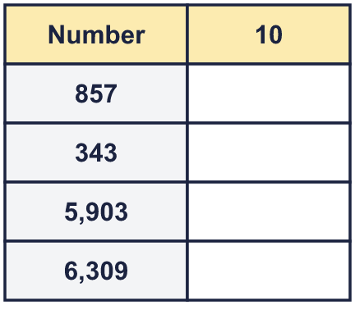
  6 | Round each number to the nearest 10. Complete the table.
  7 | Circle the numbers that round to 510 to the nearest 10. Write their letters.  a) 514  b) 505  c) 524  d) 497  e) 515  f) 509
  7 | Circle the numbers that round to 510 to the nearest 10. Write their letters.  a) 514  b) 505  c) 524  d) 497  e) 515  f) 509
  8 | The jars hold different numbers of sweets. Round the number of sweets in each jar to the nearest 10. Complete the last column of the table.  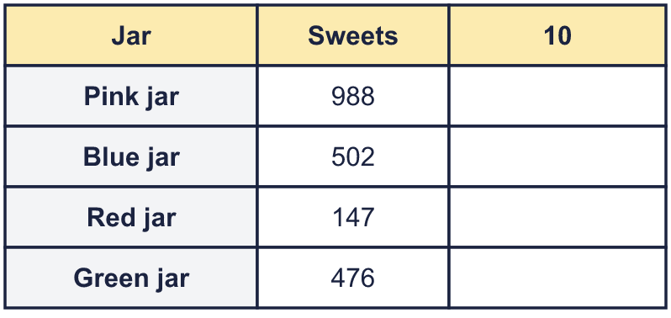
  8 | The jars hold different numbers of sweets. Round the number of sweets in each jar to the nearest 10. Complete the last column of the table.

  9 | Is Boba correct? Circle yes or no.  Yes / No  Explain how you know.
    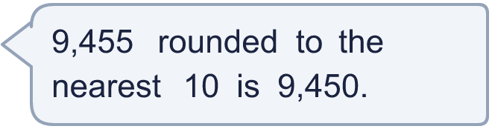
  9 | Is Boba correct? Circle yes or no.  Yes / No  Explain how you know.
  10 | A whole number rounds to 290 to the nearest 10.  a) What is the greatest it could be?  b) What is the smallest it could be?
  10 | A whole number rounds to 290 to the nearest 10.  a) What is the greatest it could be?  b) What is the smallest it could be?
  11 | a) Who is correct?  b) Explain the mistakes the other two have made.
     | 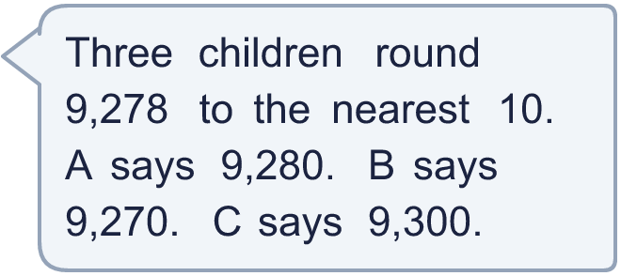
  11 | a) Who is correct?  b) Explain the mistakes the other two have made.
  12 | a) 528 rounded to the nearest 10 is  b) 379 rounded to the nearest 10 is  c) The estimated total is  d) The exact total is
     | 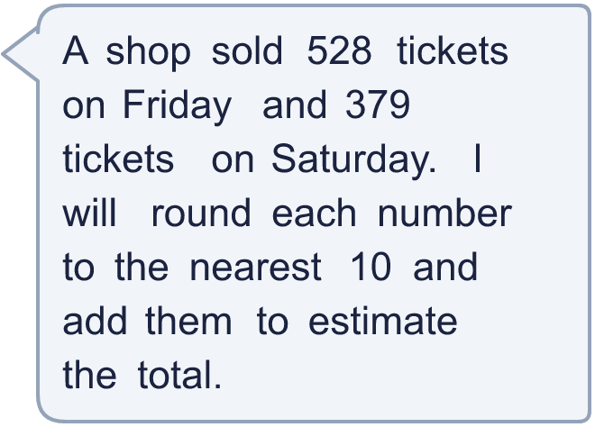
  12 | a) 528 rounded to the nearest 10 is  b) 379 rounded to the nearest 10 is  c) The estimated total is  d) The exact total is
  13 | There is a digit missing from each number. Write the digits that make it round to the number shown. There may be more than one.  a) 61_ rounds to 620 (nearest 10)  b) 7,95_ rounds to 7,960 (nearest 10)
  13 | There is a digit missing from each number. Write the digits that make it round to the number shown. There may be more than one.  a) 61_ rounds to 620 (nearest 10)  b) 7,95_ rounds to 7,960 (nearest 10)
  14 | Write three different numbers that round to 8,840 to the nearest 10.
  14 | Write three different numbers that round to 8,840 to the nearest 10.

Year 4 · Place value · Step 8
Round to the nearest 10
Answers (teacher copy)

  1 | Round each number to the nearest 10.  a) 75 to the nearest 10 = 80  b) 21 to the nearest 10 = 20  c) 86 to the nearest 10 = 90
  2 | The arrows show two numbers: A is 74 and B is 78. Round each to the nearest 10.  A rounds to 70 B rounds to 80
  3 | Round each number to the nearest 10.  a) 670 to the nearest 10 = 670  b) 905 to the nearest 10 = 910  c) 996 to the nearest 10 = 1,000
  4 | Complete the sentences.  a) 723 is closer to 720 than 730  b) 723 rounds to 720 to the nearest 10  c) 546 is closer to 550 than 540  d) 546 rounds to 550 to the nearest 10
  5 | Round each number to the nearest 10.  a) 4,086 to the nearest 10 = 4,090  b) 2,941 to the nearest 10 = 2,940  c) 6,998 to the nearest 10 = 7,000
  6 | Round each number to the nearest 10. Complete the table.  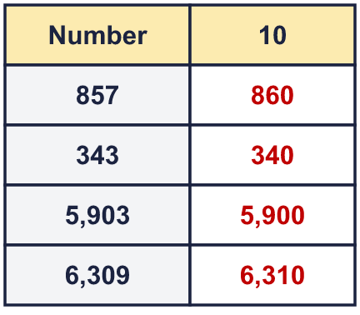
  7 | Circle the numbers that round to 510 to the nearest 10. Write their letters.  a) 514  b) 505  c) 524  d) 497  e) 515  f) 509  a, b, f
  8 | The jars hold different numbers of sweets. Round the number of sweets in each jar to the nearest 10. Complete the last column of the table.  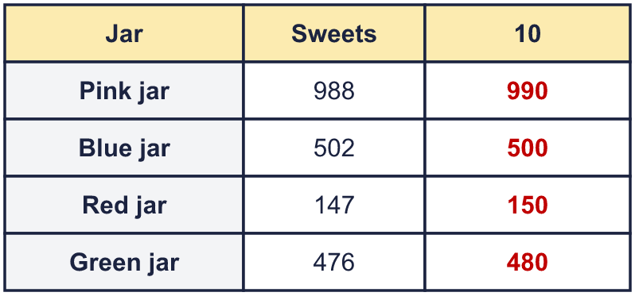
  9 | Is Boba correct? Circle yes or no.  Yes / No  Explain how you know.  The digit to the right of the rounding column is 5, which is 5 or more, so we round up. 9,455 rounds to 9,460, not 9,450.
  10 | A whole number rounds to 290 to the nearest 10.  a) What is the greatest it could be? 294  b) What is the smallest it could be? 285
  11 | a) Who is correct? A  b) Explain the mistakes the other two have made.  The correct answer is 9,280. The digit to the right of the rounding column is 8, so we round up. One of the others rounded to the nearest 100, and one always rounded down.
  12 | a) 528 rounded to the nearest 10 is 530  b) 379 rounded to the nearest 10 is 380  c) The estimated total is 910  d) The exact total is 907
  13 | There is a digit missing from each number. Write the digits that make it round to the number shown. There may be more than one.  a) 61_ rounds to 620 (nearest 10) 5, 6, 7, 8, 9  b) 7,95_ rounds to 7,960 (nearest 10) 5, 6, 7, 8, 9
  14 | Write three different numbers that round to 8,840 to the nearest 10.  Any three numbers from 8,835 to 8,844, for example 8,835, 8,840, 8,844

