  Year 4 · Place value · Step 17  Round to the nearest 10, 100 or 1,000 | 
  Year 4 · Place value · Step 17
  Round to the nearest 10, 100 or 1,000
  1 | The arrow shows 645 on each number line. Complete the sentences.  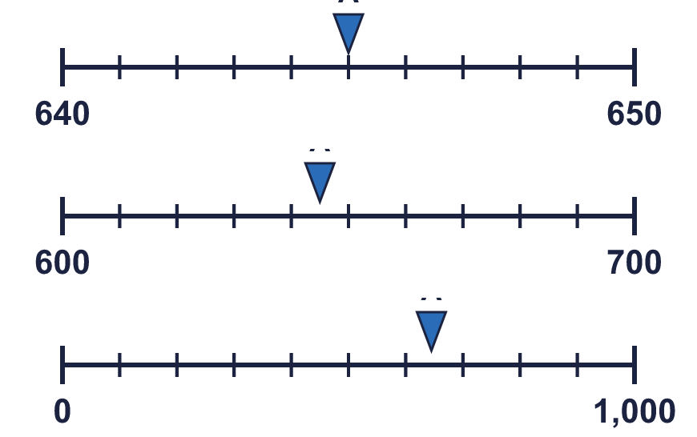
    a) | 645 rounded to the nearest 10 is
    b) | 645 rounded to the nearest 100 is
    c) | 645 rounded to the nearest 1,000 is
  1 | The arrow shows 645 on each number line. Complete the sentences.
    a) | 645 rounded to the nearest 10 is
    b) | 645 rounded to the nearest 100 is
    c) | 645 rounded to the nearest 1,000 is
  2 | The arrow shows 4,517 on each number line. Complete the sentences.  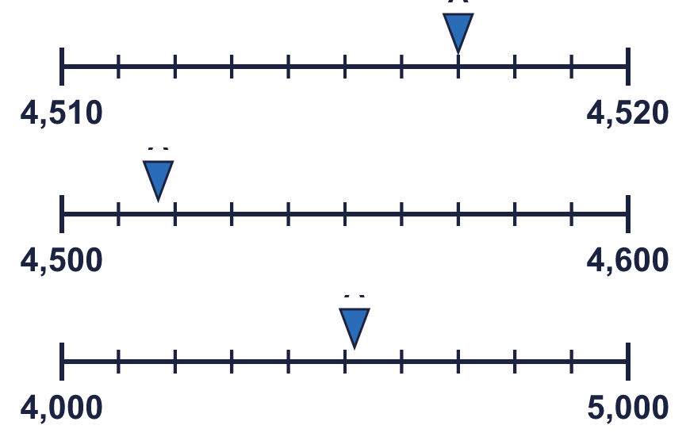
    a) | 4,517 rounded to the nearest 10 is
    b) | 4,517 rounded to the nearest 100 is
    c) | 4,517 rounded to the nearest 1,000 is
  2 | The arrow shows 4,517 on each number line. Complete the sentences.
    a) | 4,517 rounded to the nearest 10 is
    b) | 4,517 rounded to the nearest 100 is
    c) | 4,517 rounded to the nearest 1,000 is
  3 | Complete the sentences.
    a) | 292 rounded to the nearest 100 is
    b) | 7,891 rounded to the nearest 100 is
    c) | 4,796 rounded to the nearest 10 is
    d) | 3,375 rounded to the nearest 1,000 is
    e) | 2,403 rounded to the nearest 10 is
    f) | 6,141 rounded to the nearest 1,000 is
  3 | Complete the sentences.
    a) | 292 rounded to the nearest 100 is
    b) | 7,891 rounded to the nearest 100 is
    c) | 4,796 rounded to the nearest 10 is
    d) | 3,375 rounded to the nearest 1,000 is
    e) | 2,403 rounded to the nearest 10 is
    f) | 6,141 rounded to the nearest 1,000 is
  4 | Circle the numbers that round to 2,300 to the nearest 100. Write their letters.  a) 2,158  b) 2,339  c) 2,256  d) 2,437  e) 2,350  f) 2,250
  4 | Circle the numbers that round to 2,300 to the nearest 100. Write their letters.  a) 2,158  b) 2,339  c) 2,256  d) 2,437  e) 2,350  f) 2,250
  5 | Circle the numbers that round to 6,000 to the nearest 1,000. Write their letters.  a) 5,500  b) 6,132  c) 7,451  d) 4,574  e) 6,500  f) 5,515
  5 | Circle the numbers that round to 6,000 to the nearest 1,000. Write their letters.  a) 5,500  b) 6,132  c) 7,451  d) 4,574  e) 6,500  f) 5,515
  6 | Round 2,252 to each place.  a) the nearest 10 =  b) the nearest 100 =  c) the nearest 1,000 =
  6 | Round 2,252 to each place.  a) the nearest 10 =  b) the nearest 100 =  c) the nearest 1,000 =
  7 | Round each number to the nearest 10, the nearest 100 and the nearest 1,000. Complete the table.  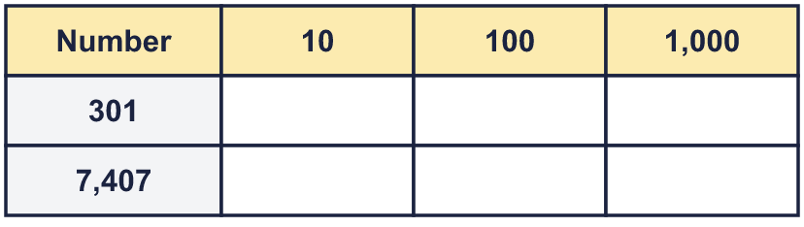
  7 | Round each number to the nearest 10, the nearest 100 and the nearest 1,000. Complete the table.
  8 | Round each number to the nearest 10.  a) 3,438 to the nearest 10 =  b) 7,260 to the nearest 10 =  c) 9,367 to the nearest 10 =
  8 | Round each number to the nearest 10.  a) 3,438 to the nearest 10 =  b) 7,260 to the nearest 10 =  c) 9,367 to the nearest 10 =

  9 | Is Boba correct? Circle yes or no.  Yes / No  Explain how you know.
    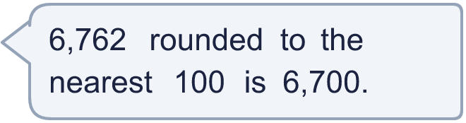
  9 | Is Boba correct? Circle yes or no.  Yes / No  Explain how you know.
  10 | There are 4,095 children in a school.
    a) | Round it to the nearest 10
    b) | Round it to the nearest 100
    c) | Round it to the nearest 1,000
    d) | The school needs to order one book for every child. Which place is the most appropriate to round to? Write 10, 100 or 1,000.
  10 | There are 4,095 children in a school.
    a) | Round it to the nearest 10
    b) | Round it to the nearest 100
    c) | Round it to the nearest 1,000
    d) | The school needs to order one book for every child. Which place is the most appropriate to round to? Write 10, 100 or 1,000.
  11 | 3,493 fans attend a music concert.
    a) | Round it to the nearest 10
    b) | Round it to the nearest 100
    c) | Round it to the nearest 1,000
    d) | The organiser keeps a record of the approximate number of fans at each concert. Which place is the most appropriate? Write 10, 100 or 1,000.
  11 | 3,493 fans attend a music concert.
    a) | Round it to the nearest 10
    b) | Round it to the nearest 100
    c) | Round it to the nearest 1,000
    d) | The organiser keeps a record of the approximate number of fans at each concert. Which place is the most appropriate? Write 10, 100 or 1,000.
  12 | Write a number that rounds to 1,900 to the nearest 100 and to 2,000 to the nearest 1,000.
  12 | Write a number that rounds to 1,900 to the nearest 100 and to 2,000 to the nearest 1,000.
  13 | Write a number that rounds to 5,190 to the nearest 10 and to 5,200 to the nearest 100.
  13 | Write a number that rounds to 5,190 to the nearest 10 and to 5,200 to the nearest 100.
  14 | A whole number rounds to 3,000 to the nearest 1,000.  a) What is the greatest it could be?  b) What is the smallest it could be?
  14 | A whole number rounds to 3,000 to the nearest 1,000.  a) What is the greatest it could be?  b) What is the smallest it could be?

Year 4 · Place value · Step 17
Round to the nearest 10, 100 or 1,000
Answers (teacher copy)

  1 | The arrow shows 645 on each number line. Complete the sentences.  a) 645 rounded to the nearest 10 is 650  b) 645 rounded to the nearest 100 is 600  c) 645 rounded to the nearest 1,000 is 1,000
  2 | The arrow shows 4,517 on each number line. Complete the sentences.  a) 4,517 rounded to the nearest 10 is 4,520  b) 4,517 rounded to the nearest 100 is 4,500  c) 4,517 rounded to the nearest 1,000 is 5,000
  3 | Complete the sentences.  a) 292 rounded to the nearest 100 is 300  b) 7,891 rounded to the nearest 100 is 7,900  c) 4,796 rounded to the nearest 10 is 4,800  d) 3,375 rounded to the nearest 1,000 is 3,000  e) 2,403 rounded to the nearest 10 is 2,400  f) 6,141 rounded to the nearest 1,000 is 6,000
  4 | Circle the numbers that round to 2,300 to the nearest 100. Write their letters.  a) 2,158  b) 2,339  c) 2,256  d) 2,437  e) 2,350  f) 2,250  b, c, f
  5 | Circle the numbers that round to 6,000 to the nearest 1,000. Write their letters.  a) 5,500  b) 6,132  c) 7,451  d) 4,574  e) 6,500  f) 5,515  a, b, f
  6 | Round 2,252 to each place.  a) the nearest 10 = 2,250  b) the nearest 100 = 2,300  c) the nearest 1,000 = 2,000
  7 | Round each number to the nearest 10, the nearest 100 and the nearest 1,000. Complete the table.  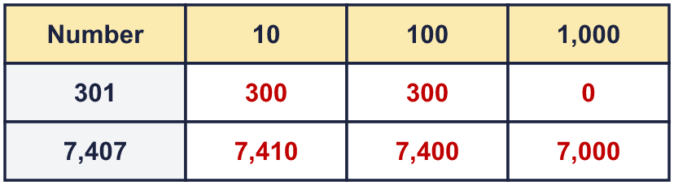
  8 | Round each number to the nearest 10.  a) 3,438 to the nearest 10 = 3,440  b) 7,260 to the nearest 10 = 7,260  c) 9,367 to the nearest 10 = 9,370
  9 | Is Boba correct? Circle yes or no.  Yes / No  Explain how you know.  The digit to the right of the rounding column is 6, which is 5 or more, so we round up. 6,762 rounds to 6,800, not 6,700.
  10 | There are 4,095 children in a school.  a) Round it to the nearest 10 4,100  b) Round it to the nearest 100 4,100  c) Round it to the nearest 1,000 4,000  d) The school needs to order one book for every child. Which place is the most appropriate to round to? Write 10, 100 or 1,000. 10
  11 | 3,493 fans attend a music concert.  a) Round it to the nearest 10 3,490  b) Round it to the nearest 100 3,500  c) Round it to the nearest 1,000 3,000  d) The organiser keeps a record of the approximate number of fans at each concert. Which place is the most appropriate? Write 10, 100 or 1,000. 100
  12 | Write a number that rounds to 1,900 to the nearest 100 and to 2,000 to the nearest 1,000.  Any number from 1,850 to 1,949, for example 1,899
  13 | Write a number that rounds to 5,190 to the nearest 10 and to 5,200 to the nearest 100.  Any number from 5,185 to 5,194, for example 5,189
  14 | A whole number rounds to 3,000 to the nearest 1,000.  a) What is the greatest it could be? 3,499  b) What is the smallest it could be? 2,500

