  Year 4 · Place value · Step 10  Round to the nearest 1,000 | 
  Year 4 · Place value · Step 10
  Round to the nearest 1,000
  1 | Round each number to the nearest 1,000.  a) 2,644 to the nearest 1,000 =  b) 8,154 to the nearest 1,000 =  c) 6,846 to the nearest 1,000 =
  1 | Round each number to the nearest 1,000.  a) 2,644 to the nearest 1,000 =  b) 8,154 to the nearest 1,000 =  c) 6,846 to the nearest 1,000 =
  2 | The arrows show two numbers: A is 8,210 and B is 8,670. Round each to the nearest 1,000.  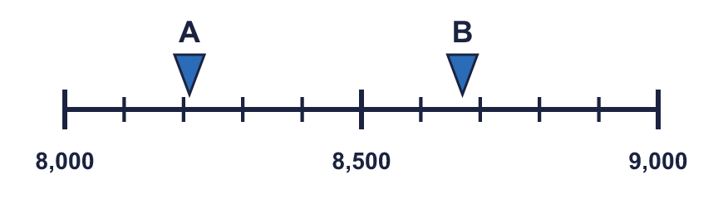
    A rounds to
    B rounds to
  2 | The arrows show two numbers: A is 8,210 and B is 8,670. Round each to the nearest 1,000.
    A rounds to
    B rounds to
  3 | Round each number to the nearest 1,000.  a) 3,309 to the nearest 1,000 =  b) 9,822 to the nearest 1,000 =  c) 1,099 to the nearest 1,000 =
  3 | Round each number to the nearest 1,000.  a) 3,309 to the nearest 1,000 =  b) 9,822 to the nearest 1,000 =  c) 1,099 to the nearest 1,000 =
  4 | Complete the sentences.
    a) | 6,399 is closer to
    than
    b) | 6,399 rounds to
    to the nearest 1,000
    c) | 9,502 is closer to
    than
    d) | 9,502 rounds to
    to the nearest 1,000
  4 | Complete the sentences.
    a) | 6,399 is closer to
    than
    b) | 6,399 rounds to
    to the nearest 1,000
    c) | 9,502 is closer to
    than
    d) | 9,502 rounds to
    to the nearest 1,000
  5 | Round each number to the nearest 100 and the nearest 1,000. The headings show the place to round to. Complete the table.  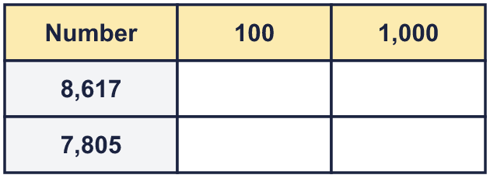
  5 | Round each number to the nearest 100 and the nearest 1,000. The headings show the place to round to. Complete the table.
  6 | Circle the numbers that round to 2,000 to the nearest 1,000. Write their letters.  a) 3,124  b) 1,565  c) 1,500  d) 2,369  e) 2,500  f) 739
  6 | Circle the numbers that round to 2,000 to the nearest 1,000. Write their letters.  a) 3,124  b) 1,565  c) 1,500  d) 2,369  e) 2,500  f) 739
  7 | Round 1,659 to each place.  a) the nearest 10 =  b) the nearest 100 =  c) the nearest 1,000 =
  7 | Round 1,659 to each place.  a) the nearest 10 =  b) the nearest 100 =  c) the nearest 1,000 =
  8 | Round the number of seats in each place to the nearest 1,000 and the nearest 100. Complete the table.  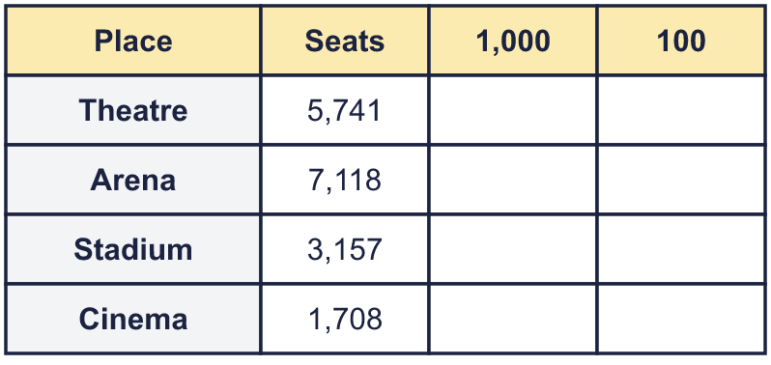
  8 | Round the number of seats in each place to the nearest 1,000 and the nearest 100. Complete the table.

  9 | Is Boba correct? Circle yes or no.  Yes / No  Explain how you know.
    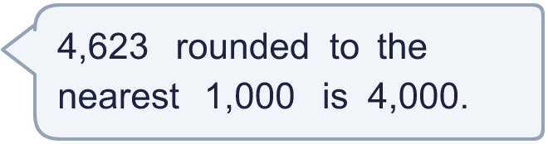
  9 | Is Boba correct? Circle yes or no.  Yes / No  Explain how you know.
  10 | A whole number rounds to 5,000 to the nearest 1,000.  a) What is the greatest it could be?  b) What is the smallest it could be?
  10 | A whole number rounds to 5,000 to the nearest 1,000.  a) What is the greatest it could be?  b) What is the smallest it could be?
  11 | The number in the report has been rounded. What is the greatest number of people who could have been at the match if it was rounded to the nearest...  a) 1,000  b) 100  c) 10
     | 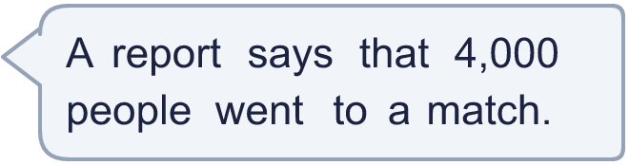
  11 | The number in the report has been rounded. What is the greatest number of people who could have been at the match if it was rounded to the nearest...  a) 1,000  b) 100  c) 10
  12 | a) 4,576 rounded to the nearest 1,000 is  b) 3,532 rounded to the nearest 1,000 is  c) The estimated total is  d) The exact total is
    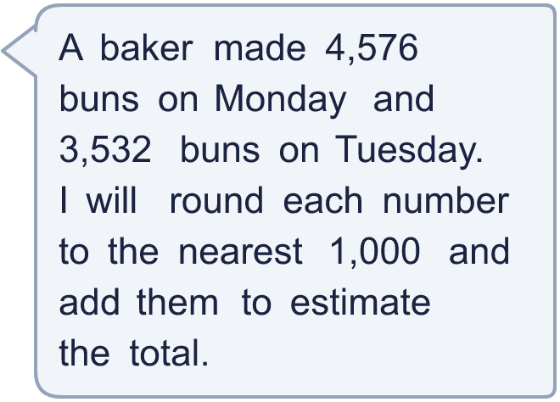
  12 | a) 4,576 rounded to the nearest 1,000 is  b) 3,532 rounded to the nearest 1,000 is  c) The estimated total is  d) The exact total is
  13 | a) Which place did the newspaper round to? Write 10, 100, 1,000.  b) What is the crowd rounded to the nearest 100?
     | 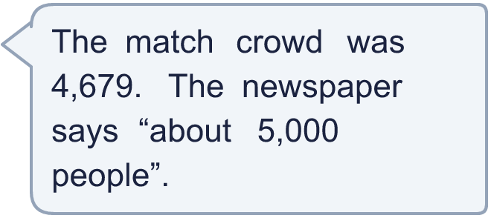
  13 | a) Which place did the newspaper round to? Write 10, 100, 1,000.  b) What is the crowd rounded to the nearest 100?
  14 | Write a number that rounds to 5,900 to the nearest 100 and to 6,000 to the nearest 1,000.
  14 | Write a number that rounds to 5,900 to the nearest 100 and to 6,000 to the nearest 1,000.

Year 4 · Place value · Step 10
Round to the nearest 1,000
Answers (teacher copy)

  1 | Round each number to the nearest 1,000.  a) 2,644 to the nearest 1,000 = 3,000  b) 8,154 to the nearest 1,000 = 8,000  c) 6,846 to the nearest 1,000 = 7,000
  2 | The arrows show two numbers: A is 8,210 and B is 8,670. Round each to the nearest 1,000.  A rounds to 8,000 B rounds to 9,000
  3 | Round each number to the nearest 1,000.  a) 3,309 to the nearest 1,000 = 3,000  b) 9,822 to the nearest 1,000 = 10,000  c) 1,099 to the nearest 1,000 = 1,000
  4 | Complete the sentences.  a) 6,399 is closer to 6,000 than 7,000  b) 6,399 rounds to 6,000 to the nearest 1,000  c) 9,502 is closer to 10,000 than 9,000  d) 9,502 rounds to 10,000 to the nearest 1,000
  5 | Round each number to the nearest 100 and the nearest 1,000. The headings show the place to round to. Complete the table.  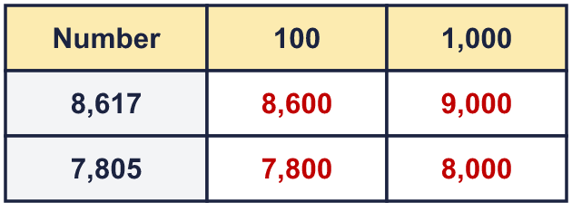
  6 | Circle the numbers that round to 2,000 to the nearest 1,000. Write their letters.  a) 3,124  b) 1,565  c) 1,500  d) 2,369  e) 2,500  f) 739  b, c, d
  7 | Round 1,659 to each place.  a) the nearest 10 = 1,660  b) the nearest 100 = 1,700  c) the nearest 1,000 = 2,000
  8 | Round the number of seats in each place to the nearest 1,000 and the nearest 100. Complete the table.  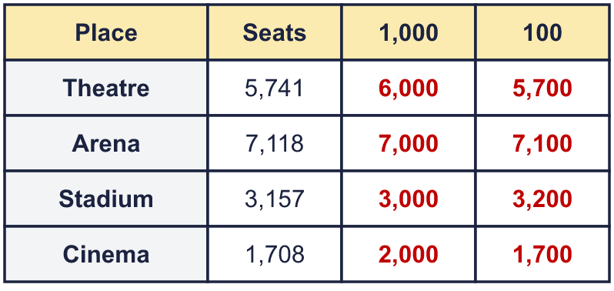
  9 | Is Boba correct? Circle yes or no.  Yes / No  Explain how you know.  The digit to the right of the rounding column is 6, which is 5 or more, so we round up. 4,623 rounds to 5,000, not 4,000.
  10 | A whole number rounds to 5,000 to the nearest 1,000.  a) What is the greatest it could be? 5,499  b) What is the smallest it could be? 4,500
  11 | The number in the report has been rounded. What is the greatest number of people who could have been at the match if it was rounded to the nearest...  a) 1,000 4,499  b) 100 4,049  c) 10 4,004
  12 | a) 4,576 rounded to the nearest 1,000 is 5,000  b) 3,532 rounded to the nearest 1,000 is 4,000  c) The estimated total is 9,000  d) The exact total is 8,108
  13 | a) Which place did the newspaper round to? Write 10, 100, 1,000. 1,000  b) What is the crowd rounded to the nearest 100? 4,700
  14 | Write a number that rounds to 5,900 to the nearest 100 and to 6,000 to the nearest 1,000.  Any number from 5,850 to 5,949, for example 5,899

