  Year 4 · Place value · Step 13  Roman numerals | 
  Year 4 · Place value · Step 13
  Roman numerals
  1 | Write each Roman numeral as a number.  a) XIV =  b) XVI =  c) XXVI =
  1 | Write each Roman numeral as a number.  a) XIV =  b) XVI =  c) XXVI =
  2 | Write each number as a Roman numeral.  a) 17 =  b) 53 =  c) 99 =
  2 | Write each number as a Roman numeral.  a) 17 =  b) 53 =  c) 99 =
  3 | Complete the Roman numeral number track.  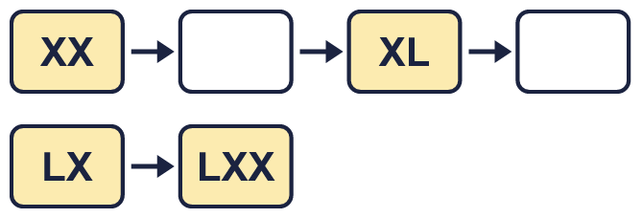
  3 | Complete the Roman numeral number track.
  4 | Change each one. Roman numerals go up to C, which is 100.  a) LXV =  b) 69 =  c) XCV =
  4 | Change each one. Roman numerals go up to C, which is 100.  a) LXV =  b) 69 =  c) XCV =
  5 | Write each number in Roman numerals.  a) forty-seven =  b) twenty-one =  c) nineteen =
  5 | Write each number in Roman numerals.  a) forty-seven =  b) twenty-one =  c) nineteen =
  6 | Work out each calculation. Write the answer in Roman numerals.  a) L + I =  b) L + III =  c) XL + XX =
  6 | Work out each calculation. Write the answer in Roman numerals.  a) L + I =  b) L + III =  c) XL + XX =
  7 | Write <, > or = in each box.
    a) | LXII |  | 54
    b) | XLVIII |  | 45
    c) | XV |  | 12
  7 | Write <, > or = in each box.
    a) | LXII |  | 54
    b) | XLVIII |  | 45
    c) | XV |  | 12
  8 | House numbers go up in 2s. Complete the Roman numeral number track.  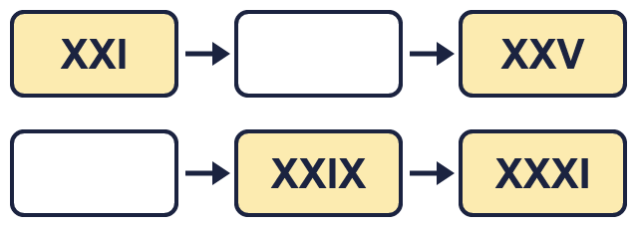
  8 | House numbers go up in 2s. Complete the Roman numeral number track.

  9 | a) Who is correct?  b) What mistake has the other child made?
     | 
  9 | a) Who is correct?  b) What mistake has the other child made?
  10 | Is Boba correct? Circle yes or no.  Yes / No  Explain how you know.
     | 
  10 | Is Boba correct? Circle yes or no.  Yes / No  Explain how you know.
  11 | Put these Roman numerals in order. Start with the largest.  XXXVII LXXI XXI LXVII
  11 | Put these Roman numerals in order. Start with the largest.  XXXVII LXXI XXI LXVII
  12 | a) What number does Tia live at?  b) The house 2 doors further up is number... (write it in Roman numerals)
     | 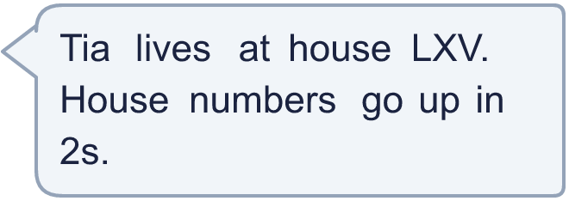
  12 | a) What number does Tia live at?  b) The house 2 doors further up is number... (write it in Roman numerals)
  13 | a) Write the number the standard way.  b) Explain what Boba did.
    
  13 | a) Write the number the standard way.  b) Explain what Boba did.
  14 | Write three different Roman numerals that are greater than L and less than XC.
  14 | Write three different Roman numerals that are greater than L and less than XC.

Year 4 · Place value · Step 13
Roman numerals
Answers (teacher copy)

  1 | Write each Roman numeral as a number.  a) XIV = 14  b) XVI = 16  c) XXVI = 26
  2 | Write each number as a Roman numeral.  a) 17 = XVII  b) 53 = LIII  c) 99 = XCIX
  3 | Complete the Roman numeral number track.  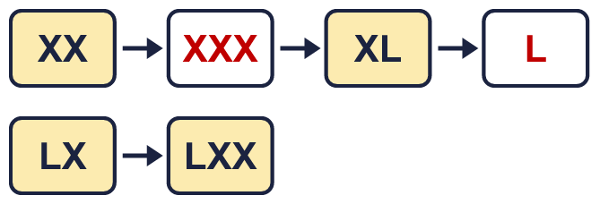
  4 | Change each one. Roman numerals go up to C, which is 100.  a) LXV = 65  b) 69 = LXIX  c) XCV = 95
  5 | Write each number in Roman numerals.  a) forty-seven = XLVII  b) twenty-one = XXI  c) nineteen = XIX
  6 | Work out each calculation. Write the answer in Roman numerals.  a) L + I = LI  b) L + III = LIII  c) XL + XX = LX
  7 | Write <, > or = in each box.  a) LXII > 54  b) XLVIII > 45  c) XV > 12
  8 | House numbers go up in 2s. Complete the Roman numeral number track.  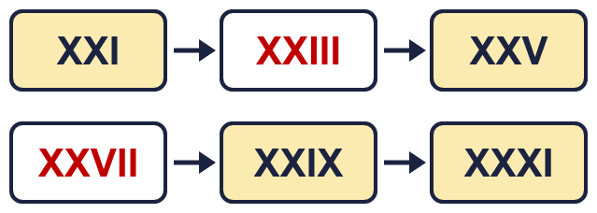
  9 | a) Who is correct? Theo  b) What mistake has the other child made?  Maya wrote the smaller letter first. In VLI the V is smaller than the L, and VL is not one of the special pairs (IV, IX, XL, XC). The biggest letter comes first, so 56 is LVI.
  10 | Is Boba correct? Circle yes or no.  Yes / No  Explain how you know.  LXX is 70 and XX is 20. 70 − 20 = 50, which is L, not XC.
  11 | Put these Roman numerals in order. Start with the largest.  XXXVII LXXI XXI LXVII  LXXI, LXVII, XXXVII, XXI
  12 | a) What number does Tia live at? 65  b) The house 2 doors further up is number... (write it in Roman numerals) LXIX
  13 | a) Write the number the standard way. LXIV  b) Explain what Boba did.  Boba added the letters without using the shorter forms. We write 4 as IV, 9 as IX, 40 as XL and 90 as XC. 64 is LXIV.
  14 | Write three different Roman numerals that are greater than L and less than XC.  Any three correct numerals, for example LIII, LXXI, LXXXVII

