  Year 4 · Place value · Step 1  Represent numbers to 1000 | 
  Year 4 · Place value · Step 1
  Represent numbers to 1000
  1 | What number is shown in the place value chart?  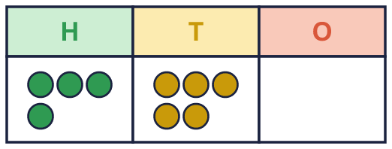
    The number is
  1 | What number is shown in the place value chart?
    The number is
  2 | What number do the base ten blocks show?  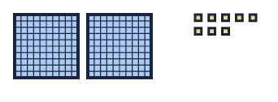
    The number is
  2 | What number do the base ten blocks show?
    The number is
  3 | Here are some sweets, shown with base ten blocks. Ben takes 399 of the sweets.  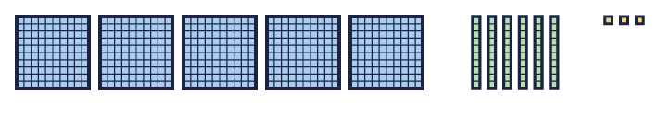  a) How many sweets are there?  b) Kim takes the rest. How many sweets does Kim take?
  3 | Here are some sweets, shown with base ten blocks. Ben takes 399 of the sweets.  a) How many sweets are there?  b) Kim takes the rest. How many sweets does Kim take?
  4 | Use base ten to make 943. Draw the blocks in your book.    a) How many flats did you draw?  b) How many rods did you draw?  c) How many cubes did you draw?
  4 | Use base ten to make 943. Draw the blocks in your book.  a) How many flats did you draw?  b) How many rods did you draw?  c) How many cubes did you draw?
  5 | Write each number.  a) 5 hundreds, 0 tens and 1 one =  b) 2 hundreds, 4 tens and 0 ones =  c) 6 hundreds, 1 ten and 6 ones =
  5 | Write each number.  a) 5 hundreds, 0 tens and 1 one =  b) 2 hundreds, 4 tens and 0 ones =  c) 6 hundreds, 1 ten and 6 ones =
  6 | Dani is making the number 150 with place value counters. Some counters are already in the chart.  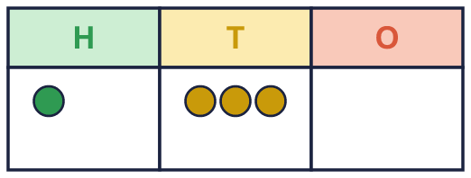  How many more counters of each kind does Dani need?
     | hundreds, |  | tens and
    ones
  6 | Dani is making the number 150 with place value counters. Some counters are already in the chart.  How many more counters of each kind does Dani need?
     | hundreds, |  | tens and
    ones
  7 | Which picture shows 781? Write the letter.  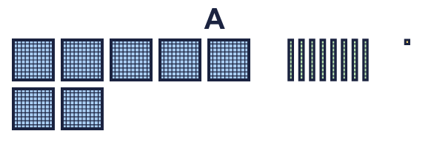  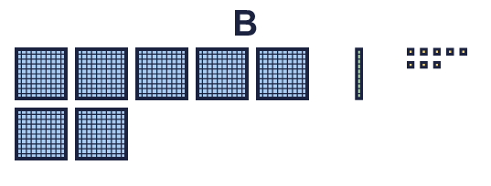
    The answer is picture
  7 | Which picture shows 781? Write the letter.
    The answer is picture
  8 | Look at the number 307.  a) How many hundreds does it have?  b) How many tens does it have?  c) How many ones does it have?
  8 | Look at the number 307.  a) How many hundreds does it have?  b) How many tens does it have?  c) How many ones does it have?

  9 | Three children look at these blocks.  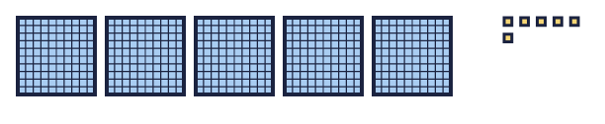  Who is correct?  Explain the mistakes the other two have made.
     | 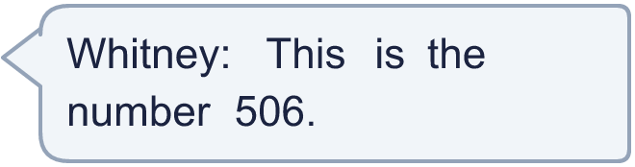
     | 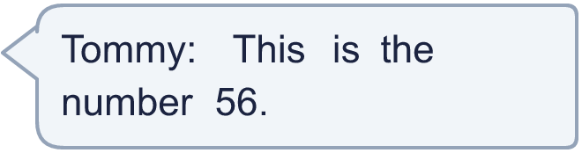
    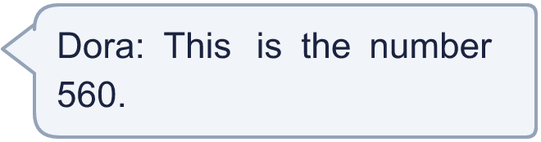
  9 | Three children look at these blocks.  Who is correct?  Explain the mistakes the other two have made.
  10 | Tiny makes 845 in different ways. Which picture does not show 845? Write the letter.  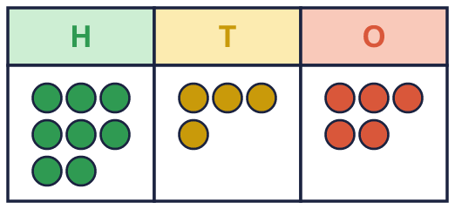  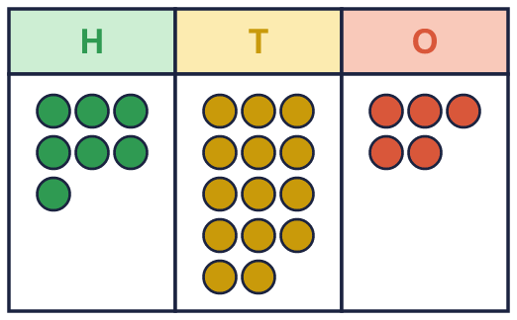  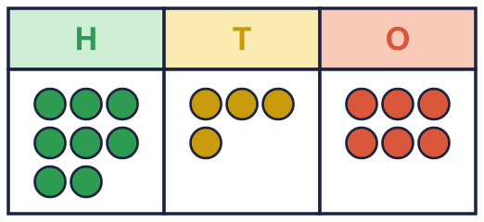
    The picture that does not show 845 is picture
  10 | Tiny makes 845 in different ways. Which picture does not show 845? Write the letter.
    The picture that does not show 845 is picture
  11 | A number is made with place value counters. There are more than 9 tens, so some tens can be exchanged for a hundred.  a) 2 hundreds, 12 tens and 5 ones =
  11 | A number is made with place value counters. There are more than 9 tens, so some tens can be exchanged for a hundred.  a) 2 hundreds, 12 tens and 5 ones =
  12 | 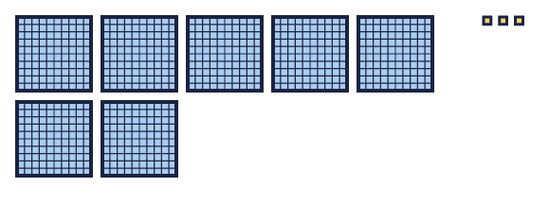  Is Dora correct? Circle yes or no.  Yes / No  Explain how you know.
     | 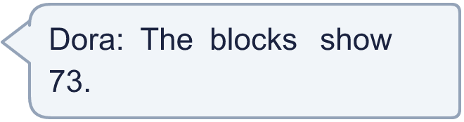
  12 | Is Dora correct? Circle yes or no.  Yes / No  Explain how you know.
  13 | I am thinking of a 3-digit number. The hundreds digit is 2 more than the ones digit. The tens digit is 1 more than the ones digit.
    How many different numbers could it be?
  13 | I am thinking of a 3-digit number. The hundreds digit is 2 more than the ones digit. The tens digit is 1 more than the ones digit.
    How many different numbers could it be?
  14 | Write three different ways to make 450 using hundreds and tens counters. For example, 2 hundreds and 25 tens.
  14 | Write three different ways to make 450 using hundreds and tens counters. For example, 2 hundreds and 25 tens.

Year 4 · Place value · Step 1
Represent numbers to 1000
Answers (teacher copy)

  1 | What number is shown in the place value chart?  The number is 450
  2 | What number do the base ten blocks show?  The number is 208
  3 | Here are some sweets, shown with base ten blocks. Ben takes 399 of the sweets.  a) How many sweets are there? 563  b) Kim takes the rest. How many sweets does Kim take? 164
  4 | Use base ten to make 943. Draw the blocks in your book.  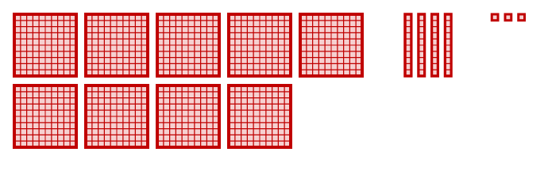  a) How many flats did you draw? 9  b) How many rods did you draw? 4  c) How many cubes did you draw? 3
  5 | Write each number.  a) 5 hundreds, 0 tens and 1 one = 501  b) 2 hundreds, 4 tens and 0 ones = 240  c) 6 hundreds, 1 ten and 6 ones = 616
  6 | Dani is making the number 150 with place value counters. Some counters are already in the chart.  How many more counters of each kind does Dani need?  0 hundreds, 2 tens and 0 ones
  7 | Which picture shows 781? Write the letter.  The answer is picture A
  8 | Look at the number 307.  a) How many hundreds does it have? 3  b) How many tens does it have? 0  c) How many ones does it have? 7
  9 | Three children look at these blocks.  Who is correct? Whitney  Explain the mistakes the other two have made.  Whitney is correct: 5 hundreds, 0 tens and 6 ones make 506. The others have not used a zero in the tens place, or have put the digits in the wrong places.
  10 | Tiny makes 845 in different ways. Which picture does not show 845? Write the letter.  The picture that does not show 845 is picture C
  11 | A number is made with place value counters. There are more than 9 tens, so some tens can be exchanged for a hundred.  a) 2 hundreds, 12 tens and 5 ones = 325
  12 | Is Dora correct? Circle yes or no.  Yes / No  Explain how you know.  No. There are 7 hundreds, 0 tens and 3 ones, so the blocks show 703.
  13 | I am thinking of a 3-digit number. The hundreds digit is 2 more than the ones digit. The tens digit is 1 more than the ones digit.  How many different numbers could it be? 8
  14 | Write three different ways to make 450 using hundreds and tens counters. For example, 2 hundreds and 25 tens.  for example 4 hundreds and 5 tens; 3 hundreds and 15 tens; 45 tens

