  Year 4 · Place value · Step 1  Represent numbers to 10,000 | 
  Year 4 · Place value · Step 1
  Represent numbers to 10,000
  1 | What number is shown in the place value chart?
    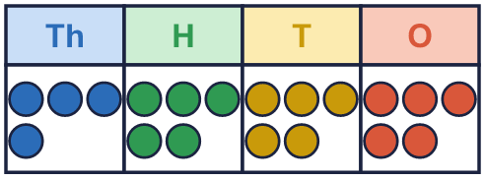
  1 | What number is shown in the place value chart?
  2 | What number is shown in the place value chart?
    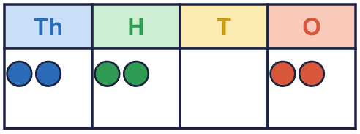
  2 | What number is shown in the place value chart?
  3 | What number is shown in the place value chart?
    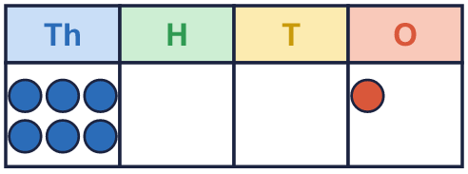
  3 | What number is shown in the place value chart?
  4 | Draw counters to show 2,204 in a place value chart.  Draw your counters here:  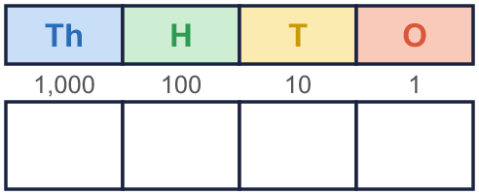
  4 | Draw counters to show 2,204 in a place value chart.  Draw your counters here:
  5 | What is the value of the 6 in each number?  a) 8,061 =  b) 69 =  c) 6,531 =  d) 326 =
  5 | What is the value of the 6 in each number?  a) 8,061 =  b) 69 =  c) 6,531 =  d) 326 =
  6 | Work out the missing numbers.  a) 6,783 + 1 =  b) 6,783 + 10 =  c) 6,783 + 100 =  d) 6,783 + 1,000 =
  6 | Work out the missing numbers.  a) 6,783 + 1 =  b) 6,783 + 10 =  c) 6,783 + 100 =  d) 6,783 + 1,000 =
  7 | Partition the number. Fill in the missing parts.
    9,063 = | 9,000 | + |  | +
  7 | Partition the number. Fill in the missing parts.
    9,063 = | 9,000 | + |  | +
  8 | The Gattegno chart shows a number. What is the number?  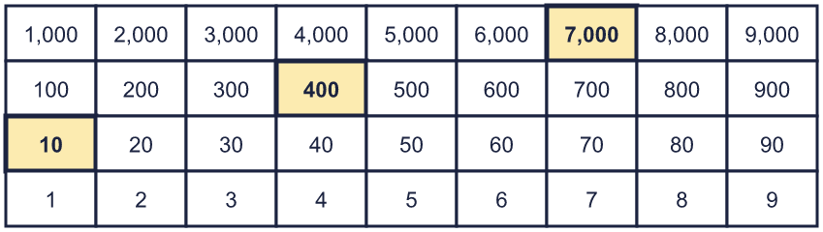
  8 | The Gattegno chart shows a number. What is the number?

  9 | Which numbers have a 4 in the tens column? Write the letters.  a) 46  b) 474  c) 94  d) 448  Answer:
     | 
  9 | Which numbers have a 4 in the tens column? Write the letters.  a) 46  b) 474  c) 94  d) 448  Answer:
  10 | • Its digit total is 10.  • There are 3 more counters in the hundreds column than in the thousands column.  • The ones column is empty.  Write all the numbers I could have made.
    
  10 | • Its digit total is 10.  • There are 3 more counters in the hundreds column than in the thousands column.  • The ones column is empty.  Write all the numbers I could have made.
  11 | Is Boba correct? Circle yes or no.  Yes / No  Explain how you know.
    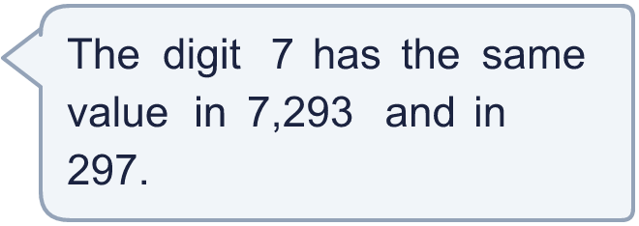
  11 | Is Boba correct? Circle yes or no.  Yes / No  Explain how you know.
  12 | 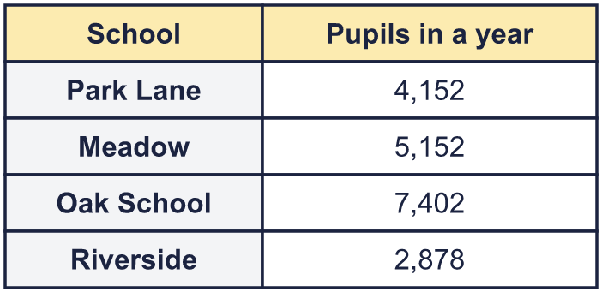  a) Write the schools in order, smallest number first.  b) Which school had 1,000 more pupils than Park Lane?  c) What is the value of the digit in the box in the Riverside number: 2,878?
     | 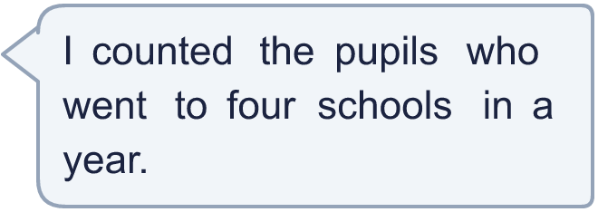
  12 | a) Write the schools in order, smallest number first.  b) Which school had 1,000 more pupils than Park Lane?  c) What is the value of the digit in the box in the Riverside number: 2,878?
  13 | • The digits add up to 21.  • The hundreds digit is 7.  • The thousands digit is 5.  • The ones digit is 4.  What is my number?
     | 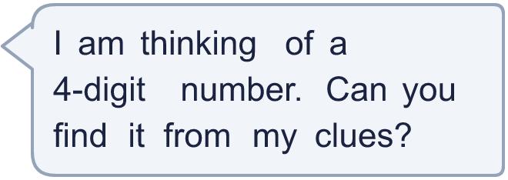
  13 | • The digits add up to 21.  • The hundreds digit is 7.  • The thousands digit is 5.  • The ones digit is 4.  What is my number?
  14 | Write three different 4-digit numbers in which the digit 4 is worth 4,000.
  14 | Write three different 4-digit numbers in which the digit 4 is worth 4,000.

Year 4 · Place value · Step 1
Represent numbers to 10,000
Answers (teacher copy)

  1 | What number is shown in the place value chart?
    4,555
  2 | What number is shown in the place value chart?
    2,202
  3 | What number is shown in the place value chart?
    6,001
  4 | Draw counters to show 2,204 in a place value chart.  Draw your counters here:  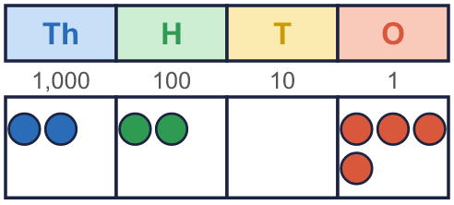
  5 | What is the value of the 6 in each number?  a) 8,061 = 60  b) 69 = 60  c) 6,531 = 6,000  d) 326 = 6
  6 | Work out the missing numbers.  a) 6,783 + 1 = 6,784  b) 6,783 + 10 = 6,793  c) 6,783 + 100 = 6,883  d) 6,783 + 1,000 = 7,783
  7 | Partition the number. Fill in the missing parts.  9,063 = 9,000 + 60 + 3
  8 | The Gattegno chart shows a number. What is the number?  7,410
  9 | Which numbers have a 4 in the tens column? Write the letters.  a) 46  b) 474  c) 94  d) 448  Answer: a and d
  10 | • Its digit total is 10.  • There are 3 more counters in the hundreds column than in the thousands column.  • The ones column is empty.  Write all the numbers I could have made.  1,450, 2,530, 3,610
  11 | Is Boba correct? Circle yes or no.  Yes / No  Explain how you know.  In 7,293 the 7 is worth 7,000. In 297 it is worth 7. The columns are different, so the values are different.
  12 | a) Write the schools in order, smallest number first. Riverside, Park Lane, Meadow, Oak School  b) Which school had 1,000 more pupils than Park Lane? Meadow  c) What is the value of the digit in the box in the Riverside number: 2,878? 800
  13 | • The digits add up to 21.  • The hundreds digit is 7.  • The thousands digit is 5.  • The ones digit is 4.  What is my number?  5,754
  14 | Write three different 4-digit numbers in which the digit 4 is worth 4,000.  Any numbers with the 4 in the thousands column, for example 4,514, 4,352, 4,822

