  Year 4 · Place value · Step 2  Partition numbers to 1000 | 
  Year 4 · Place value · Step 2
  Partition numbers to 1000
  1 | Complete the number sentence.
    356 = | 300 | + |  | +
  1 | Complete the number sentence.
    356 = | 300 | + |  | +
  2 | Complete the number sentence. One of the places is empty, so there are only two parts.
    904 = |  | +
  2 | Complete the number sentence. One of the places is empty, so there are only two parts.
    904 = |  | +
  3 | Fill in the missing part of each number sentence.
    a) | 473 = |  | + | 70 | + | 3
    b) | 796 = |  | + | 96
    c) | 861 = | 800 | + | 60 | +
  3 | Fill in the missing part of each number sentence.
    a) | 473 = |  | + | 70 | + | 3
    b) | 796 = |  | + | 96
    c) | 861 = | 800 | + | 60 | +
  4 | Complete the sentences about 643.  a) The number of hundreds is  b) The number of tens in the tens place is  c) The number of ones is
  4 | Complete the sentences about 643.  a) The number of hundreds is  b) The number of tens in the tens place is  c) The number of ones is
  5 | Complete the part-whole models.
    a)  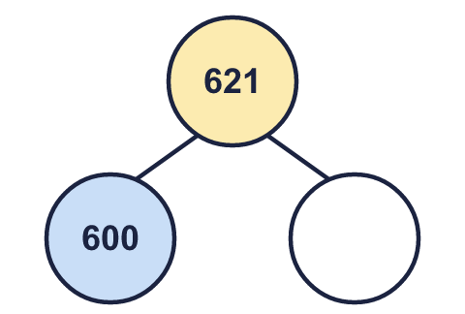 | b)  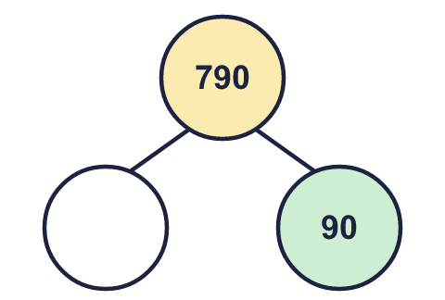 | c)  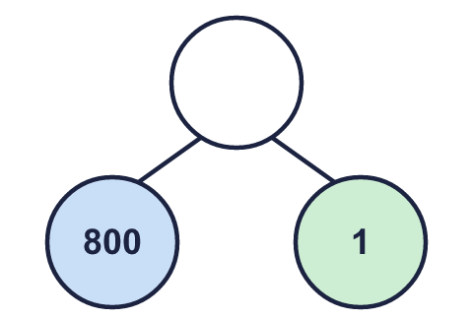
  5 | Complete the part-whole models.
    a) | b) | c)
  6 | Write the number.
    7 hundreds, 8 tens and 6 ones =
  6 | Write the number.
    7 hundreds, 8 tens and 6 ones =
  7 | Fill in the missing part of each number sentence.
    a) | 260 = | 200 | +
    b) | 206 = | 200 | +
  7 | Fill in the missing part of each number sentence.
    a) | 260 = | 200 | +
    b) | 206 = | 200 | +
  8 | A number is made of 6 hundreds, 19 tens and 9 ones. What is the number?
  8 | A number is made of 6 hundreds, 19 tens and 9 ones. What is the number?

  9 | a) Which part is wrong?  b) What should it be?
     | 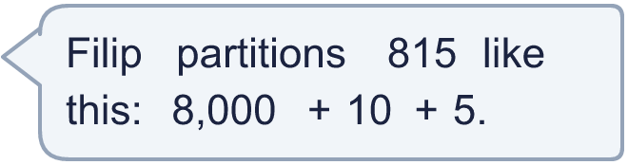
  9 | a) Which part is wrong?  b) What should it be?
  10 | Tom makes a 3-digit number greater than 600. What number could he have made? Partition your number.
     | 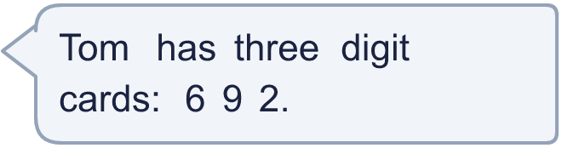
  10 | Tom makes a 3-digit number greater than 600. What number could he have made? Partition your number.
  11 | Esther spilt paint on a question: 5__ = 500 + __ + __  The number of tens is double the number of ones. Both the missing digits are less than 5.  Write all the numbers it could be.
  11 | Esther spilt paint on a question: 5__ = 500 + __ + __  The number of tens is double the number of ones. Both the missing digits are less than 5.  Write all the numbers it could be.
  12 | Complete the part-whole models. Each one shows 740 split in a different way.
    a)  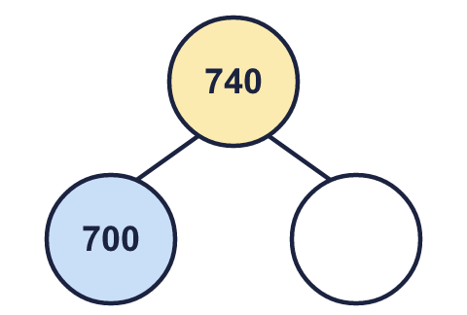 | b)  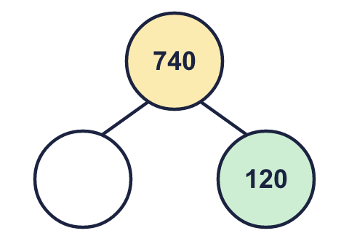 | c)  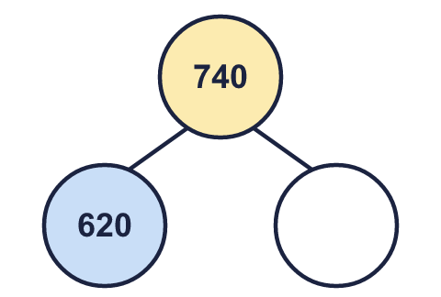
  12 | Complete the part-whole models. Each one shows 740 split in a different way.
    a) | b) | c)
  13 | 737 = 700 + ___ + ___  Write two different pairs of numbers that make this number sentence correct.
  13 | 737 = 700 + ___ + ___  Write two different pairs of numbers that make this number sentence correct.
  14 | Write 543 in three different ways using hundreds, tens and ones. For example, 5 hundreds, 4 tens and 3 ones.
  14 | Write 543 in three different ways using hundreds, tens and ones. For example, 5 hundreds, 4 tens and 3 ones.

Year 4 · Place value · Step 2
Partition numbers to 1000
Answers (teacher copy)

  1 | Complete the number sentence.  356 = 300 + 50 + 6
  2 | Complete the number sentence. One of the places is empty, so there are only two parts.  904 = 900 + 4
  3 | Fill in the missing part of each number sentence.  a) 473 = 400 + 70 + 3  b) 796 = 700 + 96  c) 861 = 800 + 60 + 1
  4 | Complete the sentences about 643.  a) The number of hundreds is 6  b) The number of tens in the tens place is 4  c) The number of ones is 3
  5 | Complete the part-whole models.  a) 21 b) 700 c) 801
    a)  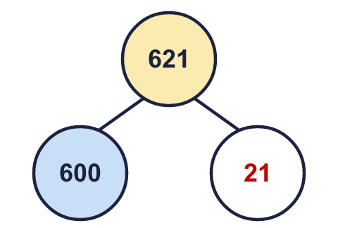 | b)  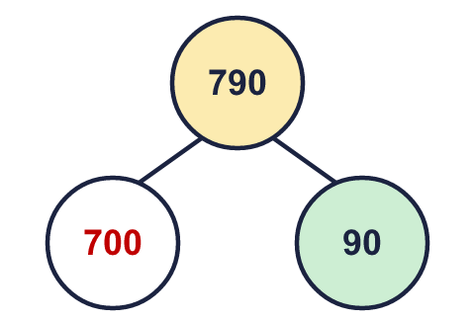 | c)  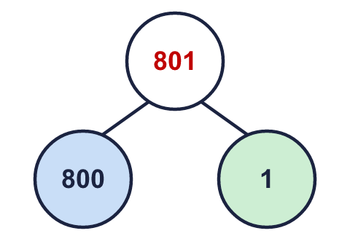
  6 | Write the number.  7 hundreds, 8 tens and 6 ones = 786
  7 | Fill in the missing part of each number sentence.  a) 260 = 200 + 60  b) 206 = 200 + 6
  8 | A number is made of 6 hundreds, 19 tens and 9 ones. What is the number?  799
  9 | a) Which part is wrong? 8,000  b) What should it be? 800
  10 | Tom makes a 3-digit number greater than 600. What number could he have made? Partition your number.  for example 962 = 900 + 60 + 2
  11 | Esther spilt paint on a question: 5__ = 500 + __ + __  The number of tens is double the number of ones. Both the missing digits are less than 5.  Write all the numbers it could be.  500, 521, 542
  12 | Complete the part-whole models. Each one shows 740 split in a different way.  a) 40 b) 620 c) 120
    a)  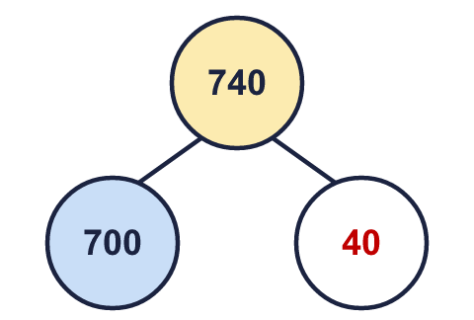 | b)  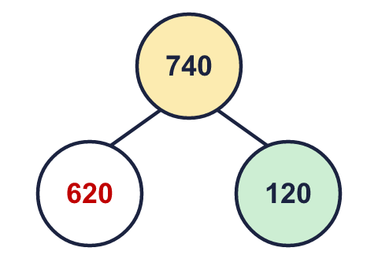 | c)  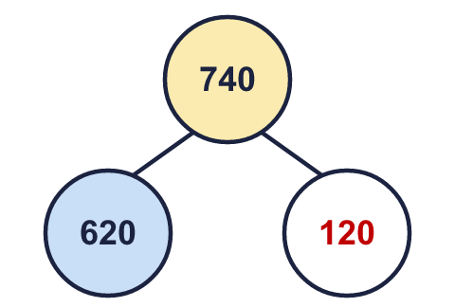
  13 | 737 = 700 + ___ + ___  Write two different pairs of numbers that make this number sentence correct.  Any two pairs that add to 37, for example 30 and 7; 20 and 17
  14 | Write 543 in three different ways using hundreds, tens and ones. For example, 5 hundreds, 4 tens and 3 ones.  for example 5 hundreds and 43 ones; 4 hundreds and 143 ones; 54 tens and 3 ones

