  Year 4 · Place value · Step 2  Partition numbers to 10,000 | 
  Year 4 · Place value · Step 2
  Partition numbers to 10,000
  1 | Partition the number. Fill in the missing parts.
    3,885 =
    3,000 | + |  | + | 80 | +
  1 | Partition the number. Fill in the missing parts.
    3,885 =
    3,000 | + |  | + | 80 | +
  2 | Partition the number. Fill in the missing parts.
    9,105 =
    9,000 | + |  | +
  2 | Partition the number. Fill in the missing parts.
    9,105 =
    9,000 | + |  | +
  3 | Fill in the missing part of each number sentence.
    a) | 9,622 = | 9,600 | +
    b) | 7,145 =
    7,000 | + | 140 | +
    c) | 4,895 =
    4,000 | + | 800 | +
  3 | Fill in the missing part of each number sentence.
    a) | 9,622 = | 9,600 | +
    b) | 7,145 =
    7,000 | + | 140 | +
    c) | 4,895 =
    4,000 | + | 800 | +
  4 | Complete the part-whole models.
    a)  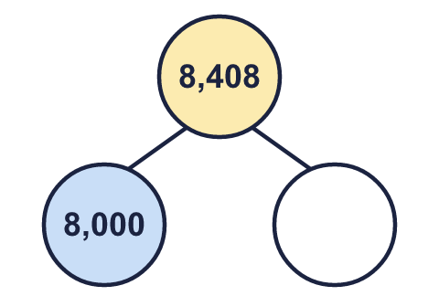 | b)  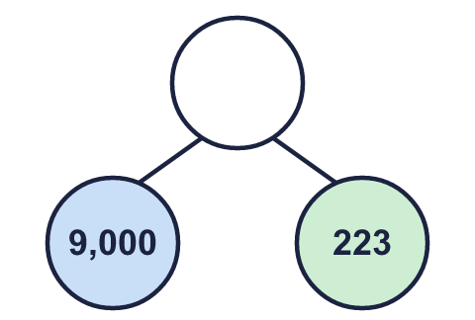 | c)  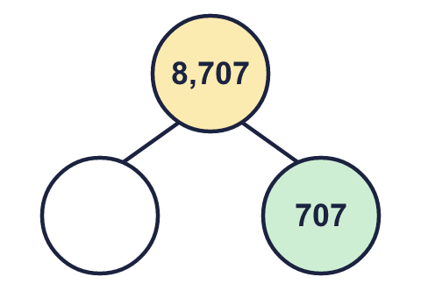
  4 | Complete the part-whole models.
    a) | b) | c)
  5 | A number is made of 6 thousands, 4 ones, 6 tens and 2 hundreds. What is the number?
  5 | A number is made of 6 thousands, 4 ones, 6 tens and 2 hundreds. What is the number?
  6 | Write each as a number.  a) 23 hundreds =  b) 230 tens =  c) 4 thousands and 15 hundreds =
  6 | Write each as a number.  a) 23 hundreds =  b) 230 tens =  c) 4 thousands and 15 hundreds =
  7 | Fill in the missing part of each number sentence. The parts are not always in the usual columns.
    a) | 3,623 = |  | + | 623
    b) | 7,413 = |  | + | 3
    c) | 7,226 =
     | + | 200 | + | 26
  7 | Fill in the missing part of each number sentence. The parts are not always in the usual columns.
    a) | 3,623 = |  | + | 623
    b) | 7,413 = |  | + | 3
    c) | 7,226 =
     | + | 200 | + | 26
  8 | Partition each number into its thousands part and its rest.
    a) | 8,186 = |  | + | 186
    b) | 2,733 = | 2,000 | +
    c) | 1,242 = |  | + | 242
  8 | Partition each number into its thousands part and its rest.
    a) | 8,186 = |  | + | 186
    b) | 2,733 = | 2,000 | +
    c) | 1,242 = |  | + | 242

  9 | What number am I thinking of?
     | 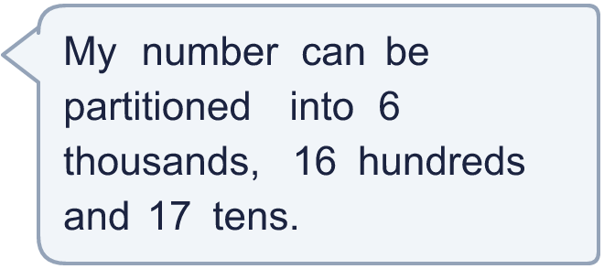
  9 | What number am I thinking of?
  10 | Partition 2,663 in three different ways. Each way must add up to 2,663.
  10 | Partition 2,663 in three different ways. Each way must add up to 2,663.
  11 | Which of these are equal to 8,000? Write the letters.  a) 1,000 more than 9,000  b) 800 hundreds  c) 4,000 + 4,000  d) 800 tens  e) 80 tens  f) 7,800 + 200
  11 | Which of these are equal to 8,000? Write the letters.  a) 1,000 more than 9,000  b) 800 hundreds  c) 4,000 + 4,000  d) 800 tens  e) 80 tens  f) 7,800 + 200
  12 | a) Which part is wrong?  b) What should it be?
     | 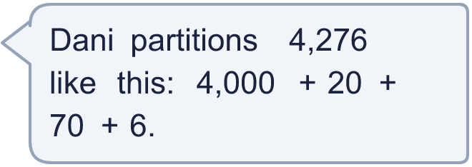
  12 | a) Which part is wrong?  b) What should it be?
  13 | Complete the part-whole models. Each one shows 5,800 split in a different way.
    a)  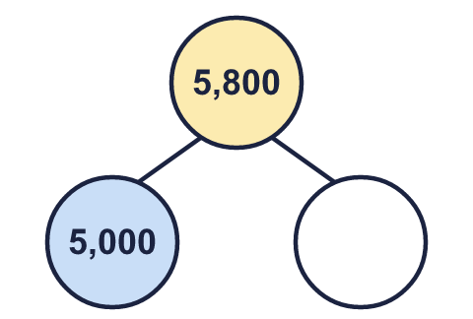 | b)  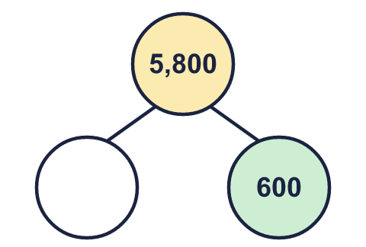 | c)  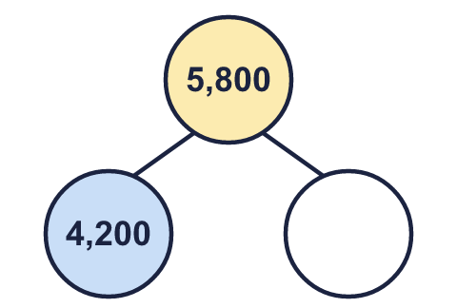
  13 | Complete the part-whole models. Each one shows 5,800 split in a different way.
    a) | b) | c)
  14 | 8,555 = 8,000 + ___ + ___ + 5  Write two different pairs of numbers that make this number sentence correct.
  14 | 8,555 = 8,000 + ___ + ___ + 5  Write two different pairs of numbers that make this number sentence correct.

Year 4 · Place value · Step 2
Partition numbers to 10,000
Answers (teacher copy)

  1 | Partition the number. Fill in the missing parts.  3,885 = 3,000 + 800 + 80 + 5
  2 | Partition the number. Fill in the missing parts.  9,105 = 9,000 + 100 + 5
  3 | Fill in the missing part of each number sentence.  a) 9,622 = 9,600 + 22  b) 7,145 = 7,000 + 140 + 5  c) 4,895 = 4,000 + 800 + 95
  4 | Complete the part-whole models.  a) 408 b) 9,223 c) 8,000
    a)  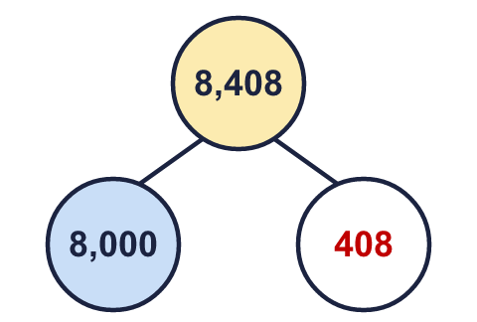 | b)  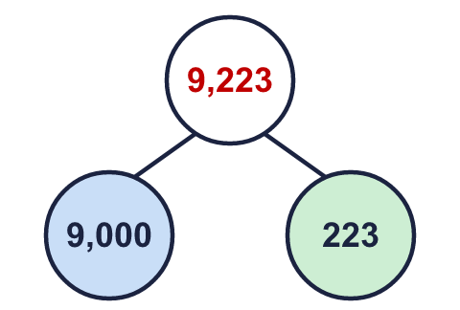 | c)  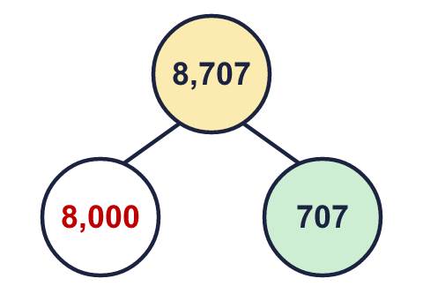
  5 | A number is made of 6 thousands, 4 ones, 6 tens and 2 hundreds. What is the number?  6,264
  6 | Write each as a number.  a) 23 hundreds = 2,300  b) 230 tens = 2,300  c) 4 thousands and 15 hundreds = 5,500
  7 | Fill in the missing part of each number sentence. The parts are not always in the usual columns.  a) 3,623 = 3,000 + 623  b) 7,413 = 7,410 + 3  c) 7,226 = 7,000 + 200 + 26
  8 | Partition each number into its thousands part and its rest.  a) 8,186 = 8,000 + 186  b) 2,733 = 2,000 + 733  c) 1,242 = 1,000 + 242
  9 | What number am I thinking of? 7,770
  10 | Partition 2,663 in three different ways. Each way must add up to 2,663.  Any three correct ways, for example 2,000 + 600 + 60 + 3; 2,000 + 663; 2,600 + 63
  11 | Which of these are equal to 8,000? Write the letters.  a) 1,000 more than 9,000  b) 800 hundreds  c) 4,000 + 4,000  d) 800 tens  e) 80 tens  f) 7,800 + 200  c and d and f
  12 | a) Which part is wrong? 20  b) What should it be? 200
  13 | Complete the part-whole models. Each one shows 5,800 split in a different way.  a) 800 b) 5,200 c) 1,600
    a)  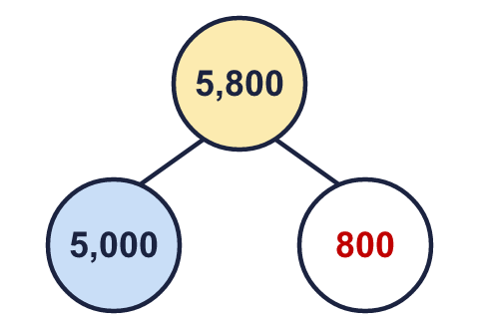 | b)  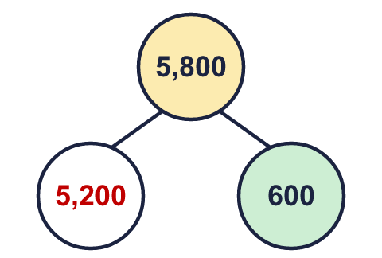 | c)  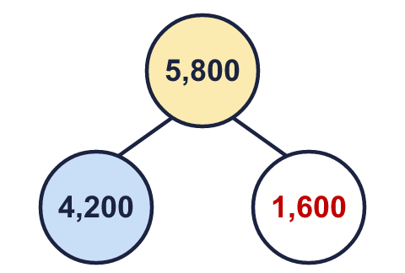
  14 | 8,555 = 8,000 + ___ + ___ + 5  Write two different pairs of numbers that make this number sentence correct.  Any two pairs that add to 550, for example 500 and 50; 400 and 150

