  Year 4 · Place value · Step 12  Order numbers to 10,000 | 
  Year 4 · Place value · Step 12
  Order numbers to 10,000
  1 | Write the numbers in order. Start with the greatest number.  7,690 7,620 7,670
  1 | Write the numbers in order. Start with the greatest number.  7,690 7,620 7,670
  2 | Write the numbers in order.  a) smallest first: 3,238 2,923 3,805 2,695  b) largest first: 898 961 248 345
  2 | Write the numbers in order.  a) smallest first: 3,238 2,923 3,805 2,695  b) largest first: 898 961 248 345
  3 | Circle the greatest number. Write it.  a) 2,366 8,528 5,041 5,338
  3 | Circle the greatest number. Write it.  a) 2,366 8,528 5,041 5,338
  4 | Circle the smallest number in each set. Write it.  a) 4,714 2,757 4,174 131  b) 7,160 7,400 7,230 7,600  c) 8,606 8,660 8,760 8,657
  4 | Circle the smallest number in each set. Write it.  a) 4,714 2,757 4,174 131  b) 7,160 7,400 7,230 7,600  c) 8,606 8,660 8,760 8,657
  5 | Write the numbers in order.  a) smallest first: 1,814 388 9,812 389 6,716
  5 | Write the numbers in order.  a) smallest first: 1,814 388 9,812 389 6,716
  6 | The table shows the distances of five cities from London.  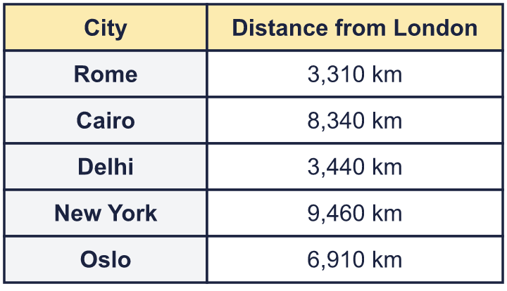  a) Which city is closest to London?  b) Which city is furthest from London?  c) Which city is 3rd closest to London?
  6 | The table shows the distances of five cities from London.  a) Which city is closest to London?  b) Which city is furthest from London?  c) Which city is 3rd closest to London?
  7 | Whitney, Tom and Dani make numbers with place value counters.  Whitney: 5 thousands, 4 hundreds, 0 tens and 6 ones  Tom: 6 thousands, 4 hundreds, 6 tens and 4 ones  Dani: 5 thousands, 8 hundreds, 6 tens and 6 ones  a) Who made the greatest number?  b) Write the numbers in order, smallest first.
  7 | Whitney, Tom and Dani make numbers with place value counters.  Whitney: 5 thousands, 4 hundreds, 0 tens and 6 ones  Tom: 6 thousands, 4 hundreds, 6 tens and 4 ones  Dani: 5 thousands, 8 hundreds, 6 tens and 6 ones  a) Who made the greatest number?  b) Write the numbers in order, smallest first.
  8 | Teddy uses ten counters to make 7,300 on a place value chart.  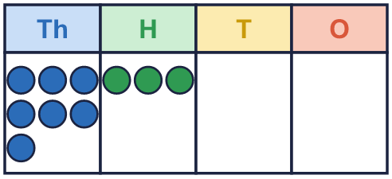  a) Rearrange the counters to make a number that is less than Teddy’s. Use all ten counters.  b) Rearrange the counters to make a number that is greater than Teddy’s. Use all ten counters.
  8 | Teddy uses ten counters to make 7,300 on a place value chart.  a) Rearrange the counters to make a number that is less than Teddy’s. Use all ten counters.  b) Rearrange the counters to make a number that is greater than Teddy’s. Use all ten counters.

  9 | Is Jack correct? Circle yes or no.  Yes / No  Explain the mistake.
     | 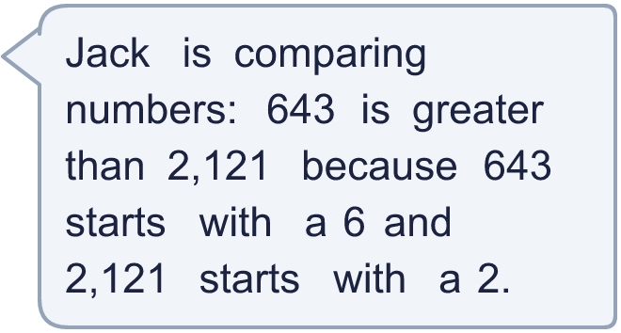
  9 | Is Jack correct? Circle yes or no.  Yes / No  Explain the mistake.
  10 | These numbers are in order from smallest to greatest. Each has a digit missing.  7,_65 7,51_ 7,_61  What could each missing digit be? List all the digits that could work.  a) 7,_65 :  b) 7,51_ :  c) 7,_61 :
  10 | These numbers are in order from smallest to greatest. Each has a digit missing.  7,_65 7,51_ 7,_61  What could each missing digit be? List all the digits that could work.  a) 7,_65 :  b) 7,51_ :  c) 7,_61 :
  11 | 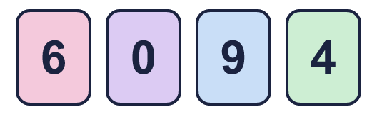  a) What is the largest 4-digit number I can make?  b) What is the smallest 4-digit number I can make?  c) How much greater is the largest than the smallest?
    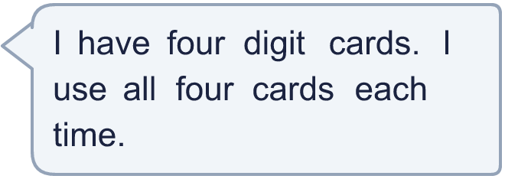
  11 | a) What is the largest 4-digit number I can make?  b) What is the smallest 4-digit number I can make?  c) How much greater is the largest than the smallest?
  12 | 333 1,223 6,825 4,319 8,741  Is Tiara correct? Circle yes or no.  Yes / No  Explain how you know.
     | 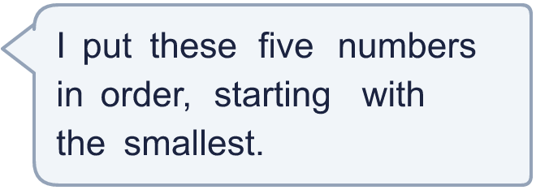
  12 | 333 1,223 6,825 4,319 8,741  Is Tiara correct? Circle yes or no.  Yes / No  Explain how you know.
  13 | These numbers are all close to 5,000. Write them in order.  a) smallest first: 5,001 4,999 4,990 5,010  b) largest first: 5,009 5,100 4,900 4,991
  13 | These numbers are all close to 5,000. Write them in order.  a) smallest first: 5,001 4,999 4,990 5,010  b) largest first: 5,009 5,100 4,900 4,991
  14 | Use five counters to make four different numbers in a place value chart. Write your numbers in order, smallest first.  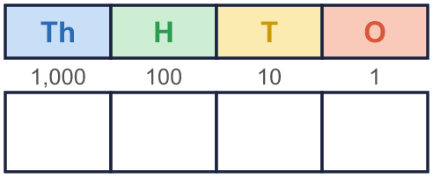
  14 | Use five counters to make four different numbers in a place value chart. Write your numbers in order, smallest first.

Year 4 · Place value · Step 12
Order numbers to 10,000
Answers (teacher copy)

  1 | Write the numbers in order. Start with the greatest number.  7,690 7,620 7,670  7,690, 7,670, 7,620
  2 | Write the numbers in order.  a) smallest first: 3,238 2,923 3,805 2,695  2,695, 2,923, 3,238, 3,805  b) largest first: 898 961 248 345  961, 898, 345, 248
  3 | Circle the greatest number. Write it.  a) 2,366 8,528 5,041 5,338 8,528
  4 | Circle the smallest number in each set. Write it.  a) 4,714 2,757 4,174 131 131  b) 7,160 7,400 7,230 7,600 7,160  c) 8,606 8,660 8,760 8,657 8,606
  5 | Write the numbers in order.  a) smallest first: 1,814 388 9,812 389 6,716  388, 389, 1,814, 6,716, 9,812
  6 | The table shows the distances of five cities from London.  a) Which city is closest to London? Rome  b) Which city is furthest from London? New York  c) Which city is 3rd closest to London? Oslo
  7 | Whitney, Tom and Dani make numbers with place value counters.  Whitney: 5 thousands, 4 hundreds, 0 tens and 6 ones  Tom: 6 thousands, 4 hundreds, 6 tens and 4 ones  Dani: 5 thousands, 8 hundreds, 6 tens and 6 ones  a) Who made the greatest number? Tom  b) Write the numbers in order, smallest first. 5,406, 5,866, 6,464
  8 | Teddy uses ten counters to make 7,300 on a place value chart.  a) Rearrange the counters to make a number that is less than Teddy’s. Use all ten counters.  for example 6,301  b) Rearrange the counters to make a number that is greater than Teddy’s. Use all ten counters.  for example 8,200
  9 | Is Jack correct? Circle yes or no.  Yes / No  Explain the mistake.  Jack has only looked at the first digit. 2,121 has 2 thousands and 643 has 0 thousands, so 2,121 is greater.
  10 | These numbers are in order from smallest to greatest. Each has a digit missing.  7,_65 7,51_ 7,_61  What could each missing digit be? List all the digits that could work.  a) 7,_65 : 0, 1, 2, 3, 4  b) 7,51_ : 0, 1, 2, 3, 4, 5, 6, 7, 8, 9  c) 7,_61 : 5, 6, 7, 8, 9
  11 | a) What is the largest 4-digit number I can make? 9,640  b) What is the smallest 4-digit number I can make? 4,069  c) How much greater is the largest than the smallest? 5,571
  12 | 333 1,223 6,825 4,319 8,741  Is Tiara correct? Circle yes or no.  Yes / No  Explain how you know.  6,825 is bigger than 4,319, so it should come after it. The numbers should be: 333, 1,223, 4,319, 6,825, 8,741.
  13 | These numbers are all close to 5,000. Write them in order.  a) smallest first: 5,001 4,999 4,990 5,010  4,990, 4,999, 5,001, 5,010  b) largest first: 5,009 5,100 4,900 4,991  5,100, 5,009, 4,991, 4,900
  14 | Use five counters to make four different numbers in a place value chart. Write your numbers in order, smallest first.  Any four different numbers whose digits add up to 5, for example 1,004, 1,211, 2,003, 3,101

