  Year 4 · Place value · Step 3  Number line to 1000 | 
  Year 4 · Place value · Step 3
  Number line to 1000
  1 | Complete the number line.  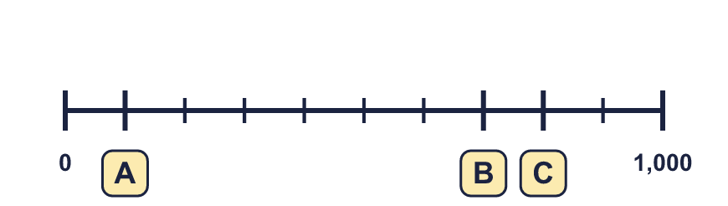
  1 | Complete the number line.
  2 | What numbers are the arrows pointing to?  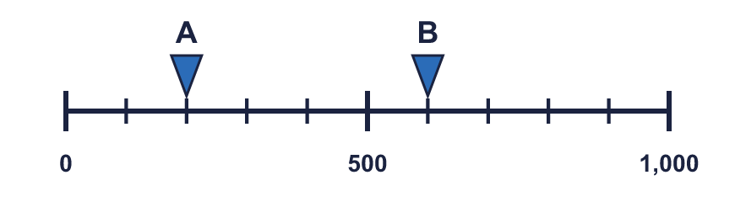
  2 | What numbers are the arrows pointing to?
  3 | Which arrow points to 900? Write its letter.  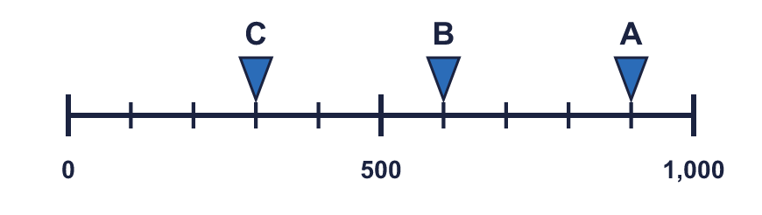  Answer:
  3 | Which arrow points to 900? Write its letter.  Answer:
  4 | What number is the arrow pointing to?
    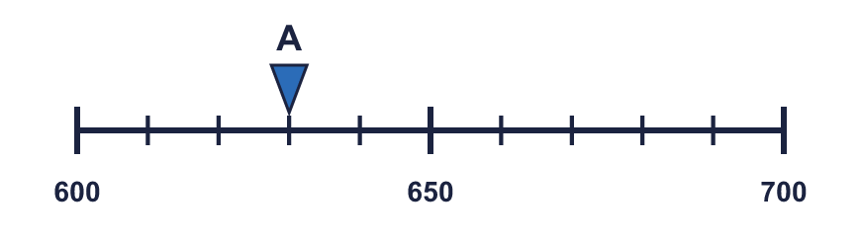
  4 | What number is the arrow pointing to?
  5 | Look at the number line.  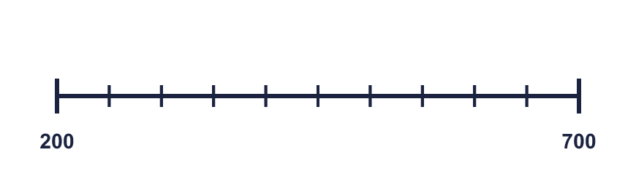  The difference between the start and the end is  The line counts up in
    There are |  | equal intervals.
  5 | Look at the number line.  The difference between the start and the end is  The line counts up in
    There are |  | equal intervals.
  6 | Write the missing numbers on the line.  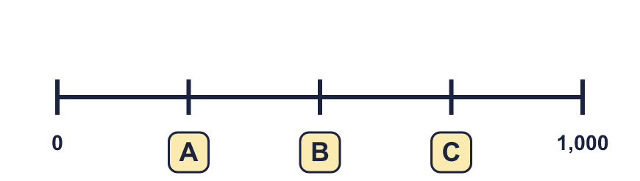
  6 | Write the missing numbers on the line.
  7 | What numbers are the arrows pointing to?  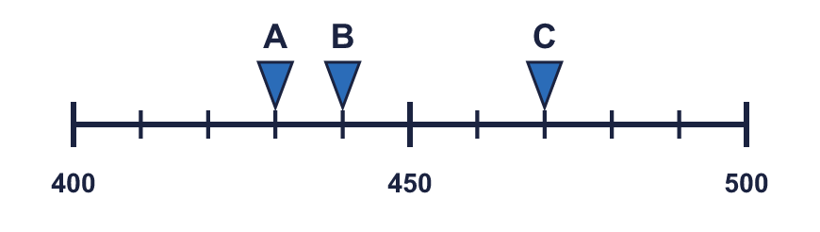
  7 | What numbers are the arrows pointing to?
  8 | The arrow is between two marks. Which number is it closest to? Write the letter.  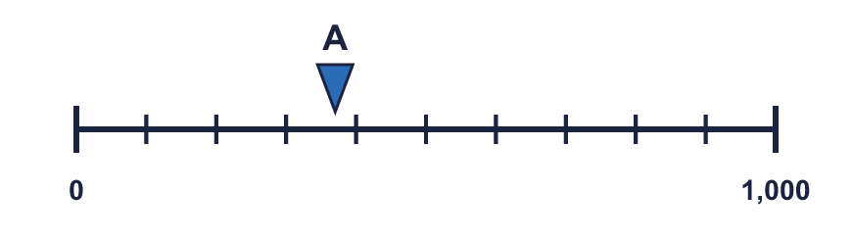  a) 100  b) 400  c) 700  Answer:
  8 | The arrow is between two marks. Which number is it closest to? Write the letter.  a) 100  b) 400  c) 700  Answer:

  9 | 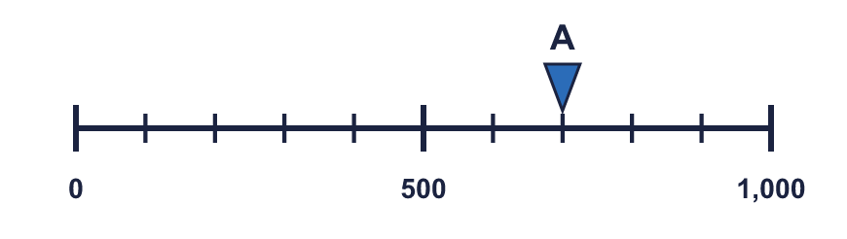  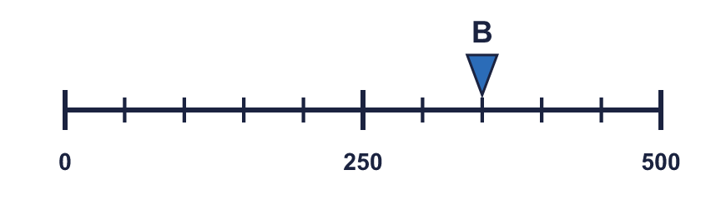  Is Boba correct? Circle yes or no.  Yes / No  Explain how you know.
    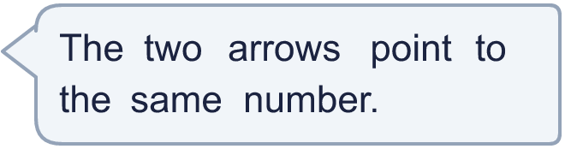
  9 | Is Boba correct? Circle yes or no.  Yes / No  Explain how you know.
  10 | 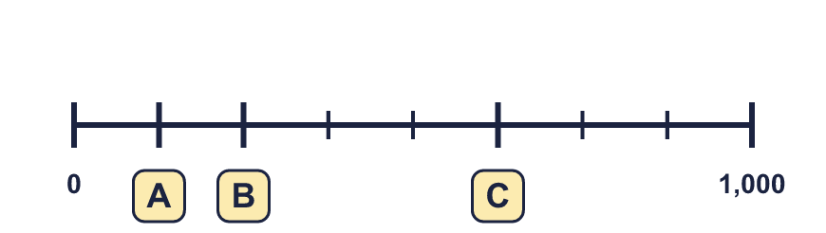
     | 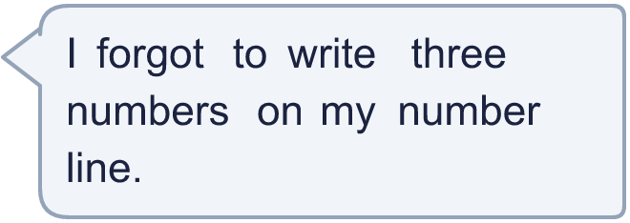
  10
  11 | 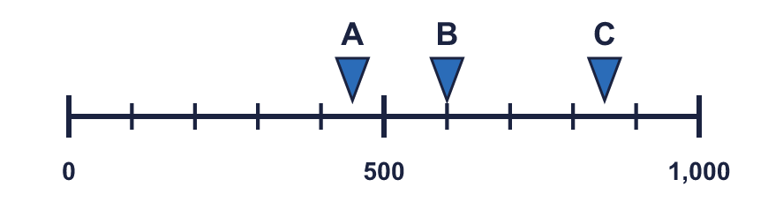  a) What number is arrow A pointing to?  b) What is the difference between B and C?
     | 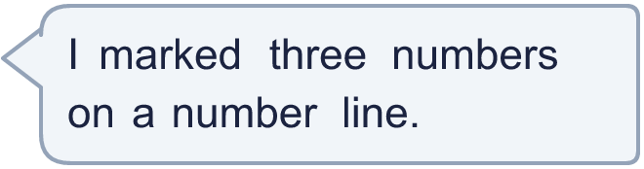
  11 | a) What number is arrow A pointing to?  b) What is the difference between B and C?
  12 | What numbers are the arrows pointing to?  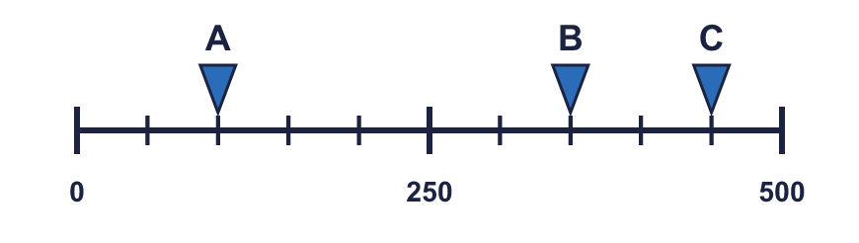
  12 | What numbers are the arrows pointing to?
  13 | 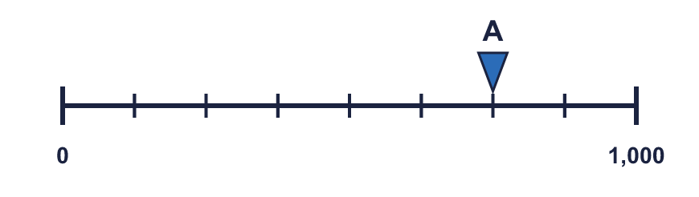  a) What is each step worth?  b) What number is arrow A pointing to?
     | 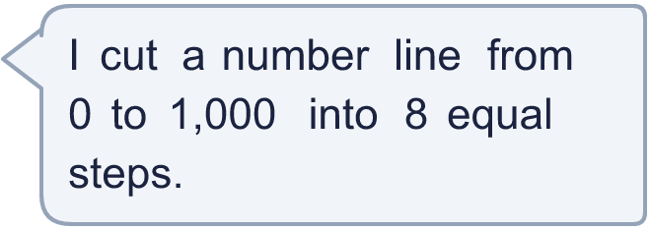
  13 | a) What is each step worth?  b) What number is arrow A pointing to?
  14 | 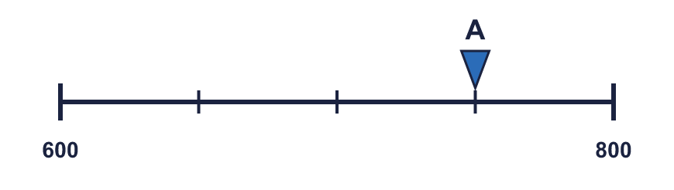  a) What mistake has Boba made?  b) What number is arrow A pointing to?
    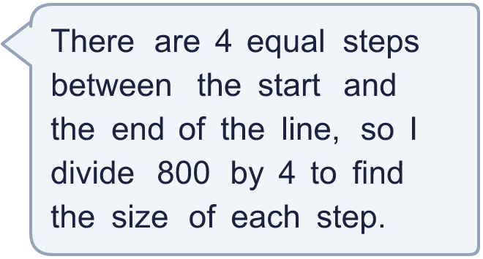
  14 | a) What mistake has Boba made?  b) What number is arrow A pointing to?

Year 4 · Place value · Step 3
Number line to 1000
Answers (teacher copy)

  1 | Complete the number line.  A = 100 B = 700 C = 800
  2 | What numbers are the arrows pointing to?  A = 200 B = 600
  3 | Which arrow points to 900? Write its letter.  Answer: A
  4 | What number is the arrow pointing to?
    630
  5 | Look at the number line.  The difference between the start and the end is 500  There are 10 equal intervals.  The line counts up in 50
  6 | Write the missing numbers on the line.  A = 250 B = 500 C = 750
  7 | What numbers are the arrows pointing to?  A = 430 B = 440 C = 470
  8 | The arrow is between two marks. Which number is it closest to? Write the letter.  a) 100  b) 400  c) 700  Answer: b
  9 | Is Boba correct? Circle yes or no.  Yes / No  Explain how you know.  Arrow A points to 700 and arrow B points to 350. The lines have different scales: line A ends at 1,000 and line B ends at 500.
  10 | A = 125 B = 250 C = 625
  11 | a) What number is arrow A pointing to? 450  b) What is the difference between B and C? 250
  12 | What numbers are the arrows pointing to?  A = 100 B = 350 C = 450
  13 | a) What is each step worth? 125  b) What number is arrow A pointing to? 750
  14 | a) What mistake has Boba made?  Boba divided the end number. The line does not start at 0, so each step is (800 − 600) ÷ 4 = 50.  b) What number is arrow A pointing to? 750

