  Year 4 · Place value · Step 9  Number line to 10,000 | 
  Year 4 · Place value · Step 9
  Number line to 10,000
  1 | What numbers are the arrows pointing to?  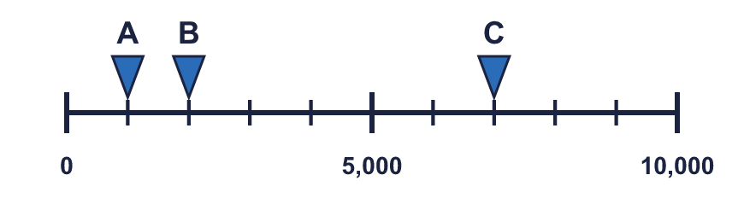
  1 | What numbers are the arrows pointing to?
  2 | What numbers are the arrows pointing to?  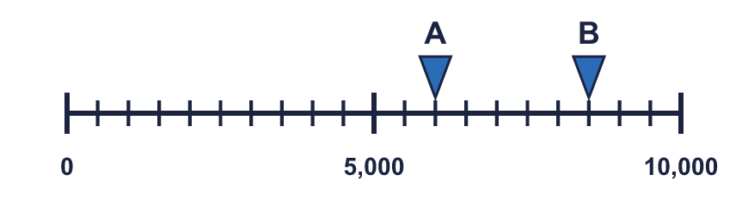
  2 | What numbers are the arrows pointing to?
  3 | Which arrow points to 6,000? Write its letter.  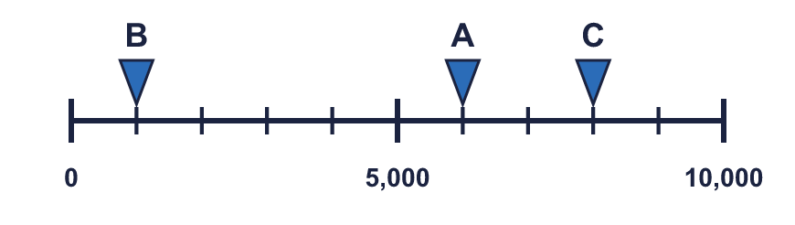  Answer:
  3 | Which arrow points to 6,000? Write its letter.  Answer:
  4 | What number is the arrow pointing to?  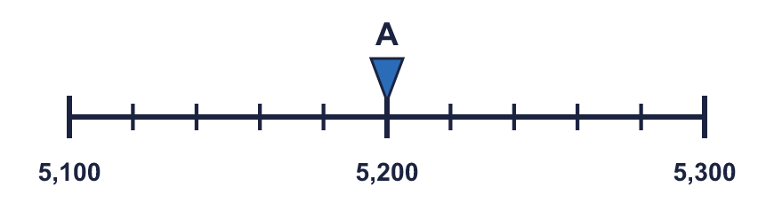
  4 | What number is the arrow pointing to?
  5 | Complete the number line.  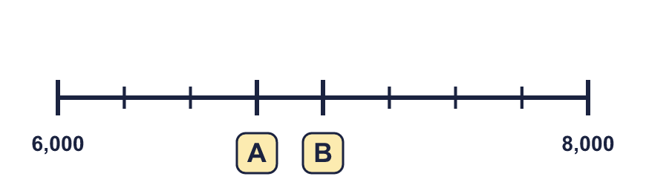
  5 | Complete the number line.
  6 | What numbers are the arrows pointing to?  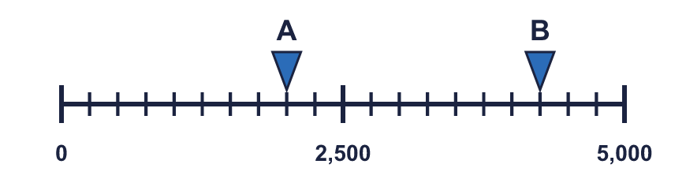
  6 | What numbers are the arrows pointing to?
  7 | Look at the number line.  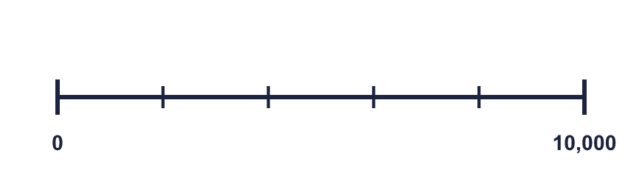  The difference between the start and the end is  The line counts up in
    There are |  | equal intervals.
  7 | Look at the number line.  The difference between the start and the end is  The line counts up in
    There are |  | equal intervals.
  8 | What numbers are the arrows pointing to?  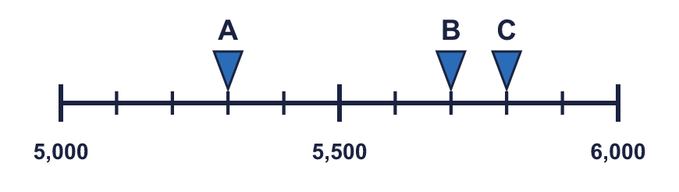
  8 | What numbers are the arrows pointing to?

  9 | 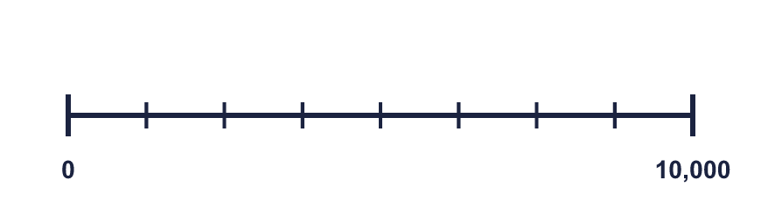  Is Dexter correct? Circle yes or no.  Yes / No  Explain how you know.
     | 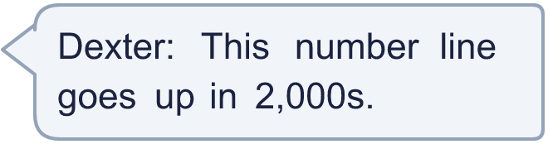
  9 | Is Dexter correct? Circle yes or no.  Yes / No  Explain how you know.
  10 | 4,800 is exactly halfway between two numbers on a number line.  Write two different pairs of numbers that it could be between.
  10 | 4,800 is exactly halfway between two numbers on a number line.  Write two different pairs of numbers that it could be between.
  11 | 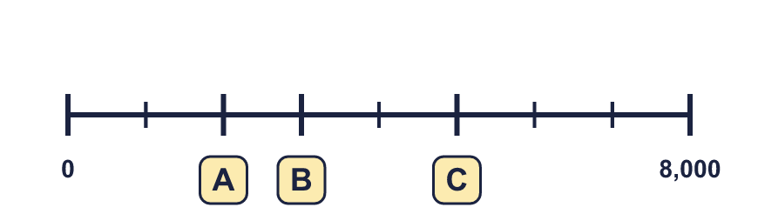
    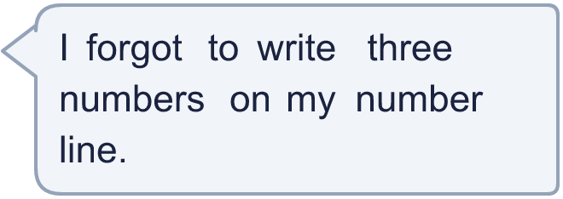
  11
  12 | 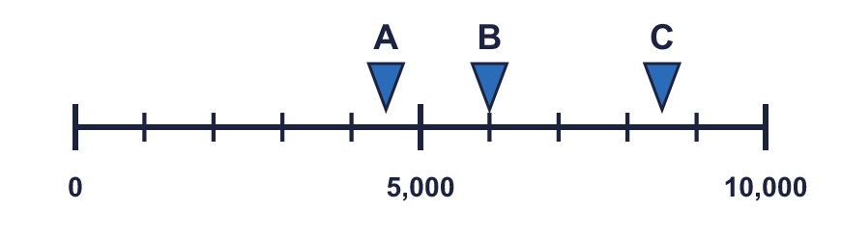  a) What number is arrow A pointing to?  b) What is the difference between B and C?
     | 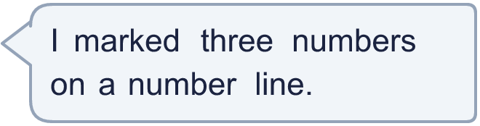
  12 | a) What number is arrow A pointing to?  b) What is the difference between B and C?
  13 | 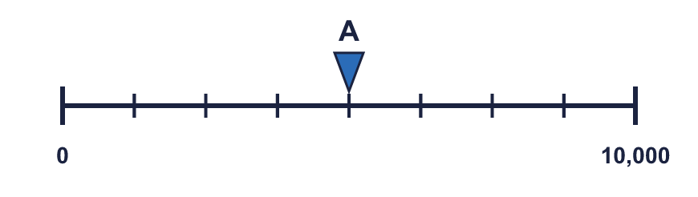  a) What is each step worth?  b) What number is arrow A pointing to?
     | 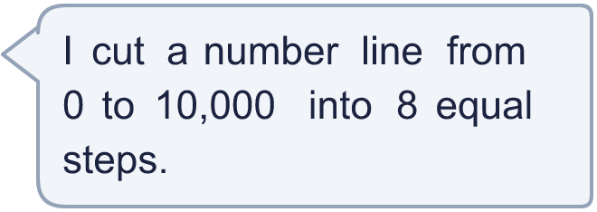
  13 | a) What is each step worth?  b) What number is arrow A pointing to?
  14 | 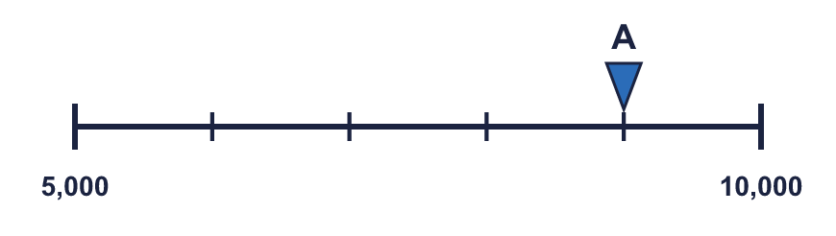  a) What mistake has Boba made?  b) What number is arrow A pointing to?
    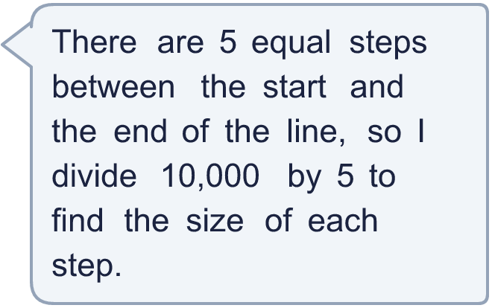
  14 | a) What mistake has Boba made?  b) What number is arrow A pointing to?

Year 4 · Place value · Step 9
Number line to 10,000
Answers (teacher copy)

  1 | What numbers are the arrows pointing to?  A = 1,000 B = 2,000 C = 7,000
  2 | What numbers are the arrows pointing to?  A = 6,000 B = 8,500
  3 | Which arrow points to 6,000? Write its letter.  Answer: A
  4 | What number is the arrow pointing to?  A = 5,200
  5 | Complete the number line.  A = 6,750 B = 7,000
  6 | What numbers are the arrows pointing to?  A = 2,000 B = 4,250
  7 | Look at the number line.  The difference between the start and the end is 10,000  There are 5 equal intervals.  The line counts up in 2,000
  8 | What numbers are the arrows pointing to?  A = 5,300 B = 5,700 C = 5,800
  9 | Is Dexter correct? Circle yes or no.  Yes / No  Explain how you know.  No. If it went up in 2,000s there would be 5 intervals between 0 and 10,000. There are 8 intervals on the number line, so it goes up in 1,250s.
  10 | 4,800 is exactly halfway between two numbers on a number line.  Write two different pairs of numbers that it could be between.  for example 4,700 and 4,900; 4,790 and 4,810
  11 | A = 2,000 B = 3,000 C = 5,000
  12 | a) What number is arrow A pointing to? 4,500  b) What is the difference between B and C? 2,500
  13 | a) What is each step worth? 1,250  b) What number is arrow A pointing to? 5,000
  14 | a) What mistake has Boba made?  Boba divided the end number. The line does not start at 0, so each step is (10,000 − 5,000) ÷ 5 = 1,000.  b) What number is arrow A pointing to? 9,000

