  Year 4 · Place value · Step 7  Flexible partitioning of numbers to 10,000 | 
  Year 4 · Place value · Step 7
  Flexible partitioning of numbers to 10,000
  1 | Dani exchanges 1 hundred for 10 tens.  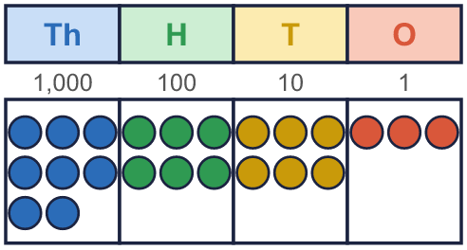
  1 | Dani exchanges 1 hundred for 10 tens.
  2 | Write each as a number.  a) 54 tens =  b) 29 hundreds =  c) 408 ones =
  2 | Write each as a number.  a) 54 tens =  b) 29 hundreds =  c) 408 ones =
  3 | Fill in the missing part.  a) 8,539 = 85 hundreds +  b) 7,617 = 760 tens +
  3 | Fill in the missing part.  a) 8,539 = 85 hundreds +  b) 7,617 = 760 tens +
  4 | Write <, > or = in each box.
    a) | 23 tens |  | 23 ones
    b) | 6 hundreds |  | 600
    c) | 23 tens + 6 ones |  | 236
    d) | 230 ones |  | 23 hundreds
  4 | Write <, > or = in each box.
    a) | 23 tens |  | 23 ones
    b) | 6 hundreds |  | 600
    c) | 23 tens + 6 ones |  | 236
    d) | 230 ones |  | 23 hundreds
  5 | A hundred, or a thousand, has been exchanged. Fill in the missing part of each sentence.
    a) | 3,531 =
    3,000 | + | 400 | + |  | + | 1
    b) | 6,684 =
    5,000 | + |  | + | 80 | + | 4
  5 | A hundred, or a thousand, has been exchanged. Fill in the missing part of each sentence.
    a) | 3,531 =
    3,000 | + | 400 | + |  | + | 1
    b) | 6,684 =
    5,000 | + |  | + | 80 | + | 4
  6 | Write each as a number of hundreds.
    a) | 8,200 = |  | hundreds
    b) | 8,000 = |  | hundreds
  6 | Write each as a number of hundreds.
    a) | 8,200 = |  | hundreds
    b) | 8,000 = |  | hundreds
  7 | Three of these cards show the same number. Which card is different?  a) 930 ones  b) 8 thousands and 13 hundreds  c) 9,000 + 300  d) 93 hundreds
  7 | Three of these cards show the same number. Which card is different?  a) 930 ones  b) 8 thousands and 13 hundreds  c) 9,000 + 300  d) 93 hundreds
  8 | Is Tommy correct? Circle yes or no.  Yes / No  Explain how you know.
     | 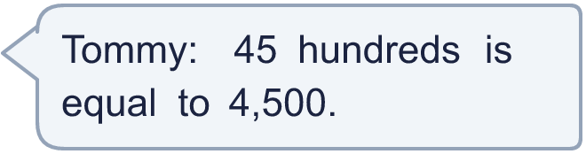
  8 | Is Tommy correct? Circle yes or no.  Yes / No  Explain how you know.

  9 | Write three parts each time to complete the number sentences. Each sentence must add to 5,756.  5,756 = 5,000 + ____ + ____ + ____  5,756 = 4,000 + ____ + ____ + ____  5,756 = 3,000 + ____ + ____ + ____
  9 | Write three parts each time to complete the number sentences. Each sentence must add to 5,756.  5,756 = 5,000 + ____ + ____ + ____  5,756 = 4,000 + ____ + ____ + ____  5,756 = 3,000 + ____ + ____ + ____
  10 | A number has 6 hundreds. The number of tens is double the number of ones. Both the tens and the ones are less than 6.  Write all the numbers it could be.
  10 | A number has 6 hundreds. The number of tens is double the number of ones. Both the tens and the ones are less than 6.  Write all the numbers it could be.
  11 | Is Alex correct? Circle yes or no.  Yes / No  Explain how you know.
    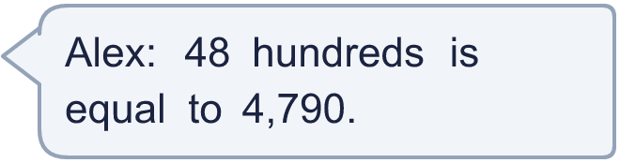
  11 | Is Alex correct? Circle yes or no.  Yes / No  Explain how you know.
  12 | Tommy exchanges 1 thousand for 10 hundreds.  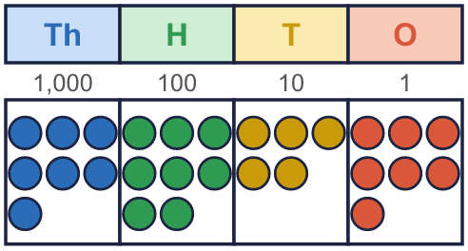
  12 | Tommy exchanges 1 thousand for 10 hundreds.
  13 | Write 2,700 in three different ways using thousands, hundreds or tens. For example, 1 thousands and 17 hundreds.
  13 | Write 2,700 in three different ways using thousands, hundreds or tens. For example, 1 thousands and 17 hundreds.
  14 | Write <, > or = in each box.
    a) | 5 thousands + 7 hundreds
    570 tens
    b) | 41 hundreds |  | 417 tens
    c) | 410 tens + 7 ones |  | 4,144
  14 | Write <, > or = in each box.
    a) | 5 thousands + 7 hundreds
    570 tens
    b) | 41 hundreds |  | 417 tens
    c) | 410 tens + 7 ones |  | 4,144

Year 4 · Place value · Step 7
Flexible partitioning of numbers to 10,000
Answers (teacher copy)

  1 | Dani exchanges 1 hundred for 10 tens.  How many hundreds are there now? 5  How many tens are there now? 16
  2 | Write each as a number.  a) 54 tens = 540  b) 29 hundreds = 2,900  c) 408 ones = 408
  3 | Fill in the missing part.  a) 8,539 = 85 hundreds + 39  b) 7,617 = 760 tens + 17
  4 | Write <, > or = in each box.  a) 23 tens > 23 ones  b) 6 hundreds = 600  c) 23 tens + 6 ones = 236  d) 230 ones < 23 hundreds
  5 | A hundred, or a thousand, has been exchanged. Fill in the missing part of each sentence.  a) 3,531 = 3,000 + 400 + 130 + 1  b) 6,684 = 5,000 + 1,600 + 80 + 4
  6 | Write each as a number of hundreds.  a) 8,200 = 82 hundreds  b) 8,000 = 80 hundreds
  7 | Three of these cards show the same number. Which card is different?  a) 930 ones  b) 8 thousands and 13 hundreds  c) 9,000 + 300  d) 93 hundreds  The different card is 930 ones
  8 | Is Tommy correct? Circle yes or no.  Yes / No  Explain how you know.  Yes. 45 hundreds is 4,500.
  9 | Write three parts each time to complete the number sentences. Each sentence must add to 5,756.  5,756 = 5,000 + ____ + ____ + ____  5,756 = 4,000 + ____ + ____ + ____  5,756 = 3,000 + ____ + ____ + ____  for example 250 + 250 + 256; 580 + 580 + 596; 910 + 920 + 926
  10 | A number has 6 hundreds. The number of tens is double the number of ones. Both the tens and the ones are less than 6.  Write all the numbers it could be.  600, 621, 642
  11 | Is Alex correct? Circle yes or no.  Yes / No  Explain how you know.  No. 48 hundreds is 4,800.
  12 | Tommy exchanges 1 thousand for 10 hundreds.  How many thousands are there now? 6  How many hundreds are there now? 18
  13 | Write 2,700 in three different ways using thousands, hundreds or tens. For example, 1 thousands and 17 hundreds.  for example 27 hundreds; 2 thousands and 7 hundreds; 270 tens
  14 | Write <, > or = in each box.  a) 5 thousands + 7 hundreds = 570 tens  b) 41 hundreds < 417 tens  c) 410 tens + 7 ones < 4,144

