  Year 4 · Place value · Step 3  Find 1, 10, 100 and 1,000 more or less | 
  Year 4 · Place value · Step 3
  Find 1, 10, 100 and 1,000 more or less
  1 | Complete the number track. It goes up in 10s.  
  1 | Complete the number track. It goes up in 10s.
  2 | Complete the number track. It goes down in 10s.  
  2 | Complete the number track. It goes down in 10s.
  3 | Complete the number track. It goes up in 100s.  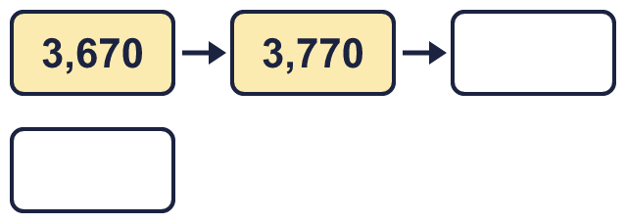
  3 | Complete the number track. It goes up in 100s.
  4 | Complete the number track. It goes up in 1,000s.  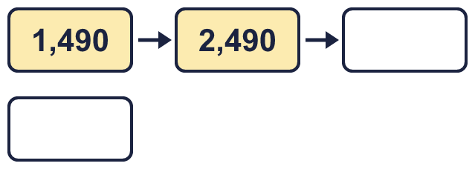
  4 | Complete the number track. It goes up in 1,000s.
  5 | This number is shown in the place value chart.  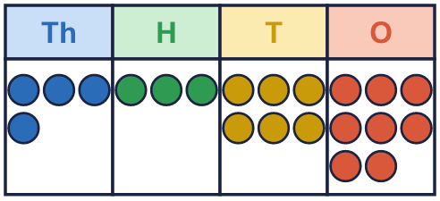  Work out the missing numbers.  a) 1,000 more than 4,368 =  b) 100 more than 4,368 =  c) 1 less than 4,368 =  d) 10 more than 4,368 =
  5 | This number is shown in the place value chart.  Work out the missing numbers.  a) 1,000 more than 4,368 =  b) 100 more than 4,368 =  c) 1 less than 4,368 =  d) 10 more than 4,368 =
  6 | Work out the missing numbers.  a) 1,000 more than 7,439 =  b) 100 less than 2,063 =  c) 10 more than 5,995 =
  6 | Work out the missing numbers.  a) 1,000 more than 7,439 =  b) 100 less than 2,063 =  c) 10 more than 5,995 =
  7 | Start with 2,586. Write the number that is...  a) 10 more =  b) 100 more =  c) 1,000 more =  d) 1 less =
  7 | Start with 2,586. Write the number that is...  a) 10 more =  b) 100 more =  c) 1,000 more =  d) 1 less =
  8 | Complete the number track. It goes down in 100s.  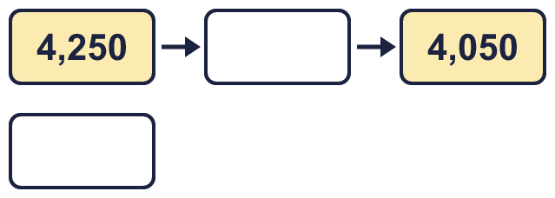
  8 | Complete the number track. It goes down in 100s.

  9 | 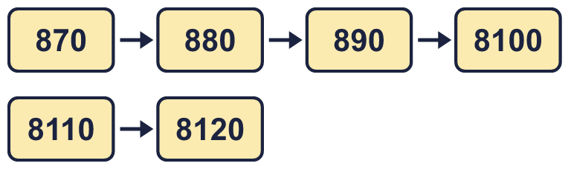  a) Explain the mistake Boba has made.  b) What number should come after 890?
     | 
  9 | a) Explain the mistake Boba has made.  b) What number should come after 890?
  10 | Is Boba correct? Circle yes or no.  Yes / No  Explain how you know.
    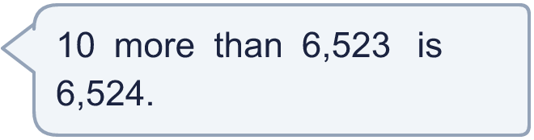
  10 | Is Boba correct? Circle yes or no.  Yes / No  Explain how you know.
  11 | Is Boba correct? Circle yes or no.  Yes / No  Explain how you know.
     | 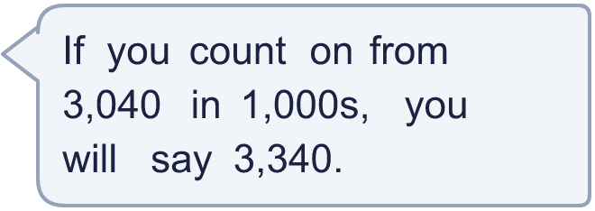
  11 | Is Boba correct? Circle yes or no.  Yes / No  Explain how you know.
  12 | a) How many times was it watched in April?  b) How many times was it watched in May?
    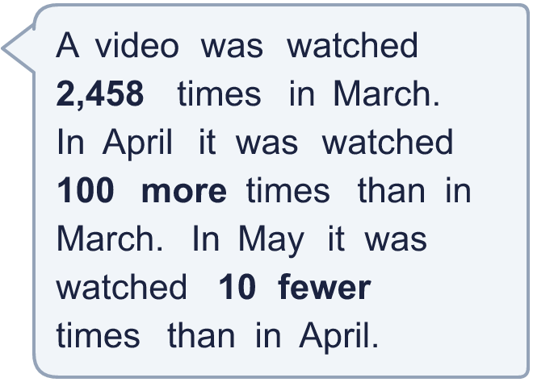
  12 | a) How many times was it watched in April?  b) How many times was it watched in May?
  13 | a) 100 more than my first number is 7,390. What is my first number?  b) 1,000 less than my second number is 3,238. What is my second number?
    
  13 | a) 100 more than my first number is 7,390. What is my first number?  b) 1,000 less than my second number is 3,238. What is my second number?
  14 | • Tia: "My number is 1,000 more than Rosie's."  • Malachi: "My number is 100 more than Rosie's."  • Zach: "My number is 10 less than Malachi's."  Match each child to their number.  Rosie  Tia  Malachi  Zach
     | 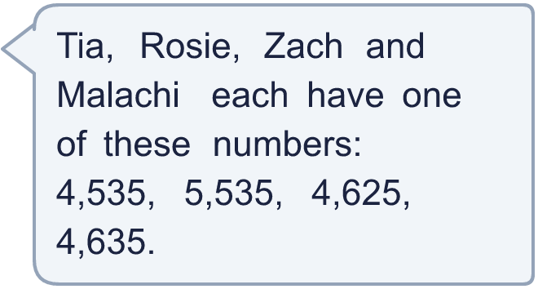
  14 | • Tia: "My number is 1,000 more than Rosie's."  • Malachi: "My number is 100 more than Rosie's."  • Zach: "My number is 10 less than Malachi's."  Match each child to their number.  Rosie  Tia  Malachi  Zach

Year 4 · Place value · Step 3
Find 1, 10, 100 and 1,000 more or less
Answers (teacher copy)

  1 | Complete the number track. It goes up in 10s.  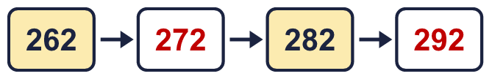
  2 | Complete the number track. It goes down in 10s.  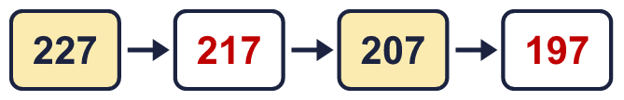
  3 | Complete the number track. It goes up in 100s.  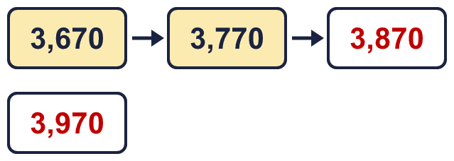
  4 | Complete the number track. It goes up in 1,000s.  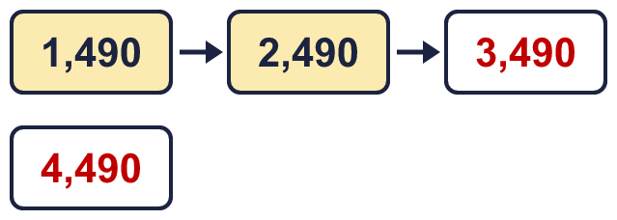
  5 | This number is shown in the place value chart.  Work out the missing numbers.  a) 1,000 more than 4,368 = 5,368  b) 100 more than 4,368 = 4,468  c) 1 less than 4,368 = 4,367  d) 10 more than 4,368 = 4,378
  6 | Work out the missing numbers.  a) 1,000 more than 7,439 = 8,439  b) 100 less than 2,063 = 1,963  c) 10 more than 5,995 = 6,005
  7 | Start with 2,586. Write the number that is...  a) 10 more = 2,596  b) 100 more = 2,686  c) 1,000 more = 3,586  d) 1 less = 2,585
  8 | Complete the number track. It goes down in 100s.  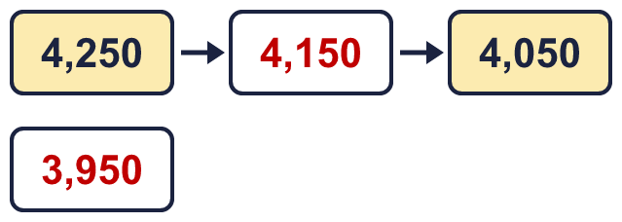
  9 | a) Explain the mistake Boba has made.  890 + 10 = 900, not 8100. When the tens column passes 90 the hundreds digit goes up by 1, so the tens column starts again at 0.  b) What number should come after 890? 900
  10 | Is Boba correct? Circle yes or no.  Yes / No  Explain how you know.  10 more than 6,523 is 6,533. Boba changed the wrong column: 6,524 is 1 more.
  11 | Is Boba correct? Circle yes or no.  Yes / No  Explain how you know.  Counting on in 1,000s from 3,040 you say 4,040, 5,040, 6,040... 3,340 is not one of them.
  12 | a) How many times was it watched in April? 2,558  b) How many times was it watched in May? 2,548
  13 | a) 100 more than my first number is 7,390. What is my first number? 7,290  b) 1,000 less than my second number is 3,238. What is my second number? 4,238
  14 | • Tia: "My number is 1,000 more than Rosie's."  • Malachi: "My number is 100 more than Rosie's."  • Zach: "My number is 10 less than Malachi's."  Match each child to their number.  Rosie 4,535  Tia 5,535  Malachi 4,635  Zach 4,625

