  Year 4 · Place value · Step 4  Estimate on a number line to 10,000 | 
  Year 4 · Place value · Step 4
  Estimate on a number line to 10,000
  1 | What number is the arrow pointing to?
    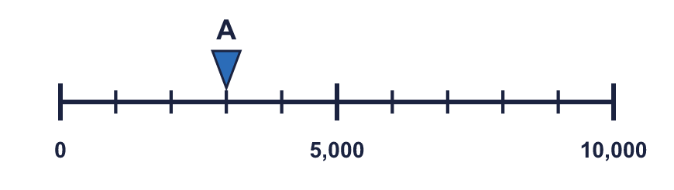
  1 | What number is the arrow pointing to?
  2 | What numbers are the arrows pointing to?  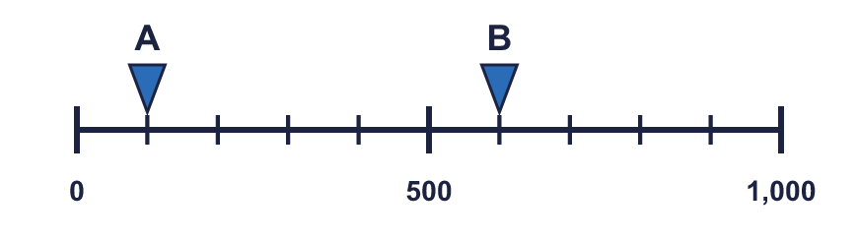
  2 | What numbers are the arrows pointing to?
  3 | Which arrow points to 1,000? Write its letter.  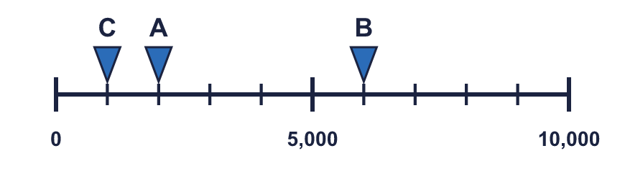  Answer:
  3 | Which arrow points to 1,000? Write its letter.  Answer:
  4 | Look at the number line.  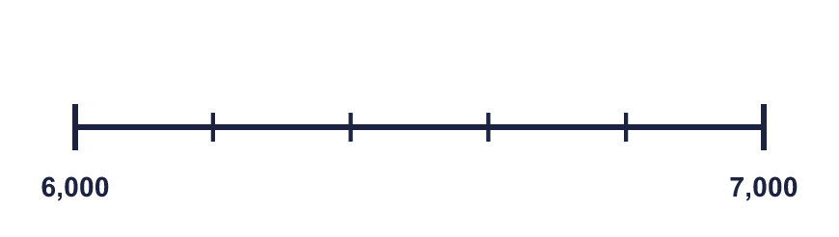  The difference between the start and the end is  The line counts up in
    There are |  | equal intervals.
  4 | Look at the number line.  The difference between the start and the end is  The line counts up in
    There are |  | equal intervals.
  5 | Write the missing numbers on the line.  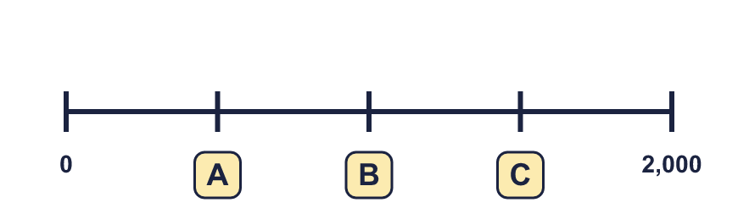
  5 | Write the missing numbers on the line.
  6 | What number is the arrow pointing to?
    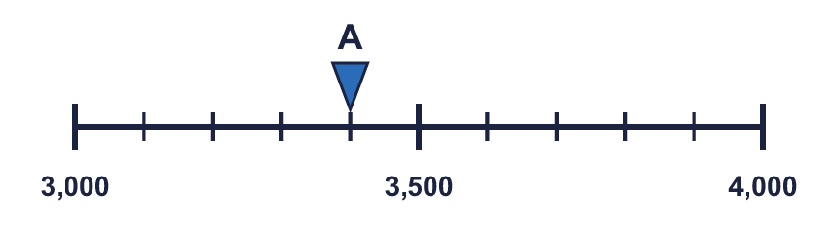
  6 | What number is the arrow pointing to?
  7 | What number is the arrow pointing to? It is exactly halfway between two marks.
    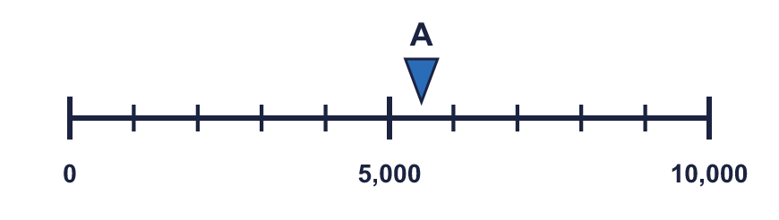
  7 | What number is the arrow pointing to? It is exactly halfway between two marks.
  8 | The arrow is between two marks. Which number is it closest to? Write the letter.  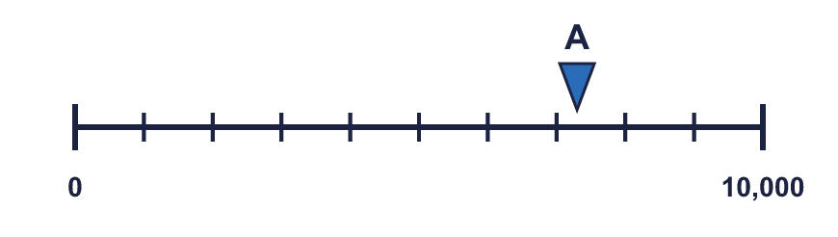  a) 7,500  b) 9,000  c) 5,500  Answer:
  8 | The arrow is between two marks. Which number is it closest to? Write the letter.  a) 7,500  b) 9,000  c) 5,500  Answer:

  9 | 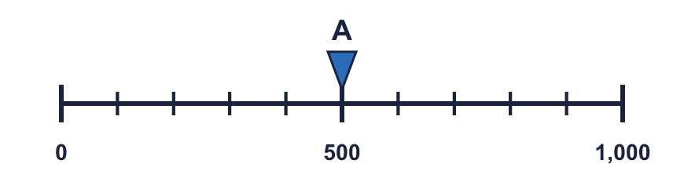  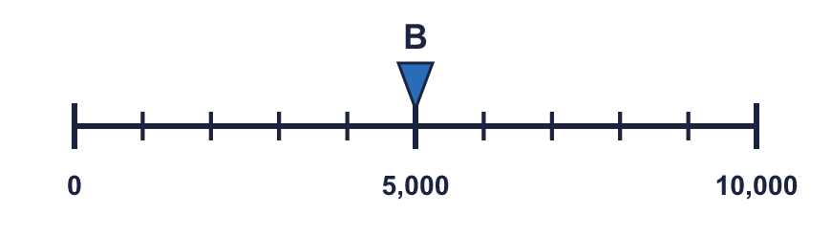  Is Boba correct? Circle yes or no.  Yes / No  Explain how you know.
    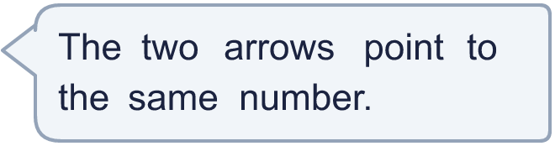
  9 | Is Boba correct? Circle yes or no.  Yes / No  Explain how you know.
  10 | 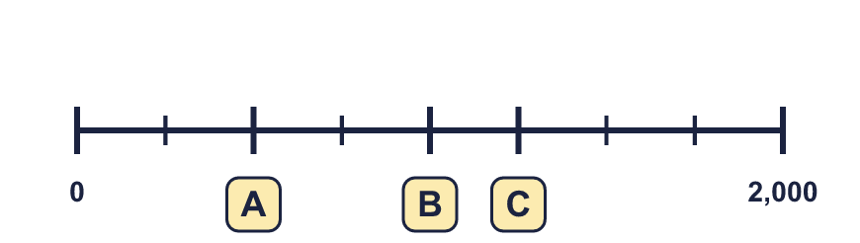
     | 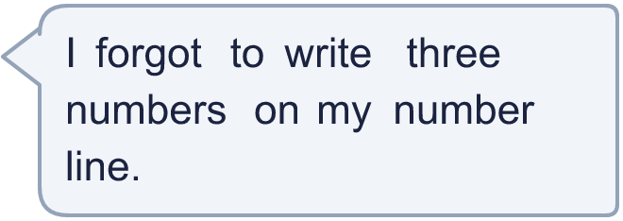
  10
  11 | 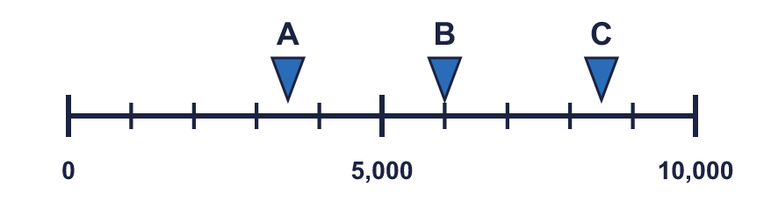  a) What number is arrow A pointing to?  b) What is the difference between B and C?
     | 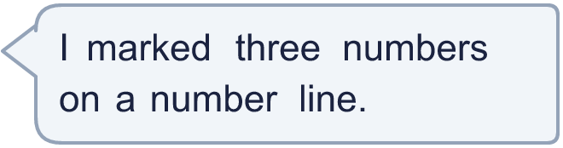
  11 | a) What number is arrow A pointing to?  b) What is the difference between B and C?
  12 | What numbers are the arrows pointing to?  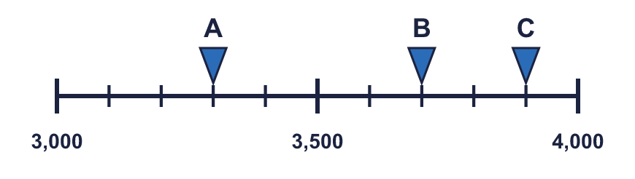
  12 | What numbers are the arrows pointing to?
  13 | 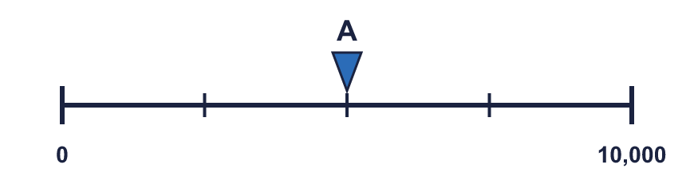  a) What is each step worth?  b) What number is arrow A pointing to?
     | 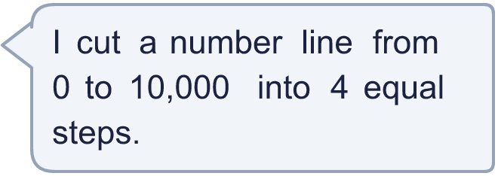
  13 | a) What is each step worth?  b) What number is arrow A pointing to?
  14 | 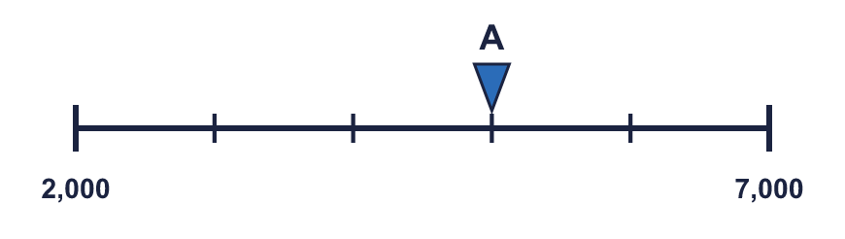  a) What mistake has Boba made?  b) What number is arrow A pointing to?
    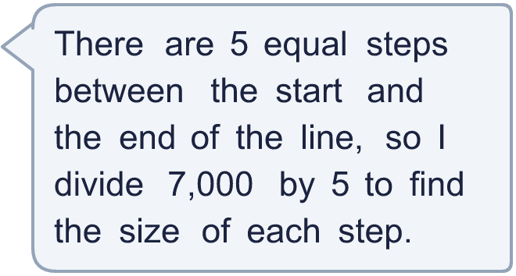
  14 | a) What mistake has Boba made?  b) What number is arrow A pointing to?

Year 4 · Place value · Step 4
Estimate on a number line to 10,000
Answers (teacher copy)

  1 | What number is the arrow pointing to?
    3,000
  2 | What numbers are the arrows pointing to?  A = 100 B = 600
  3 | Which arrow points to 1,000? Write its letter.  Answer: C
  4 | Look at the number line.  The difference between the start and the end is 1,000  There are 5 equal intervals.  The line counts up in 200
  5 | Write the missing numbers on the line.  A = 500 B = 1,000 C = 1,500
  6 | What number is the arrow pointing to?
    3,400
  7 | What number is the arrow pointing to? It is exactly halfway between two marks.
    5,500
  8 | The arrow is between two marks. Which number is it closest to? Write the letter.  a) 7,500  b) 9,000  c) 5,500  Answer: a
  9 | Is Boba correct? Circle yes or no.  Yes / No  Explain how you know.  Arrow A points to 500 and arrow B points to 5,000. The lines have different scales: line A ends at 1,000 and line B ends at 10,000.
  10 | A = 500 B = 1,000 C = 1,250
  11 | a) What number is arrow A pointing to? 3,500  b) What is the difference between B and C? 2,500
  12 | What numbers are the arrows pointing to?  A = 3,300 B = 3,700 C = 3,900
  13 | a) What is each step worth? 2,500  b) What number is arrow A pointing to? 5,000
  14 | a) What mistake has Boba made?  Boba divided the end number. The line does not start at 0, so each step is (7,000 − 2,000) ÷ 5 = 1,000.  b) What number is arrow A pointing to? 5,000

