  Year 4 · Place value · Step 6  Count backwards through zero | 
  Year 4 · Place value · Step 6
  Count backwards through zero
  1 | The numbers go down in 1s. Work out the missing numbers.  4, 3, ?, 1, 0, ?, ?, −3, −4
    The missing numbers are
  1 | The numbers go down in 1s. Work out the missing numbers.  4, 3, ?, 1, 0, ?, ?, −3, −4
    The missing numbers are
  2 | Write the missing numbers in the boxes on the number line.  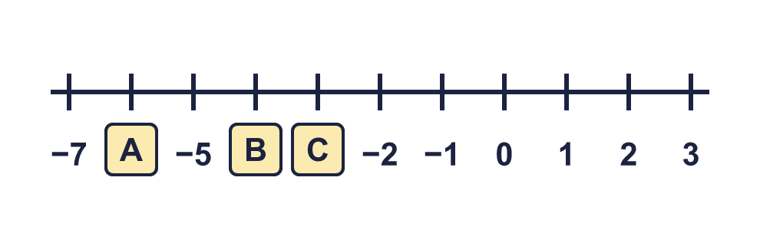
    A = |  | B = |  | C =
  2 | Write the missing numbers in the boxes on the number line.
    A = |  | B = |  | C =
  3 | What numbers are the arrows pointing to?  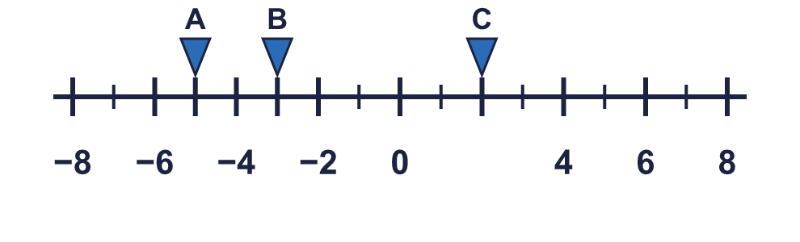
    A = |  | B = |  | C =
  3 | What numbers are the arrows pointing to?
    A = |  | B = |  | C =
  4 | The numbers go down in equal steps. Work out the missing numbers.  9, 6, ?, ?, ?, −6, −9
    The missing numbers are
  4 | The numbers go down in equal steps. Work out the missing numbers.  9, 6, ?, ?, ?, −6, −9
    The missing numbers are
  5 | Write the next three numbers in each sequence.
    a) 1, 0, −1, −2, −3,
    b) 2, 0, −2, −4, −6,
    c) 8, 4, 0, −4, −8,
    d) 40, 20, 0, −20, −40,
  5 | Write the next three numbers in each sequence.
    a) 1, 0, −1, −2, −3,
    b) 2, 0, −2, −4, −6,
    c) 8, 4, 0, −4, −8,
    d) 40, 20, 0, −20, −40,
  6 | Work out the new temperatures.  a) The temperature is 5 °C. It falls by 9 degrees. What is it now? °C  b) The temperature is 2 °C. It falls by 6 degrees. What is it now? °C
  6 | Work out the new temperatures.  a) The temperature is 5 °C. It falls by 9 degrees. What is it now? °C  b) The temperature is 2 °C. It falls by 6 degrees. What is it now? °C
  7 | A diver is swimming at −9 m. The surface of the water is 0 m. The diver goes up 3 m every minute.
    How many minutes does the diver take to reach the surface?
    minutes
  7 | A diver is swimming at −9 m. The surface of the water is 0 m. The diver goes up 3 m every minute.
    How many minutes does the diver take to reach the surface?
    minutes
  8 | Write the rule for each sequence. Write it like this: subtract 2.
    a) 2, 1, 0, −1, …
    b) 4, 2, 0, −2, …
    c) 10, 5, 0, −5, …
    d) 8, 4, 0, −4, …
  8 | Write the rule for each sequence. Write it like this: subtract 2.
    a) 2, 1, 0, −1, …
    b) 4, 2, 0, −2, …
    c) 10, 5, 0, −5, …
    d) 8, 4, 0, −4, …

  9 | Tiny is counting back in 5s from 14.  Is Boba correct? Circle yes or no.  Yes / No  Explain the mistake. Then write the correct numbers from the mistake onwards.
     | 
    The correct numbers are
  9 | Tiny is counting back in 5s from 14.  Is Boba correct? Circle yes or no.  Yes / No  Explain the mistake. Then write the correct numbers from the mistake onwards.
    The correct numbers are
  10 | Whitney is counting back from 3.  Is Boba correct? Circle yes or no.  Yes / No  Explain the mistake. Then write the number that was missed.
     | 
    The number that was missed is
  10 | Whitney is counting back from 3.  Is Boba correct? Circle yes or no.  Yes / No  Explain the mistake. Then write the number that was missed.
    The number that was missed is
  11 | A submarine is at sea level (0 m). It dives 9 m, then dives a further 8 m. Then it rises 5 m.  Write each position as a number. A position below sea level is a negative number.
    Position after the two dives:
    m
    Position after it rises: |  | m
  11 | A submarine is at sea level (0 m). It dives 9 m, then dives a further 8 m. Then it rises 5 m.  Write each position as a number. A position below sea level is a negative number.
    Position after the two dives:
    m
    Position after it rises: |  | m
  12 | Write the next three numbers in each sequence.
    a) 7, 4, 1,
    b) −8, −5, −2,
    c) 9, 5, 1,
    d) −8, −5, −2,
  12 | Write the next three numbers in each sequence.
    a) 7, 4, 1,
    b) −8, −5, −2,
    c) 9, 5, 1,
    d) −8, −5, −2,
  13 | 10, 5, 0, ?, ?  Explain the pattern.
    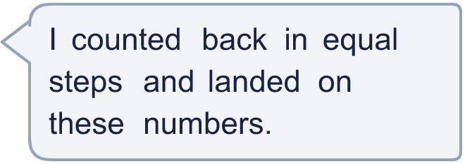
    The missing numbers are
  13 | 10, 5, 0, ?, ?  Explain the pattern.
    The missing numbers are
  14 | A fish is swimming at −3 m. It swims down another 2 m. Ron says that it is now at −1 m.  Is Boba correct? Circle yes or no.  Yes / No  Explain the mistake. Then write the correct answer.
    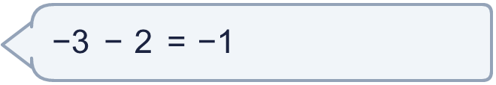
  14 | A fish is swimming at −3 m. It swims down another 2 m. Ron says that it is now at −1 m.  Is Boba correct? Circle yes or no.  Yes / No  Explain the mistake. Then write the correct answer.

Year 4 · Place value · Step 6
Count backwards through zero
Answers (teacher copy)

  1 | The numbers go down in 1s. Work out the missing numbers.  4, 3, ?, 1, 0, ?, ?, −3, −4  The missing numbers are 2, −1, −2
  2 | Write the missing numbers in the boxes on the number line.  A = −6 B = −4 C = −3
  3 | What numbers are the arrows pointing to?  A = −5 B = −3 C = 2
  4 | The numbers go down in equal steps. Work out the missing numbers.  9, 6, ?, ?, ?, −6, −9  The missing numbers are 3, 0, −3
  5 | Write the next three numbers in each sequence.  a) 1, 0, −1, −2, −3, −4, −5, −6  b) 2, 0, −2, −4, −6, −8, −10, −12  c) 8, 4, 0, −4, −8, −12, −16, −20  d) 40, 20, 0, −20, −40, −60, −80, −100
  6 | Work out the new temperatures.  a) The temperature is 5 °C. It falls by 9 degrees. What is it now? −4 °C  b) The temperature is 2 °C. It falls by 6 degrees. What is it now? −4 °C
  7 | A diver is swimming at −9 m. The surface of the water is 0 m. The diver goes up 3 m every minute.  How many minutes does the diver take to reach the surface? 3 minutes
  8 | Write the rule for each sequence. Write it like this: subtract 2.  a) 2, 1, 0, −1, … subtract 1  b) 4, 2, 0, −2, … subtract 2  c) 10, 5, 0, −5, … subtract 5  d) 8, 4, 0, −4, … subtract 4
  9 | Tiny is counting back in 5s from 14.  Is Boba correct? Circle yes or no.  Yes / No  Explain the mistake. Then write the correct numbers from the mistake onwards.  No. 4 − 5 = −1, not 0. Tiny counted 0 as one of the 5 steps. Count back the whole 5 from 4.  The correct numbers are −1, −6
  10 | Whitney is counting back from 3.  Is Boba correct? Circle yes or no.  Yes / No  Explain the mistake. Then write the number that was missed.  No. The count missed out 0. 0 comes between 1 and −1.  The number that was missed is 0
  11 | A submarine is at sea level (0 m). It dives 9 m, then dives a further 8 m. Then it rises 5 m.  Write each position as a number. A position below sea level is a negative number.  Position after the two dives: −17 m  Position after it rises: −12 m
  12 | Write the next three numbers in each sequence.  a) 7, 4, 1, −2, −5, −8  b) −8, −5, −2, 1, 4, 7  c) 9, 5, 1, −3, −7, −11  d) −8, −5, −2, 1, 4, 7
  13 | 10, 5, 0, ?, ?  The missing numbers are −5, −10  Explain the pattern.  The numbers go down by 5 each time: 10, 5, 0, then −5 and −10.
  14 | A fish is swimming at −3 m. It swims down another 2 m. Ron says that it is now at −1 m.  Is Boba correct? Circle yes or no.  Yes / No  Explain the mistake. Then write the correct answer.  No. Swimming down means the number gets smaller, so the fish is further below zero. How do you know Ron must be wrong? −1 is higher than −3. The correct answer is −5.  −5

