  Year 4 · Place value · Step 5  Compare and order numbers to 10,000 | 
  Year 4 · Place value · Step 5
  Compare and order numbers to 10,000
  1 | Write the number shown in each place value chart. Then write <, > or = to compare them.  Chart A  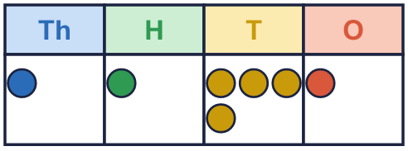  Chart B  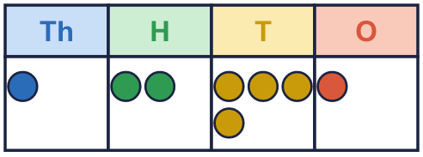
    A |  | B
  1 | Write the number shown in each place value chart. Then write <, > or = to compare them.  Chart A  Chart B
    A |  | B
  2 | Write <, > or = in each box.  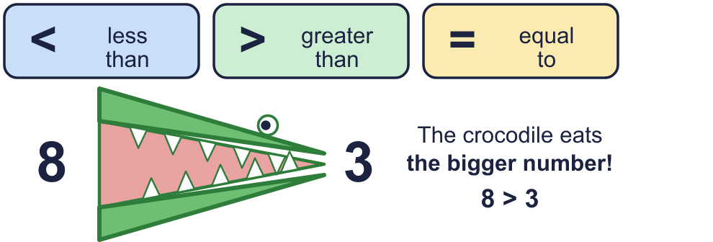
    a) | 952 |  | 953
    b) | 7,461 |  | 7,441
    c) | 2,189 |  | 1,989
  2 | Write <, > or = in each box.
    a) | 952 |  | 953
    b) | 7,461 |  | 7,441
    c) | 2,189 |  | 1,989
  3 | Circle the greater number in each pair. Write it.  a) 3,000 or 300  b) 731 or 741  c) 4,522 or 4,521  d) 9,199 or 3,425
  3 | Circle the greater number in each pair. Write it.  a) 3,000 or 300  b) 731 or 741  c) 4,522 or 4,521  d) 9,199 or 3,425
  4 | Write the numbers in order.  a) smallest first: 496 1,462 9,537 4,035  b) largest first: 795 1,747 9,719 9,374
  4 | Write the numbers in order.  a) smallest first: 496 1,462 9,537 4,035  b) largest first: 795 1,747 9,719 9,374
  5 | Write a digit in each box to make the statement correct. There may be more than one answer.
    a) | 2 |  | 5 | > | 254
    b) | 4,4 |  | 2 | < | 4,431
    c) |  | ,261 | > | 6,269
  5 | Write a digit in each box to make the statement correct. There may be more than one answer.
    a) | 2 |  | 5 | > | 254
    b) | 4,4 |  | 2 | < | 4,431
    c) |  | ,261 | > | 6,269
  6 | Work out the left side. Then write <, > or = in each box.
    a) | 3,000 + 600 + 10 |  | 3,610
    b) | 999 + 1 |  | 1,000
  6 | Work out the left side. Then write <, > or = in each box.
    a) | 3,000 + 600 + 10 |  | 3,610
    b) | 999 + 1 |  | 1,000
  7 | 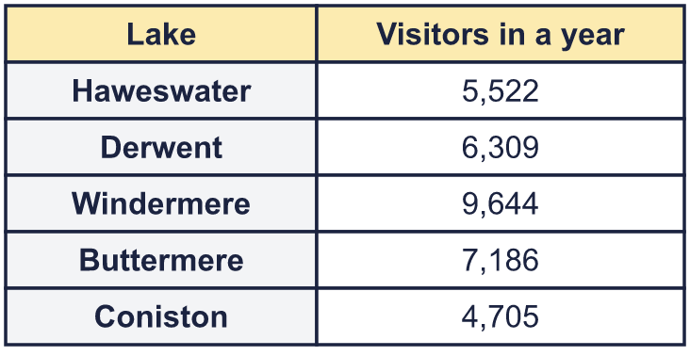  a) Write the lakes in order, fewest visitors first.  b) Which lake had the most visitors?
  7 | a) Write the lakes in order, fewest visitors first.  b) Which lake had the most visitors?
  8 | Write <, > or = in each box.
    a) | XCIX |  | 99
    b) | XXXIX |  | 31
    c) | LXIV |  | 67
  8 | Write <, > or = in each box.
    a) | XCIX |  | 99
    b) | XXXIX |  | 31
    c) | LXIV |  | 67

  9 | 862 1,412 7,729 6,944  Is Boba correct? Circle yes or no.  Yes / No  Explain how you know.
     | 
  9 | 862 1,412 7,729 6,944  Is Boba correct? Circle yes or no.  Yes / No  Explain how you know.
  10 | Write three numbers that could go in the middle, in order.
     | 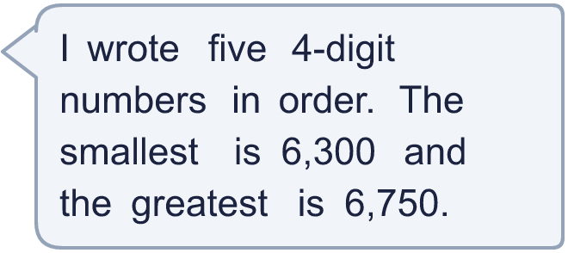
  10 | Write three numbers that could go in the middle, in order.
  11 | Look at the two place value charts.  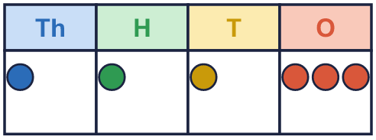  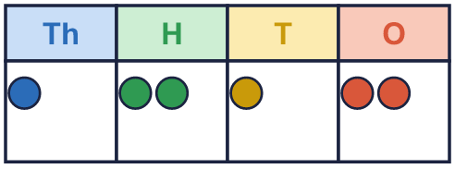  a) Which chart shows the greater number? Write A or B.  b) How much greater is it?
  11 | Look at the two place value charts.  a) Which chart shows the greater number? Write A or B.  b) How much greater is it?
  12 | 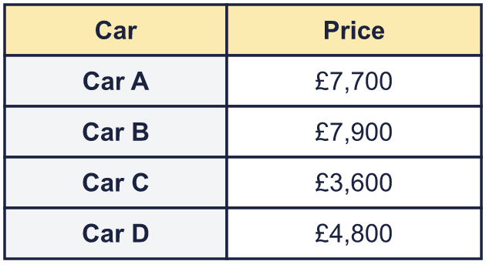  a) Write the cars in order, most expensive first.  b) How much more is the most expensive car than the cheapest?
     | 
  12 | a) Write the cars in order, most expensive first.  b) How much more is the most expensive car than the cheapest?
  13 | 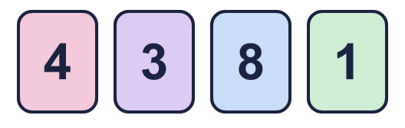  a) What is the largest 4-digit number I can make?  b) What is the smallest 4-digit number I can make?  c) How much greater is the largest than the smallest?
    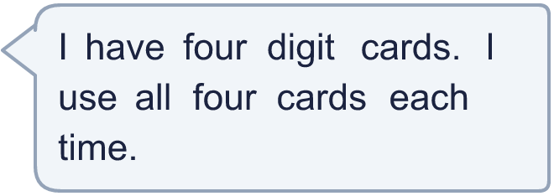
  13 | a) What is the largest 4-digit number I can make?  b) What is the smallest 4-digit number I can make?  c) How much greater is the largest than the smallest?
  14 | Use five counters to make four different numbers in a place value chart. Write your numbers in order, smallest first.  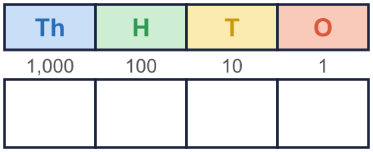
  14 | Use five counters to make four different numbers in a place value chart. Write your numbers in order, smallest first.

Year 4 · Place value · Step 5
Compare and order numbers to 10,000
Answers (teacher copy)

  1 | Write the number shown in each place value chart. Then write <, > or = to compare them.  Chart A  Chart B  A = 1,141 B = 1,241  A < B
  2 | Write <, > or = in each box.  a) 952 < 953  b) 7,461 > 7,441  c) 2,189 > 1,989
  3 | Circle the greater number in each pair. Write it.  a) 3,000 or 300 3,000  b) 731 or 741 741  c) 4,522 or 4,521 4,522  d) 9,199 or 3,425 9,199
  4 | Write the numbers in order.  a) smallest first: 496 1,462 9,537 4,035  496, 1,462, 4,035, 9,537  b) largest first: 795 1,747 9,719 9,374  9,719, 9,374, 1,747, 795
  5 | Write a digit in each box to make the statement correct. There may be more than one answer.  a) 2 5, 6, 7, 8, 9 5 > 254  b) 4,4 0, 1, 2 2 < 4,431  c) 7, 8, 9 ,261 > 6,269
  6 | Work out the left side. Then write <, > or = in each box.  a) 3,000 + 600 + 10 = 3,610  b) 999 + 1 = 1,000
  7 | a) Write the lakes in order, fewest visitors first. Coniston, Haweswater, Derwent, Buttermere, Windermere  b) Which lake had the most visitors? Windermere
  8 | Write <, > or = in each box.  a) XCIX = 99  b) XXXIX > 31  c) LXIV < 67
  9 | 862 1,412 7,729 6,944  Is Boba correct? Circle yes or no.  Yes / No  Explain how you know.  7,729 is bigger than 6,944, so it should come after it. The numbers should be: 862, 1,412, 6,944, 7,729.
  10 | Write three numbers that could go in the middle, in order.  Any three numbers between 6,300 and 6,750 in order, for example 6,410, 6,530, 6,640
  11 | Look at the two place value charts.  a) Which chart shows the greater number? Write A or B. B  b) How much greater is it? 99
  12 | a) Write the cars in order, most expensive first. Car B, Car A, Car D, Car C  b) How much more is the most expensive car than the cheapest? £4,300
  13 | a) What is the largest 4-digit number I can make? 8,431  b) What is the smallest 4-digit number I can make? 1,348  c) How much greater is the largest than the smallest? 7,083
  14 | Use five counters to make four different numbers in a place value chart. Write your numbers in order, smallest first.  Any four different numbers whose digits add up to 5, for example 1,112, 1,211, 2,003, 4,001

