  Year 4 · Multiplication and division A · Step 6  The 3, 6 and 9 times-tables | 
  Year 4 · Multiplication and division A · Step 6
  The 3, 6 and 9 times-tables
  1 | Complete the number track. It counts up in 3s.  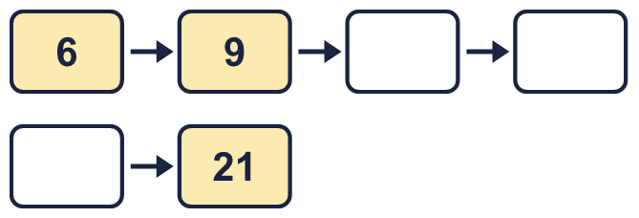
  1 | Complete the number track. It counts up in 3s.
  2 | Complete the number track. It counts down in 6s.  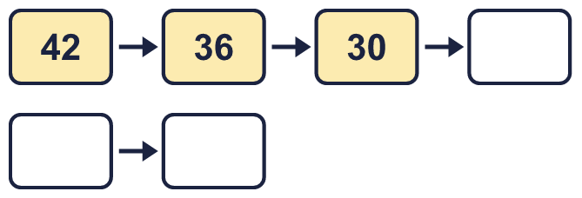
  2 | Complete the number track. It counts down in 6s.
  3 | Complete the number track. It counts up in 9s.  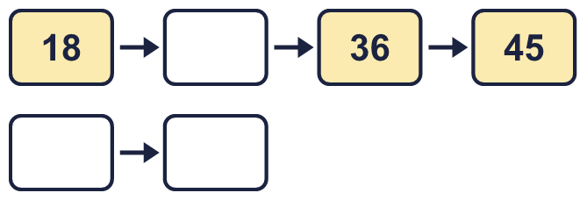
  3 | Complete the number track. It counts up in 9s.
  4 | Work out the multiplications.  a) 9 × 3 =  b) 8 × 3 =  c) 12 × 3 =
  4 | Work out the multiplications.  a) 9 × 3 =  b) 8 × 3 =  c) 12 × 3 =
  5 | Work out the multiplications.  a) 5 × 6 =  b) 6 × 2 =  c) 9 × 6 =
  5 | Work out the multiplications.  a) 5 × 6 =  b) 6 × 2 =  c) 9 × 6 =
  6 | Work out the divisions.  a) 90 ÷ 9 =  b) 108 ÷ 9 =  c) 36 ÷ 9 =
  6 | Work out the divisions.  a) 90 ÷ 9 =  b) 108 ÷ 9 =  c) 36 ÷ 9 =
  7 | Write which of 3, 6 and 9 each number is a multiple of. Write none if it is not a multiple of any of them.
    a) | 32 is a multiple of
    b) | 36 is a multiple of
    c) | 14 is a multiple of
    d) | 52 is a multiple of
    e) | 90 is a multiple of
  7 | Write which of 3, 6 and 9 each number is a multiple of. Write none if it is not a multiple of any of them.
    a) | 32 is a multiple of
    b) | 36 is a multiple of
    c) | 14 is a multiple of
    d) | 52 is a multiple of
    e) | 90 is a multiple of
  8 | Write the missing number in each calculation.
    a) |  | ÷ 6 | = | 10
    b) | 72 ÷ 6 | =
    c) | 6 × |  | = | 30
  8 | Write the missing number in each calculation.
    a) |  | ÷ 6 | = | 10
    b) | 72 ÷ 6 | =
    c) | 6 × |  | = | 30

  9 | Is this statement always, sometimes or never true? Write the word, then explain with examples.
     | 
    The statement is
  9 | Is this statement always, sometimes or never true? Write the word, then explain with examples.
    The statement is
  10 | Is this statement always, sometimes or never true? Write the word, then explain with examples.
    
    The statement is
  10 | Is this statement always, sometimes or never true? Write the word, then explain with examples.
    The statement is
  11 | Is this statement always, sometimes or never true? Write the word, then explain with examples.
    
    The statement is
  11 | Is this statement always, sometimes or never true? Write the word, then explain with examples.
    The statement is
  12 | a) Use this fact to work out 6 × 15.  b) Now work out 90 ÷ 6.
     | 
  12 | a) Use this fact to work out 6 × 15.  b) Now work out 90 ÷ 6.
  13 | a) Use this fact to work out 9 × 13.  b) Now work out 117 ÷ 9.
    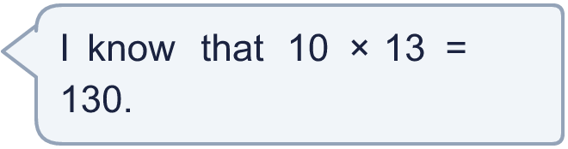
  13 | a) Use this fact to work out 9 × 13.  b) Now work out 117 ÷ 9.
  14 | Huan is thinking of three different multiples of 9 that are less than 90. The sum of the numbers is 117.  What could the numbers be?
  14 | Huan is thinking of three different multiples of 9 that are less than 90. The sum of the numbers is 117.  What could the numbers be?

Year 4 · Multiplication and division A · Step 6
The 3, 6 and 9 times-tables
Answers (teacher copy)

  1 | Complete the number track. It counts up in 3s.  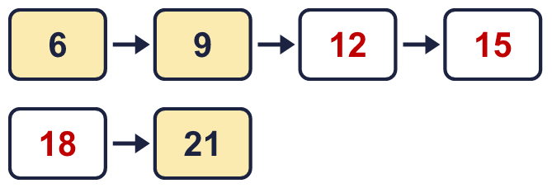
  2 | Complete the number track. It counts down in 6s.  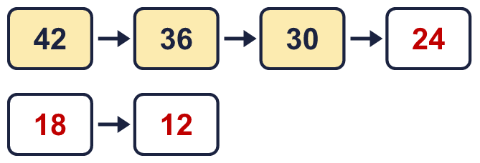
  3 | Complete the number track. It counts up in 9s.  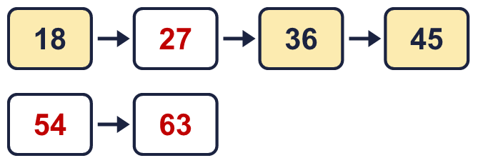
  4 | Work out the multiplications.  a) 9 × 3 = 27  b) 8 × 3 = 24  c) 12 × 3 = 36
  5 | Work out the multiplications.  a) 5 × 6 = 30  b) 6 × 2 = 12  c) 9 × 6 = 54
  6 | Work out the divisions.  a) 90 ÷ 9 = 10  b) 108 ÷ 9 = 12  c) 36 ÷ 9 = 4
  7 | Write which of 3, 6 and 9 each number is a multiple of. Write none if it is not a multiple of any of them.  a) 32 is a multiple of none  b) 36 is a multiple of 3, 6, 9  c) 14 is a multiple of none  d) 52 is a multiple of none  e) 90 is a multiple of 3, 6, 9
  8 | Write the missing number in each calculation.  a) 60 ÷ 6 = 10  b) 72 ÷ 6 = 12  c) 6 × 5 = 30
  9 | Is this statement always, sometimes or never true? Write the word, then explain with examples.  The statement is Always  For example, 18 and 27 are multiples of 9, and they are also multiples of 3.
  10 | Is this statement always, sometimes or never true? Write the word, then explain with examples.  The statement is Sometimes  For example, 6 is a multiple of 3 and of 6, but 3 is a multiple of 3 and not of 6.
  11 | Is this statement always, sometimes or never true? Write the word, then explain with examples.  The statement is Sometimes  For example, 18 is a multiple of 6 and of 9, but 6 is a multiple of 6 and not of 9.
  12 | a) Use this fact to work out 6 × 15. 90  b) Now work out 90 ÷ 6. 15
  13 | a) Use this fact to work out 9 × 13. 117  b) Now work out 117 ÷ 9. 13
  14 | Huan is thinking of three different multiples of 9 that are less than 90. The sum of the numbers is 117.  What could the numbers be?  for example 9 + 27 + 81

