  Year 4 · Multiplication and division A · Step 4  Multiply and divide by 9 | 
  Year 4 · Multiplication and division A · Step 4
  Multiply and divide by 9
  1 | A farm has 4 boxes. Each box holds 9 eggs.  a) How many eggs are there altogether?  b) 8 eggs are sold. How many eggs are left?
  1 | A farm has 4 boxes. Each box holds 9 eggs.  a) How many eggs are there altogether?  b) 8 eggs are sold. How many eggs are left?
  2 | Work out the multiplications.  a) 9 × 9 =  b) 9 × 11 =  c) 9 × 3 =
  2 | Work out the multiplications.  a) 9 × 9 =  b) 9 × 11 =  c) 9 × 3 =
  3 | Complete the number sentences to describe the array.  
     | × |  | =
     | × |  | =
     | ÷ |  | =
     | ÷ |  | =
  3 | Complete the number sentences to describe the array.
     | × |  | =
     | × |  | =
     | ÷ |  | =
     | ÷ |  | =
  4 | Work out the divisions.  a) 36 ÷ 9 =  b) 45 ÷ 9 =  c) 18 ÷ 9 =
  4 | Work out the divisions.  a) 36 ÷ 9 =  b) 45 ÷ 9 =  c) 18 ÷ 9 =
  5 | Write the missing number in each calculation.
    a) | 72 ÷ 9 | =
    b) |  | × 9 | = | 54
    c) |  | ÷ 9 | = | 9
  5 | Write the missing number in each calculation.
    a) | 72 ÷ 9 | =
    b) |  | × 9 | = | 54
    c) |  | ÷ 9 | = | 9
  6 | Work out the multiplications.  a) 3 × 9 =  b) 6 × 9 =  c) 4 × 9 =
  6 | Work out the multiplications.  a) 3 × 9 =  b) 6 × 9 =  c) 4 × 9 =
  7 | 72 strawberries are shared equally between 9 bowls.  a) How many strawberries are in each bowl?  90 children sit in rows. There are 9 children in each row.  b) How many rows are there?
  7 | 72 strawberries are shared equally between 9 bowls.  a) How many strawberries are in each bowl?  90 children sit in rows. There are 9 children in each row.  b) How many rows are there?
  8 | Work out the calculations.  a) 27 ÷ 9 =  b) 9 × 10 =  c) 5 × 9 =
  8 | Work out the calculations.  a) 27 ÷ 9 =  b) 9 × 10 =  c) 5 × 9 =

  9 | a) How long is the yellow ribbon?  b) How much longer is the yellow ribbon than the red ribbon?
     | 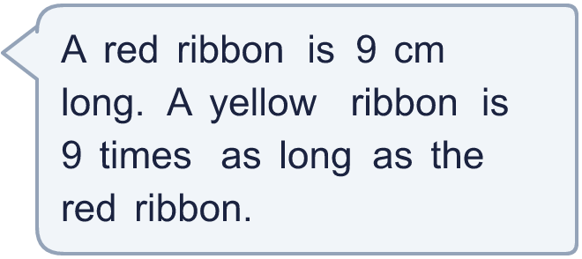
  9 | a) How long is the yellow ribbon?  b) How much longer is the yellow ribbon than the red ribbon?
  10 | Is Boba correct? Circle yes or no.  Yes / No  What is the correct answer?  Explain Boba’s mistake.
    
  10 | Is Boba correct? Circle yes or no.  Yes / No  What is the correct answer?  Explain Boba’s mistake.
  11 | Write true or false for each statement.
    a) | 4 × 9 = 3 × 9 + 4
    b) | 8 × 9 = 4 × 18
    c) | 4 × 9 = 5 × 9 + 9
    d) | 4 × 9 = 5 × 9 - 9
  11 | Write true or false for each statement.
    a) | 4 × 9 = 3 × 9 + 4
    b) | 8 × 9 = 4 × 18
    c) | 4 × 9 = 5 × 9 + 9
    d) | 4 × 9 = 5 × 9 - 9
  12 | a) Use this fact to work out 9 × 26.  b) Now work out 234 ÷ 9.
     | 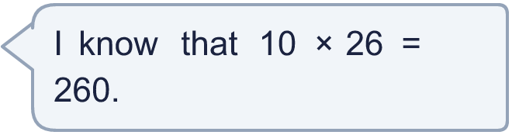
  12 | a) Use this fact to work out 9 × 26.  b) Now work out 234 ÷ 9.
  13 | Find the digit sum of each number. Is the number a multiple of the number shown?
    a) | 297: digit sum
    multiple of 9?
    b) | 127: digit sum
    multiple of 9?
    c) | 198: digit sum
    multiple of 9?
  13 | Find the digit sum of each number. Is the number a multiple of the number shown?
    a) | 297: digit sum
    multiple of 9?
    b) | 127: digit sum
    multiple of 9?
    c) | 198: digit sum
    multiple of 9?
  14 | Write three different multiples of 9 that are between 20 and 60.
  14 | Write three different multiples of 9 that are between 20 and 60.

Year 4 · Multiplication and division A · Step 4
Multiply and divide by 9
Answers (teacher copy)

  1 | A farm has 4 boxes. Each box holds 9 eggs.  a) How many eggs are there altogether? 36  b) 8 eggs are sold. How many eggs are left? 28
  2 | Work out the multiplications.  a) 9 × 9 = 81  b) 9 × 11 = 99  c) 9 × 3 = 27
  3 | Complete the number sentences to describe the array.  2 × 9 = 18  9 × 2 = 18  18 ÷ 9 = 2  18 ÷ 2 = 9
  4 | Work out the divisions.  a) 36 ÷ 9 = 4  b) 45 ÷ 9 = 5  c) 18 ÷ 9 = 2
  5 | Write the missing number in each calculation.  a) 72 ÷ 9 = 8  b) 6 × 9 = 54  c) 81 ÷ 9 = 9
  6 | Work out the multiplications.  a) 3 × 9 = 27  b) 6 × 9 = 54  c) 4 × 9 = 36
  7 | 72 strawberries are shared equally between 9 bowls.  a) How many strawberries are in each bowl? 8  90 children sit in rows. There are 9 children in each row.  b) How many rows are there? 10
  8 | Work out the calculations.  a) 27 ÷ 9 = 3  b) 9 × 10 = 90  c) 5 × 9 = 45
  9 | a) How long is the yellow ribbon? 81 cm  b) How much longer is the yellow ribbon than the red ribbon? 72 cm
  10 | Is Boba correct? Circle yes or no.  Yes / No  What is the correct answer? 81  Explain Boba’s mistake.  9 × 9 = 81. Boba’s answer is not 9 groups of 9: 9 groups of 9 make 81.
  11 | Write true or false for each statement.  a) 4 × 9 = 3 × 9 + 4 False  b) 8 × 9 = 4 × 18 True  c) 4 × 9 = 5 × 9 + 9 False  d) 4 × 9 = 5 × 9 - 9 True
  12 | a) Use this fact to work out 9 × 26. 234  b) Now work out 234 ÷ 9. 26
  13 | Find the digit sum of each number. Is the number a multiple of the number shown?  a) 297: digit sum 18 multiple of 9? Yes  b) 127: digit sum 10 multiple of 9? No  c) 198: digit sum 18 multiple of 9? Yes
  14 | Write three different multiples of 9 that are between 20 and 60.  for example 27, 36, 45

