  Year 4 · Multiplication and division A · Step 7  Multiply and divide by 7 | 
  Year 4 · Multiplication and division A · Step 7
  Multiply and divide by 7
  1 | A baker makes 5 trays of buns. Each tray has 7 buns.  a) How many buns are there?  b) 2 buns are eaten. How many buns are left?
  1 | A baker makes 5 trays of buns. Each tray has 7 buns.  a) How many buns are there?  b) 2 buns are eaten. How many buns are left?
  2 | Work out the multiplications.  a) 7 × 2 =  b) 7 × 6 =  c) 7 × 8 =
  2 | Work out the multiplications.  a) 7 × 2 =  b) 7 × 6 =  c) 7 × 8 =
  3 | Complete the number sentences to describe the array.  
     | × |  | =
     | × |  | =
     | ÷ |  | =
     | ÷ |  | =
  3 | Complete the number sentences to describe the array.
     | × |  | =
     | × |  | =
     | ÷ |  | =
     | ÷ |  | =
  4 | Work out the divisions.  a) 49 ÷ 7 =  b) 28 ÷ 7 =  c) 35 ÷ 7 =
  4 | Work out the divisions.  a) 49 ÷ 7 =  b) 28 ÷ 7 =  c) 35 ÷ 7 =
  5 | Write the missing number in each calculation.
    a) | 7 × |  | = | 35
    b) |  | ÷ 7 | = | 4
    c) | 77 ÷ 7 | =
  5 | Write the missing number in each calculation.
    a) | 7 × |  | = | 35
    b) |  | ÷ 7 | = | 4
    c) | 77 ÷ 7 | =
  6 | Work out the multiplications.  a) 11 × 7 =  b) 2 × 7 =  c) 8 × 7 =
  6 | Work out the multiplications.  a) 11 × 7 =  b) 2 × 7 =  c) 8 × 7 =
  7 | 49 strawberries are shared equally between 7 bowls.  a) How many strawberries are in each bowl?  42 children sit in rows. There are 7 children in each row.  b) How many rows are there?
  7 | 49 strawberries are shared equally between 7 bowls.  a) How many strawberries are in each bowl?  42 children sit in rows. There are 7 children in each row.  b) How many rows are there?
  8 | Work out the calculations.  a) 56 ÷ 8 =  b) 3 × 7 =  c) 7 × 2 =
  8 | Work out the calculations.  a) 56 ÷ 8 =  b) 3 × 7 =  c) 7 × 2 =

  9 | a) How long is the yellow ribbon?  b) How much longer is the yellow ribbon than the red ribbon?
     | 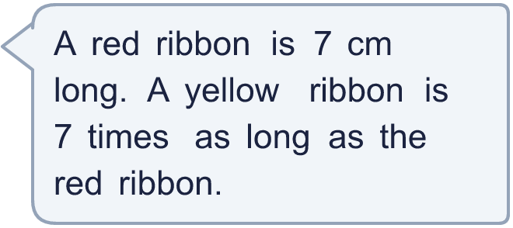
  9 | a) How long is the yellow ribbon?  b) How much longer is the yellow ribbon than the red ribbon?
  10 | There are 7 players in a team. 5 teams have signed up for a tournament.  a) How many players have signed up?  b) The tournament needs 56 players. How many more teams are needed?
  10 | There are 7 players in a team. 5 teams have signed up for a tournament.  a) How many players have signed up?  b) The tournament needs 56 players. How many more teams are needed?
  11 | Is Boba correct? Circle yes or no.  Yes / No  What is the correct answer?  Explain Boba’s mistake.
    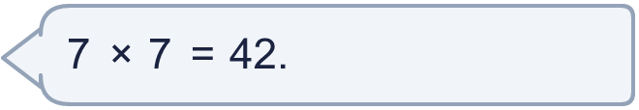
  11 | Is Boba correct? Circle yes or no.  Yes / No  What is the correct answer?  Explain Boba’s mistake.
  12 | Write true or false for each statement.
    a) | 9 × 7 = 10 × 7 - 7
    b) | 18 × 7 = 9 × 14
    c) | 9 × 7 = 10 × 7 + 7
    d) | 9 × 7 = 9 × 8 - 7
  12 | Write true or false for each statement.
    a) | 9 × 7 = 10 × 7 - 7
    b) | 18 × 7 = 9 × 14
    c) | 9 × 7 = 10 × 7 + 7
    d) | 9 × 7 = 9 × 8 - 7
  13 | a) Use these facts to work out 7 × 16.  b) Now work out 112 ÷ 7.
     | 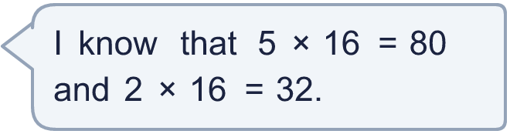
  13 | a) Use these facts to work out 7 × 16.  b) Now work out 112 ÷ 7.
  14 | Write three different multiples of 7 that are between 30 and 70.
  14 | Write three different multiples of 7 that are between 30 and 70.

Year 4 · Multiplication and division A · Step 7
Multiply and divide by 7
Answers (teacher copy)

  1 | A baker makes 5 trays of buns. Each tray has 7 buns.  a) How many buns are there? 35  b) 2 buns are eaten. How many buns are left? 33
  2 | Work out the multiplications.  a) 7 × 2 = 14  b) 7 × 6 = 42  c) 7 × 8 = 56
  3 | Complete the number sentences to describe the array.  2 × 7 = 14  7 × 2 = 14  14 ÷ 7 = 2  14 ÷ 2 = 7
  4 | Work out the divisions.  a) 49 ÷ 7 = 7  b) 28 ÷ 7 = 4  c) 35 ÷ 7 = 5
  5 | Write the missing number in each calculation.  a) 7 × 5 = 35  b) 28 ÷ 7 = 4  c) 77 ÷ 7 = 11
  6 | Work out the multiplications.  a) 11 × 7 = 77  b) 2 × 7 = 14  c) 8 × 7 = 56
  7 | 49 strawberries are shared equally between 7 bowls.  a) How many strawberries are in each bowl? 7  42 children sit in rows. There are 7 children in each row.  b) How many rows are there? 6
  8 | Work out the calculations.  a) 56 ÷ 8 = 7  b) 3 × 7 = 21  c) 7 × 2 = 14
  9 | a) How long is the yellow ribbon? 49 cm  b) How much longer is the yellow ribbon than the red ribbon? 42 cm
  10 | There are 7 players in a team. 5 teams have signed up for a tournament.  a) How many players have signed up? 35  b) The tournament needs 56 players. How many more teams are needed? 3
  11 | Is Boba correct? Circle yes or no.  Yes / No  What is the correct answer? 49  Explain Boba’s mistake.  7 × 7 = 49. Boba’s answer is not 7 groups of 7: 7 groups of 7 make 49.
  12 | Write true or false for each statement.  a) 9 × 7 = 10 × 7 - 7 True  b) 18 × 7 = 9 × 14 True  c) 9 × 7 = 10 × 7 + 7 False  d) 9 × 7 = 9 × 8 - 7 False
  13 | a) Use these facts to work out 7 × 16. 112  b) Now work out 112 ÷ 7. 16
  14 | Write three different multiples of 7 that are between 30 and 70.  for example 35, 42, 49

