  Year 4 · Multiplication and division A · Step 2  Multiply and divide by 6 | 
  Year 4 · Multiplication and division A · Step 2
  Multiply and divide by 6
  1 | Dani buys 6 packs of stickers. There are 6 stickers in each pack.  a) How many stickers does Dani buy?  b) She gives 7 stickers to a friend. How many does she have now?
  1 | Dani buys 6 packs of stickers. There are 6 stickers in each pack.  a) How many stickers does Dani buy?  b) She gives 7 stickers to a friend. How many does she have now?
  2 | Work out the multiplications.  a) 6 × 10 =  b) 6 × 8 =  c) 6 × 2 =
  2 | Work out the multiplications.  a) 6 × 10 =  b) 6 × 8 =  c) 6 × 2 =
  3 | Complete the number sentences to describe the array.  
     | × |  | =
     | × |  | =
     | ÷ |  | =
     | ÷ |  | =
  3 | Complete the number sentences to describe the array.
     | × |  | =
     | × |  | =
     | ÷ |  | =
     | ÷ |  | =
  4 | Work out the divisions.  a) 42 ÷ 6 =  b) 72 ÷ 6 =  c) 30 ÷ 6 =
  4 | Work out the divisions.  a) 42 ÷ 6 =  b) 72 ÷ 6 =  c) 30 ÷ 6 =
  5 | Write the missing number in each calculation.
    a) | 72 ÷ 6 | =
    b) |  | ÷ 6 | = | 3
    c) |  | × 6 | = | 36
  5 | Write the missing number in each calculation.
    a) | 72 ÷ 6 | =
    b) |  | ÷ 6 | = | 3
    c) |  | × 6 | = | 36
  6 | Work out the multiplications.  a) 5 × 6 =  b) 11 × 6 =  c) 7 × 6 =
  6 | Work out the multiplications.  a) 5 × 6 =  b) 11 × 6 =  c) 7 × 6 =
  7 | 30 strawberries are shared equally between 6 bowls.  a) How many strawberries are in each bowl?  18 children sit in rows. There are 6 children in each row.  b) How many rows are there?
  7 | 30 strawberries are shared equally between 6 bowls.  a) How many strawberries are in each bowl?  18 children sit in rows. There are 6 children in each row.  b) How many rows are there?
  8 | Work out the calculations.  a) 36 ÷ 6 =  b) 9 × 6 =  c) 6 × 2 =
  8 | Work out the calculations.  a) 36 ÷ 6 =  b) 9 × 6 =  c) 6 × 2 =

  9 | a) How long is the yellow ribbon?  b) How much longer is the yellow ribbon than the red ribbon?
     | 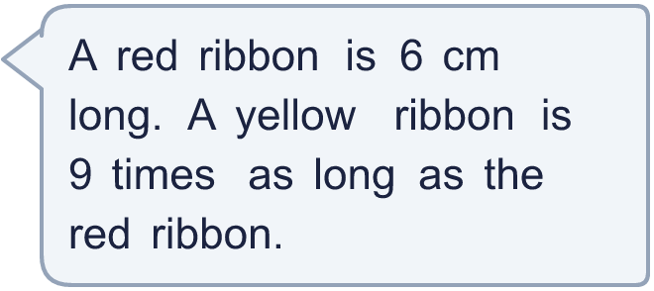
  9 | a) How long is the yellow ribbon?  b) How much longer is the yellow ribbon than the red ribbon?
  10 | There are 6 players in a team. 3 teams have signed up for a tournament.  a) How many players have signed up?  b) The tournament needs 36 players. How many more teams are needed?
  10 | There are 6 players in a team. 3 teams have signed up for a tournament.  a) How many players have signed up?  b) The tournament needs 36 players. How many more teams are needed?
  11 | Is Boba correct? Circle yes or no.  Yes / No  What is the correct answer?  Explain Boba’s mistake.
    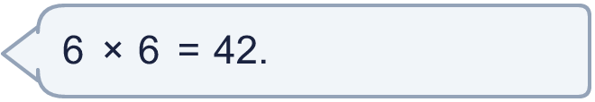
  11 | Is Boba correct? Circle yes or no.  Yes / No  What is the correct answer?  Explain Boba’s mistake.
  12 | Write true or false for each statement.
    a) | 6 × 6 = 3 × 12
    b) | 3 × 6 = 4 × 6 + 6
    c) | 3 × 6 = 3 × 7 - 6
    d) | 3 × 6 = 2 × 6 + 6
  12 | Write true or false for each statement.
    a) | 6 × 6 = 3 × 12
    b) | 3 × 6 = 4 × 6 + 6
    c) | 3 × 6 = 3 × 7 - 6
    d) | 3 × 6 = 2 × 6 + 6
  13 | a) Use this fact to work out 6 × 21.  b) Now work out 126 ÷ 6.
     | 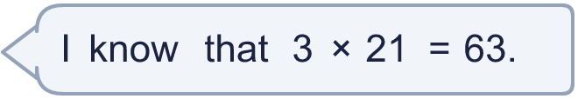
  13 | a) Use this fact to work out 6 × 21.  b) Now work out 126 ÷ 6.
  14 | Write three different multiples of 6 that are between 30 and 70.
  14 | Write three different multiples of 6 that are between 30 and 70.

Year 4 · Multiplication and division A · Step 2
Multiply and divide by 6
Answers (teacher copy)

  1 | Dani buys 6 packs of stickers. There are 6 stickers in each pack.  a) How many stickers does Dani buy? 36  b) She gives 7 stickers to a friend. How many does she have now? 29
  2 | Work out the multiplications.  a) 6 × 10 = 60  b) 6 × 8 = 48  c) 6 × 2 = 12
  3 | Complete the number sentences to describe the array.  3 × 6 = 18  6 × 3 = 18  18 ÷ 6 = 3  18 ÷ 3 = 6
  4 | Work out the divisions.  a) 42 ÷ 6 = 7  b) 72 ÷ 6 = 12  c) 30 ÷ 6 = 5
  5 | Write the missing number in each calculation.  a) 72 ÷ 6 = 12  b) 18 ÷ 6 = 3  c) 6 × 6 = 36
  6 | Work out the multiplications.  a) 5 × 6 = 30  b) 11 × 6 = 66  c) 7 × 6 = 42
  7 | 30 strawberries are shared equally between 6 bowls.  a) How many strawberries are in each bowl? 5  18 children sit in rows. There are 6 children in each row.  b) How many rows are there? 3
  8 | Work out the calculations.  a) 36 ÷ 6 = 6  b) 9 × 6 = 54  c) 6 × 2 = 12
  9 | a) How long is the yellow ribbon? 54 cm  b) How much longer is the yellow ribbon than the red ribbon? 48 cm
  10 | There are 6 players in a team. 3 teams have signed up for a tournament.  a) How many players have signed up? 18  b) The tournament needs 36 players. How many more teams are needed? 3
  11 | Is Boba correct? Circle yes or no.  Yes / No  What is the correct answer? 36  Explain Boba’s mistake.  6 × 6 = 36. Boba’s answer is not 6 groups of 6: 6 groups of 6 make 36.
  12 | Write true or false for each statement.  a) 6 × 6 = 3 × 12 True  b) 3 × 6 = 4 × 6 + 6 False  c) 3 × 6 = 3 × 7 - 6 False  d) 3 × 6 = 2 × 6 + 6 True
  13 | a) Use this fact to work out 6 × 21. 126  b) Now work out 126 ÷ 6. 21
  14 | Write three different multiples of 6 that are between 30 and 70.  for example 36, 42, 48

