  Year 4 · Multiplication and division A · Step 1  Multiples of 3 | 
  Year 4 · Multiplication and division A · Step 1
  Multiples of 3
  1 | Complete the number track. It counts up in 3s.  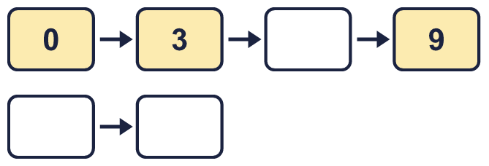
  1 | Complete the number track. It counts up in 3s.
  2 | Work out the multiplications.  a) 8 × 3 =  b) 4 × 3 =  c) 10 × 3 =
  2 | Work out the multiplications.  a) 8 × 3 =  b) 4 × 3 =  c) 10 × 3 =
  3 | Circle the multiples of 3. Write them below.  38 69 30 11 48 28
  3 | Circle the multiples of 3. Write them below.  38 69 30 11 48 28
  4 | Find the digit sum of each number. Is the number a multiple of the number shown?
    a) | 321: digit sum
    multiple of 3?
    b) | 361: digit sum
    multiple of 3?
    c) | 380: digit sum
    multiple of 3?
  4 | Find the digit sum of each number. Is the number a multiple of the number shown?
    a) | 321: digit sum
    multiple of 3?
    b) | 361: digit sum
    multiple of 3?
    c) | 380: digit sum
    multiple of 3?
  5 | Complete the number track. It counts down in 3s.  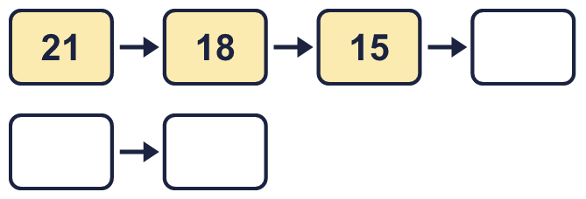
  5 | Complete the number track. It counts down in 3s.
  6 | Write the missing number in each calculation.
    a) |  | ÷ 3 | = | 11
    b) |  | × 3 | = | 12
    c) | 15 ÷ 3 | =
  6 | Write the missing number in each calculation.
    a) |  | ÷ 3 | = | 11
    b) |  | × 3 | = | 12
    c) | 15 ÷ 3 | =
  7 | List the multiples of 3 that are between 20 and 80.
  7 | List the multiples of 3 that are between 20 and 80.
  8 | How many multiples of 3 are there from 3 up to 80?
  8 | How many multiples of 3 are there from 3 up to 80?

  9 | Is Boba correct? Circle yes or no.  Yes / No  Explain your answer.
     | 
  9 | Is Boba correct? Circle yes or no.  Yes / No  Explain your answer.
  10 | Omar is thinking of three different multiples of 3 that are less than 30. The sum of the numbers is 69.  What could the numbers be?
  10 | Omar is thinking of three different multiples of 3 that are less than 30. The sum of the numbers is 69.  What could the numbers be?
  11 | a) How long is the yellow ribbon?  b) How much longer is the yellow ribbon than the red ribbon?
     | 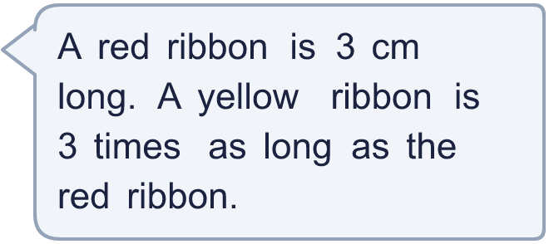
  11 | a) How long is the yellow ribbon?  b) How much longer is the yellow ribbon than the red ribbon?
  12 | Aisha has three times as many stickers as Tom. Tom has three times as many stickers as Jo. Tom has 18 stickers.  a) How many stickers does Aisha have?  b) How many stickers do they have in total?
  12 | Aisha has three times as many stickers as Tom. Tom has three times as many stickers as Jo. Tom has 18 stickers.  a) How many stickers does Aisha have?  b) How many stickers do they have in total?
  13 | Which number is the odd one out?  30 12 65 24  The odd one out is  Explain why it is the odd one out.
  13 | Which number is the odd one out?  30 12 65 24  The odd one out is  Explain why it is the odd one out.
  14 | Is Boba correct? Circle yes or no.  Yes / No  What is the correct answer?  Explain Boba’s mistake.
    
  14 | Is Boba correct? Circle yes or no.  Yes / No  What is the correct answer?  Explain Boba’s mistake.

Year 4 · Multiplication and division A · Step 1
Multiples of 3
Answers (teacher copy)

  1 | Complete the number track. It counts up in 3s.  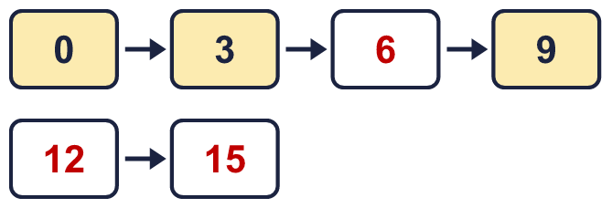
  2 | Work out the multiplications.  a) 8 × 3 = 24  b) 4 × 3 = 12  c) 10 × 3 = 30
  3 | Circle the multiples of 3. Write them below.  38 69 30 11 48 28  30, 48, 69
  4 | Find the digit sum of each number. Is the number a multiple of the number shown?  a) 321: digit sum 6 multiple of 3? Yes  b) 361: digit sum 10 multiple of 3? No  c) 380: digit sum 11 multiple of 3? No
  5 | Complete the number track. It counts down in 3s.  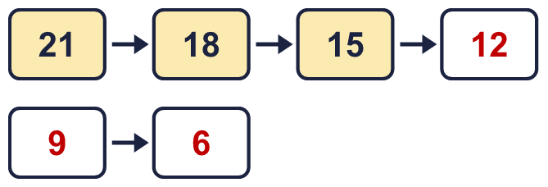
  6 | Write the missing number in each calculation.  a) 33 ÷ 3 = 11  b) 4 × 3 = 12  c) 15 ÷ 3 = 5
  7 | List the multiples of 3 that are between 20 and 80.  21, 24, 27, 30, 33, 36, 39, 42, 45, 48, 51, 54, 57, 60, 63, 66, 69, 72, 75, 78
  8 | How many multiples of 3 are there from 3 up to 80?  26
  9 | Is Boba correct? Circle yes or no.  Yes / No  Explain your answer.  No. 3 is a multiple of 3, but it does not fit the statement.
  10 | Omar is thinking of three different multiples of 3 that are less than 30. The sum of the numbers is 69.  What could the numbers be?  for example 18 + 24 + 27
  11 | a) How long is the yellow ribbon? 9 cm  b) How much longer is the yellow ribbon than the red ribbon? 6 cm
  12 | Aisha has three times as many stickers as Tom. Tom has three times as many stickers as Jo. Tom has 18 stickers.  a) How many stickers does Aisha have? 54  b) How many stickers do they have in total? 78
  13 | Which number is the odd one out?  30 12 65 24  The odd one out is 65  Explain why it is the odd one out.  65 is not a multiple of 3. The other three numbers are multiples of 3.
  14 | Is Boba correct? Circle yes or no.  Yes / No  What is the correct answer? 18  Explain Boba’s mistake.  6 × 3 = 18. Boba’s answer is not 6 groups of 3: 6 groups of 3 make 18.

