  Year 4 · Multiplication and division A · Step 5  9 times-table and division facts | 
  Year 4 · Multiplication and division A · Step 5
  9 times-table and division facts
  1 | Complete the number sentences to describe the array.  
     | × |  | =
     | × |  | =
     | ÷ |  | =
     | ÷ |  | =
  1 | Complete the number sentences to describe the array.
     | × |  | =
     | × |  | =
     | ÷ |  | =
     | ÷ |  | =
  2 | Complete the number track. It counts up in 9s.  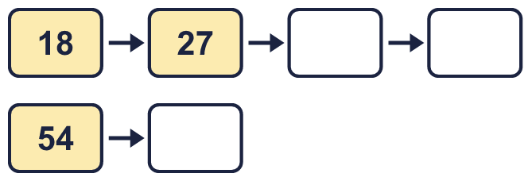
  2 | Complete the number track. It counts up in 9s.
  3 | Work out the multiplications.  a) 7 × 9 =  b) 9 × 12 =  c) 2 × 9 =
  3 | Work out the multiplications.  a) 7 × 9 =  b) 9 × 12 =  c) 2 × 9 =
  4 | Work out the divisions.  a) 72 ÷ 9 =  b) 54 ÷ 9 =  c) 18 ÷ 9 =
  4 | Work out the divisions.  a) 72 ÷ 9 =  b) 54 ÷ 9 =  c) 18 ÷ 9 =
  5 | Write the missing number in each calculation.
    a) |  | × 9 | = | 45
    b) |  | ÷ 9 | = | 2
    c) | 72 ÷ 9 | =
  5 | Write the missing number in each calculation.
    a) |  | × 9 | = | 45
    b) |  | ÷ 9 | = | 2
    c) | 72 ÷ 9 | =
  6 | Circle the multiples of 9. Write them below.  22 31 15 99 54 27
  6 | Circle the multiples of 9. Write them below.  22 31 15 99 54 27
  7 | Work out the calculations.  a) 9 × 7 =  b) 108 ÷ 12 =  c) 18 ÷ 9 =
  7 | Work out the calculations.  a) 9 × 7 =  b) 108 ÷ 12 =  c) 18 ÷ 9 =
  8 | Complete the number track. It counts down in 9s.  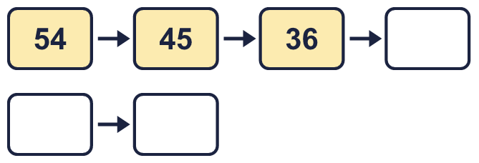
  8 | Complete the number track. It counts down in 9s.

  9 | Write true or false for each statement.
    a) | 8 × 9 = 7 × 9 + 9
    b) | 16 × 9 = 8 × 18
    c) | 8 × 9 = 8 × 10 - 9
    d) | 8 × 9 = 9 × 9 + 9
  9 | Write true or false for each statement.
    a) | 8 × 9 = 7 × 9 + 9
    b) | 16 × 9 = 8 × 18
    c) | 8 × 9 = 8 × 10 - 9
    d) | 8 × 9 = 9 × 9 + 9
  10 | Is Boba correct? Circle yes or no.  Yes / No  What is the correct answer?  Explain Boba’s mistake.
    
  10 | Is Boba correct? Circle yes or no.  Yes / No  What is the correct answer?  Explain Boba’s mistake.
  11 | Sort the numbers into the table. Write none if a box is empty. 81 74 48 37 54 27 18 88
    Multiples of 9 and even:
    Multiples of 9 and odd:
    Not multiples of 9 and even:
    Not multiples of 9 and odd:
  11 | Sort the numbers into the table. Write none if a box is empty. 81 74 48 37 54 27 18 88
    Multiples of 9 and even:
    Multiples of 9 and odd:
    Not multiples of 9 and even:
    Not multiples of 9 and odd:
  12 | a) Use this fact to work out 9 × 12.  b) Now work out 108 ÷ 9.
     | 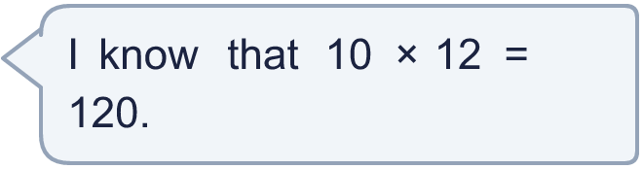
  12 | a) Use this fact to work out 9 × 12.  b) Now work out 108 ÷ 9.
  13 | There are 9 players in a team. 3 teams have signed up for a tournament.  a) How many players have signed up?  b) The tournament needs 72 players. How many more teams are needed?
  13 | There are 9 players in a team. 3 teams have signed up for a tournament.  a) How many players have signed up?  b) The tournament needs 72 players. How many more teams are needed?
  14 | Write three different multiples of 9 that are between 30 and 70.
  14 | Write three different multiples of 9 that are between 30 and 70.

Year 4 · Multiplication and division A · Step 5
9 times-table and division facts
Answers (teacher copy)

  1 | Complete the number sentences to describe the array.  5 × 9 = 45  9 × 5 = 45  45 ÷ 9 = 5  45 ÷ 5 = 9
  2 | Complete the number track. It counts up in 9s.  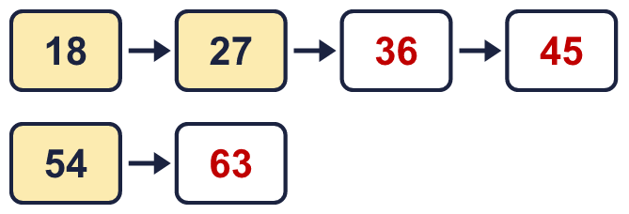
  3 | Work out the multiplications.  a) 7 × 9 = 63  b) 9 × 12 = 108  c) 2 × 9 = 18
  4 | Work out the divisions.  a) 72 ÷ 9 = 8  b) 54 ÷ 9 = 6  c) 18 ÷ 9 = 2
  5 | Write the missing number in each calculation.  a) 5 × 9 = 45  b) 18 ÷ 9 = 2  c) 72 ÷ 9 = 8
  6 | Circle the multiples of 9. Write them below.  22 31 15 99 54 27  27, 54, 99
  7 | Work out the calculations.  a) 9 × 7 = 63  b) 108 ÷ 12 = 9  c) 18 ÷ 9 = 2
  8 | Complete the number track. It counts down in 9s.  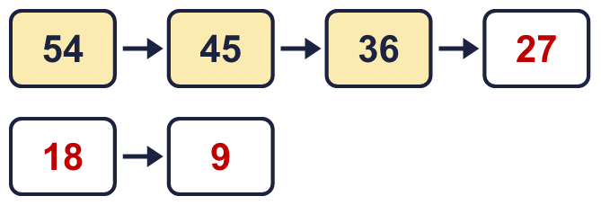
  9 | Write true or false for each statement.  a) 8 × 9 = 7 × 9 + 9 True  b) 16 × 9 = 8 × 18 True  c) 8 × 9 = 8 × 10 - 9 False  d) 8 × 9 = 9 × 9 + 9 False
  10 | Is Boba correct? Circle yes or no.  Yes / No  What is the correct answer? 81  Explain Boba’s mistake.  9 × 9 = 81. Boba’s answer is not 9 groups of 9: 9 groups of 9 make 81.
  11 | Sort the numbers into the table. Write none if a box is empty. 81 74 48 37 54 27 18 88  Multiples of 9 and even: 18, 54  Multiples of 9 and odd: 27, 81  Not multiples of 9 and even: 48, 74, 88  Not multiples of 9 and odd: 37
  12 | a) Use this fact to work out 9 × 12. 108  b) Now work out 108 ÷ 9. 12
  13 | There are 9 players in a team. 3 teams have signed up for a tournament.  a) How many players have signed up? 27  b) The tournament needs 72 players. How many more teams are needed? 5
  14 | Write three different multiples of 9 that are between 30 and 70.  for example 36, 45, 54

